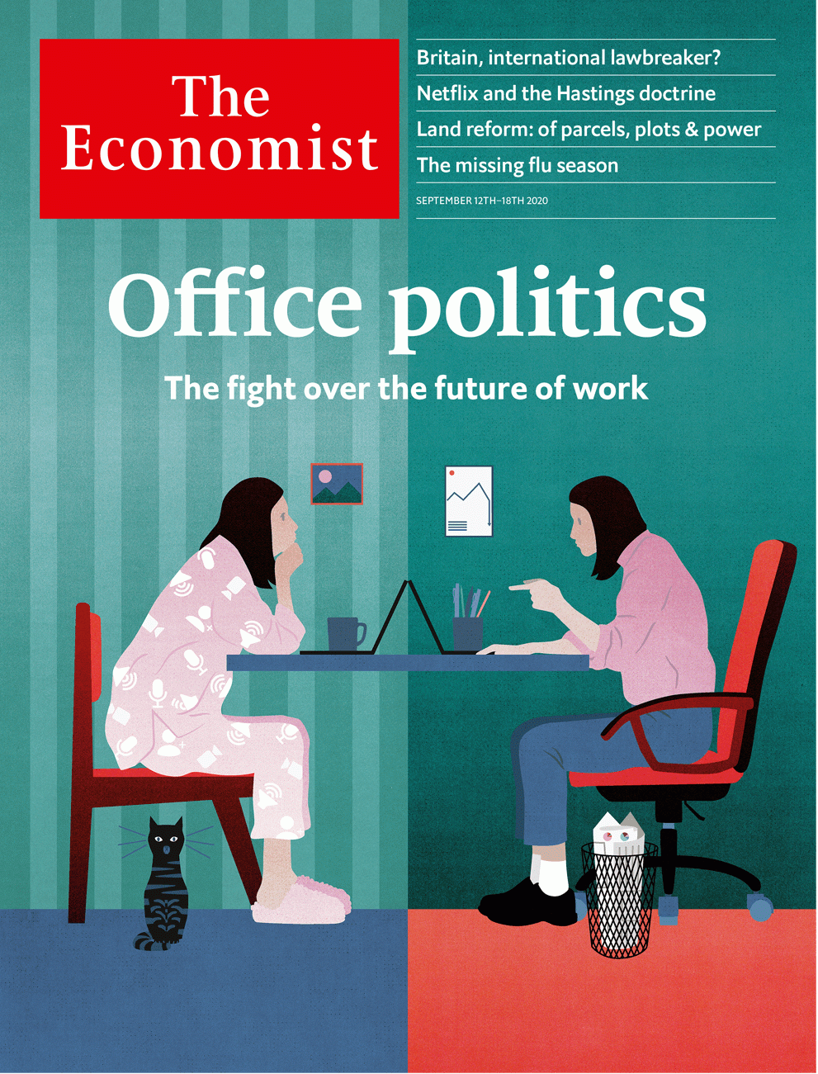

# Table of Contents

The world this week

Politics this week

Business this week

KAL’s cartoon

Leaders

Work and: Office politics

Belarus: Don’t let Putin swallow Belarus

Brexit and international law: A shocking breach

Wildfires: Burning up

Title and ownership: Whose land?

Letters

Letters to the editor: On digital trade, Ferdinand Magellan, the centre-left, mental health, diplomacy, economics

Briefing

The future of the office: What a way to make a living

Asia

Kashmir: Highland brig

India’s border with China: Ice and fire

Railways in Japan: Undo the locomotion

Myanmar and the Rohingya: They shot the smoking guns

Banyan: The new weather gods

China

Party building: The red front-line

Foreign media: Bumping heads

Chaguan: More red than green

United States

Generations and the election: The boomers’ last stand

Rap on the block: Sotheby’s hip-hop auction

The horse race: One trot closer

Political skulduggery in Missouri: The will of the...whatever

Eviction: Shelter in place

Lexington: The view from the scaffold

Middle East & Africa

Property rights: Parcels, plots and power

Jordan: Failing the test

Serbia, Kosovo and Israel: An awkward embrace

America and the Middle East: Stealth diplomacy

The Americas

Education in Latin America: Home truths

Mexico: Air show

Bello: Damned either way

Europe

Turkey: Erdogan’s world

Italy’s migrants: Blamed for the virus

Germany and Russia: The lady may toughen up

French intellectuals: Sex, lies and philosophy

Charlemagne: Last of the centre-lefties

Britain

Brexit negotiations: A new barrier

Suburban life: The end of commuterland

Sandwich strategies: Getting out of a pickle

Education: Famine to feast

Climate change: Extinguished Rebellion

Metal detectorists: Gold diggers

Bagehot: Revolutionary conservatism

International

The World Health Organisation: What’s wrong with the WHO

Business

Netflix: The Hastings doctrine

Vaccines: Strong medicine

Beverages (1): Caffeine clash

Beverages (2): Bottle shock

America v Huawei: Creative destruction

Bartleby: The delight is in the detail

Schumpeter: The one that got away

Finance & economics

Stockmarkets: Techtonic shifts

Fractional ownership: Money in the Banksy

Global trade: Down but not out

Climate change: Stormy waters

Buttonwood: Eggheads

Cyber-heists: Malware and mules

European banks: Badwill hunting

Free exchange: Which market model is best?

Schools brief

Government debt: Putting on weight

Science & technology

Natural disasters: Learning to live with it

Atmospheric dynamics: Fire, then ice

Palaeontology: Bones of contention

Immunology: Green shoots

Armoured warfare: Army surplus?

Books & arts

Globalisation: Lowering the drawbridge

American history: Out of the closet

Prairie gothic: Thicker than water

Philosophy: New speak

Irish fiction: Memory lane

Economic & financial indicators

Economic data, commodities and markets

Graphic detail

Influenza: Cold case

Obituary

Comrade Duch: The mathematics of death



### Friday, September 11, 2020

|  |  |
| --- | --- |
| The world this week | 3 |
| Leaders | 5 |
| Letters | 1 |
| Briefing | 1 |
| Asia | 5 |
| China | 3 |
| United States | 6 |
| Middle East & Africa | 4 |
| The Americas | 3 |
| Europe | 5 |
| Britain | 7 |
| International | 1 |
| Business | 7 |
| Finance & economics | 8 |
| Schools brief | 1 |
| Science & technology | 5 |
| Books & arts | 5 |
| Economic & financial indicators | 1 |
| Graphic detail | 1 |
| Obituary | 1 |

|  |  |  |
| --- | --- | --- |
|  | Sections | Leaders |

The world this week

Politics this week

.

Business this week

.

KAL’s cartoon

.

|  |  |  |
| --- | --- | --- |
|  | Sections | Leaders |

|  |  |  |  |
| --- | --- | --- | --- |
|  | Articles | Sections | Next |

# Politics this week

Sep 12th 2020 |

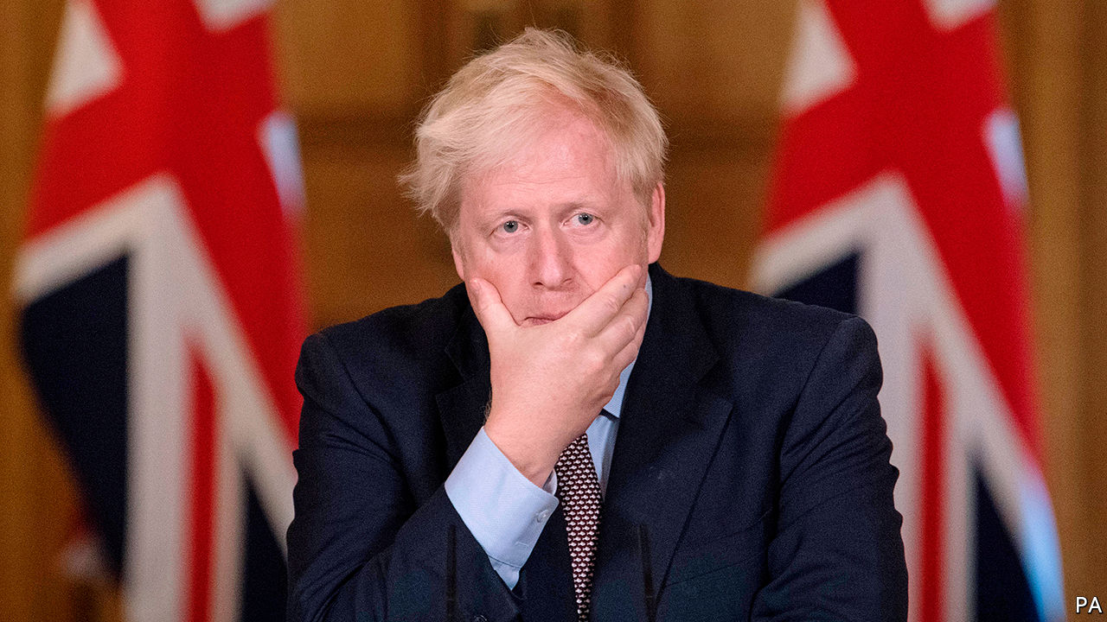

Boris Johnson, the British prime minister, proposed a unilateral change to parts of the Brexit withdrawal agreement related to the Northern Ireland protocol, which averts a hard border with the European Union. There is no precedent for Britain breaching international law in this way. It may be British brinkmanship, as talks over a trade deal continue. But Ursula von der Leyen, head of the European Commission, said it might result in no deal at all. See [article](https://www.economist.com/node/21791739).

A fire destroyed the largest camp for migrants in Greece, Moria on the island of Lesbos, leaving 13,000 people without shelter. Some 400 unaccompanied minors are being taken to the mainland. It is not clear what will happen to the rest.

Plain-clothes thugs abducted one of the leaders of Belarus’s protests, Maria Kolesnikova. They drove her to the border with Ukraine and tried to expel her, but she tore up her passport to frustrate them. In Minsk, the capital, ambassadors from three EU countries stationed themselves in the flat of another leading protester, a Nobel-prize winning writer, to prevent her arrest. See [article](https://www.economist.com/node/21791743).

Alexei Navalny, Russia’s main opposition leader who was poisoned last month and medevaced to Germany, was brought out of an induced coma, and was said to be responding to verbal stimuli.

America’s presidential election drew closer. North Carolina began posting ballots to voters who have requested them. Donald Trump urged his supporters to vote by mail and then show up to vote in person, to check whether safeguards against illegally voting twice were in place. Critics said he was trying to cast doubt on the veracity of the result, should he lose on November 3rd. He trails Joe Biden in the polls.

Juan Guaidó, who is recognised by many countries as Venezuela’s interim president, urged a boycott of legislative elections in December, which the dictatorial regime of Nicolás Maduro is likely to rig. Some prominent opposition members may participate anyway. See [article](https://www.economist.com/node/21791744).

Andrew Holness, Jamaica’s prime minister, was re-elected. His Jamaica Labour Party won 49 of the 63 seats in the lower house of Parliament. Covid-19 suppressed turnout, which fell to 37% from 48% in 2016.

The corruption conviction of Rafael Correa, who was Ecuador’s president from 2007 to 2017, was confirmed by a court. The decision means that Mr Correa cannot carry out his plan to be the running-mate of Andrés Arauz, a left-wing candidate for the presidency.

A court in Saudi Arabia commuted the death sentences of five men convicted of murdering Jamal Khashoggi, a dissident journalist, inside the Saudi consulate in Istanbul in 2018. Prosecutors said Khashoggi’s family agreed to pardon the killers, who were instead given 20-year jail terms. But his fiancée, who lives abroad, said the ruling made “a complete mockery of justice”.

The UN’s nuclear watchdog said Iran has ten times the amount of enriched uranium, a nuclear fuel, permitted under the deal it signed with world powers in 2015. Iran would need to enrich the uranium further, a long process, to make a bomb.

Donald Trump brokered a deal between Kosovo and Serbia that, among other things, would see both countries establish embassies in Jerusalem. That provoked a warning from the EU, which the Balkan states hope to join: it wants the status of Jerusalem to be worked out in peace talks. See [article](https://www.economist.com/node/21791734).

West Africa’s regional bloc, ECOWAS, said it will impose more economic sanctions on Mali unless the leaders of a coup hand power to civilians by September 15th and pledge to hold elections within a year.

The Tigray region of Ethiopia defied the central government by holding state elections, putting further strain on an already troubled federation. Voting across the rest of the country has been indefinitely postponed because of covid-19.

Police in Hong Kong arrested nearly 300 people during protests against a new national-security law and the postponement of elections for the Legislative Council.

Two Australian journalists in China sought refuge in diplomatic missions after police knocked on their doors at midnight. They were told they would be questioned about a third Australian citizen who is being held on national-security grounds. They agreed to be interviewed on condition that they were allowed to leave the country, which they did. No Australian news media remain in mainland China. See article.

Troops from China and India exchanged fire across their disputed border in the Himalayas for the first time since 1975. The two nuclear powers, who fought a brief war in 1962, both say they want to lower tensions; each accuses the other of stoking them. See article.

A politician sentenced to death for murdering a member of a rival party was brought from prison to be sworn in as an MP for Sri Lanka’s ruling party.

Amrullah Saleh, Afghanistan’s vice-president and an opponent of the Taliban, survived an assassination attempt that killed ten bystanders. The Taliban, which is due to begin peace talks with the government, denied responsibility.

## Coronavirus briefs

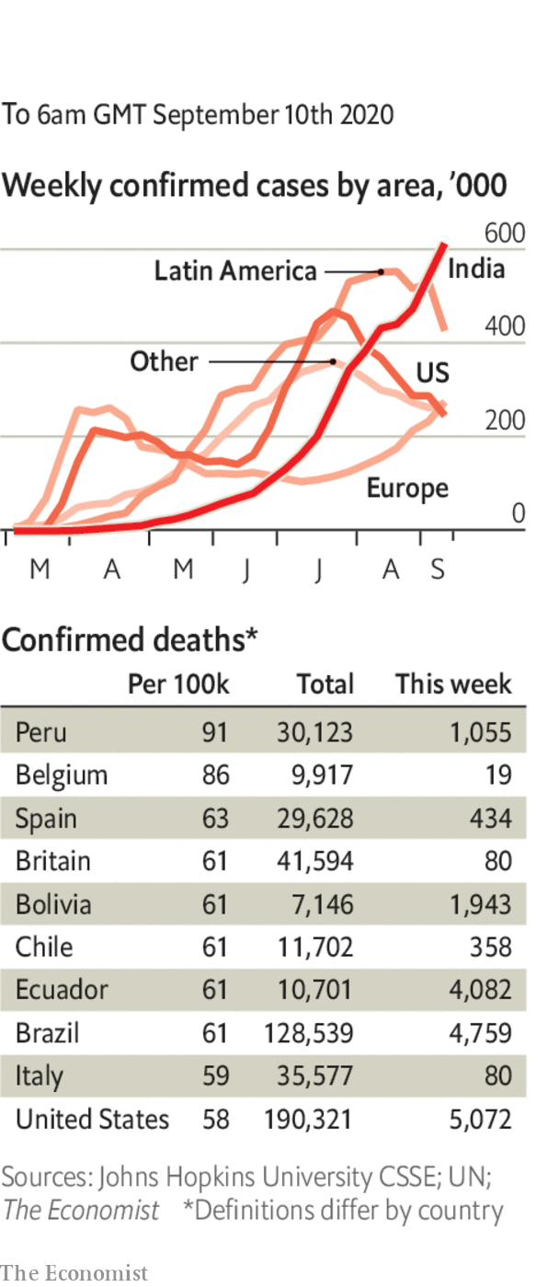

A promising trial of a vaccine that AstraZeneca is developing with Oxford University was temporarily put on hold after one of the volunteers fell ill.

Social gatherings of more than six people were banned in England after a surge in the disease, notably among gregarious young people.

The number of new daily infections in the United States fell below 30,000 for the first time since June.

In South Africa new cases dropped under 1,000 a day. In July they averaged 11,000.

Emmanuel Macron urged people to be “collectively much more responsible” as the number of deaths in France crept up to levels last seen in June.

Wearing a face mask in shops and public buildings became mandatory again in the Czech Republic. The stipulation had been lifted in July.

This article was downloaded by calibre from <https://www.economist.com/the-world-this-week/2020/09/12/politics-this-week>

|  |  |  |  |
| --- | --- | --- | --- |
|  | Articles | Sections | Next |

|  |  |  |  |
| --- | --- | --- | --- |
| Previous | Articles | Sections | Next |

# Business this week

Sep 10th 2020 |



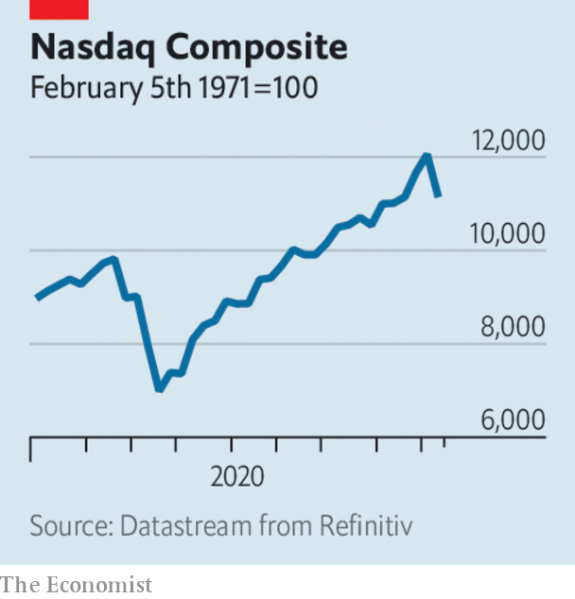

A sell-off in tech stocks led to the worst trading period for the Nasdaq since mid-March, at the start of the covid-19 crisis. Over a few days the share prices of Amazon, Alphabet, Facebook and Microsoft fell by more than 10% from recent highs; Apple’s dropped by 16%. The rout also put a dent in the S&P 500, which fell back from a record close, and other stockmarkets. Tech companies’ share prices have soared this year, far ahead of the rest of the market. Some investors think they are long overdue for a price correction; others that this week was just a blip. See [article](https://www.economist.com/node/21791718).

## There she blows!

SoftBank’s share price fell by 7% in a day, after it was revealed as the mystery “whale” making risky bets in tech stocks. The Japanese conglomerate has reportedly placed huge amounts of call options (derivatives that allowed it to buy shares at a set price on a specific date) on companies listed on the Nasdaq. See [article](https://www.economist.com/node/21791718).

Slack’s quarterly earnings disappointed investors. Although revenue was up by 49% year on year, the messaging platform has not done as well as other team-communication services during the pandemic, such as Zoom, and expects sales to slow this quarter. It also faces an assertive challenge from Microsoft’s Teams app. In July Slack filed an antitrust suit in the EU accusing Microsoft of unfairly bundling Teams with Office software.

It was also a rough week for the oil market. The price of Brent crude slipped below $40 a barrel for the first time since June, after it emerged that Saudi Arabia had reduced its oil rates for Asia and America.

The Pentagon confirmed that it was considering adding SMIC, China’s biggest chip manufacturer, to a list of companies deemed to be working against America’s national-security interests. The news that SMIC might be put on the list wiped out almost a quarter of its value on the Hong Kong stockmarket. It insists it is a purely commercial entity with no ties to the Chinese armed forces. See [article](https://www.economist.com/node/21791727).

The IPO of Nongfu Spring, a Chinese bottled-water company, was a sparkling success on the Hong Kong stock exchange. The flotation left its founder, Zhong Shanshan, who left school at 12, as one of China’s richest men, with a fortune roughly equal to that of Jack Ma, Alibaba’s founder. See [article](https://www.economist.com/node/21791720).

CaixaBank and Bankia, two banks in Spain, confirmed they were talking about merging, which would create the country’s biggest lender.

South Africa’s economy was 16.4% smaller in the second quarter compared with the first, the worst contraction since the 1990s. Infections from covid-19 have slowed, allowing the government to lift some restrictions, such as on sales of alcohol. But a recovery is being hampered by creaking electricity infrastructure, which has led to power blackouts and energy rationing.

America’s unemployment rate fell to 8.4%. That is below the level reached during and after the global financial crisis over a decade ago, although the number remains affected by a “misclassification error” in the survey used to produce it. In April the rate had surged to 14.7%. But it never reached the 20% that some were predicting at the start of the pandemic. After the news Republicans proposed new stimulus measures that fall far short of what the Democrats are calling for. The Republican plan provides for a $300-per-week unemployment benefit top up, which the Democrats want restored to $600 a week.

China’s exports roared back last month, increasing by 9.5% in dollar terms compared with August 2019. China’s monthly trade surplus with America rose to $34.2bn, the most since November 2018.

Germany’s exports rose again in July on the previous month, though they were still 11% lower than in July 2019. Industrial production is also recovering from the pandemic slump, though output remains a tenth smaller than what it was a year ago.

## Handbags at dawn

LVMH’s $17bn takeover of Tiffany appeared to be off. The French luxury-goods conglomerate struck a deal to buy the American jeweller last November, but now says the French government has stymied its proposal because of a row with America over tariffs on items such as handbags and cosmetics. Tiffany has gone to court accusing LVMH of using delaying tactics to renegotiate the terms of its offer because of a flop in sales during lockdown.

Tesla’s newly split stock was hammered during the tech bloodbath on Wall Street, plunging by a third over a few days before recovering somewhat. It was also hurt by the surprise news that the electric-car maker still hasn’t made the cut for inclusion in the S&P 500, which would have driven appetite for its shares from index funds. Elon Musk, who recently became only the fifth man in the world to be worth over $100bn, has seen his fortune diminish in less than a week to a mere $78bn.

This article was downloaded by calibre from <https://www.economist.com/the-world-this-week/2020/09/10/business-this-week>

|  |  |  |  |
| --- | --- | --- | --- |
| Previous | Articles | Sections | Next |

|  |  |  |  |
| --- | --- | --- | --- |
| Previous | Articles | Sections | Next |

# KAL’s cartoon

Sep 10th 2020 |

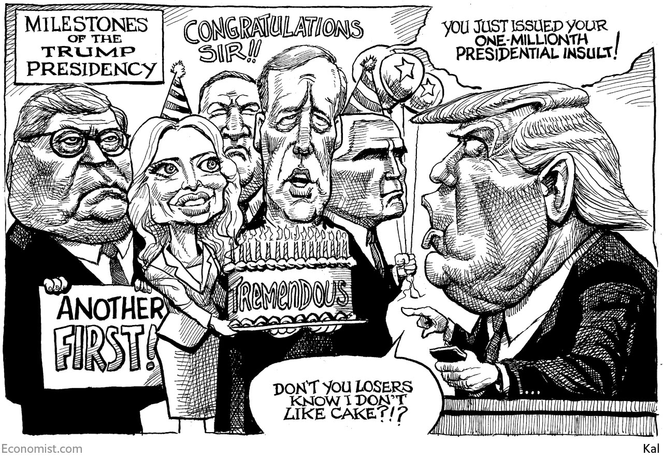

This article was downloaded by calibre from <https://www.economist.com/the-world-this-week/2020/09/10/kals-cartoon>

|  |  |  |  |
| --- | --- | --- | --- |
| Previous | Articles | Sections | Next |

|  |  |  |
| --- | --- | --- |
| The world this week | Sections | Letters |

Leaders

Work and: Office politics

.

Belarus: Don’t let Putin swallow Belarus

.

Brexit and international law: A shocking breach

.

Wildfires: Burning up

.

Title and ownership: Whose land?

.

|  |  |  |
| --- | --- | --- |
| The world this week | Sections | Letters |

|  |  |  |  |
| --- | --- | --- | --- |
|  | Articles | Sections | Next |

#### The future of work

# Is the office finished?

The fight over the future of the workplace

Sep 12th 2020 |

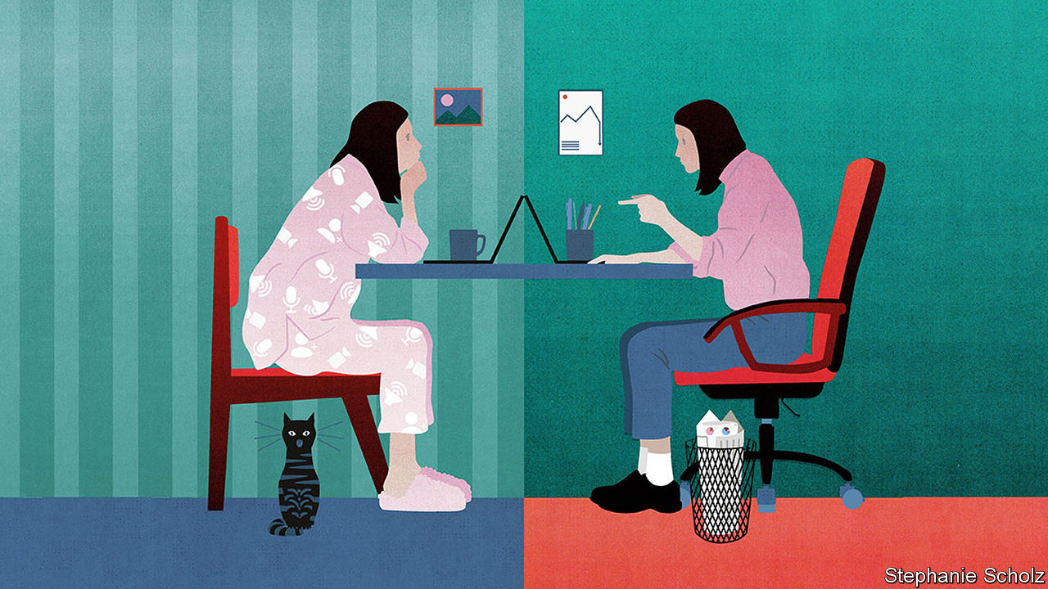

Editor’s note: Some of our covid-19 coverage is free for readers of The Economist Today, our daily [newsletter](https://my.economist.com/user#newsletter). For more stories and our pandemic tracker, see our [hub](https://www.economist.com/news/2020/03/11/the-economists-coverage-of-the-coronavirus)

MOST PEOPLE associate the office with routine and conformity, but it is fast becoming a source of economic uncertainty and heated dispute. Around the world workers, bosses, landlords and governments are trying to work out if the office is obsolete—and are coming to radically different conclusions (see article). Some 84% of French office workers are back at their desks, but less than 40% of British ones are. Jack Dorsey, the head of Twitter, says the company’s staff can work from home “forever” but Reed Hastings, the founder of Netflix, says home-working is “a pure negative”. As firms dither, the $30trn global commercial-property market is stalked by fears of a deeper slump. And while some workers dream of a Panglossian future without commutes and Pret A Manger, others wonder about the threat to promotions, pay and job security.

The disagreement reflects uncertainty about how effective social distancing will be and how long it will take before a covid-19 vaccine is widely available. But it is about more than that: the pandemic has revealed just how many offices were being run as relics of the 20th century, even as it triggered the mass-adoption of technologies that can transform white-collar work. As a result the covid calamity will prompt a long-overdue phase of technological and social experimentation, neither business as usual nor a fatal blow to the office. This era holds promise but also brings threats, not least to companies’ cultures. Instead of resisting change, governments need to update antiquated employment laws and begin reimagining city centres.

Two hundred years ago steam power brought workers to factories where they could use new machines. As corporate giants emerged in the late 19th century, staff were needed to administer them. They held planning meetings and circulated memos, invoices and other paperwork to record what they had done. All this required workers to be close together and created the pattern of people commuting by car or train in order to meet in a central office.

This system always had glaring shortcomings, some of which have become worse over time. Most people hate the hassle and expense of commuting, which eats up over four hours a week for the average American worker. Some dislike the noise and formality of offices, or suffer from discrimination within them. Office-bound workers find it harder to look after their children, a growing issue as more families have two working parents.

You might think that new technologies would have shaken up this unsatisfactory status quo. After all, the PDF electronic document was born in 1991, the cost of bandwidth collapsed in the 2000s, and Zoom and Slack, two firms whose technology powers remote working, are both nearly a decade old. Yet inertia has allowed the office to escape serious disruption. Before covid-19 struck, for example, flexible-office companies (including the troubled WeWork) had a tiny global market share of under 5%. Most businesses were unwilling to switch wholesale to remote-working technologies before their clients did; or to write off sunk costs in the form of property assets and leases.

Covid-19 has upended all this. Before the pandemic only 3% of Americans worked from home regularly; now a huge number have tried it. Even Xerox, a firm synonymous with office printers spewing unread pages, has many of its staff working from home. As more people adopt remote-working technologies there is a powerful network effect, with each new customer making the service more useful. Together Microsoft Teams, Zoom, Google Meet and Cisco Webex now have well over 300m users. Bureaucratic hurdles to remote work have been blasted out of the way. Civil courts are operating remotely. Notaries have gone online and some banks have eliminated the need for new customers to enter a branch to confirm their identity and open an account.

How much of this change will stick when a vaccine arrives? The best available guide is from countries where the virus is under control. There the picture is of an “optional office”, which people attend, but less frequently. In Germany, for example, 74% of office workers now go to their place of work, but only half of them are there five days a week, according to surveys by Morgan Stanley. The exact balance will depend on the industry and city. In places with easy commutes more workers will go to the office; megacities with long, expensive journeys may see fewer.

Companies will have to adapt to this pattern of sporadic attendance in which the office is a hub, not a second home. There is a risk that over time a firm’s social capital erodes, creativity flags, hierarchies ossify and team spirit fades, as Mr Hastings fears (see article). The answer is more targeted staff interactions, with groups gathering at specific times to refresh friendships and swap information. New technologies that “gamify” online interactions to prompt spontaneity may eventually supersede the stilted world of Zoom. As they retool their cultures firms will need to rejig their property: sober investors expect a reduction of at least 10% in the stock of office space in big cities. With the typical corporate lease lasting at least half a decade, this will take time to play out.

For governments the temptation is to turn the clock back to limit the economic damage, from the collapse of city-centre cafés to the $16bn budget shortfall that New York’s subway system faces. Britain’s government has tried to cajole workers back to the office. But rather than resist technological change, it is far better to anticipate its consequences. Two priorities stand out.

First, a vast corpus of employment law will need to be modernised. Already the gig economy has shown that it is out of date. Now new prickly questions about workers’ rights and responsibilities loom: can firms monitor remote workers to assess their productivity? Who is liable if employees injure themselves at home? Any sense that white-collar workers are getting perks will create simmering resentment in the rest of the workforce.

The second priority is city centres. For a century they have been dominated by towers filled with swivel chairs and tonnes of yellowing paper. Now complex urban-planning rules will need a systematic overhaul to allow buildings and districts to be redeveloped for new uses, including flats and recreation. If you step back into the office this month, sit down and log on to your computer—but don’t get too comfortable.■

This article was downloaded by calibre from <https://www.economist.com/leaders/2020/09/12/is-the-office-finished>

|  |  |  |  |
| --- | --- | --- | --- |
|  | Articles | Sections | Next |

|  |  |  |  |
| --- | --- | --- | --- |
| Previous | Articles | Sections | Next |

#### A desperate despot’s dodgy deal

# Will Putin save Lukashenko?

In exchange for Russian support, an autocrat prepares to sell out his country

Sep 12th 2020 |



“FIRST THEY stole our country. [Now] they are stealing the best of us.” So said Svetlana Alexievich, a Nobel prize-winning writer, of the rulers of her native Belarus. Since mass protests erupted after a blatantly rigged presidential election in August, riot police and plain-clothes goons have been beating up peaceful demonstrators. On September 7th, in broad daylight, men without uniforms abducted Maria Kolesnikova (pictured), one of three women leading the protests and the only one still inside the country. They threw her into a van and drove her to the border with Ukraine, like gangsters trying to drive a rival off their turf. Defiantly, she ripped up her passport, so she could not cross. She is now in detention in Belarus.

Ms Kolesnikova is being persecuted not only for her role in the protests but also, more importantly, because she is the leading member of the National Co-ordinating Council. This body was launched by Svetlana Tikhanovskaya, who probably won the election on August 9th but who has been forced into exile. It aims to negotiate a peaceful end to the unpopular dictatorship of Alexander Lukashenko. He has refused to negotiate, just as he has refused to talk to the German chancellor, Angela Merkel.

He prefers to talk to Vladimir Putin, the president of next-door Russia, who props up his regime. Mr Putin, whose own challenger, Alexei Navalny, has been poisoned by a nerve agent, has endorsed Mr Lukashenko’s rigged election and his use of violence. He has warned the West not to meddle in Belarus, which Russia has subsidised for many years and with which it has a common market. At Mr Lukashenko’s request, Mr Putin has pledged to support Belarus with his own law-enforcers if necessary. He has also dispatched propagandists to run its airwaves and consultants to manage the crisis. Russia’s prime minister and finance minister have flown to Minsk to talk about an economic rescue package.

The West’s reaction has been divided, slow and weak. The Baltic states and Poland, which have had first-hand experience of Soviet occupation, have imposed sanctions on Mr Lukashenko and offered support to the Belarusian opposition. Germany and France, however, appear to have heeded Mr Putin’s warning to stay out of the dispute. The European Union has yet to impose any sanctions on Mr Lukashenko, though some measures are under discussion. Such caution about Belarus contrasts with bolder statements about Mr Navalny’s poisoning from Mrs Merkel. She has pointed a finger at the Kremlin and raised the possibility of cancelling Nord Stream 2, a huge and controversial gas-pipeline project (see article).

The EU should speak up loudly about Belarus, and with one voice. Simply warning Mr Putin against sending troops is not enough. A Russian invasion was unlikely from the start. Instead, Mr Putin wants the tottering Belarusian tyrant to integrate his country more deeply with Russia, giving Mr Putin control over its defence, internal security and certain key economic assets. In return, Mr Lukashenko might get an honorary post in Moscow some day. Russia might be hoping for a soft Anschluss. That would be no more acceptable than Mr Putin’s annexation of Crimea, a Ukrainian peninsula, in 2014.

Belarusians have woken up. They will not submit quietly to Moscow’s rule and they continue to protest in vast numbers. They deserve support. The EU should impose personal sanctions against Mr Lukashenko and his henchmen. And it must state that any agreement with Russia signed by Mr Lukashenko on behalf of the people who have clearly rejected him has no legal basis or validity. No one should recognise a dodgy deal struck by a desperate despot who would sell his country to save himself. ■

This article was downloaded by calibre from <https://www.economist.com/leaders/2020/09/12/will-putin-save-lukashenko>

|  |  |  |  |
| --- | --- | --- | --- |
| Previous | Articles | Sections | Next |

|  |  |  |  |
| --- | --- | --- | --- |
| Previous | Articles | Sections | Next |

#### Brexit and international law

# Britain threatens to flout international law

Boris Johnson’s readiness to break a treaty as a negotiating tactic is both foolish and dangerous

Sep 9th 2020 |

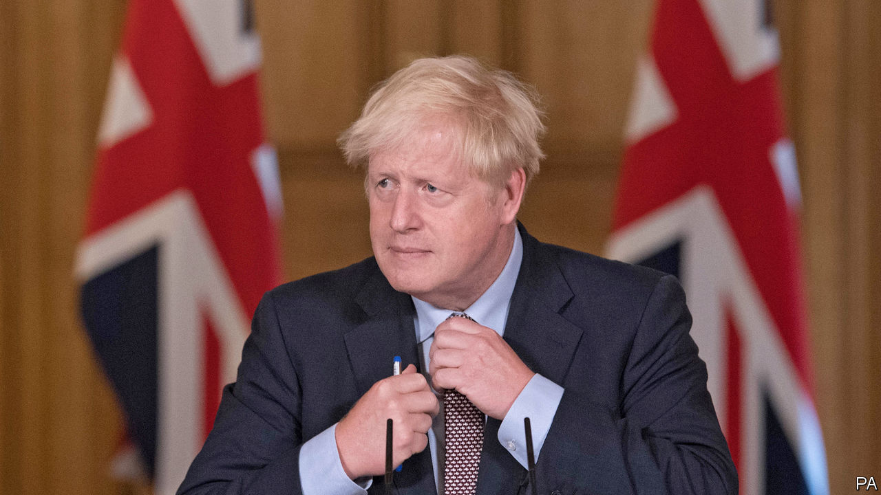

IT IS STAGGERING to see a British minister brazenly admit to Parliament that the government intends to breach international law. Yet that is what Brandon Lewis, the Northern Ireland secretary, did this week—even if he sought to qualify the move as “very specific and limited”. The plan in the proposed internal-market bill is to override parts of the Brexit withdrawal agreement, a treaty ratified only in January, that relate to trade between Great Britain and Northern Ireland. Because it will remain subject to the European Union’s customs code and single-market rules, special treatment is needed for the province to avert a hard border with Ireland. Reflecting the fact that there is no precedent for Britain unilaterally breaching an international treaty in this way, the government’s most senior legal adviser promptly quit.

What is Boris Johnson’s government playing at? It may be that he is resigned to Britain leaving the transition period on December 31st without a trade deal with the EU in place. The Brexit talks seem irretrievably stuck, so some in Downing Street now favour this option. Yet a kinder interpretation is that the prime minister is engaging in a tactical ploy to ratchet up the pressure on the EU. Threats to rewrite the withdrawal agreement are of a piece with his insistence that, unlike his predecessor, Theresa May, he will not blink at the last minute, and his claim that no deal would be a “good outcome” for Britain. By making no deal look more chaotic, he may hope to force EU leaders to compromise in their rigid demand for a level playing-field on state subsidies (see [article](https://www.economist.com/node/21791761)).

Yet such a tactical game is unlikely to work. As the world’s biggest market, the EU is a tough negotiator that does not commonly give in to threats. EU leaders know that the disruption and economic damage caused by no deal would be far worse for Britain than it would be for them. Faced with a similar prospect last year, it was not the EU but Mr Johnson who gave ground by accepting a separate status for Northern Ireland which implied customs checks in the Irish Sea. Moreover, to rewrite the withdrawal agreement unilaterally would undermine trust in the British negotiators. As EU leaders are already asking, how can they do a trade deal with a country that is talking of ripping up a treaty it agreed with them less than a year ago?

The ramifications of Mr Johnson’s threat to breach international law go wider than Britain’s relationship with the EU. Because his plan revives fears of a hard border in Ireland, it would go down very badly in America. Congress has already made clear that it will not ratify a free-trade deal with Britain if Brexit undermines the Good Friday peace process. The other prospective partners that post-Brexit Britain hopes to do trade deals with will be similarly deterred by the sight of it breezily overriding international commitments. Mrs May was right this week to wonder how other countries could now be reassured that Britain can be trusted to abide by its legal obligations.

Britain is a proud founding father of international law. If it is seen to be flouting it, that will only encourage others who dislike the concept (Vladimir Putin? Xi Jinping?) and would prefer to escape any constraints that it imposes. The Chinese press was quick to report the British case; China imposed its new security law unilaterally on Hong Kong. It would not be too far-fetched to expect other countries to think of their own cases. Spain, for example, might wish unilaterally to revisit the Treaty of Utrecht of 1713, under which it handed sovereignty over Gibraltar to Britain.

If Mr Johnson is unhappy with certain provisions in the withdrawal agreement, there is a procedure to clarify them in a joint committee with the EU. That is the right forum to use, not unilateral domestic legislation. He should drop his plan immediately and return to the negotiating table to secure a good deal with Britain’s biggest trade partner, which is what he promised voters he would do before last December’s election. ■

This article was downloaded by calibre from <https://www.economist.com/leaders/2020/09/09/britain-threatens-to-flout-international-law>

|  |  |  |  |
| --- | --- | --- | --- |
| Previous | Articles | Sections | Next |

|  |  |  |  |
| --- | --- | --- | --- |
| Previous | Articles | Sections | Next |

#### Golden State ablaze

# Why is California burning?

It’s time to think harder about incentives

Sep 12th 2020 |

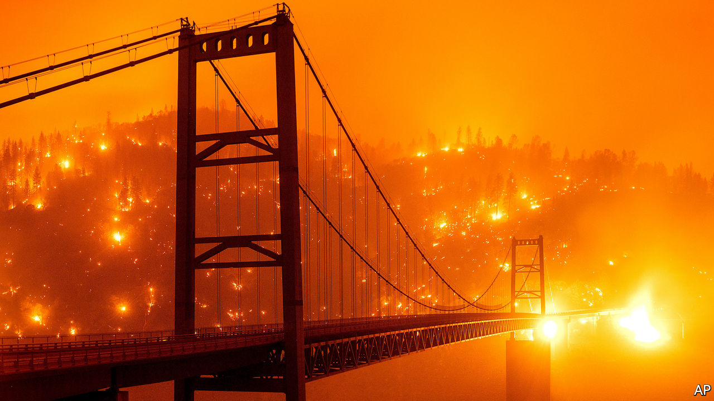

FOR DECADES environmentalists have warned that the world is going to burn. Mostly, they meant it figuratively. But footage of fires sweeping through the Siberian steppe, the Amazon forest, parts of Australia and now, once again, California, make it easy to believe the planet is, literally, on fire. New infernos have been whipped up by strong winds and scorching temperatures across the Golden State. On September 7th PG&E, a utility serving northern California, shut off the power supply to tens of thousands of homes in an attempt to stop live lines from sparking more blazes. So far this year, California has seen more than 2.5m acres (1m hectares) burned and more than 3,700 structures destroyed—all before the autumn months when the Santa Ana winds normally stir up the worst of the annual blazes. With over three months remaining of this year’s fire season, few doubt the state is facing its worst yet.

The fires themselves cannot be stopped; they are fuelled by climate change layered on top of an ecosystem that burns regularly as part of its natural cycle. Hotter temperatures and drier landscapes mean more fires. But the damage need not be so great. Much of California’s mess is of its own making. It has made itself more vulnerable with a litany of out-of-date regulations and self-defeating policies.

California does deserve credit for being the only American state to have adopted fire-safe building codes for what is known as the “wildland-urban interface”, where houses are sparsely dotted through tall, flammable trees and vegetation, often on steep slopes that flames can race up. Evidence suggests the codes do help limit damage. However, they apply only to new structures, and do nothing about the need to retrofit the vast majority of existing houses and other properties. Nor are there subsidies or other incentives to nudge people and firms to take on the onerous and expensive task of making buildings safe.

Furthermore, the codes date back to 2008 and have not yet been updated to include the latest science on why buildings burn. That includes strong evidence that the first five feet around a structure are key to its defence but all too often consist of flammable materials. Today, landscapers can still draw up designs where bark mulch—an almost perfect fuel—is laid down around the periphery of a home, office, or even hospital.

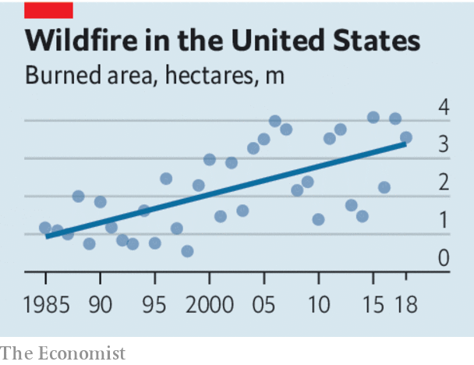

Fire-risk maps and zoning, which determine who must follow building codes, are in desperate need of a rethink. Among other things, they consider urbanised areas “unburnable”, which ignores science showing that the majority of buildings catch fire when flying embers are blown a mile or more away from the flaming vegetation. As a result, communities that are at risk from wildfires are not held to fire-safety rules—sometimes with dire consequences. When Coffey Park in Santa Rosa was destroyed by wildfire in 2017, the city vowed to rebuild better; but it wavered because of unfounded fears that being fire-safe would be a lot more costly. Stringent fire codes were not enforced, and the community once more had to evacuate during a fire in 2019 rather than shelter-in-place.

California is compounding its problems by undermining the correct pricing of risk, which is essential to encourage homeowners to move out of the most dangerous areas. The state has imposed ill-conceived new rules on insurers, temporarily barring them from refusing to renew policies in high-risk areas. And regulators are discouraging the industry from using fire risk as a reason to turn down business anywhere in the state.

No wonder California is caught in a burn-rebuild-burn-again cycle. The fires are not going away. But if state leaders rethought their misguided policies, they would at least wreak less havoc. ■

For more coverage of climate change, register for The Climate Issue, our fortnightly [newsletter](https://www.economist.com/theclimateissue/), or visit our [climate-change hub](https://www.economist.com/news/2020/04/24/the-economists-coverage-of-climate-change)

This article was downloaded by calibre from <https://www.economist.com/leaders/2020/09/12/why-is-california-burning>

|  |  |  |  |
| --- | --- | --- | --- |
| Previous | Articles | Sections | Next |

|  |  |  |  |
| --- | --- | --- | --- |
| Previous | Articles | Sections | Next |

#### Land reform

# Who owns what?

Enforceable property rights are still far too rare in poor countries

Sep 12th 2020 |

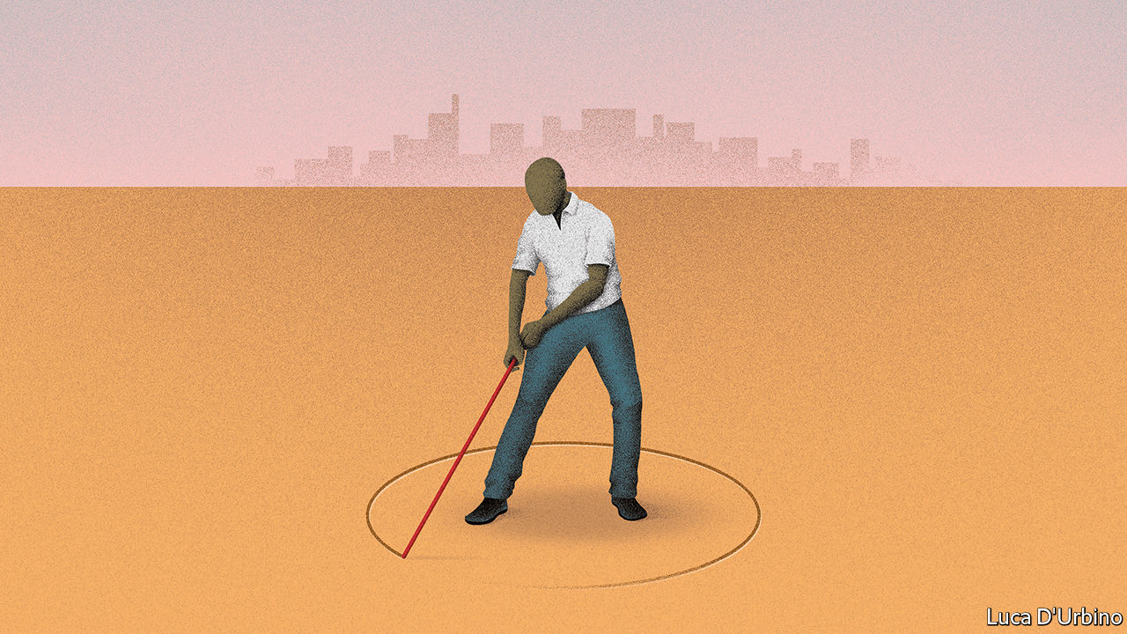

TWENTY YEARS ago a Peruvian economist made a startling observation. People in poor countries are not as poor as they seem. They have assets—lots of them. But they cannot prove that they own them, so they cannot use them as collateral. Hernando de Soto estimated that the total value of informally owned land, homes and other fixed assets was a whopping $9.3trn in 2000 ($13.5trn in today’s money). That was more than 20 times the total of foreign direct investment into developing countries over the preceding decade. If small farmers and shantytown-dwellers had clear, legal title to their property, they could borrow money more easily to buy better seeds or start a business. They could invest in their land—by irrigating it or erecting a shop—without fear that someone might one day grab it. Property rights would make the poor richer, he argued.

Since his book, “The Mystery of Capital”, was published, its ideas have spread. Indonesia, Thailand and Vietnam have pursued vast titling projects, mapping and registering millions of land parcels. India wants to use drones to map its villages. Ethiopia has registered millions of tracts. Rwanda has mapped and titled all its territory for $7 per parcel, thanks to cheap aerial photography. Studies suggest that titling has boosted agricultural productivity, especially in Asia and Latin America. The World Bank wants 70% of people to have secure property rights by 2030.

That is unlikely to happen, however. Despite all these efforts, only 30% of the world’s people have formal titles today. In rural sub-Saharan Africa a dismal 10% do (see article). Just 22% of countries, including only 4% of African ones, have mapped and registered the private land in their capital cities. As covid-19 destroys jobs, there has been a global upsurge in evictions and home demolitions, says the UN. Some 1bn people, nearly one in five adults, according to another survey, fear they will be evicted within five years, often because they do not formally own the land under their homes. Almost half of sub-Saharan women fear that divorce or widowhood would mean losing their fields or the roof over their heads.

As Mr de Soto warned, establishing a system of secure property rights is hard. Simply giving property-holders a title deed is not enough. A legal document is worth little if its owner cannot easily use it. Even in Rwanda, 87% of sales involving parcels of rural land were still done informally five years after the drive to give everyone deeds ended. Other countries have seen similar failures. All too often the institutions needed to enforce property rights smoothly, impartially and transparently are missing.

In many countries transactions are painfully slow. Registering a property takes an average of 108 days in South Asia and 64 in Latin America, as against just 24 days in OECD countries. In India two-thirds of civil-court cases are land disputes, which take an average of 20 years to resolve. New software platforms that make transactions and mediation easier should help. But technology can do only so much.

Other laws often undermine property rights. In more than 30 countries daughters and widows do not have the same land-inheritance rights as sons or widowers. In dozens more women find it hard to own land because of customary law, which is unwritten but vigorously enforced in many villages. Mining and forestry laws may override land laws, as in Mozambique. Ethiopia’s registering of millions of land parcels in the 2000s was undermined by restrictions on their use as collateral.

Restrictive planning laws make matters worse. In South Asia, where 130m people live in slums, zoning rules and land-hoarding by government agencies make it harder and costlier for people to buy formal property. And where title is insecure, land is less likely to be developed. Instead, people are pushed into low-rise slums far from the centre: the resulting sprawl means South Asian cities are growing twice as fast in area as in population. In Anglophone Africa some planning laws draw on colonial-era statutes designed for spacious English suburbs. In Dar es Salaam in Tanzania, the minimum plot size for a formal dwelling is 400 square metres. A slum home is perhaps one-fortieth of that.

One reason why reform is hard is that politicians often have a strong incentive to oppose it. In much of the developing world, the power to allocate land—or to decide who does so—is extremely lucrative. Politicians are often the worst land-grabbers, in order to enrich themselves and to reward supporters. Stronger property rights for the little guy would make such looting harder.

Ruling parties often ally with rural traditional leaders to thwart change. Globally 2.5bn-3bn people live on some 6bn hectares of communal land (or three Russias and a Brazil). In Africa more than 50% of people do. Since 1990, 39 of Africa’s 54 countries have passed land laws to give people on communal land stronger ownership rights. Yet in some countries, such as Malawi and Zambia, chiefs have blocked reforms. In others toxic deals between urban and rural bigwigs deprive poor people of rights to their own land. This is an acute problem in South Africa’s “former homelands”, where many black people were consigned during apartheid and where one-third of South Africans still live, with minimal property rights.

Well-meaning laws sometimes have loopholes for elites to exploit. Rules that allow expropriation in the public interest are abused to transfer land to cronies, for example. One study of African and Asian laws found that only half required compensation in the case of state-led expropriation. Some governments simply ignore the law. Officials in Brazil, Colombia and Kenya have thrown slum-dwellers out of their shacks or bulldozed rural people’s ancestral land. In Niger, Indonesia and the Philippines land-rights activists have been locked up or intimidated. Property rights cannot work unless the law applies to everyone.

Land is an emotive issue, especially where memories of colonial expropriation still linger. In parts of southern Africa, when a baby is born, its umbilical cord is buried in the ground. The introduction of modern, legally enforceable property rights will always be politically fraught. Nonetheless, reformers must keep up the long, hard slog of recording who owns what, cementing individual property rights in law and building the institutions to uphold them. As Mr de Soto argued, capitalism should be for the many, not just the few. ■

This article was downloaded by calibre from <https://www.economist.com/leaders/2020/09/12/who-owns-what>

|  |  |  |  |
| --- | --- | --- | --- |
| Previous | Articles | Sections | Next |

|  |  |  |
| --- | --- | --- |
| Leaders | Sections | Briefing |

Letters

Letters to the editor: On digital trade, Ferdinand Magellan, the centre-left, mental health, diplomacy, economics

.

|  |  |  |
| --- | --- | --- |
| Leaders | Sections | Briefing |

|  |  |  |  |
| --- | --- | --- | --- |
|  | Articles | Sections | Next |

#### On digital trade, Ferdinand Magellan, the centre-left, mental health, diplomacy, economics

# Letters to the editor

A selection of correspondence

Sep 12th 2020 |

Letters are welcome via e-mail to [letters@economist.com](https://mail.google.com/mail/?view=cm&fs=1&tf=1&to=letters@economist.com)

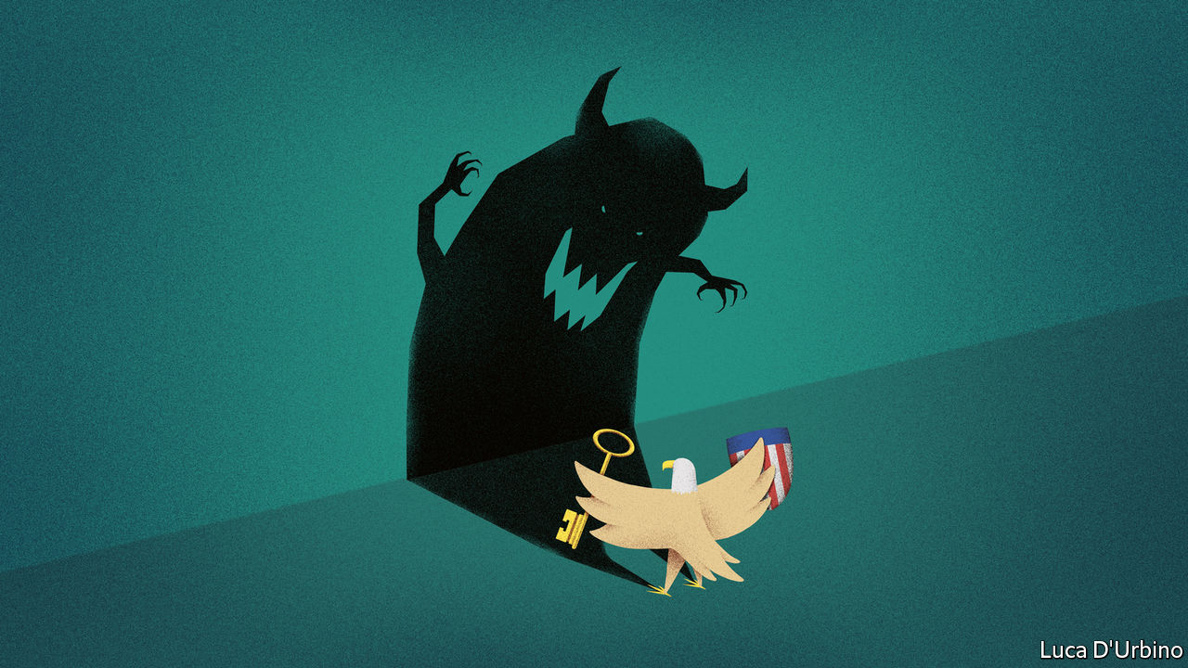

## Digital protection

You went through the arguments about the multilateral rules that are needed to deal with America’s justification of national security when it acts unilaterally as tensions arise within the digital economy (“[From iPhones to aircraft carriers](https://www.economist.com/united-states/2020/08/20/american-national-security-maximalism-can-be-self-defeating)”, August 22nd). Such rules exist in Article 21 of the General Agreement on Tariffs and Trade (GATT). The article allows any contracting party to take “any action it considers necessary for the protection of its essential security interests”. Resorting to this rarely used provision, however, presents a conundrum for the World Trade Organisation when dealing with disputes.

Either the WTO dispute-settlement body rules that it cannot second guess a member’s security interests, prompting a flood of similar petitions of Article 21, or it finds against the party invoking Article 21, which, could well prompt America’s departure from the WTO. Hence the problem underlying all of this. The multilateral trading system can no longer rely on America, its most powerful member, to uphold its principles. America must temper its exercise of national sovereignty through its self-harming unilateral action and respect international norms.

It remains to be seen whether this will change after November’s presidential election, with a return, perhaps, to earlier, more open, American policies that encouraged America to run faster in the global tech race. Probably not.

KEN HEYDON  
Former deputy director for trade at the OECDArbois, France

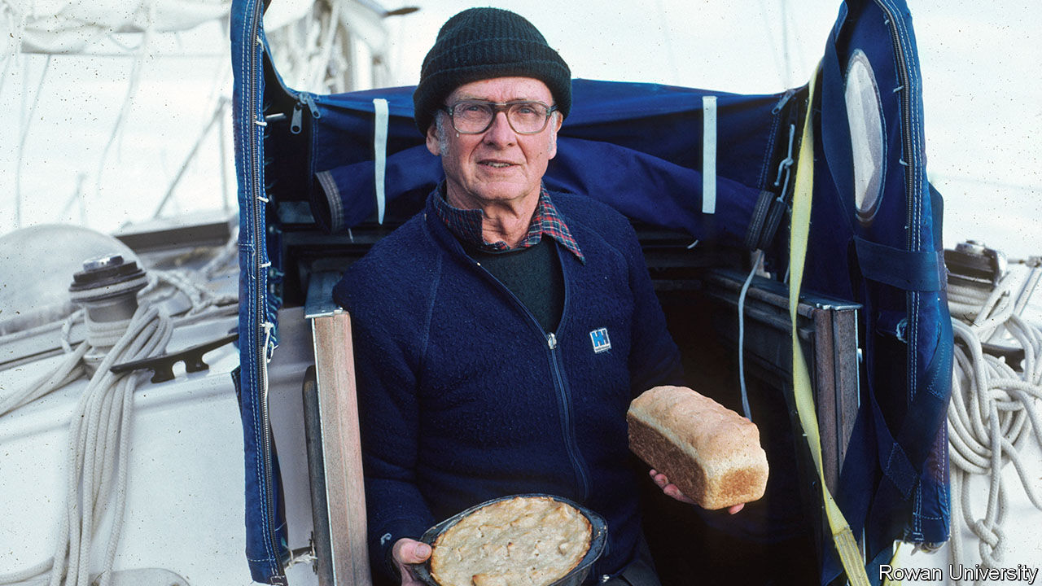

## Magellan didn’t quite make it

Ferdinand Magellan was not “the first known circumnavigator” ([Obituary for Marvin Creamer](https://www.economist.com/obituary/2020/08/29/marvin-creamer-died-on-august-12th), August 29th). He commanded the flotilla of five ships and 239 sailors that sailed in 1519 from Spain but he died in combat in the Philippines in 1521 before completing the round-the-world voyage. Juan Sebastián Elcano was then elected leader for the rest of it, reaching Spain in the only remaining ship, Victoria, in 1522. He and the 18 emaciated survivors who dragged themselves ashore were indeed the first true circumnavigators.

MARQUéS DE TAMARóN  
Madrid

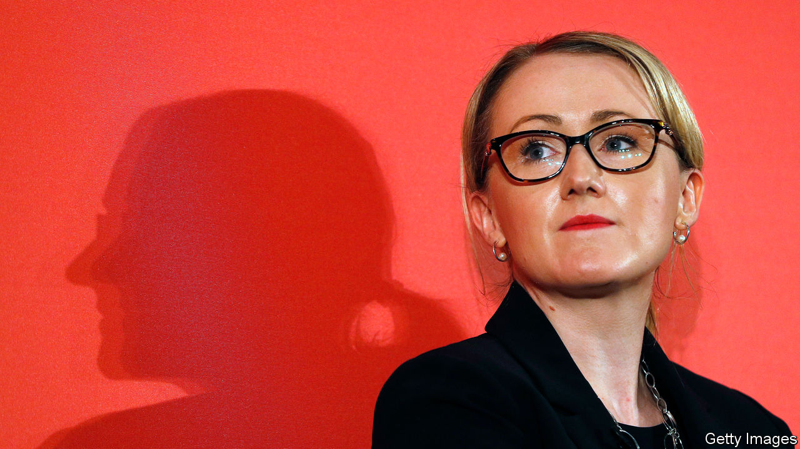

## Lessons for the centre-left

Anyone in Labour who wants a fairer, more balanced progressive Britain would be advised to steer well clear of Saul Alinsky’s “Rules for Radicals” (“[Left out](https://www.economist.com/britain/2020/08/20/labours-left-wing-is-trying-a-new-strategy-to-gain-influence)”, August 22nd). The book was published in 1971 and encouraged the Democrats in America to embrace the presidential candidacy of the unelectable George McGovern. The next 40 years saw the triumph of Ronald Reagan, the Wall Street-besotted Bill Clinton and ever-rising inequality.

The American left is irrelevant. If the British left wants inspiration there are plenty of examples from social democratic parties in Germany or the Nordic countries. Not as flashy as American radicalism but closer to what can be done in Britain’s constipated, class-ridden, centralised, obsequious, Treasury-run monarchy.

DENIS MACSHANE  
Senior adviser  
Avisa Partners  
Brussels

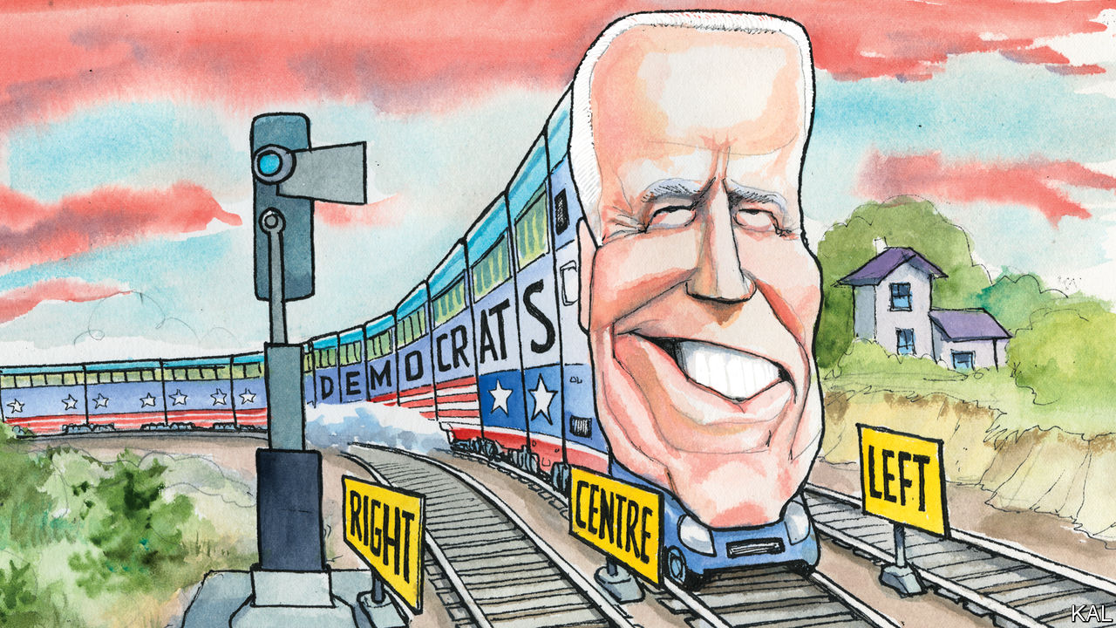

[Lexington](https://www.economist.com/united-states/2020/08/22/democrats-set-factionalism-aside-for-the-big-push-against-donald-trump) wrote about the “asymmetric polarisation” thesis, which says that the Republican Party has moved well to the right while the Democratic Party has remained more or less on the centre-left (August 22nd). The problem with this theory, which was developed in the early 2010s, is that it focuses narrowly on certain public-policy issues and largely ignores the raging culture war, where the Democrats have indeed drifted to the left. It takes no account of the fundamental asymmetry that defines modern politics.

For better or worse, progressivism tends to progress, and reactionaries tend to react. This is the rule the world over, and in this, as in many other things, America is not really an exception.

JOHN SEXTON  
Chicago

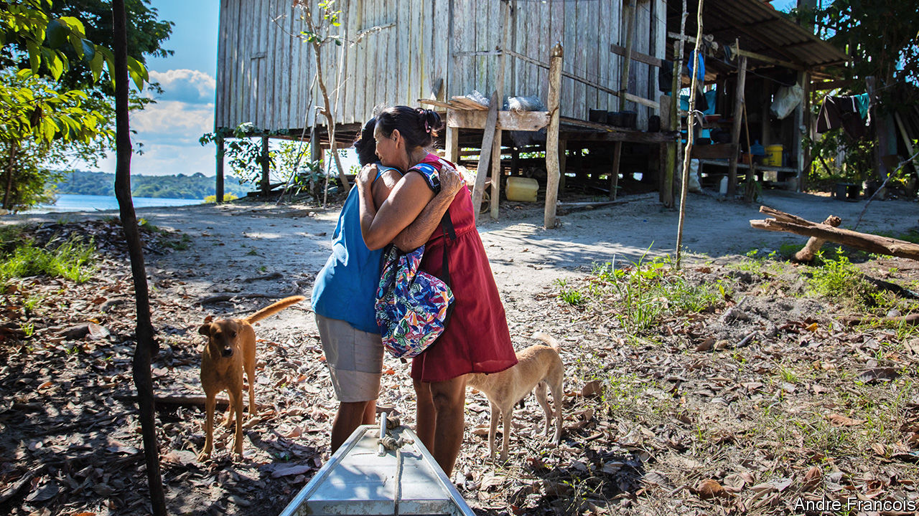

## Keep calm

I applaud the attention you gave to the mental-health effects of covid-19 in “[The common tragedy](https://www.economist.com/international/2020/08/29/worldwide-covid-19-is-causing-a-new-form-of-collective-trauma)” (August 29th). However, to suggest that there “were no large-scale psychological studies during the first or second world wars” is to neglect J.T. McCurdy’s brilliant “The Structure of Morale”, published in 1943. The book was a psychological examination of British resilience during the Blitz and draws a conclusion from which we can draw strength today: “When fear that has been conditioned with some danger is extinguished, it does not leave a vacuum. There remains a less dramatic feeling, one of courage, confidence, or merely security.”

DAVID PEDUTO  
Westminster, Colorado

You spoke positively about the French system of “psychological emergency units” that offer mental-health support immediately after a terrorist attack. Although these interventions are well-intentioned, I must point out that there is no good evidence that they reduce the incidence of post-traumatic stress disorder. On the contrary, there are many studies to suggest that early psychological interventions after trauma might even worsen symptoms, through a process of retraumatisation.

DR LOUIS DE BOISANGER  
Royal Edinburgh Psychiatric Hospital

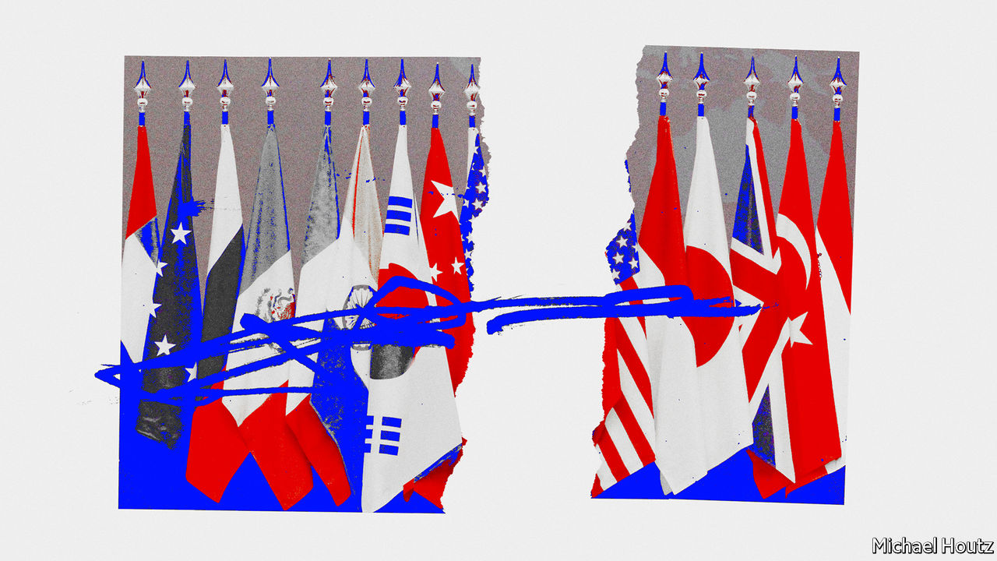

## Leadership starts at the top

Thank you for your excellent if depressing article on the status of American diplomacy and the State Department, even though it came perilously close to being an obituary (“[The dereliction of diplomacy](https://www.economist.com/international/2020/08/13/the-dereliction-of-american-diplomacy)”, August 15th). However, no amount of money, manpower, or far-better management will produce an increased role for professional diplomacy in American foreign policy. That objective is determined by Congress and the White House.

The State Department, like all departments, is an agent, not a principal. There is an old Foreign Service legend that when questioned by an irritated President John Kennedy as to what was wrong with “that department of yours”, Ambassador Chip Bohlen replied “You are, Mr President, you are.”

AMBASSADOR (RET) EDWARD MARKS  
Foreign Service of the United States  
Washington, DC

According to a recent study former volunteers and staff in the Peace Corps constitute an extraordinary percentage of Foreign Service recruits, rising to assistant secretary and ambassadorial levels. Because of covid-19, some 8,000 volunteers and staff were returned to the United States; if Donald Trump is re-elected it is unlikely that the Peace Corps will be recreated.

WILLIAM JOSEPHSON  
Founding counsel  
Peace Corps, 1961-66  
New York

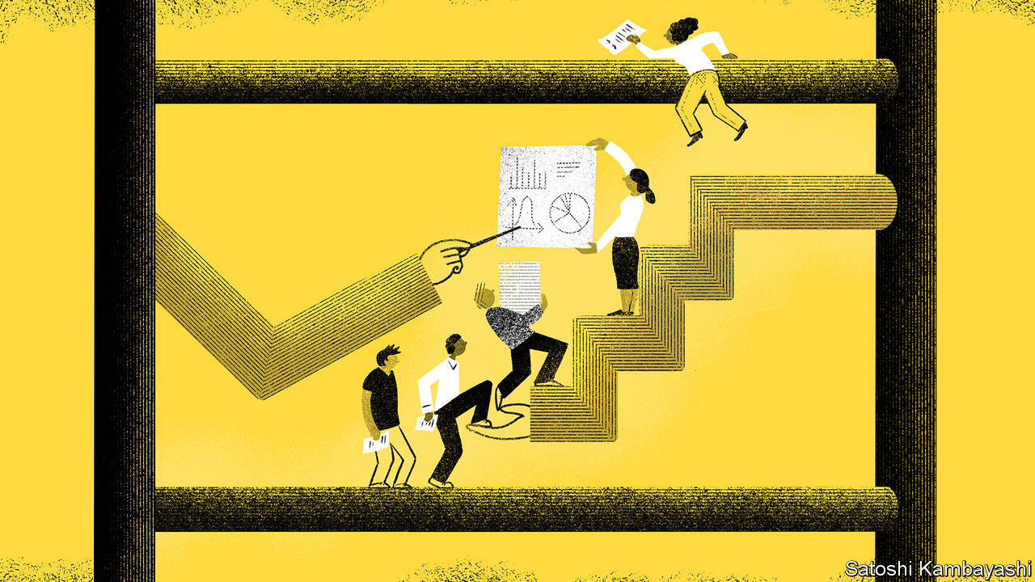

## Cost-benefit analysis

In regards to pursuing a career as an academic economist (“[Selection effects](https://www.economist.com/finance-and-economics/2020/08/08/what-it-takes-to-become-an-academic-economist-is-changing)”, August 8th) let’s be honest, up to seven destitute years studying for a PhD really isn’t that bad. Although don’t forget the pre-doc to hone your skills and the pre-pre-doc so that you come prepared. Nor would it be wise to neglect a post-doc in case you miss out on the opportunity for networking.

As I said, is ten years studying for a PhD in economics really that bad?

ELLIOT FOOTE  
Melbourne

This article was downloaded by calibre from <https://www.economist.com/letters/2020/09/12/letters-to-the-editor>

|  |  |  |  |
| --- | --- | --- | --- |
|  | Articles | Sections | Next |

|  |  |  |
| --- | --- | --- |
| Letters | Sections | Asia |

Briefing

The future of the office: What a way to make a living

.

|  |  |  |
| --- | --- | --- |
| Letters | Sections | Asia |

|  |  |  |  |
| --- | --- | --- | --- |
|  | Articles | Sections | Next |

#### The future of the office

# Covid-19 has forced a radical shift in working habits

Mostly for the better

Sep 12th 2020 |



Editor’s note: Some of our covid-19 coverage is free for readers of The Economist Today, our daily [newsletter](https://my.economist.com/user#newsletter). For more stories and our pandemic tracker, see our [hub](https://www.economist.com/news/2020/03/11/the-economists-coverage-of-the-coronavirus)

SELF-STYLED visionaries and people particularly fond of their pyjamas have for decades been arguing that a lot of work done in large shared offices could better be done at home. With covid-19 their ideas were put to the test in a huge if not randomised trial. The preliminary results are now in: yes, a lot of work can be done at home; and what is more, many people seem to prefer doing it there.

This does not, in itself, mean the end of the non-home office. It does mean that there is a live debate to be had. Some companies appear relaxed about a domestic shift. On August 28th Pinterest, a social-media firm, paid $90m to end a new lease obligation on office space near its headquarters in San Francisco to create a “more distributed workforce”. Others seem to be against it. Also that month, Facebook signed a new lease on a big office in Manhattan. Bloomberg is reportedly offering a stipend of up to £55 ($75) a day to get its workers back to its building in London. Governments, on which some of the burden will fall if the pandemic persists, are taking a similar tack, encouraging people “back to work”—by which they mean “back to the office”.

They face a difficult task. For working from home seems to have suited many white-collar employees. As lockdowns have eased, people have gone out into the world once more: retail spending has jumped across the rich world while restaurant reservations have sharply risen. Yet many continue to shun the office, even as schools reopen and thus make it a more feasible option for working parents. The latest data suggest that only 50% of people in five big European countries spend every work-day in the office (see chart 1). A quarter remain at home full-time.

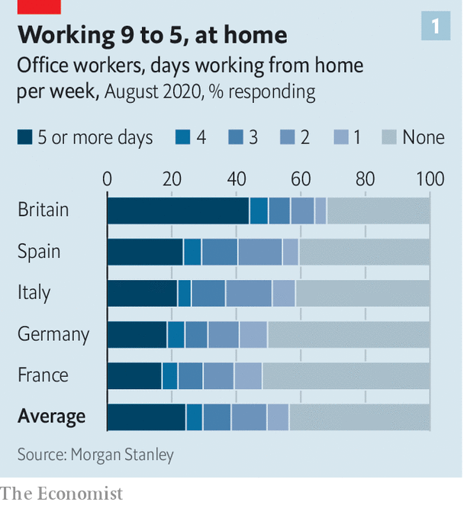

This may be due to the residual fear of covid-19 and the inconvenience of reduced-capacity offices. Until social-distancing guidance ends, offices cannot work at full steam. The average office can work with 25-60% of its staff while maintaining a two-metre (six-foot) distance between workers. Offices which span more than five floors rely on lifts; the queues for access, when only two people are allowed inside one, can stretch around the block.

Some offices are trying to make themselves safer places to work. The managers of a new skyscraper in London, 22 Bishopsgate, have switched off its recirculated air-conditioning. Others have installed hand-sanitising stations and put up plastic barriers. But even if offices are safer, it can still be hard to get there. Many employees do not want to or are discouraged from using public transport—and one-quarter of commuters in New York City live more than 15 miles (24km) from the office, too far to walk or cycle.

However it also appears to be the case that working from home can make people happier. A paper published in 2017 in the American Economic Review found that workers were willing to accept an 8% pay cut to work from home, suggesting it gives them non-monetary benefits. Average meeting lengths appear to decline (see chart 2). And people commute less, or not at all. That is great for wellbeing. A study from 2004 by Daniel Kahneman of Princeton University and colleagues found that commuting was among the least enjoyable activities that people regularly did. Britain’s Office for National Statistics has found that “commuters have lower life satisfaction...lower levels of happiness and higher anxiety on average than non-commuters” (see article).

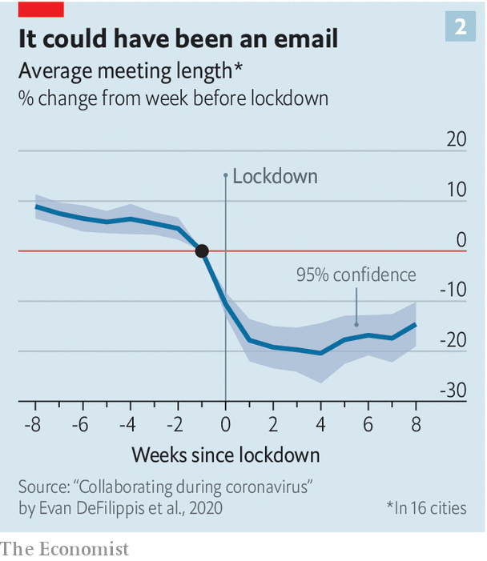

The working-from-home happiness boost could, in turn, make workers more productive. In most countries the average worker reports that, under lockdown, she got more done than she would have in the office. In the current circumstances, however, it is hard to be sure whether home-working or office-working is more efficient. Many people, particularly women, have had to work while caring for children who would normally be in school. That might make it seem as though working from home was less productive than it could theoretically be (ie, when the kids were in school).

## Tumble outta bed into the kitchen

But there are lockdown-specific effects which create the opposite bias, making work-from-home seem artificially productive. During lockdown workers may have upped their game for fear of being let go by their company—evidence from America suggests that more than half of workers are worried about losing their job due to the outbreak. A separate problem is that most studies under lockdown have relied on workers to self-report their productivity, and the data generated in this way tend not to be very reliable.

Research published before the pandemic provides a clearer picture. A study in 2015 by Nicholas Bloom of Stanford University and his colleagues looked at Chinese call-centre workers. They found that those who worked from home were more productive (they processed more calls). One-third of the increase was due to having a quieter environment. The rest was due to people working more hours. Sick days for employees plummeted. Another study, looking at workers at America’s Patent and Trademark Office, found similar results. A study in 2007 from America’s Bureau of Labour Statistics found that home-workers are paid a tad more than equivalent office workers, suggesting higher productivity.

The experience of lockdown has simply accelerated pre-existing trends, thinks Harry Badham, the developer of 22 Bishopsgate. That may be an understatement. Although the share of people regularly working from home was rising before the pandemic, absolute numbers remained small (see chart 3). According to one view, the fact that office-working was so dominant until recently reveals that it must be more efficient than home-based work both for firms and for workers. By this logic the success of a country’s emergence from lockdown can be measured by how many people are back at their desks.

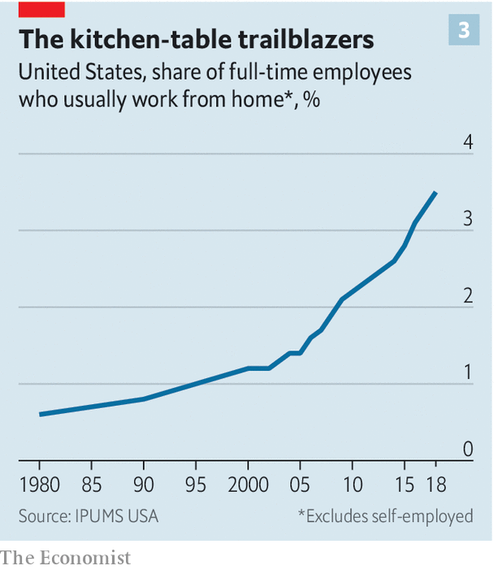

But there is another interpretation. This says that home-working is actually more efficient than office-work, and that the glory days of the office are gone. The office, after all, came into being when the world of work involved processing lots of paper. The fact that it remained so dominant for so long may instead reflect a market failure. Before covid-19 the world may have been stuck in a “bad equilibrium” in which home-work was less prevalent than it should have been. The pandemic represents an enormous shock which is putting the world into a new, better equilibrium.

Brent Neiman of the University of Chicago suggests three factors which prevented the growth of home-working before now. The first relates to information. Bosses simply did not know whether clustering in an office was essential or not. The past six months have let them find out. The second relates to co-ordination: it may have been difficult for a single firm unilaterally to move to home-working, perhaps because its suppliers or clients would have found it strange. The pandemic, however, forced all firms who could do so to shift to home-working all at once. Amid this mass migration, people were less likely to look askance at companies which did so.

The third factor is to do with investment. The large fixed costs associated with moving from office- to home-based work may have dissuaded firms from trying it out. Evidence from surveys suggests that firms have in recent months spent big on equipment such as laptops to enable staff to work from home; this is one reason why global trade has held up better than expected since the pandemic began (see [article](https://www.economist.com/finance-and-economics/2020/09/12/how-has-trade-survived-covid)). Such investments are made at the household level too. In many rich countries the market for single-family houses is stronger than for apartments. This suggests that people are looking for extra space, possibly for a dedicated home office.

## Pour yourself a cup of ambition

The extent to which home-working remains popular long after the pandemic has passed will depend on a bargain between companies and workers. But it will also depend on whether companies embrace or reject the controversial theory that working from an office might actually impede productivity. Since the 1970s researchers who have studied physical proximity (ie, the distance employees need to travel to engage in a face-to-face interaction) have disagreed on the question of whether it facilitates or inhibits collaboration. The argument largely centres on the extent to which the bringing-together of people under one roof promotes behaviour conducive to new ideas, or whether doing so promotes idle chatter.

Such uncertainty is exemplified by a study in 2017 by Matthew Claudel of the Massachusetts Institute of Technology (MIT) and his colleagues. Their study looked at papers and patents produced by MIT researchers and the geographical distribution of those researchers. In doing so, they found a positive relationship between proximity and collaboration. But when they looked at the buildings of MIT, they found little statistical evidence for the hypothesis that “centrally positioned, densely populated and multi-disciplinary spaces would be active hotspots of collaboration”. In other words, proximity can help people come up with new ideas, but they do not necessarily need to be in an office to do so.

However, not everything about working from home is pleasurable. In July a study from economists at Harvard, Stanford and New York University found that the average workday under lockdown was nearly 50 minutes longer than it was before, and that people became more likely to send emails after work hours. There is also wide variation between workers in how much they enjoy working from home. Leesman, a workforce consultancy, has surveyed the experience of more than 100,000 white-collar workers across the rich world during the pandemic. It finds that satisfaction with working from home varies according to whether that person has dedicated office and desk space or not.

## The tide’s turned and rolling your way

And not everyone has the ability to work from home, even if they want to. Research published in April by Mr Neiman and Jonathan Dingel, both of the University of Chicago, found that across rich countries about 40% of the workforce were in occupations that could plausibly be completed from their kitchen tables. Evidence of actual working arrangements during the pandemic backs up those speculations. A paper from Erik Brynjolfsson of Stanford University and colleagues, looking at American data, suggests that of those employed before the pandemic began, about half were working from home in May.

Indeed, it is uncertain whether the benefits of working from home can last for a sustained period of time. Mr Bloom’s co-written study on Chinese call-centre workers is one of the few to assess the impact of working from home over many months. He and his colleagues found that, eventually, many people were desperate to get back to the office, if only every now and then, in part because they were lonely. Some companies which have tried large-scale remote working in the past have ultimately abandoned it, including Yahoo, a technology firm, in 2013. “Some of the best decisions and insights come from hallway and cafeteria discussions, meeting new people, and impromptu team meetings,” a leaked internal memo read that year.

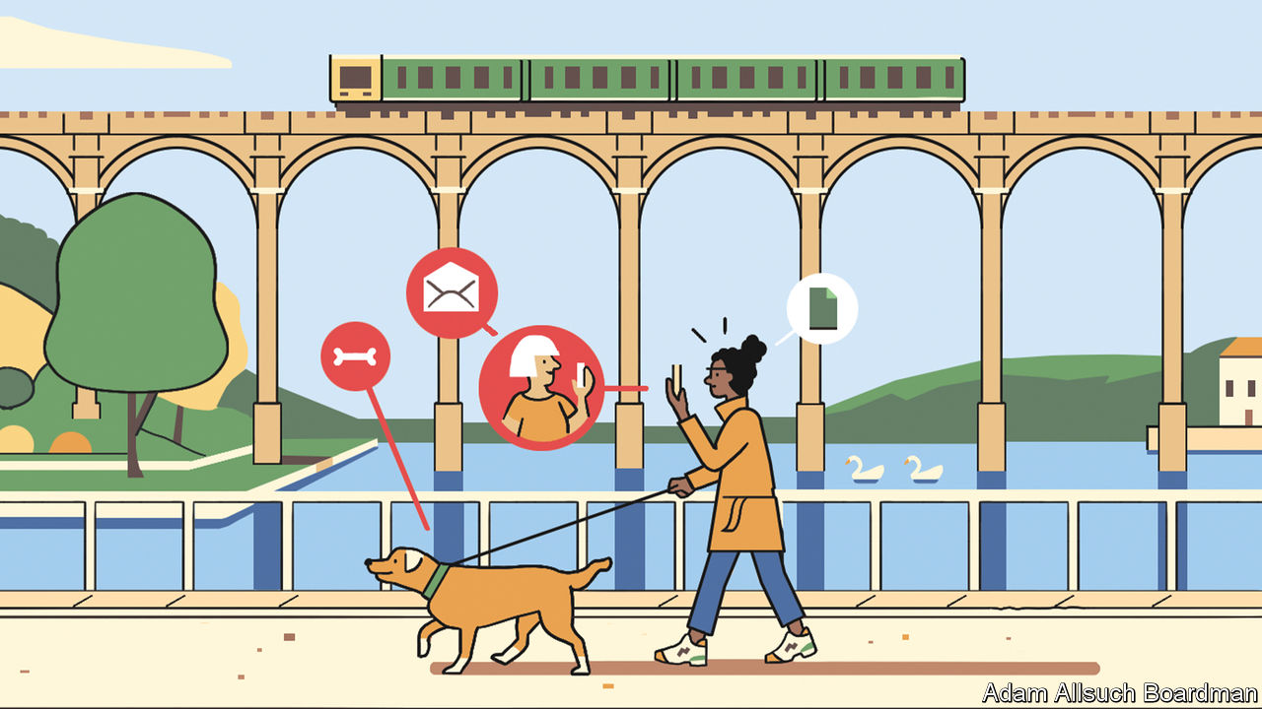

The challenge for bosses, then, is to find ways of preserving and boosting employee happiness and innovation, even as home-working becomes more common. One solution is to get everyone into the office a few days a month. An approach whereby workers dedicate a chunk of time to developing new ideas with colleagues may actually be more productive than before.

A study from Christoph Riedl of Northeastern University and Anita Williams Woolley of Carnegie Mellon University, published in 2017, suggested that “bursty” communication, where people exchange ideas rapidly for a short period of time, led to better performance than constant, but less focused, communication. Not much evidence exists that serendipity is useful for innovation, even though it is accepted by many as a self-evident truth. “A lot of people made a lot of money selling this watercooler idea,” says Mr Claudel of MIT, referring to the growth in recent decades of open-plan offices, co-working spaces and trendy “innovation districts”.

Coming into the office now and then is not the only way of generating bursty communication. The same can be achieved, say, with corporate retreats and get-togethers. Gitlab, a software company, has been “all-remote” since it was founded in 2014. With no offices, it gathers together its 1,300 “team members”, who live in 65 different countries, at least once a year for get-togethers and team bonding.

Similarly, companies such as Teemly, Sococo and Pragli offer “virtual offices”, making it easier to communicate with colleagues, rather than going through the rigmarole of scheduling a video call. Using video messaging from Loom, a worker can record her screen, voice and face and instantly share it with colleagues—more useful than a conventional video call, as the video can be sped up or rewound. Gitlab’s workers follow a “nonlinear” workday—interrupting work with bouts of leisure. Rather than talk to their colleagues over live video calls they engage in “asynchronous communication”, which is another way of saying they send their co-workers pre-recorded video messages.

More frequent working from home will also demand the use of new hardware, and the withering away of other sorts. At present, many companies host large data-centres, but these have proved less efficient as more people work from home. Goldman Sachs reckons that investment in traditional data infrastructure will fall by 3% a year in 2019-25. In its place, companies are likely to spend more on technology which allows workers to replicate the experience of being in the same physical space as someone else (higher-quality cameras and microphones, for instance). The more utopian technology analysts reckon that within five years, people will be able to put on a VR headset and immerse themselves in a virtual office—bad strip-lighting, and all.

## There’s a better life

All this has wide-ranging implications for public policy. At present it is impossible to know whether home-workers will find it easier or harder to bargain with their employer for pay rises and improvements in conditions, though the idea of asking for a raise through a video chat is hardly an appealing one. Employers may also find it easier to fire remote workers than if they had to do it face-to-face. If so, then calls may grow for governments to give home-workers greater protections.

Another problem relates to employment law, argues Jeremias Adams-Prassl of Oxford University. Just as the rise of the gig economy has prompted questions and court cases about what it means to be an employee or self-employed, the increased popularity of home-working puts pressure on laws which were constructed around the assumption that people would be toiling away in an office. No one has yet thought through how firms should go about monitoring contractual working time in a world where nobody physically clocks in, nor about the extent to which firms may surveil workers at home.

Battles over employers’ responsibilities to their home-workers surely cannot be far away. Should a business pay for a worker’s internet connection or their heating in the dead of winter? Grappling with such questions will not be easy. But governments and firms must seize the moment. The pandemic, for all its ill effects, offers a rare opportunity to rewire the world of work. ■

This article was downloaded by calibre from <https://www.economist.com/briefing/2020/09/12/covid-19-has-forced-a-radical-shift-in-working-habits>

|  |  |  |  |
| --- | --- | --- | --- |
|  | Articles | Sections | Next |

|  |  |  |
| --- | --- | --- |
| Briefing | Sections | China |

Asia

Kashmir: Highland brig

.

India’s border with China: Ice and fire

.

Railways in Japan: Undo the locomotion

.

Myanmar and the Rohingya: They shot the smoking guns

.

Banyan: The new weather gods

.

|  |  |  |
| --- | --- | --- |
| Briefing | Sections | China |

|  |  |  |  |
| --- | --- | --- | --- |
|  | Articles | Sections | Next |

#### Highland brig

# India is still trampling on civil liberties in Kashmir

Some in the Muslim-majority region have been detained without trial for over a year

Sep 12th 2020 | SRINAGAR

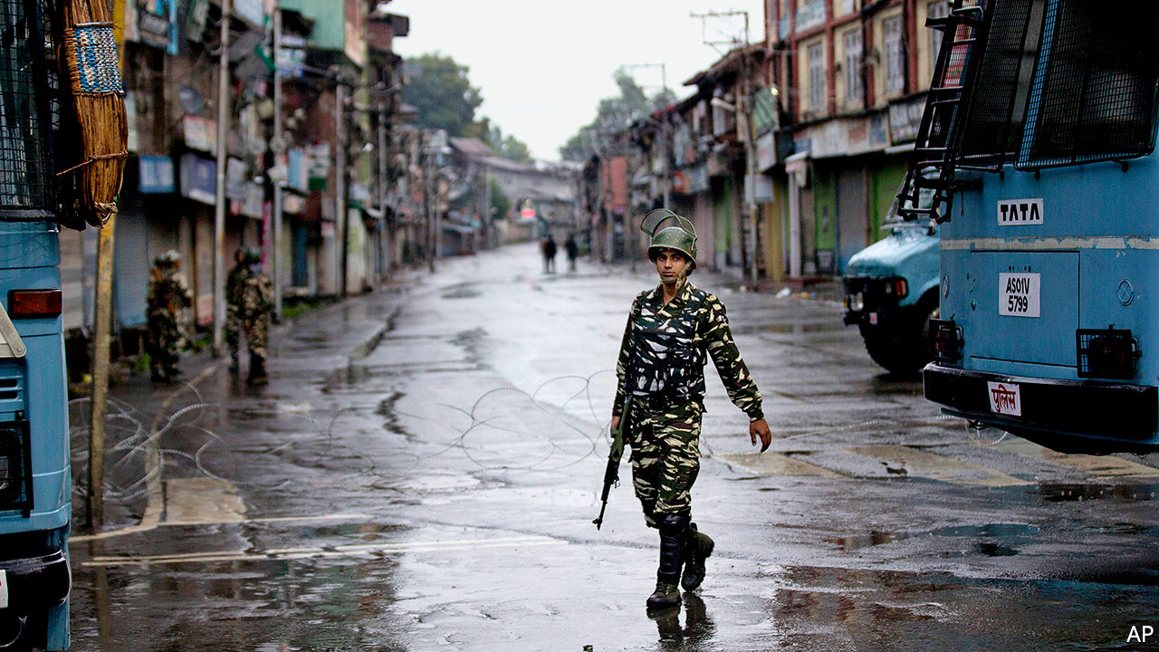

SAIFUDDIN SOZ is not under house arrest; he is just not allowed to leave his home. Now 82 years old, he once represented the northern Kashmir valley in the national parliament in Delhi. He spent five years as a minister in the government of Manmohan Singh, the prime minister who preceded the present one, Narendra Modi. Since August 5th, 2019, the day parliament deprived Jammu & Kashmir of its statehood at Mr Modi’s behest, the police have forced Mr Soz to remain in his home. “You are under house arrest,” they told him. His family petitioned the courts for his release, since he has not been charged with any crime, much less convicted. But the Supreme Court dismissed the request, since the authorities had informed the honourable justices that Mr Soz was “never detained nor under house arrest”. When local journalists went to Mr Soz’s home to get his reaction to the happy news, he tried to speak to them over the fence—until uniformed soldiers pulled him away.

The government’s blatant lying to the court (which is otherwise prickly about what it considers contempt) gives a sense of how far it is willing to go to have its way in Kashmir and how little it cares about abusing the rights of even the great and the good in the process. The state’s peculiarities have long angered the Hindu nationalists of the ruling Bharatiya Janata Party (BJP). They see it as an affront that Pakistan, which like India claims all of the former British protectorate, seized part of it in 1947. Worse, the Muslim majority in the Indian part has long chafed under Indian rule, prompting frequent popular protests and an endless insurgency. Most infuriating of all, in spite of their ingratitude, the 12m people of Jammu & Kashmir, including some 7m Muslims in the Kashmir valley, used to benefit—until last year—from a special form of autonomy accorded to no other state in India.

Mr Modi’s decision a year ago to rescind that autonomy and split the state into two territories (Jammu & Kashmir and Ladakh—see map) run directly by the national government was intended to please his supporters. It was always going to enrage Kashmiris, who were not consulted, even though the constitution demanded it. (To get around this, Mr Modi dismissed the elected state government, appointed his own lieutenant to run the state and then got this appointee to consent to the loss of autonomy and statehood on Kashmiris’ behalf.) To keep a semblance of order, the government has had to suspend local politics and many civil liberties for over a year—with no end in sight.

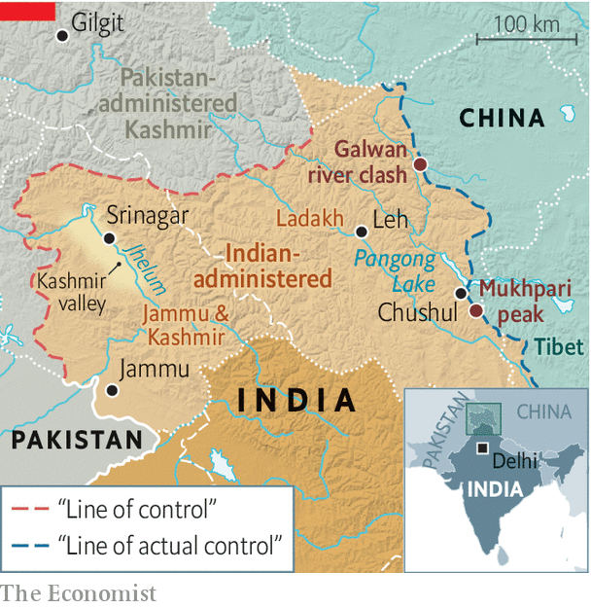

Even before the change, there were some 500,000 troops deployed in Kashmir (the government does not disclose precise numbers). About 35,000 more were sent last year to help enforce the new order. Phone lines and the internet were cut and politicians of every stripe, along with businessmen and other prominent citizens—some 7,000 people in all—were arrested without charge. Gatherings of all kinds were banned. The government claimed all this was to prevent terrorists backed by Pakistan from organising any kind of retaliation and not to prevent ordinary Kashmiris from expressing their views. In fact, the government maintained, Kashmiris were not really protesting at all, even though, as with the unfortunate Mr Soz, video footage suggested otherwise. Thirteen months later, most of the restrictions remain in some form.

The internet is back, but only sporadically and in many parts of Kashmir only via a rickety 2G service. The covid-19 pandemic has provided a new rationale to prohibit all gatherings. Such rules are enforced in Kashmir in ways not seen in the rest of India: on August 29th a procession marking the Shia Muslim holy day of Muharram was broken up by police firing shotguns. Dozens were wounded, some of them blinded, in theory to preserve public health.

Hundreds of bunkers covered in camouflage netting have popped up across Kashmir. A dozen line the embankment of the Jhelum river in Srinagar, the capital, where couples used to stroll in the evening. Blast-hardened military vehicles with gunners at their turrets roar along the highways, forcing civilian traffic to halt. Drivers can be held up for hours at the many new checkpoints, often waiting for a long military convoy to pass.

A host of repressive laws give the security services free rein. The Public Safety Act allows preventive detention at will. The Unlawful Activities (Prevention) Act criminalises speech and organisations the government considers secessionist. The Armed Forces (Special Powers) Act allows troops to kill with impunity. In May police and soldiers were filmed ransacking a village in northern Kashmir, where they beat men and women, looted stores and burned goods on the street. The rampage was a reprisal: a senior officer had been hit by a stone-thrower. If not for the footage, the episode would have gone unnoticed.

That gives the authorities an incentive to stop information flowing. A new media policy, introduced in June, allows the prosecution of publishers associated with reporting deemed “anti-national”. In August about 300 young people, mostly teenagers, were rounded up for saying things considered to be critical of the state on social media. Some were beaten, others forced to promise not to post anything political.

All this has upended ordinary life. The economy, already battered by the lockdown that came with the end of statehood, is now reeling from a second one, owing to covid-19. Schools have been open for only 20 days in the past year—and the disruption to the internet has made online learning impossible. The legal system is hamstrung: many of those detained without charge could not challenge their incarceration because the lawyers’ guild went on strike to protest the arrest of its president.

To all these tribulations Kashmiris add an extra concern—that an influx of migrants from the rest of India will turn them into a minority in their homeland. The revoked autonomy included restrictions on who could own land in the state. The government promised that the new order would preserve locals’ say over who gets to live among their alpine peaks. Yet new criteria have made many more Indians eligible for “domicile certificates”. Instead of seeking to allay such fears, Mr Modi chose to celebrate the anniversary of the abolition of Kashmir’s autonomy by laying the foundation stone of a new temple, to be built on the site of a demolished mosque. ■

This article was downloaded by calibre from <https://www.economist.com/asia/2020/09/12/india-is-still-trampling-on-civil-liberties-in-kashmir>

|  |  |  |  |
| --- | --- | --- | --- |
|  | Articles | Sections | Next |

|  |  |  |  |
| --- | --- | --- | --- |
| Previous | Articles | Sections | Next |

#### Ice and fire

# India and China exchange the first gunshots in 45 years

The Asian giants are locked in a dangerous standoff over their disputed Himalayan border

Sep 8th 2020 |

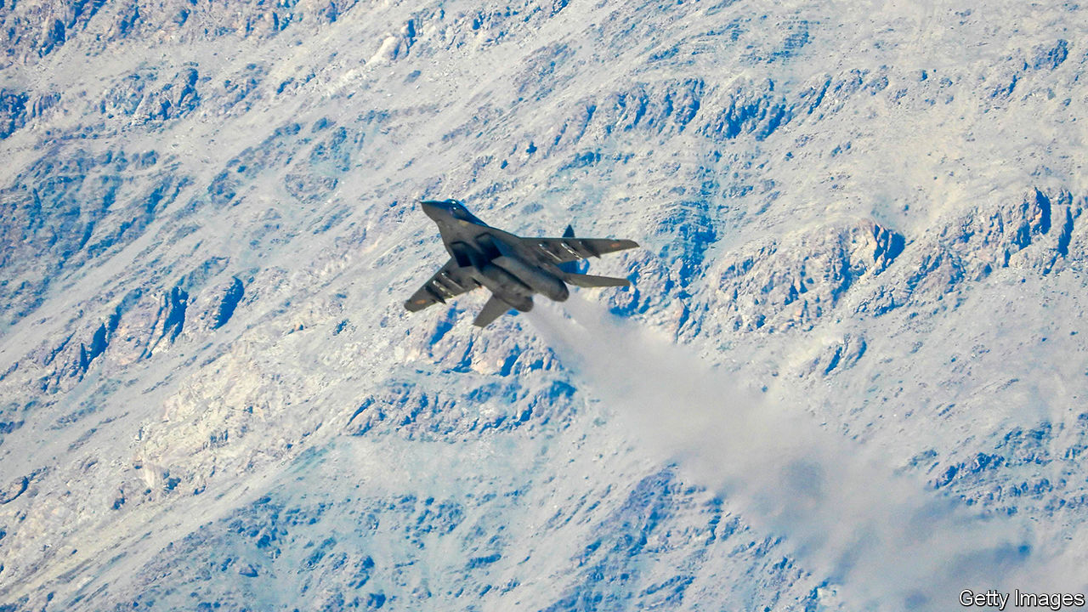

INDIA’S CONDUCT was as reckless as “doing a handstand on the edge of a cliff”, fulminated the Global Times, a state-run tabloid in China, on September 8th. “We must warn India seriously: you have crossed the line!” In India’s telling, it was Chinese troops who crossed the line, approaching an Indian position near Mukhpari peak on September 7th and firing “a few rounds” into the air. In China’s version, it was Indian troops who fired the warning shots, forcing the People’s Liberation Army (PLA) “to take an emergency response”. Either way, the bullets were the first to fly along the vast Himalayan frontier between the countries in 45 years.

For several months India and China have been locked in a tense standoff in Ladakh, a plateau to the west of Tibet (see map). India has accused the PLA of massing forces, building outposts and nibbling territory at several points along the hazy and disputed Line of Actual Control (LAC), which serves as a frontier in the absence of an agreed border. In June the two sides agreed to disengage. Days later a deadly but gun-less brawl took place at the Galwan river valley. At least 20 Indian troops were killed and many injured in hand-to-hand fighting with makeshift weapons (the number of Chinese casualties is unknown). The incident dissipated what little trust was left between the pair.

With talks over the summer going nowhere, both sides reportedly gathered tanks and other forces on the south bank of Pangong lake, where the overlap between Indian and Chinese claims—and therefore the scope for disagreement—is particularly large. In late August troops “yelled at each other and surged to within a yard or two”, according to the New York Times.



On August 30th India appears to have taken the initiative, sending its Special Frontier Force, a secretive military unit manned by Tibetans, on a six-hour trek to capture peaks in the Chushul sector, to the south of Pangong lake, supposedly to pre-empt a Chinese move. That gave its forces a commanding view of PLA positions and important passes below, as well as a potential bargaining chip in future talks (Indian officials contend that, since April or so, China has occupied 1,000 square kilometres of territory on what India believes to be its side of the LAC).

The pair also appear to be locking horns well beyond Ladakh. On September 2nd India banned 118 Chinese apps, including a hugely popular video game, China’s leading search engine and its most widely used digital-payments system. It had already banned 59 others, including TikTok and WeChat, after the June clashes. A day later India’s most senior soldier, General Bipin Rawat, said that he wanted the bloc known as the Quad (comprising America, Australia, India and Japan) to “ensure freedom of navigation operations” in Asia, referring to naval shows of force in Chinese-claimed waters in the South China Sea. Though America routinely conducts such operations, India has trodden more cautiously. Expanding its naval presence in disputed waters in the Pacific would mark a big widening of its confrontation with China.

The scramble for territory in the mountains is particularly dangerous because old rules seem to be crumbling. Over decades, India and China had agreed on various protocols at the border: firearms were forbidden, patrols that bumped into one another should not follow one another and heavy weapons should be kept to a minimum. The deadly clash at Galwan in June dealt a heavy blow to these understandings; the use of guns, if only in warning, at Mukhpari on September 7th struck another. “All past agreements have broken down,” says General D.S. Hooda, a former head of the Indian army’s Northern Command. S. Jaishankar, India’s foreign minister, acknowledges that the situation is “very serious”.

Indian and Chinese troops remain very close to one another, though it will get harder to maintain their new outposts over the coming months. “In winter this is not a good place for humans to live,” noted Zhao Lijian, a spokesman for China’s foreign ministry, on September 8th. “So we hope, through diplomatic and military channels...we can achieve disengagement as soon as possible.” That does not look likely. “All this points to the likelihood of future military escalation unless the Chinese change their obdurate attitude on disengagement,” says General Hooda. ■

This article was downloaded by calibre from <https://www.economist.com/asia/2020/09/08/india-and-china-exchange-the-first-gunshots-in-45-years>

|  |  |  |  |
| --- | --- | --- | --- |
| Previous | Articles | Sections | Next |

|  |  |  |  |
| --- | --- | --- | --- |
| Previous | Articles | Sections | Next |

#### Undo the locomotion

# Japan’s rural railways are disappearing

But Tokyo’s rail network is still expanding

Sep 12th 2020 | ONAN, SHIMANE PREFECTURE

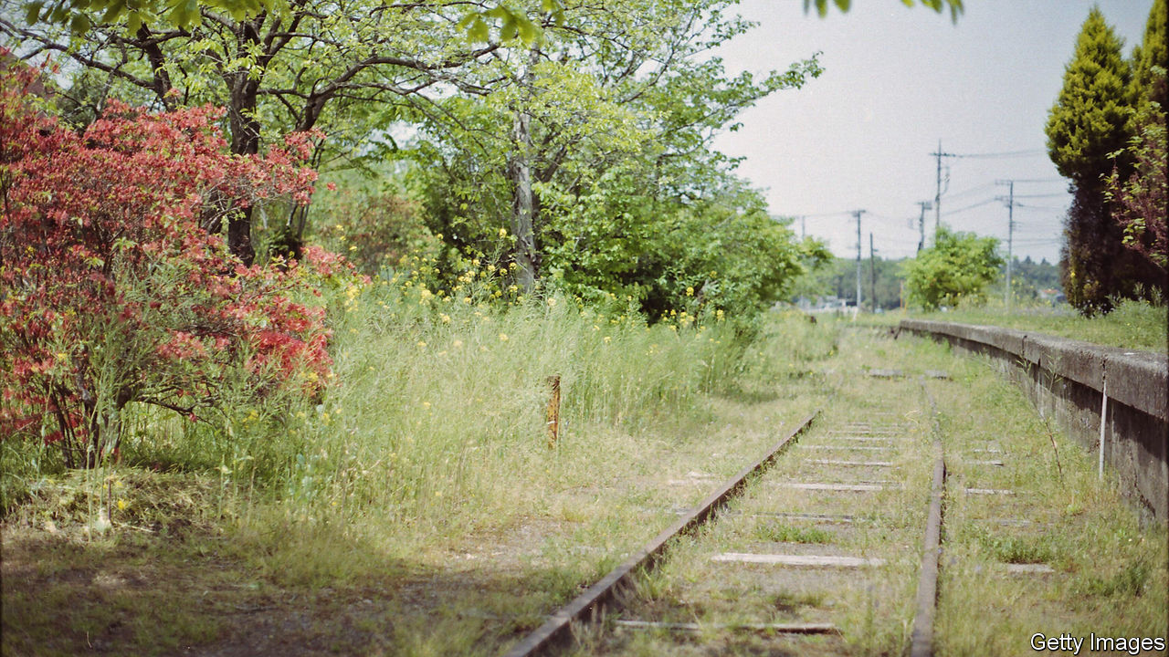

TUCKED AWAY in the verdant mountains of Shimane, in western Japan, Gobira railway station has nearly disappeared. Its signs have faded, the letters hardly legible. The tracks are blanketed in thick moss and overgrown with weeds. Its last departure was in the spring of 2018, when the 108km-long Sanko Line, which snaked through six municipalities in Shimane and Hiroshima prefectures, closed after 88 years. “It’s sad that the Sanko Line is gone,” a local reminisces. “When we were young, we would stretch our hands out of the train windows and touch the leaves of the mountain.”

The line carried an average of 83 passengers a kilometre in 2016, down from 458 in 1987. It was losing ¥900m ($8.5m) a year when it shut. “It was a difficult decision,” says Masuda Kazutoshi, a former mayor of one of the towns served, who oversaw the process. “But in reality, we all knew that this was going to happen.” A bus service has replaced the trains.

Japan is a railway powerhouse. The famed shinkansen, or bullet trains, connect far-flung corners of the country. Two new stations were added this year to Tokyo’s already expansive commuter-rail network to ease congestion at rush hour and provide better access to venues for the Olympics. One of the new stations boasts cleaning robots and an automated convenience store.

Yet many railways in rural areas face a similar fate to the Sanko Line. A total of 44 lines, spanning over 1,000km, have closed since 2000. Three-quarters of local railway companies are unprofitable. The shrinking and ageing of the population, which are especially acute in rural areas, have drained away passengers and revenue. Cars have also become more popular in rural areas, even among the elderly: the number of licence-holders over the age of 75 is climbing, according to government statistics. Covid-19, which has slashed the number of workers and tourists on rural routes, will push railways further into debt.

The government provides relatively little support for struggling lines. Japan’s railways were privatised in the late 1980s, and the subsidies train companies receive are at best a quarter of what is needed to keep them all afloat, estimates Utsunomiya Kiyohito of Kansai University. Roads, by contrast, receive massive funding. Near the defunct Gobira station, dozens of construction workers can be seen toiling on road-improvement schemes.

“Lawmakers living in Tokyo don’t see what’s happening in rural communities,” laments Kojima Mitsunobu, chairman of Ryobi Holdings, a transport company. Resentment of rural-urban disparities runs deep in the municipalities of Shimane and Hiroshima, too. “Japan thinks Tokyo is the only place people live in,” says Morita Ippei of Gounokawa Railway, an organisation seeking to revitalise the towns along the Sanko Line. “The Sanko Line disappeared. We were abandoned, discarded.”

“If we continue down this path, every form of public transport in rural regions will disappear in the future,” warns Mr Utsunomiya. The buses that replaced Gobira’s trains are empty: “carrying air”, as Mr Masuda puts it. He worries it is not so much public transport that is disappearing, but rather the communities it serves. ■

This article was downloaded by calibre from <https://www.economist.com/asia/2020/09/12/japans-rural-railways-are-disappearing>

|  |  |  |  |
| --- | --- | --- | --- |
| Previous | Articles | Sections | Next |

|  |  |  |  |
| --- | --- | --- | --- |
| Previous | Articles | Sections | Next |

#### They shot the smoking guns

# Two Burmese soldiers confess to war crimes against the Rohingya

They are being questioned by the International Criminal Court

Sep 12th 2020 | SINGAPORE

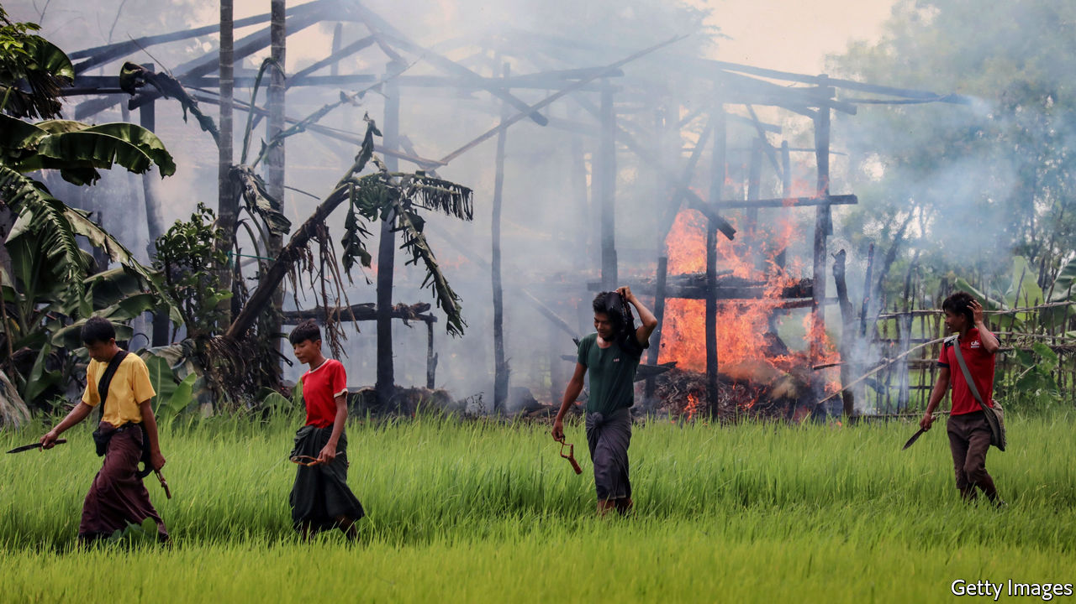

PRIVATE MYO WIN TUN looked steadily into the camera as he recounted two weeks in August 2017 when he and his battalion laid waste to several villages in Rakhine, a state in the far west of Myanmar. They were there, he said, as part of the Burmese army’s “clearance operations” targeting the Rohingya, a persecuted Muslim ethnic minority, which sparked the exodus of more than 740,000 Rohingyas to neighbouring Bangladesh. Mr Myo Win Tun confessed to participating in the massacre of 30 Rohingyas, whom he helped to bury in a mass grave, and to raping one woman. In another video, Private Zaw Naing Tun said that his battalion “wiped out about 20 Muslim villages”, and that he stood sentry while his superiors raped women. Based on their accounts, Fortify Rights, a human-rights NGO which obtained the footage, believes these two men may be directly responsible for killing 180 Rohingyas.

On September 8th the New York Times reported that the men are being questioned by the International Criminal Court (ICC), which is investigating Burmese civilian and military leaders for crimes against humanity for their treatment of the Rohingya. Whether the soldiers will be prosecuted remains unclear. Their confessions were filmed in July by the Arakan Army (AA), a rebel outfit fighting the Burmese army. Twan Mrat Naing, the AA’s commander, says that the AA helped them desert the Tatmadaw, as the Burmese army is known. They fled to Bangladesh, whose government was eventually persuaded to turn them over to the ICC, says Paul Reichler, a lawyer involved in a different case against Myanmar at the International Court of Justice (ICJ), which considers crimes committed by countries, rather than individuals.

The Burmese courts have convicted seven soldiers of killing ten Rohingyas in Rakhine in 2017. But otherwise the Burmese authorities have failed to investigate detailed accounts of widespread human-rights abuses gathered from fleeing Rohingyas, much less punish anyone. The Burmese government maintains—entirely implausibly—that any harm inflicted on civilians was neither orchestrated from on high nor systematic, but simply an unfortunate side-effect of the army’s pursuit of armed Rohingya rebels. So the testimony to the contrary of two former Burmese soldiers marks a significant strengthening of the evidence against the Burmese top brass.

Major General Zaw Min Tun, the Burmese army’s spokesman, says the soldiers’ statements are false. But evidence gathered by the UN suggests their battalions, as well as other units they mention in their statements, did indeed commit atrocities in Rakhine state in 2017. Several locals interviewed by the New York Times verified the locations of mass graves the soldiers discuss in their confessions.

The soldiers’ testimony will be of interest not just to the ICC but also the ICJ. A group of Muslim countries have accused Myanmar of genocide, but must establish not just that widespread atrocities took place but also that they were part of a deliberate policy to get rid of the Rohingya. The men’s claims that, in different areas and under different commanders, they were both instructed to kill all Rohingyas “point in the direction of genocidal intent”, says Michael Becker, a lawyer who used to work at the ICJ. Rohingya activists are encouraged: “This gives a strong signal to…top generals that they will be held accountable,” says Tun Khin of the Burma Rohingya Organisation UK. ■

This article was downloaded by calibre from <https://www.economist.com/asia/2020/09/12/two-burmese-soldiers-confess-to-war-crimes-against-the-rohingya>

|  |  |  |  |
| --- | --- | --- | --- |
| Previous | Articles | Sections | Next |

|  |  |  |  |
| --- | --- | --- | --- |
| Previous | Articles | Sections | Next |

#### Banyan

# Typhoon season makes Japan and the Koreas ponder climate change

But Japan, in particular, is a climate laggard

Sep 12th 2020 |

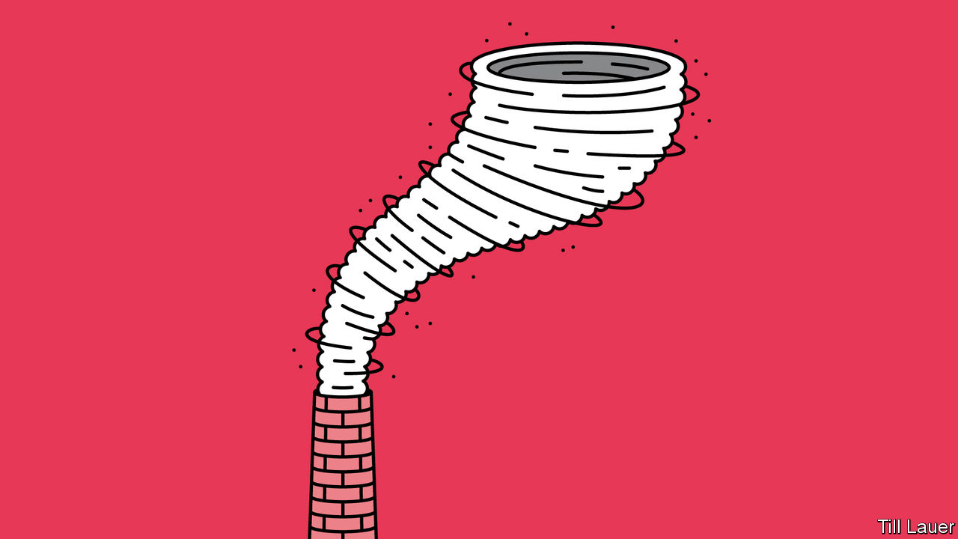

SENSO-JI IN TOKYO, dedicated to the boddhisattva of compassion, is Earth’s most visited sacred site. Some 30m people a year pass through the temple’s imposing entrance, known as Kaminarimon, or Thunder Gate, flanked by Fujin, the god of wind, and his even fiercer brother, Raijin, the god of storms and rain. They are just one of countless reminders across North-East Asia that the natural calamities of downpours and floods (not to mention earthquakes and tsunamis) are deeply enshrined in the region’s collective psyche.

Yet some recent meteorological punishment looks less divine than man-made. Two years ago Japan’s summer monsoon season was the wettest on record. In their usual iteration, the life-giving rains are welcome. In excess, they sweep away roads and houses: 225 people died across 15 prefectures in 2018. The rains of 2019 set a new record as, in turn, did this summer’s deluge.

In South Korea, too, the 54 days of rain this summer marked the longest monsoon on record. The Han river, which runs through Seoul, the capital, burst its banks. The heavy rains threatened North Korea’s already meagre food supply.

No sooner did the monsoon end than the typhoon season began. The Korean peninsula typically gets one direct hit from a typhoon a year. Over the past two weeks it got three in succession, another record. On September 8th Kim Jong Un, the North’s dictator, assembled his top brass to review the damage a week earlier from the second of the typhoons, Maysak, which destroyed 2,000 homes and washed away 60km of roads and 57 bridges. As the meeting took place, the third, Haishen, was sweeping inland. Although it had weakened before it made landfall, Haishen was the first “supertyphoon” of the season. It packed sustained winds of 135 knots (250kph).

Most of the western Pacific, the world’s biggest typhoon factory, has actually seen unusually few this season. Meteorologists had predicted that. Thanks to a regular rhythm in the climate known as the El Niño-Southern Oscillation, their models said tradewinds in lower latitudes would be stronger than usual, making it harder for typhoons to form.

Yet something man-made may be at work farther north. A facet of global warming is that the tropics are expanding. That may account for increased monsoon flooding and a shift north in the intensity of typhoons. Surface temperatures in a huge patch of ocean south of Japan have been at record highs. The heat gives strength to the typhoons passing over. As Maysak unwound, the energy it dumped into the jet stream may have contributed to savage swings from hot to cold in western America (see Science section).

Japan and South Korea grew rich by pouring concrete. Construction—dams, levees, pumping stations—still delights planners confronting threats from the weather. A shrine for the world’s disaster experts is a cathedral-like cistern under Tokyo, a 6.3km-network of tunnels and tanks supported by 500-tonne columns.

Flood mitigation is essential. Yet though Japan and South Korea have few climate-change deniers, the sense that warming is a problem generated elsewhere has persisted for too long, says Ohbayashi Mika of the Renewable Energy Institute in Tokyo. That is changing faster in South Korea. Its civil society is more vigorous than Japan’s—and in a recent Gallup poll seven out of ten Koreans said recent floods underlined the seriousness of climate change. President Moon Jae-in promises to close ten coal plants before the end of his term in 2022. This week he used the typhoons as a reason to push for a trebling of renewable generation by 2025. South Korea’s coronavirus-related spending packages have had a strongly green element, says Ms Ohbayashi, unlike Japan’s.

There, media coverage of weather events makes the link to climate change. Yet Japan’s own hefty carbon emissions rarely come up, says Watanabe Eri of 350.org, a green pressure group. Coal’s share in power generation has risen in the past decade, especially after Japan shut its nuclear plants. Targets adopted under the outgoing prime minister, Abe Shinzo, are feeble: coal will still be more than a quarter of the mix by 2030. Japan also promotes coal plants abroad.

Change is always possible. Japanese businesses are under pressure from Western partners to cut their carbon use. Three years of floods have boosted new volunteers at Ms Watanabe’s group fivefold. The numbers remain tiny—around 250 a year. But all typhoons start with the merest waft of air.

For more coverage of climate change, register for The Climate Issue, our fortnightly [newsletter](https://www.economist.com/theclimateissue/), or visit our [climate-change hub](https://www.economist.com/news/2020/04/24/the-economists-coverage-of-climate-change)

This article was downloaded by calibre from <https://www.economist.com/asia/2020/09/12/typhoon-season-makes-japan-and-the-koreas-ponder-climate-change>

|  |  |  |  |
| --- | --- | --- | --- |
| Previous | Articles | Sections | Next |

|  |  |  |
| --- | --- | --- |
| Asia | Sections | United States |

China

Party building: The red front-line

.

Foreign media: Bumping heads

.

Chaguan: More red than green

.

|  |  |  |
| --- | --- | --- |
| Asia | Sections | United States |

|  |  |  |  |
| --- | --- | --- | --- |
|  | Articles | Sections | Next |

#### The red front-line

# China’s Communist Party is splurging on new local drop-in centres

Filling them can be a challenge

Sep 12th 2020 |

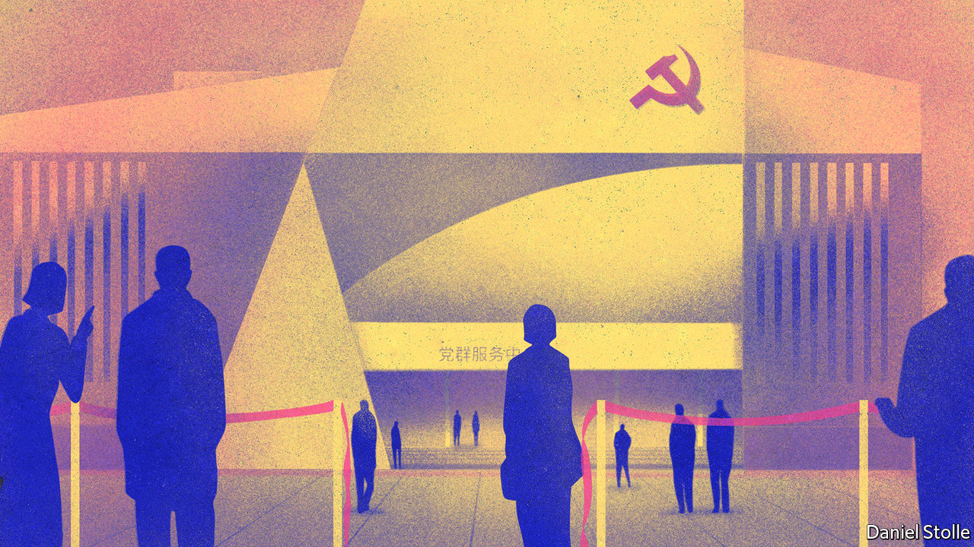

IN SHENZHEN’S GLISTENING tech district, opposite the headquarters of Tencent, a giant digital conglomerate, the Communist Party vies for attention. “Follow the party, start your business” is etched into a futuristic-looking cube at the entrance to a two-storey building, its walls sprayed with paintings of giant robots. In the lobby stands a life-size statue of Mao Zedong, flanked by other Communist leaders. But most visitors bypass the exhibit on the party’s history and head directly upstairs.

Xi Jinping Thought is not as appealing as the free classes on offer: calligraphy, kick-boxing, Pilates and Zumba. There are lectures on career-building and buying property in Shenzhen, a city bordering on Hong Kong that is one of the world’s most expensive property markets. At lunchtime, workers can enjoy free massages. “Most people find study sessions about the history of the Communist Party too dry,” says one of the centre’s staff. “They prefer attending yoga or lectures about blockchain. We even held a speed-dating event recently where we matched 15 couples.”

The building is known as a “party-masses service centre”. In recent years they have proliferated in cities, towns and villages across the country. It has been the biggest effort by the party to develop its physical infrastructure at the grassroots in decades. They are partly intended to be “one-stop shops” at which locals can get access to a wide variety of bureaucratic services that hitherto may have required visits to distant government offices. In Shenzhen, where they are called “community service centres” in English (perhaps to obscure their Communist links to politically sensitive foreigners), there are more than 1,000 of them. One is at the city’s airport. It offers karaoke, a flight simulator and a library of more than 3,500 books.

Providing entertainment and helping with government paperwork, however, are secondary functions of these centres. Their main purpose is to give ordinary party members space to meet and discuss such matters as Xi Jinping Thought and the party’s latest directives. The dismantling of many state-owned firms in the 1980s and 1990s stripped the party of much of its grassroots presence. In recent years it has been scrambling to rebuild this by setting up party organisations within private businesses and NGOs. But these often consist of just a few people who lack regular contact with higher-level party committees. The service centres help to bring disparate party bodies under one roof and make it easier to mobilise them when needed, such as to help the public during covid-related lockdowns. The one in the airport describes itself as a “red home” for nearly 10,000 party members working in more than 30 airport-related businesses. It has a dance hall that doubles as a meeting room.

Building and decking out these facilities has not been cheap. In the past two years a district of Dongguan, a city near Shenzhen, has spent more than 190m yuan (about $28m) on them. Jiayuguan, a far less affluent city about 3,000km to the north-east on the edge of the Gobi desert, has forked out a similar amount in the past five years. Nor has it been optional. Progress made in building them is used to evaluate officials’ performance. Cities have specified minimum areas for their floor space. In Shenzhen it is 650 square metres for neighbourhood ones, or more than half the size of an Olympic swimming pool. But some officials like to go larger. Shenzhen boasts the biggest neighbourhood-level party-masses centre in Guangdong province, at 8,000 square metres.

Officials have good reason to show enthusiasm. Rebuilding the party at the grassroots has been a priority for Mr Xi since he took over as China’s leader in 2012. On trips outside the capital he has paid several visits to party-masses centres. During one such in July, in the north-eastern city of Changchun, he paraphrased Mao, saying that effective work at the grassroots was essential for ensuring that the party can “sit tight on the fishing terrace despite the rising wind and waves”—in other words, maintain its grip on power.

In cosmopolitan cities such as Shenzhen, it involves appealing to a young tech-savvy elite that has little time for earnest study of party ideology. Hence the effort to entice people with services such as free advice on starting up a business. Ryan Manuel of Official China, a research firm, compares the new centres to churches in Western cities that provide busy professionals with a sense of community by arranging sports activities and night classes. In both cases the main aim remains to inspire a belief—in God at the churches, or in the party at the centres.

Even by the party’s admission, the new centres—despite being hailed as the “red front-line”—do not always perform as hoped. An article published in 2018 by the website of the People’s Daily, the party’s main mouthpiece, said many centres were “empty shells”. In some places, “the hardware is classy but the service doesn’t match and footfall is low,” lamented a county official near Kunming in another online article. In places where the buildings were empty, she wrote, citizens were also devoid of “satisfaction and happiness”.

But the party does not have to worry about attracting recruits, whose swearing-in ceremonies are often held in the new centres. In 2018 only about 10% of applicants were accepted to join the party, which has over 90m members. “Despite the party trying to be more inclusive and reach out to more people, the party itself remains highly selective in recruitment of members,” says Feng Chucheng of Plenum, a research firm. The party wants the bright tech workers of Shenzhen, but only those who will comply with its orders without question. Karaoke skills confer no advantage. ■

This article was downloaded by calibre from <https://www.economist.com/china/2020/09/12/chinas-communist-party-is-splurging-on-new-local-drop-in-centres>

|  |  |  |  |
| --- | --- | --- | --- |
|  | Articles | Sections | Next |

|  |  |  |  |
| --- | --- | --- | --- |
| Previous | Articles | Sections | Next |

#### Bumping heads

# Tensions between China and the West threaten journalism

The abrupt departure from China of two Australian correspondents highlights new perils for Western media

Sep 9th 2020 |

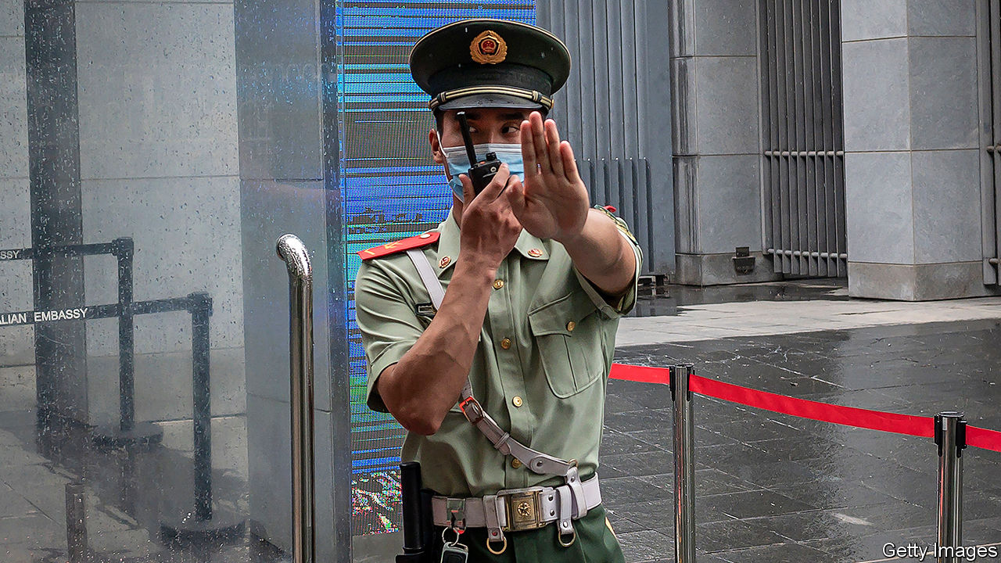

AROUND MIDNIGHT on September 2nd, seven state-security officers knocked on the door of Bill Birtles, an Australian journalist in Beijing. He was told he was involved in a case and ordered not to leave China. Instead of detaining him, however, the police said they would call him in the afternoon to arrange an interview.

At the same time in Shanghai six police visited the flat of another Australian journalist, Michael Smith, to deliver a similar message. Instead of waiting for follow-up calls, the two journalists took refuge in Australian diplomatic missions. After long negotiations, Australian and Chinese officials reached a deal. The police were allowed to interview the pair on condition that the exit ban was lifted. On September 7th the correspondents flew to Sydney.

The targeting of Mr Birtles and Mr Smith appeared to reflect worsening relations between China and Australia, which have been at odds over everything from China’s handling of the coronavirus outbreak to Australia’s exports of beef and barley. The police said they wanted to ask the two about their links with Cheng Lei, an Australian journalist working for Chinese state television who was detained in August under China’s national-security law. But during the interviews, the police raised only perfunctory questions about Ms Cheng. “It was about harassing us,” says Mr Birtles. “I think the whole thing was premeditated by the Chinese government. They wanted to get us out without expelling us. It’s a good outcome for China—now there is no Australian media on the ground in China.”

The journalists’ departure was also a sign of how increasingly precarious foreign reporters’ lives are becoming in China. The Communist Party has never had an easy relationship with them, but has largely tolerated their presence. Tensions with the West are changing this. In the first half of 2020 China forced 17 foreign reporters to leave. Previously it had only pushed the occasional one out.

The surge is in part a response to America’s scaling back of the Chinese media presence in the United States. But it coincides with a more disdainful attitude towards the Western media generally among Chinese officials. Foreign journalists who are ethnic Chinese often get treated worst. While reporting this month on protests in Inner Mongolia, a northern region, Alice Su of the Los Angeles Times was detained for more than four hours. An officer grabbed her throat with both hands and shoved her into a cell. She was not allowed to contact the American embassy.

In the case of the Australians, the Chinese government may have felt it had cause to retaliate. On September 8th China’s state news agency, Xinhua, said Australian intelligence officers had searched the homes of Chinese journalists in Australia in June, questioning them and seizing their computers and mobile phones. The journalists were told to remain silent about the incident, Xinhua reported. Australian security agencies have refused to comment.

Western reporters, naturally, writhe at China’s growing tendency to treat them as proxies of their governments (their job is not the same as that of Chinese state-media workers). But as the Australians’ plight has shown, they may increasingly have to turn to their governments for help. ■

This article was downloaded by calibre from <https://www.economist.com/china/2020/09/09/tensions-between-china-and-the-west-threaten-journalism>

|  |  |  |  |
| --- | --- | --- | --- |
| Previous | Articles | Sections | Next |

|  |  |  |  |
| --- | --- | --- | --- |
| Previous | Articles | Sections | Next |

#### Chaguan

# China’s authoritarian approach won’t save the environment

A truly sustainable future needs more than order and rules

Sep 12th 2020 |

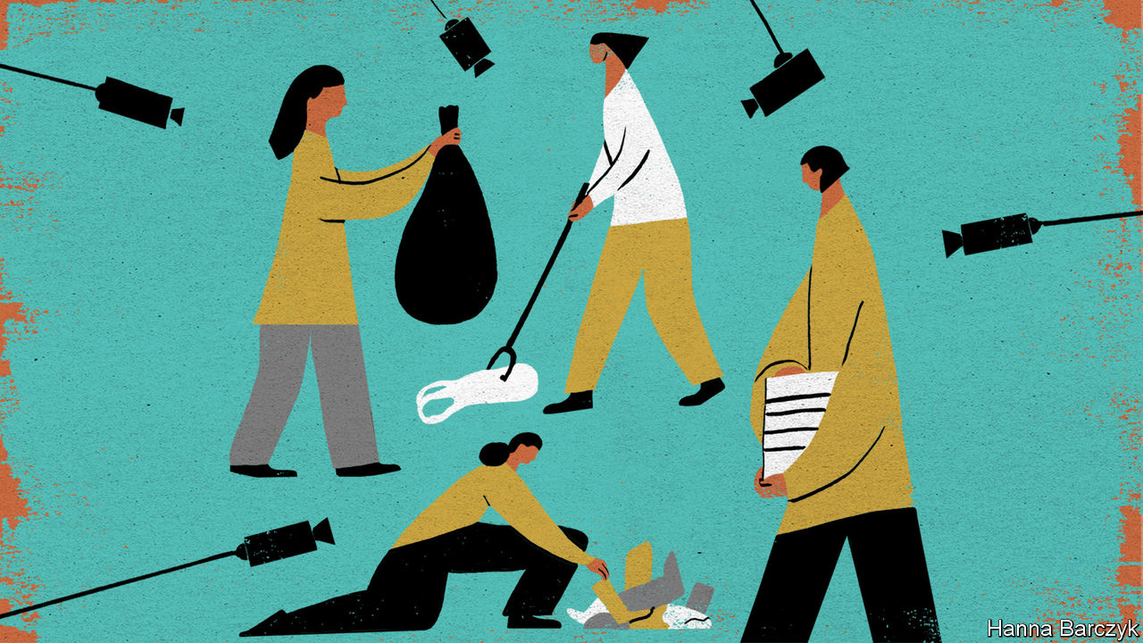

IT IS TIME that civic-minded Chinese become better acquainted with rubbish, suggests Chen Yu, a retired publisher from Shanghai, at the end of a Saturday spent counting litter on the banks of the Yangzi river. This afternoon’s survey has a scientific purpose. Undaunted by the muggy heat and mosquitoes of late summer, Mrs Chen and three dozen other volunteers sort river debris on a concrete breakwater, before weighing and recording each pile on a smartphone app. The heap of takeaway food packaging is dismayingly large, and there are a surprising number of shoes.

The data are being collected by a Chinese environmental group, Rendu Ocean, which runs 90 coastal monitoring sites with the help of about 1,000 volunteers. Mrs Chen, who also has an unpaid post helping neighbours navigate Shanghai’s strict new rubbish-recycling rules, is not surprised that the beach cleaners are mostly young and female. Older men can be conservative and easily embarrassed, she says, and this sort of volunteering is still rather new in China. Now 74, she is glad that youngsters are joining the cause: “It’s good for the country, as well as the environment.”

That patriotic note is echoed by Liu Yonglong, Rendu Ocean’s founder. He emphasises that his non-profit organisation’s work on the environment is complementary to that of the state. The enthusiasm of volunteers is “our comparative advantage to the government”, he says. “The disadvantage is that of course we are not as professional. That is where the government can come in.”

The official connections of Chinese NGOs often make foreign campaign groups wary, report the authors of “China Goes Green”, a new book that analyses the country’s stated ambitions to build an “ecological civilisation” and then share that model with the world. One of the co-authors, Judith Shapiro of American University in Washington, DC, records a discreet approach from a Dutch foundation that wanted to give an award to Ma Jun, founder of the Institute of Public and Environmental Affairs, a well-known Chinese NGO, but wondered whether he was “sufficiently independent of the government”. Wrong question, replied Ms Shapiro, urging the fretful Dutch to understand the scrutiny applied to Chinese civil-society groups, including “chats” over tea with security officials. Mr Ma has enlarged the boundaries of what is allowed, she argued. His group has empowered citizens to report polluters, helping allies within government to enforce environmental rules.

Successful green policies in China share common elements, the book argues. They eschew rigid targets and top-down solutions that “cut everything with the same knife”, to borrow the Chinese phrase for one-size-fits-all prescriptions. Success stories also typically involve the state working with volunteer groups and seeking input from civil society. The book cites a reforestation scheme in the late 1990s in the Loess Plateau of north-western China. Designers spent two years consulting local farmers and scientists, tailoring their plans to local conditions. Orchards of walnuts and dates, shielded by desert willows and traditional landscaping techniques, slowly returned life to barren lands. Later, when impatient officials tried to scale up the scheme with the mass-planting of a few types of fast-growing, water-hungry tree, they failed.

As well as showing the limits of central planning, the book argues that China’s rulers use greenery to cloak their long-standing authoritarian ambitions. Nomads in Inner Mongolia or Tibet were once stripped of their herds and forcibly moved to drab housing blocks in the name of modernity. Now they are subjected to “ecological migration”, ostensibly to save grasslands from their grazing animals. Vast hydroelectric dams are still built over the objections of locals and environmentalists, but now in the name of fighting climate change. Abroad, China stresses the green credentials of its global infrastructure scheme, the Belt and Road Initiative. It delivers cheap technologies to developing countries. But its leaders’ green conscience is selective. In pursuit of national interests they send fishing fleets to pillage far-off seas. They sign opaque contracts with foreign governments to build coal-fired power stations, polluting mines and habitat-wrecking dams. They often rely on authoritarian allies to quell local protests.

## Eco-authoritarianism as a means or an end?

In such cases, domestic and global environmental harms can be attributed directly to ruthless, top-down Chinese governance, suggests “China Goes Green”. That matters because a growing number of foreign observers ask whether China’s model of decisive, technocratic one-party rule might be Earth’s last, best hope, at a time when liberal democracies seem unable to act. Essays and books have appeared with titles like “Will China Save the Planet?” and “The Coming of Environmental Authoritarianism”. Such works typically praise Chinese promises to fight climate change, and its hefty investments in wind farms or electric vehicles. But then, too often, some foreign admirers turn to wondering—with varying degrees of regret—whether the coercive powers of a dictatorship may be the only way to curb unsustainable ecological behaviours.

Examine the record, and in reality Chinese authoritarianism more often undercuts green goals. At moments, it is hard to tell whether the driving force behind a green policy is a desire for a cleaner environment, or an obsession with social controls. Take Shanghai’s recycling rules, which came into force in July 2019. Though the regulations address a real problem, they are fiddly and onerous and reek of distrust for residents. Li Yifei of New York University in Shanghai, the other author of “China Goes Green”, reports conversations with rubbish inspectors in that city, discussing their powers to rummage inside residents’ refuse sacks and to punish those who dump garbage outside approved hours. Soon, several inspectors boasted, bins will have facial-recognition cameras to catch violators, bringing an “orderly future” a step closer. Yet a truly sustainable future needs more than order and rules: it relies on citizens’ free choices. Coercion cannot save the planet. ■

For more coverage of climate change, register for The Climate Issue, our fortnightly [newsletter](https://www.economist.com/theclimateissue/), or visit our [climate-change hub](https://www.economist.com/news/2020/04/24/the-economists-coverage-of-climate-change)

This article was downloaded by calibre from <https://www.economist.com/china/2020/09/12/chinas-authoritarian-approach-wont-save-the-environment>

|  |  |  |  |
| --- | --- | --- | --- |
| Previous | Articles | Sections | Next |

|  |  |  |
| --- | --- | --- |
| China | Sections | Middle East & Africa |

United States

Generations and the election: The boomers’ last stand

.

Rap on the block: Sotheby’s hip-hop auction

.

The horse race: One trot closer

.

Political skulduggery in Missouri: The will of the...whatever

.

Eviction: Shelter in place

.

Lexington: The view from the scaffold

.

|  |  |  |
| --- | --- | --- |
| China | Sections | Middle East & Africa |

|  |  |  |  |
| --- | --- | --- | --- |
|  | Articles | Sections | Next |

#### The boomers’ last stand

# Younger Americans feel their voting weight

After years of elder-power, a new generation may well decide the election

Sep 12th 2020 |



THIS HAS been a year of the young. The protesters against racial injustice have mostly been in their 20s. The average age of demonstrators arrested since mid-June in Portland, Oregon (one of the centres of activity) was 28. The young have not suffered as much as others from covid-19 itself but were hardest hit by the consequences of the virus. More than half of those between 18 and 29 lost a job or took a significant pay cut in April, or live in a household where that has happened. About two-fifths of those aged 50 to 64 have experienced the same thing. Young people are the most likely to work in jobs vulnerable to closure, such as waitressing or retail.

And 2020 will be a year of the young in one more important respect. Electorally, it will be the last stand of the baby-boomers (born between 1946 and 1964) and the first poll in which voting will be dominated by generations younger than 40, especially millennials, defined here as those born between 1981 and 1996. As Bill Frey, a demographer at the Brookings Institution, a think-tank, puts it: “America is moving from largely white, baby-boomer-dominated politics and culture in the second half of the 20th century to a more racially diverse country fuelled by younger generations: millennials, Gen Z-ers and their juniors.”

Boomers have dominated American politics since the 1990s, when they became the largest living generation and started to cast the largest number of votes. (Boomers and millennials have an official status, since the Census Bureau uses those terms; all the other generations are private classifications.) Since Bill Clinton’s election in 1992, six of the eight presidents and vice-presidents have been boomers (Joe Biden, the Democratic candidate, is one of the exceptions, being too old). So are most of Congress. Since 1998, the median age of congressional representatives has put them in the boomer class.

But boomers lost their status as the largest generation in 2019, when millennials overtook them in absolute numbers. That year, there were 72m millennials aged 23 to 38, according to the Pew Research Centre, 500,000 more than boomers (then 55 to 73). For the first time in 2019, more than half of Americans were millennials or younger (meaning members of the generations that came afterwards, called Gen z, born between 1997 and 2012, and post-Gen Z, born after 2013). The three younger groups made up 51% of the population in 2019, compared with only 41% the beginning of the decade.

The electoral impact of these demographic shifts has been muted so far because most Gen Zs are below voting age, and because millennials have a reputation—not entirely deserved—for being apathetic about politics. But things are changing. “Millennials and Gen Z will comprise almost 40% of the electorate in 2020,” says Carolyn DeWitt, head of Rock the Vote, an electoral-mobilisation group, “giving them enormous power.” The two youngest voting-age groups are likely to have more votes than the two oldest, boomers and the so-called silent generation born before 1946 (see chart 1).

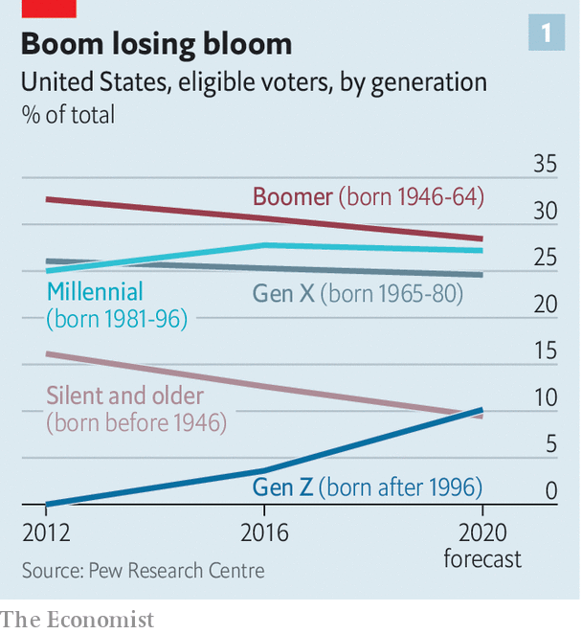

The shift towards the young has occurred surprisingly swiftly, not in tiny steps. In the 2010 mid-terms, boomers and older people outvoted the younger generations almost two to one. As recently as 2014 a disparity remained: boomers cast 57m votes; younger voters, 36m. Four years later, the three younger generations (which now include a few Gen Zs) outvoted the older ones. Not by coincidence, the 2018 mid-terms were a blue wave, in which Democrats regained the House.

Younger generations differ from their elders in attitudes, ethnicity and education. According to Pew, millennials and Gen Z-ers are the most likely to say governments should do more to solve problems, that same-sex marriage is good for society, that climate change is caused by human activity and that blacks are treated less fairly than whites. They are also more likely to say fetters should be put on capitalism, says Pew’s Richard Fry, perhaps because both generations started looking for jobs during recessions, the Great Recession for millennials, the covid recession for Gen Z.

## Pushing up Zs

They are also more likely to be from minorities themselves. As a simple rule, the younger you are, the more likely you are to be black, Hispanic or Asian. Mr Frey calculates that almost three-quarters of 60-somethings are white. Half of those under 20 are not. The impact of young minorities is especially great in sunbelt states. In Texas, 44% of eligible voters are Hispanic or black. But among voters under 40, the minority share is over half. In Arizona, Hispanics are 31% of all eligible voters but 44% of those under 40. In eight states, including Georgia and Florida, over half of voters under 40 are non-white. These are places that Democrats have a shot at winning for the first time in a generation. They are also the people most likely to be galvanised by the killings of George Floyd and others.

Millennials and Gen Z-ers are better educated than their parents and grandparents (though not necessarily wiser). The Pew Research Centre looked at the educational attainment of 25- to 37-year-olds in each generation. For boomers, roughly 25% had a college degree or higher. For millennials, the share was 39%. The leap has been especially great for women. Among boomers, more men than women have degrees. Among millennials, 43% of women have degrees, seven points more than men. The Republicans’ disastrous performance in 2018 in suburban counties, former strongholds, owes much to the revulsion felt by college-educated millennial women for Mr Trump. Education and race are among the most reliable predictors of party affiliation. African Americans vote for Democrats by ten to one or more; Hispanics and Asians by about two to one; 53% of college graduates identify with Democrats, only 40% with Republicans.

Put all this together, and it is hardly surprising to find that millennials and Gen Z-ers are far to the left of boomers. Younger voters identify with issues, not parties, but they tend to vote Democratic (see chart 2). In 2016, calculates Mr Frey of Brookings, people aged 30 to 44 (older millennials) voted for Hillary Clinton by ten points (55% to 45%); voters aged 18 to 29 (younger millennials and Gen Z-ers) by 19 points. Millennials form the bedrock of support for the progressive left, who have done well in Democratic primary contests this year.

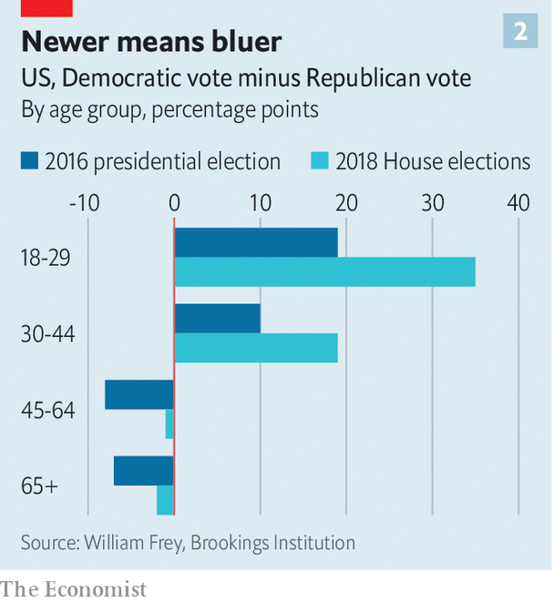

But will they turn out? This year, admits Ms DeWitt, “the top of the ticket won’t be a motivator.” Voters under 30 have always voted less than older ones anyway, often by large margins, though this may owe as much to political parties as to voters themselves. In 2016 two-thirds of young voters said they had not been contacted by any party before the election, probably because parties concentrate their get-out-the-vote efforts on those who have voted before (making low turnout among the young a self-fulfilling prophecy). “Young people are issue-based voters,” says Wisdom Cole of the NAACP. “We’re not going to turn them out by just saying, ‘Go Vote! Go Vote!’.”

Pew’s Mr Fry says, “how the pandemic affects turnout is anyone’s guess.” Our guess, based on crunching Census data and polls from YouGov, is that the turnout rate for the under-30 cohort might be 11 points lower than for the other generations this November. That sounds poor, but for comparison we reckon that gap was 20 points in the 2016 election.

Turnout among voters aged 18 to 29 almost doubled between the 2014 and 2018 mid-term elections. Anecdotally, say election organisers, Gen Z activists are more engaged in the 2020 campaign than older voters. Rock the Vote’s online voter-registration platform has processed 900,000 registrations so far this year, compared with 500,000 at the same stage in 2016. It seems likely, thinks Ms DeWitt, that anger about the death of George Floyd and others will be a wake-up for the young. Disgust at Mr Trump may transcend generations.

Democrats are understandably cautious about Joe Biden’s opinion-poll lead. As 2016 showed, leads can shrink and the electoral college can let a candidate lose the popular vote but still win the White House. But from a generational point of view, it is no surprise that the Democrat should be out in front. It reflects not only Mr Trump’s personality and record but shifts in the tectonic plates of electoral demography.■

This article was downloaded by calibre from <https://www.economist.com/united-states/2020/09/12/younger-americans-feel-their-voting-weight>

|  |  |  |  |
| --- | --- | --- | --- |
|  | Articles | Sections | Next |

|  |  |  |  |
| --- | --- | --- | --- |
| Previous | Articles | Sections | Next |

#### Rap on the block

# Sotheby’s hip-hop auction

The venerable auction house aims to push its hip-hop memorabilia real good

Sep 12th 2020 |

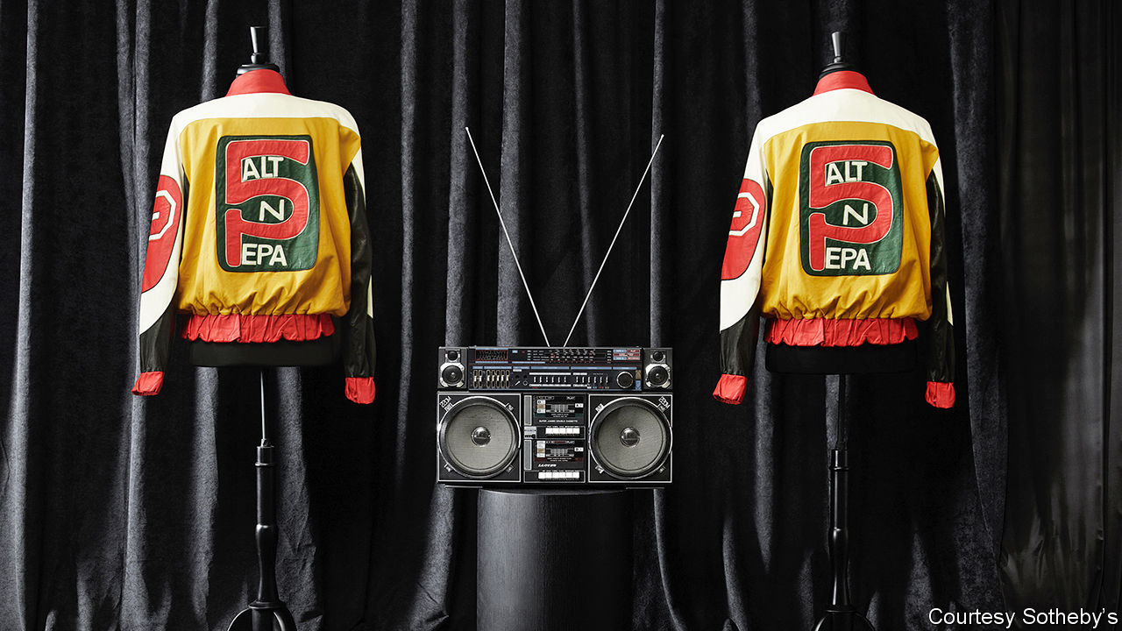

“THE SYMBOLISM of the crown was meant to convey greatness and something bigger about hip-hop,” recalls Barron Claiborne in “Contact High: a visual history of hip-hop”. The photographer was describing a crown worn by Notorious B.I.G., also known as Biggie Smalls, in a famous snap. The crown, one of 120 lots, is on the block at Sotheby’s inaugural hip-hop auction on September 15th. The sale includes items from hip-hop’s earliest days in the 1970s through to the present. It includes jewellery, art, photography, Tupac Shakur’s teenage love letters—and fashion, such as Salt-N-Pepa’s “Push It” jackets (pictured). As people age and have more disposable income they often bid up the price of things that were desirable when they were young. This sale, which is a honeypot for those who came of age in the 1980s and 1990s, is expected to yield $1.2m-1.7m. As Biggie observed in his 1994 hit “Juicy”, “You never thought that hip-hop would take it this far.”

This article was downloaded by calibre from <https://www.economist.com/united-states/2020/09/12/sothebys-hip-hop-auction>

|  |  |  |  |
| --- | --- | --- | --- |
| Previous | Articles | Sections | Next |

|  |  |  |  |
| --- | --- | --- | --- |
| Previous | Articles | Sections | Next |

#### Our election model

# Donald Trump could still stage a comeback (again)

The newest polls and economic data have shored up the president’s odds, though they remain worse than in 2016

Sep 10th 2020 | WASHINGTON, DC

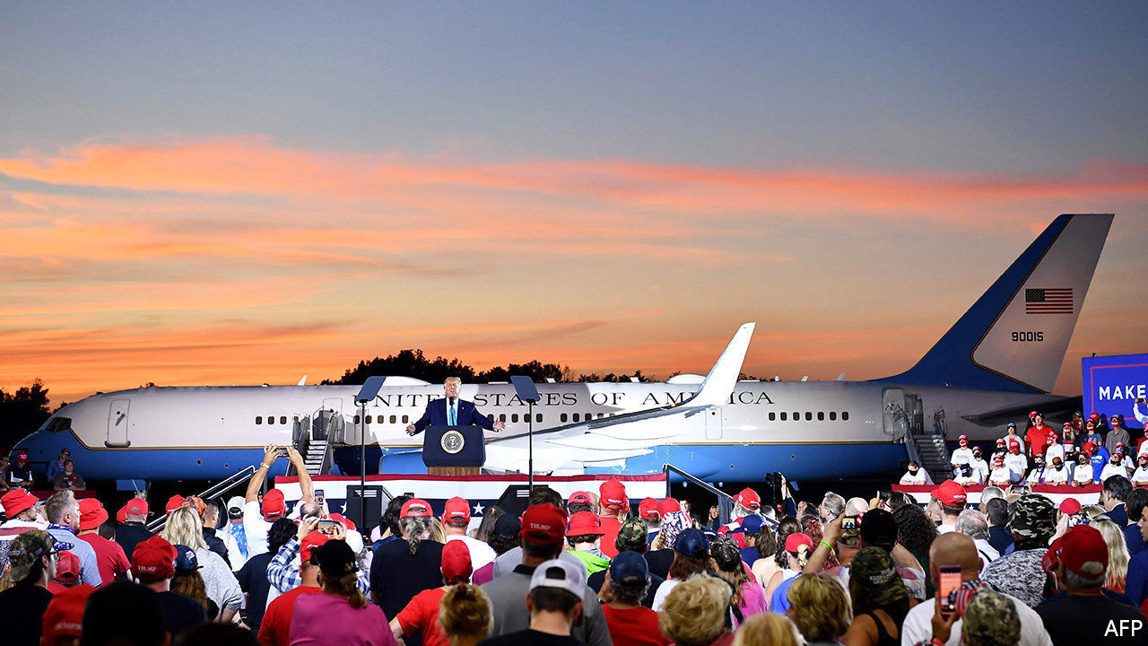

EVERY FOUR years, political journalists and prognosticators deem America’s presidential contest the “election of the century”. By definition, each cannot be. But at the risk of causing readers’ eyes to roll backwards, the stakes really do appear higher than usual this time round. In early June The Economist published its own statistical forecasting model for this November’s presidential contest to guide such handicapping. Back then, it gave Mr Trump at best a one-in-five chance of winning a second term. But by July, as unrest and the coronavirus ravaged the nation, his odds had slumped to as low as one-in-ten. There they stayed until the middle of August. Now, our model shows Mr Trump has clawed back a sizeable chunk of support.

His nationwide deficit in vote-intentions versus Mr Biden has shrunk from ten points at its peak to just eight on September 9th. And in the key states of Florida and Pennsylvania—the two most likely to provide Mr Trump or Mr Biden with their 270th electoral vote—the president’s deficit has narrowed even more. Sunshine-state voters favoured Mr Biden by eight points at his peak in July. Now, they prefer him by just four. One high-quality pollster, Marist, has the candidates level in Florida (though more polls are surely needed to determine whether this is an outlier). In Pennsylvania, Mr Trump has risen from a nine-point deficit to a six-point one.

Other election indicators have also been good for the president of late. Our index of economic growth—which combines annual change in eight different indicators, from the unemployment rate to real personal income and manufacturing output—has been improving steadily since July. The August jobs report, which recorded a nearly two percentage-point drop in unemployment, contributed to a positive trend.

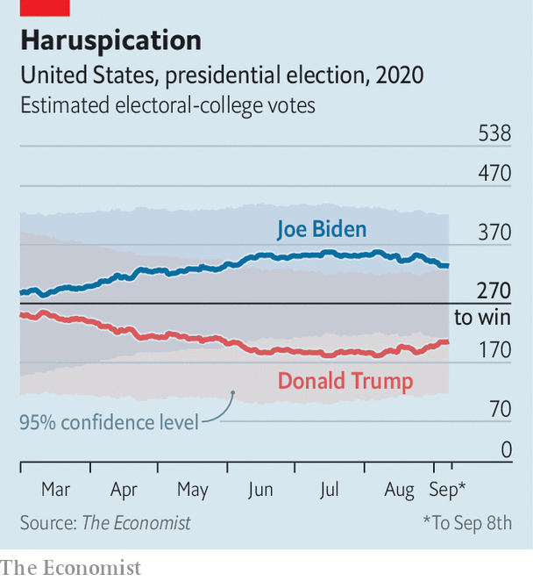

Mr Trump’s job-approval ratings have also gone up. In early August we calculated that 15 percentage points more Americans disapproved of the job he was doing as president than approved of it. By September his popularity had improved a bit, to just an 11-point deficit. Taken together, these economic and political variables alone suggest the president will lose the popular vote by five points; up from a negative-six-point projection two months ago.

Right now the most likely outcome of the election is still that Mr Trump loses. Our election-forecasting model projects that he will fall about 70 electoral votes shy of winning, though there is enough uncertainty in the election to suggest he could still prevail. We predict a relatively low (but by no means impossible) one-in-seven (14%) chance of a Trump victory. For context, our model would have given him nearly twice the chance (37%) at this point in 2016. Because of Mr Trump’s deficit in swing-state polls and the virus-stricken economy, he will have a tough slog to get a second term—despite voters’ marginally improving evaluations of his candidacy.■

Dig deeper:  
Read the [best of our 2020 campaign coverage](https://www.economist.com/us-election-2020) and our [presidential-election forecast](https://projects.economist.com/us-2020-forecast/president), then sign up for Checks and Balance, our [weekly newsletter](https://www.economist.com/checksandbalance/) and [podcast](https://www.economist.com/podcasts/2020/09/04/checks-and-balance-our-weekly-podcast-on-american-politics) on American politics.

This article was downloaded by calibre from <https://www.economist.com/united-states/2020/09/10/donald-trump-could-still-stage-a-comeback-again>

|  |  |  |  |
| --- | --- | --- | --- |
| Previous | Articles | Sections | Next |

|  |  |  |  |
| --- | --- | --- | --- |
| Previous | Articles | Sections | Next |

#### The will of the...whatever

# Political skulduggery in Missouri

A faction of Republicans, and a band of lobbyists, are campaigning to bring back gerrymandering

Sep 12th 2020 | CHICAGO

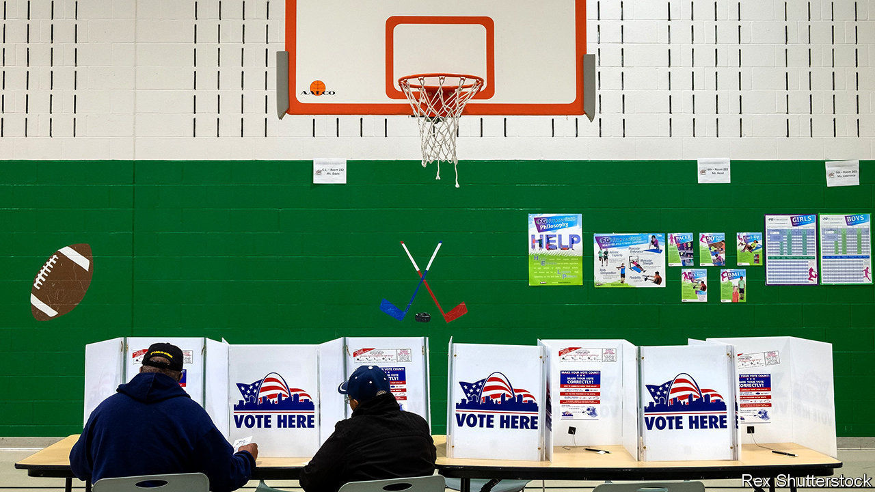

DEMOCRACY WOULD be so much easier if the pesky voters fell in line. Consider Missouri’s elected state representatives. For years party leaders could gerrymander local voting districts so that incumbents faced less risk of losing. The drawing of electoral districts was done by a bipartisan commission appointed by lawmakers, often behind closed doors. Then, in 2018, voters upset this cosy arrangement. By an overwhelming margin they backed a ballot initiative known as Clean Missouri.

This reform put a squeeze on campaign contributions and limited the value of gifts and meals lobbyists could dish out. Most awkwardly it stated that an independent demographer, starting next year, would have the final say in the redistricting commission. The demographer would also have to ensure districts were drawn so that outcomes fairly reflected the will of voters. Under the old system Republicans had most recently taken over 70% of the seats in the lower house, a supermajority, on less than 60% of the votes.

Since 2018 a defiant faction of Republicans (plus one Democrat) and lobbyists, notably a group called Cornerstone 1791, has fought back. They got a new ballot initiative through the legislature, so in November voters will decide on “Amendment 3”. This would make trivial changes to the rules on gifts and campaign spending. More significantly, explains Dave Schatz, a state senator, it would scrap the “unelected, unaccountable demographer”, whose baleful presence, he considers, creates an “absurd and unprecedented redistricting process”. (In fact, several other states have already handed over redistricting to properly independent commissions.) In effect, party bosses would take back control.

There is some political risk in this. David Kimball, a politics professor at the University of Missouri in St Louis, points out that redistricting reform was popular, whereas “overturning the will of the people doesn’t look good”. That explains why moderate Republicans will not back their colleagues. A venerable party figure, a former three-term US senator, John Danforth, has warned that “the integrity of Missouri’s democracy [is] at stake”. Missouri’s governor, Mike Parson, a Republican facing an unexpectedly tight race in November, has stayed studiously quiet about it.

Other setbacks have arisen. To give the passage of Amendment 3 a better chance, its sponsors, such as Dan Hegeman, a state senator, fudged the wording of the ballot, hiding its main purpose. But on September 2nd a court rewrote the wording on the ballot to say bluntly that Amendment 3 would “change the redistricting process voters approved in 2018” and added that it would “substantially modify, and reorder, the redistricting criteria approved by voters”.

In fact the fine print of Amendment 3 points to more minutely crafted skulduggery. It would make it difficult for anyone to claim the legal standing to challenge gerrymandering. It also seems to open the door to districts drawn not with roughly equal populations—as is usual—but instead by numbers of eligible voters. Dean Plocher, a Republican representative in St Louis, has argued that “the apportionment process being tied to citizenship protects the [idea of] one person, one vote”.

Would that change matter? Sean Nicholson of the Clean Missouri group, which works to protect the reform of 2018, calls it “offensive, heinous”. If children and non-citizens are not counted then elected officials, though supposed to represent them, might neglect them. It would also have a predictable political effect, hurting urban districts with more Latinos, African-Americans and Asian Americans while favouring rural, whiter ones, with older residents and fewer children. Half of Missouri’s Latino population, which is notably young, would no longer count in voting districts.

The effect, says Mr Kimball, would be to “weaken political power in Democratic areas”. Cities might lose state legislative districts while rural areas would do better. That looks like rigging rules to help one side. Two years ago voters appeared to reject that sort of thing. They might again. ■

Dig deeper:  
Read the [best of our 2020 campaign coverage](https://www.economist.com/us-election-2020) and our [presidential-election forecast](https://projects.economist.com/us-2020-forecast/president), then sign up for Checks and Balance, our [weekly newsletter](https://www.economist.com/checksandbalance/) and [podcast](https://play.acast.com/podcasts/2020/01/24/checks-and-balance-our-new-weekly-podcast-on-american-politics) on American politics.

This article was downloaded by calibre from <https://www.economist.com/united-states/2020/09/12/political-skulduggery-in-missouri>

|  |  |  |  |
| --- | --- | --- | --- |
| Previous | Articles | Sections | Next |

|  |  |  |  |
| --- | --- | --- | --- |
| Previous | Articles | Sections | Next |

#### Shelter in place

# Can the Trump administration halt evictions on public-health grounds?

The CDC’s decree on evictions will be challenged in court

Sep 12th 2020 | WASHINGTON, DC

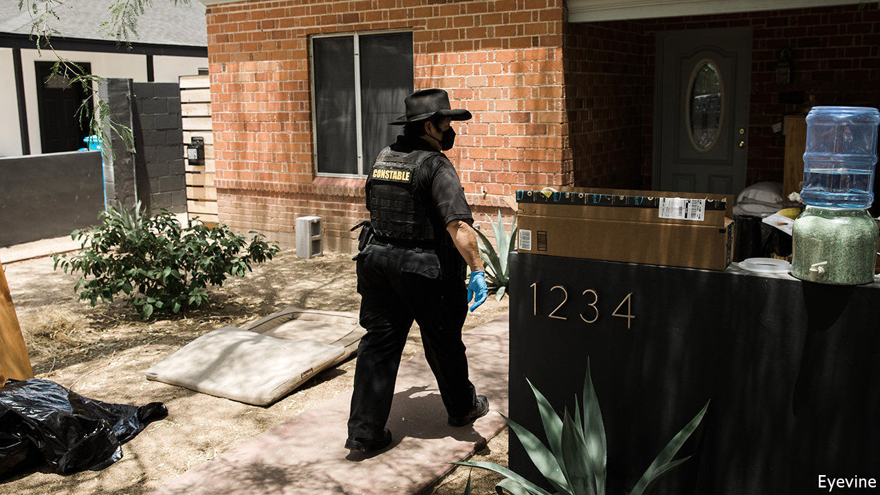

EVEN IN NORMAL times, attending housing court in America is a dispiriting encounter with the judicial system. The justice dispensed looks much like a conveyor belt. Few tenants can afford lawyers to challenge the eviction orders sought by their landlord (unlike criminal proceedings, there is no right to counsel). Many do not show up on the day, so the judge enters default evictions for them en masse. Even more dispiriting would be the spectacle of a judge pronouncing a family’s eviction by video conference in the midst of an epidemic that has killed 190,000 Americans.

Fortunately that remains rarer than the weakened economy—with 11m fewer Americans working than in February, and an unemployment rate of 8.4%—might suggest. Many cities and states issued moratoriums when it became clear that the epidemic would result in a lot of missed rent payments. The CARES Act, the enormous stimulus package passed by Congress, included an eviction moratorium for federally subsidised housing. Though it covered fewer than half of renters in the country, advocates cheered the measure before it expired on July 24th (generous federal unemployment benefits of $600 a week also expired soon afterwards).

Congress has been unable to come up with a second stimulus bill, even though Democrats and Republicans agree that one is necessary. That prompted worries of a tsunami of eviction filings. In Philadelphia, 17 protesters were arrested for blocking the entrances to court a few days after the state moratorium expired. In some cities, like Milwaukee, evictions quickly rebounded after coming to a halt (see chart). Since there seems more hope of an October vaccine than a second stimulus, the consequences looked grim.

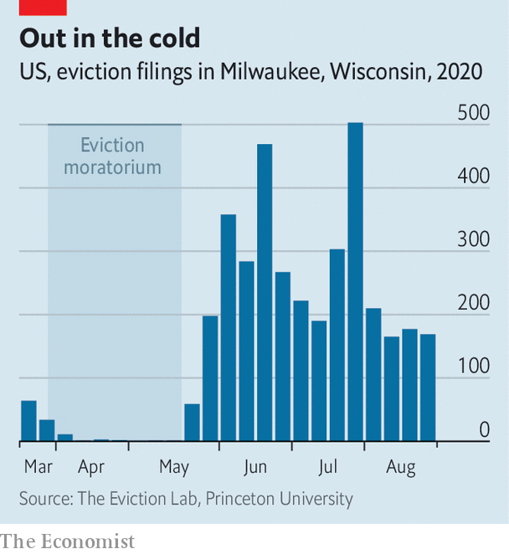

A deus ex machina of sorts has come from the Centres for Disease Control (CDC), the federal public-health agency that is occasionally the target of the president’s scorn. Arguing that evictions hasten the spread of the virus, it issued a sweeping moratorium starting on September 4th that applies to most renters nationwide (excepting American Samoa, which has been spared even a single case of covid-19). This came after an executive order from President Donald Trump that sought to “take all lawful measures to prevent residential evictions and foreclosures”. To qualify, renters must certify that they earn less than $99,000 and are unable to pay even after seeking government assistance. However, they must still make “timely partial payments” and will still owe back-rent.

The public-health rationale for the decision is straightforward. A team of epidemiologists at Harvard, the University of Illinois and the University of Pennsylvania has published a model estimating that even a low eviction rate (0.25% of households per month) would increase caseloads by 1.5% by the end of the year. But a high eviction rate (2% of households per month) would increase cases by 13%. The non-medical consequences of pausing evictions could prove equally important. Studies of the last recession showed that moving several times a year was associated with worse performance at school, the effects of which linger over a lifetime. And since evictions are caused by a failure to pay rent, reduced housing costs may allow increased spending on other necessities for struggling families.

Although the CDC order is doubtless well-intended, whether it will be judged legal is still uncertain. The latitude given to public-health officials to contain an epidemic is broad, but this kind of action has no recent precedent. Without any immediate compensation for lost rental payments, landlords will be left with mounting bills. Arguably, this stands awkwardly with the constitutional guarantee that “private property [shall not] be taken for public use, without just compensation”. Indeed, there is already a lawsuit against the city and state eviction moratoriums introduced in Seattle, Washington, on this ground. One of the plaintiffs in that case is owed $14,000 from two tenants who stopped paying rent in April.

Tenant advocates and landlord-lobby associations, usually at loggerheads, agree on one thing—they would rather the federal government footed the bill. The stimulus proposal created by Democrats in Congress would set aside $100bn to help pay for six months of back-rent and late fees, but its actual passage looks improbable. Others would like to go further. Housing Justice for All, a New York group, would like all housing costs (including utilities) incurred during the epidemic to be “automatically forgiven and never owed”. Left-leaning state legislators have introduced a bill that would do almost exactly that.

Nothing spurs policy innovation quite like a crisis. During the second world war America imposed extraordinary rent controls covering more than 80% of the national rental stock. Today, some would like to supplant national rent control with national rent cancellation.■

Editor’s note: Some of our covid-19 coverage is free for readers of The Economist Today, our daily [newsletter](https://my.economist.com/user#newsletter). For more stories and our pandemic tracker, see our [hub](https://www.economist.com/news/2020/03/11/the-economists-coverage-of-the-coronavirus)

This article was downloaded by calibre from <https://www.economist.com/united-states/2020/09/12/can-the-trump-administration-halt-evictions-on-public-health-grounds>

|  |  |  |  |
| --- | --- | --- | --- |
| Previous | Articles | Sections | Next |

|  |  |  |  |
| --- | --- | --- | --- |
| Previous | Articles | Sections | Next |

#### Lexington

# How construction workers in Ohio view the election

A return to Youngstown points to the solidity and limits of Donald Trump’s fan base

Sep 10th 2020 |

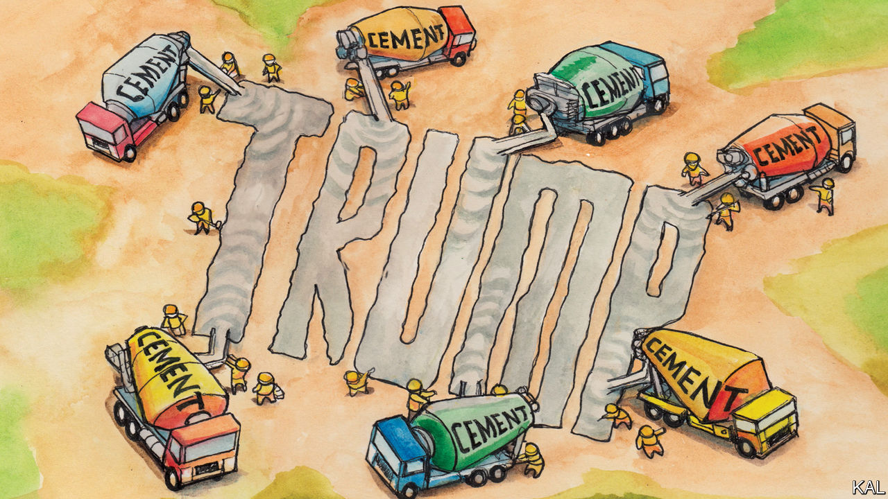

A FEW DAYS before the 2016 election, when the nature of Donald Trump’s appeal to his supporters was a matter of hot debate, Lexington joined a local builders’ union boss on a tour of construction sites in Youngstown, Ohio. Most of Rocco DiGennaro’s—male and almost exclusively white—“Local 125” members intended to vote Trump, despite many having only ever voted Democratic before. Your columnist wanted to know why.

By far their most common explanation was a hatred for Hillary Clinton. Nearly all the workmen said the Democratic candidate was dishonest and corrupt. By contrast, many expressed weaker or less defined feelings towards Mr Trump. They said they liked his tough talk, especially on immigration, and that he was a businessman. Many thought he could sort out Washington, DC, and the economy (though Youngstown’s construction industry was already booming). Those perceived qualities duly won Mr Trump a record share of white working-class votes—and thus the presidency. Even so, it was not obvious back then that his supporters would develop the ironclad allegiance to him many now profess.

Their devotion was apparent during a re-run of your columnist’s tour around Youngstown, again in Mr DiGennaro’s entertaining company. “You’re going to hear the same again, only more intense,” the burly ex-builder had predicted. He wasn’t wrong. Interviews with a score of workers on a large development project at Youngstown State University, involving several construction companies and sites, did not suggest Mr Trump had increased his local support. As in 2016, perhaps a third of the workers claimed to have no interest in the election. Yet almost all who had voted for him in 2016, even if tentatively, now vigorously endorsed him.

“He’s done a great job, he’s got everyone back to work. I’m pretty much 100% for him,” said Kyle, a 30-year-old electrician. “He shoots his mouth off but at least that shows he’s honest,” said Jason, a pipe-fitter, who said he especially liked Mr Trump’s commitment to reducing the national debt. “He’s done more for our country than the past ten presidents put together,” said an older builder, Jeff, skimming wet concrete on a new road. “He’s made—who is it, China or Japan?—pay our farmers billions of dollars. He got health care done, which the Democrats could never do. He built the wall.”

The only anti-Trump voice Lexington heard—aside from that of Mr DiGennaro, a blue-dog Democrat—belonged to Jeff’s boss, Greg, ladling concrete alongside him. “I think Trump’s bad for the country, bad for morals, a bad example to my children and I want him out,” he said—then added that his Fox News-addict wife disagreed: “I think we’re going to get divorced and I’m not joking.”

This snapshot illustrates how Mr Trump has not so much divided America as cemented its differences. Despite Joe Biden’s polling lead, Republicans are solidly behind the president. He is the most popular president with his own party on record: 94% of the people who voted for him in 2016 intend to do so again. Mr Biden’s lead owes more to his success in mobilising Democrats and former third-party voters against the president than shrinking his vote.

The construction workers’ erroneous takes on Mr Trump’s record (his administration in fact turbocharged the debt even before covid-19 struck, has reduced health-care coverage and has a lot of wall left to build) offered a clue to how he has exerted such control over his party. Notwithstanding the strength of the pre-covid economy, the loyalty of Mr Trump’s voters is not—or not mostly—a response to his policies or record. Political scientists—on the left and right—long ago discovered that most voters are flexible on such matters. They choose leaders who seem to reflect their values, rearrange their policy priorities accordingly and, in a hyper-polarised environment, also to an extent their critical judgments.

Thus the alacrity with which Republicans ditched free trade and fiscal conservatism. Thus, too, the transformation in how they viewed the economy within days of the 2016 election. Mr Trump’s subsequent success in binding in his supporters ever tighter owes to the relentlessness with which he has highlighted, again and again, the values they have entrusted him with and the threats to those values, real and imagined, he claims his critics present.

Unlike any predecessor, he has never stopped campaigning. He held a hundred rallies as president—not including presidential set pieces, such as state-of-the-union addresses, that he treats as purely political events—before his re-election campaign began. He has decried even conservative critics as enemies of what he and his voters stand for. The effect of this constant grandstanding is to keep challenging his supporters to recommit themselves to him, publicly or privately, and in the process harden their loyalty.

The only significant area of disagreement in this analysis, between scholars on the right and left, concerns what values the president is asserting. Those on the right tend to stress the populist qualities of his “America First” agenda: nationalism, paternalism, toughness—much of which Mr Trump’s supporters in Youngstown seemed to appreciate. “I want to see an end to international trade deals and all that stuff: I’m America First,” said Tony, an engineer.

## Not so shy

The liberal consensus has the same list—but adds racial anxiety to it. And Mr Trump’s race-baiting—which he is now stepping up in veiled attacks on Mr Biden’s running-mate, Kamala Harris—makes that hard to refute. So, for that matter, did the receptiveness of some in Youngstown to it. George, an electrician, described Mr Biden’s as a Trojan Horse for Ms Harris: “He’d resign on day one and then you’ve got your first woman president and she’s black, too.”

The president’s advisers suggest the polls are missing many “shy Trumpers”. But the alacrity with which Trump supporters defend his chauvinism and sometimes display their own makes that seem unlikely. It perhaps also explains why, notwithstanding his lock on his base, Mr Trump is struggling to expand it.■

Dig deeper:  
Read the [best of our 2020 campaign coverage](https://www.economist.com/us-election-2020) and our [presidential-election forecast](https://projects.economist.com/us-2020-forecast/president), then sign up for Checks and Balance, our [weekly newsletter](https://www.economist.com/checksandbalance/) and [podcast](https://play.acast.com/podcasts/2020/01/24/checks-and-balance-our-new-weekly-podcast-on-american-politics) on American politics.

This article was downloaded by calibre from <https://www.economist.com/united-states/2020/09/10/how-construction-workers-in-ohio-view-the-election>

|  |  |  |  |
| --- | --- | --- | --- |
| Previous | Articles | Sections | Next |

|  |  |  |
| --- | --- | --- |
| United States | Sections | The Americas |

Middle East & Africa

Property rights: Parcels, plots and power

.

Jordan: Failing the test

.

Serbia, Kosovo and Israel: An awkward embrace

.

America and the Middle East: Stealth diplomacy

.

|  |  |  |
| --- | --- | --- |
| United States | Sections | The Americas |

|  |  |  |  |
| --- | --- | --- | --- |
|  | Articles | Sections | Next |

#### Dreams of fields

# The quest for secure property rights in Africa

Handing out title deeds is not enough

Sep 12th 2020 | KHAYELITSHA

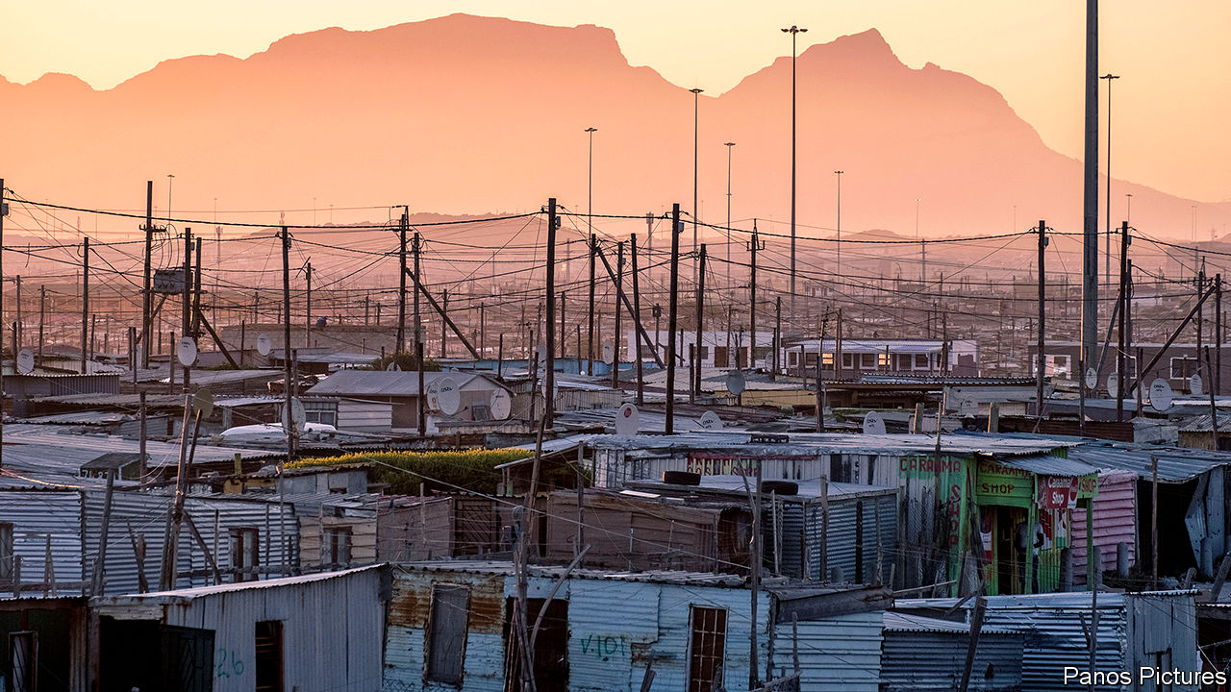

BUILDERS ARE busy outside Louisa Qangiso’s house in Khayelitsha, a township on the outskirts of Cape Town. The 49-year-old is putting up eight studio flats in her backyard that she will rent out for 3,000 rand ($177) per month. This could almost triple the value of her property, from roughly 570,000 to 1.6m rand. These are life-changing sums for Ms Qangiso, a grandmother whose warehouse job pays just 5,000 rand a month. “This is my dream come true,” she says, holding back tears.

The dream is reality because of Ms Qangiso’s grit—and because, unlike most people in the township, she can demonstrate ownership of her property. Aided by Bitprop, a startup, she proved her claim on the land, then used the title to raise money for the building works. Over the next decade she will split the rent with Bitprop, which also designs the flats, until its share is paid back. Thereafter the takings, as well as the increase in the asset value, are hers.

Ms Qangiso’s story encapsulates the latent power of property rights. Twenty years ago Hernando de Soto, a Peruvian economist, published “The Mystery of Capital”, in which he argued that, without formal title, the real estate on which billions of poor people live and work is “dead capital”. He estimated these assets to be worth $9.3trn ($13.5trn in today’s money).

Partly inspired by Mr de Soto, over the past two decades there has been a flurry of attempts to map and parcel land in the developing world. Between 2004 and 2009 the World Bank committed to 34 land-titling and registration projects worth more than $1bn, compared with three between 1990 and 1994.

Yet the potential of property rights remains largely unrealised, especially in Africa. Perhaps 90% of rural land in Africa is not formally documented. Just 4% of African countries have mapped and titled the private land in their capital cities. Well-meaning reformers have often neglected the myriad other factors affecting whether titles are useful or not, such as custom, other laws and the capacity of the state to enforce people’s legal property rights. They have also underestimated the ability of vested interests, such as traditional leaders and urban elites, to obstruct reform.

Covid-19 highlights the harm that insecure property rights cause. Evictions and land grabs are rising, as newly jobless tenants cannot pay rent and bigwigs figure they can get away with skulduggery while everyone’s attention is on the pandemic. The economic fallout of the coronavirus is so severe that some African countries face a lost decade. So they need growth-boosting reforms more than ever.

As history shows, land reform is hard. Policies in the colonial era varied, but white rulers often designated huge areas terra nullius (unoccupied land) and appropriated it for their colonies. Formal property rights were reserved for settlers and European firms. The rest of the agricultural land was given “customary” tenure, meaning it could be used but not owned, and that it was always subject to seizure by the state. Colonists often ruled indirectly, via state-sanctioned “tribal” leaders who exercised control over the land.

After independence most African governments kept bifurcated systems. Urban elites replaced white colonists in state institutions. Customary systems in rural areas endured. Only towards the end of the 20th century did the notion of formalising more of the land take off. By this time the idea that a lack of property rights was a brake on development was commonplace.

Africa has half of the world’s usable uncultivated land, and its agricultural productivity is far below its potential. That is a huge drag on growth. Because people in the countryside do not have title to their land they typically cannot rent it out while they are away, and they may fear it may be taken by someone else. This discourages migration to the cities, where wages are higher.

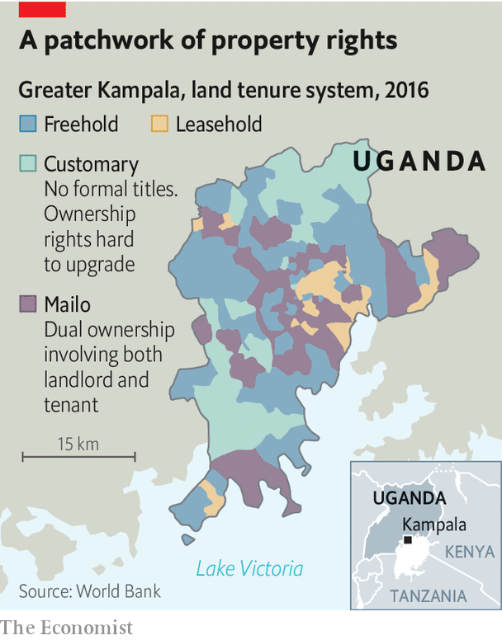

Insecure tenure makes cities poorer, too. Dense urban populations normally make it easier for people to share ideas and find work. But African cities sprawl inefficiently. The World Bank reckons that in some of them 30% of land is not built on, compared with 14% in, say, Paris. Overlapping tenure regimes are one reason why. In Kampala, Uganda, a bewildering mix of freehold, leasehold, customary and “dual ownership” systems gum up formal land markets (see map).

## Insert title

Weak property rights aggravate many other ills. They encourage environmental degradation—if it is not clear who owns the forest it is easier for well-connected businesses to claim it and cut it down. Land disputes are a common cause of conflict. Informal land markets mean governments miss out on taxes. And sexist traditions often make women’s property rights especially insecure. According to a survey by Prindex, a research group, nearly half of women in sub-Saharan Africa worry that they would lose land if they were divorced or widowed.

All rich, democratic countries have secure property rights, enabling owners to buy, sell, subdivide and collateralise their assets. Many poor countries have tried to build something similar, usually starting with a formal registry of land ownership. In 2012, for example, Rwanda, completed a programme to map and title all of its land using aerial photography, paid for by Britain’s government. Those carrying out the project had to tread carefully. Many of the original occupants of plots had been killed in the genocide in 1994; others had been locked up for their part in it. The team made visits to prisons to help resolve land disputes. The cost per parcel was just $7—much lower than efforts that relied on traditional surveying. Before the project most women were not recognised as landholders; at the end, a woman’s name was on 92% of the deeds.

Yet the overall impact of titling initiatives has been disappointing. Most African countries still use paper records. They usually do not know how many titles they have issued or whether more than one person claims ownership; in Khayelitsha, the staff at a local advice centre note that 15% of the titles in the surrounding area are in the names of dead people. The share of Africans who have formal title deeds is therefore unknown, but in some countries it is most likely in the single digits.

Poor administration compounds the problem. On average in Africa it takes 59 days to register a property. Transferring deeds costs 9% of the property’s value, more than twice the share in the OECD, a club of mostly rich countries. Land surveyors are scarce and monopolistic. A lack of trust does not help, either. In a different part of Khayelitsha from where Ms Qasingo lives, a group of women meet members of Khaya Lam (My Home), a charitable project that pays for title deeds to be proven. One lady struggles to believe that someone would help her for next to nothing. Waving her title she asks: “Is this for real?” Corruption in South Africa means people are sceptical, says Temba Nolutshungu of the Free Market Foundation, a think-tank. “People are used to being lied to by those with a political agenda.”

Technology may help. There is a good deal of enthusiasm around digital platforms such as Cadasta. These help users to prove ownership of their land and resolve disputes, rather than having to go to a bureaucrat’s office.

A crucial lesson of the past few decades, however, is that if land reform is treated purely as a top-down technical task, it will not work well. It is not enough simply to map and register a property, as several high-profile efforts show. In Ethiopia, after 20m certificates were issued in the 2000s, land records were rarely updated. In Uganda a project to digitise records has struggled with a lack of data. Even Rwanda’s scheme has had teething problems. Though land administration is working well in Rwandan cities, 87% of rural transactions remain informal (mostly because the cost of registering sales is too high).

In sub-Saharan Africa formal title seems to bring less additional security of tenure than it does in other parts of the world. In July Prindex published results of a 140-country survey on how secure people feel in their properties (see map below). It found that there was only a small difference in perceived security between sub-Saharan Africans with formal documentation (70%) and those without (65%). This was the lowest gap anywhere.

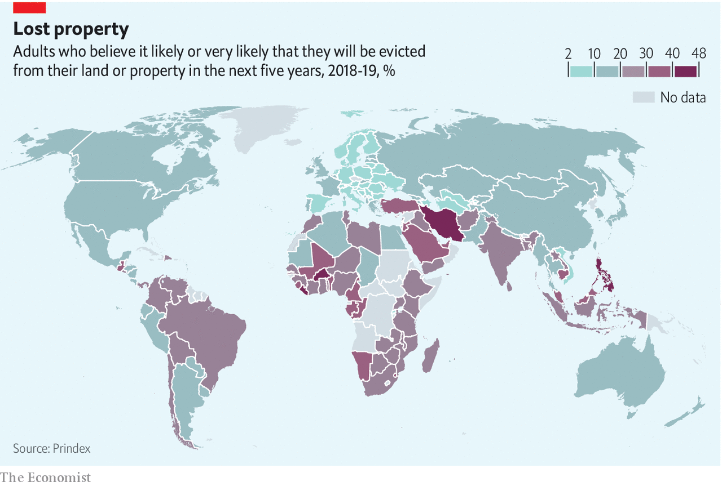

The authors suggest this may be further evidence of what researchers call the “Africa effect”. Titling also seems to make less difference to productivity in Africa than in Asia or the Americas. A paper co-authored by Steven Lawry of the Centre for International Forestry Research found that agricultural productivity increased by no more than 10% in the African studies they reviewed, compared with 50-100% in the papers from Latin America and Asia—partly because successful efforts in other regions were more efficient and pursued titling alongside other reforms.

Another explanation for the Africa effect is that customary systems offer more security than was previously assumed. These arrangements, which cover perhaps 625m people and 78% of Africa’s land, vary hugely in how they combine collective ownership with rights of individuals or families. Yet over the past 30 years there has been what Admos Chimhowu of the University of Manchester calls a “quiet paradigm shift” in customary land laws.

Since 1990, 39 of Africa’s 54 countries have passed laws overhauling communal land rights. Most create something of a middle ground between the individualistic freehold systems popular in the West and the colonial customary model where occupants had no formal rights to the land on which they lived and worked. Mr Chimhowu characterises the “old” customary system as one that did not recognise property at all, where power was vested in chiefs and where markets were absent or informal. In the “new” customary tenure, communal rights are recognised as property, local leaders are more accountable and there are greater links with formal markets. This, at least, is the theory.

## Solving the chief problem

In reality the potential of new laws, like that of titling efforts, has been undermined by vested interests. Control of land rights is so lucrative that Africa’s ruling parties and traditional authorities are reluctant to let it go. “Traditional leaders balk at surrendering what is...colonially encouraged ownership over their citizens’ lands,” notes Liz Alden Wily, an expert on land and customary law. In countries such as Ghana, Malawi, Namibia and Zambia, chiefs have stymied new laws that would have reduced their power to allocate land.

Since the end of apartheid in South Africa, successive laws have given “traditional” authorities more clout. The 35-40% of people who live in the former “homelands” created under white rule, or other communal areas, are unable to own their land. Black South Africans can now buy property outside the homelands, but inside them they remain, in effect, subjects.

Several studies have found that chiefs, in cahoots with politicians, use their powers to sell land to mining or other firms without the say-so of their people. In 2016 South Africa’s public protector, a legal ombudsman, found that the leaders of the Bapo ba Mogale people of North West province, who live on platinum-rich land, had somehow lost 800m rand that was supposed to belong to their people. Activists who raised the issue were beaten up.

A process that was meant to correct some of the injustices of apartheid has instead been hijacked by corrupt elites. Land restitution schemes are “captured” by those who have access to money and connections, according to a study of 62 land projects by the Institute for Poverty, Land and Agrarian Studies, an academic group.

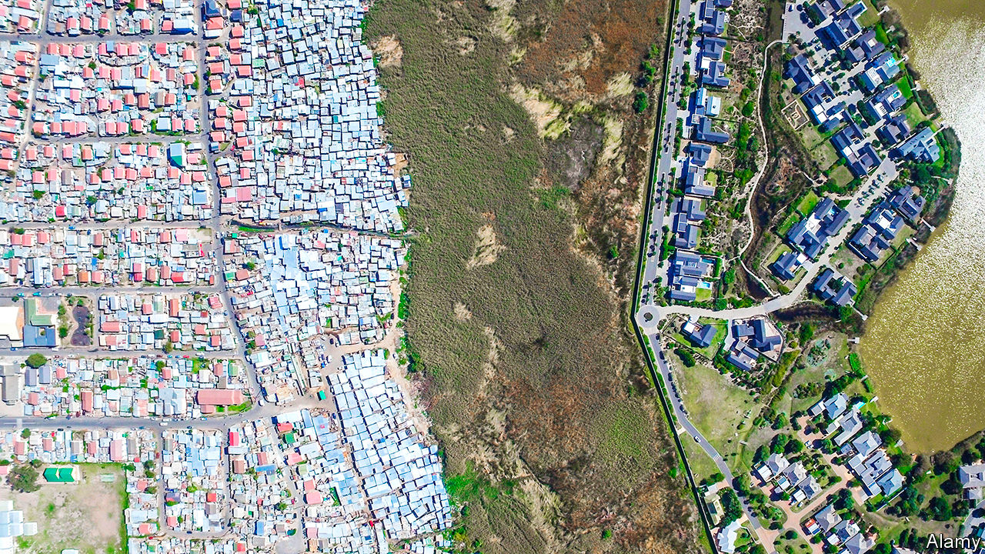

Another way in which African bigwigs exert power over land, to the detriment of ordinary citizens, is what Ms Wily calls “state landlordism”. This can take several forms. Some bigwigs abuse the process of mapping communities to grab the choicest surrounding land for agri-businesses, as in Tanzania. Some take an expansive interpretation of the state’s power to seize land in the “public interest”. In Kenya a law passed in 2012 was supposed to reduce the political power of the ministry of lands by setting up an apolitical land commission. But vested interests have eroded its authority and land grabs have increased over the past eight years. The designation of dozens of protected forests has frequently served to deprive indigenous people of their land.

State landlordism is an urban problem, too, especially as cities have grown to encompass erstwhile farmland. A report published in 2019 by ENACT, a research group funded by the EU, suggested that drug-traffickers are small fry compared with criminal landlords. “Land allocation, real estate and property development”, it wrote, “may be the largest type of organised criminal activity in Africa”.

In Kibera, a slum in Nairobi, more than 90% of residents rent their homes from absentee landlords. ENACT cites a survey estimating that 42% of these landlords “reputedly had associations with state and political actors”, while 41% were government officials and 16% were politicians. In Ghana there is a similar pattern, where urban land ownership is dominated by state bodies, political leaders and chiefs.

Those who benefit from a murky status quo can also take advantage of archaic planning laws. In former British colonies many cities are governed by laws influenced by the UK Town and Country Planning Act of 1947, which was not designed for dense Kenyan slums. This is one reason why English-speaking cities have more sprawl than French-speaking ones. French planners were generally keener on compact, dense cities, while English-speaking cities have 50% more patches of built-upon land with no surrounding developments.

Despite state landlordism, promising reforms continue. Land-rights lawyers are campaigning for governments to obey their own laws. Rwanda is trying to reverse the slide into informalisation. In Ethiopia several states are issuing certificates that allow people to formally rent out their land and to borrow against it.

The pandemic has made everything harder. Titling has slowed in Ethiopia. It is hard to gather around a map or a smartphone if you are meant to be social distancing. Courts that are not sitting cannot resolve disputes. Elsewhere covid-19 has underlined the fragility of many Africans’ land rights. Women are at risk, especially those whose husbands or fathers have died. There is some evidence that in Kenya widows were thrown out of their homes by their in-laws during lockdown, as they are seen as a burden.

Back in Khayelitsha, a few miles from Ms Qasingo’s house, is a reminder of how the pandemic and a lack of property rights combine to make people’s lives insecure. On the same day your correspondent met Ms Qasingo, scores of people left destitute by the pandemic set up shacks on state-owned land. Many had been evicted from their previous abodes; their jobs gone because of covid-19. Their new homes could be bulldozed at the click of an official’s fingers. It would be tragic if one legacy of a pandemic that forced billions to stay in their homes was that it made it harder for others to keep theirs. ■

This article was downloaded by calibre from <https://www.economist.com/middle-east-and-africa/2020/09/12/the-quest-for-secure-property-rights-in-africa>

|  |  |  |  |
| --- | --- | --- | --- |
|  | Articles | Sections | Next |

|  |  |  |  |
| --- | --- | --- | --- |
| Previous | Articles | Sections | Next |

#### Failing the test

# Schools in Jordan struggle with covid-19 and jailed teachers

The government blames Islamists for bad behaviour in class

Sep 12th 2020 | BEIRUT

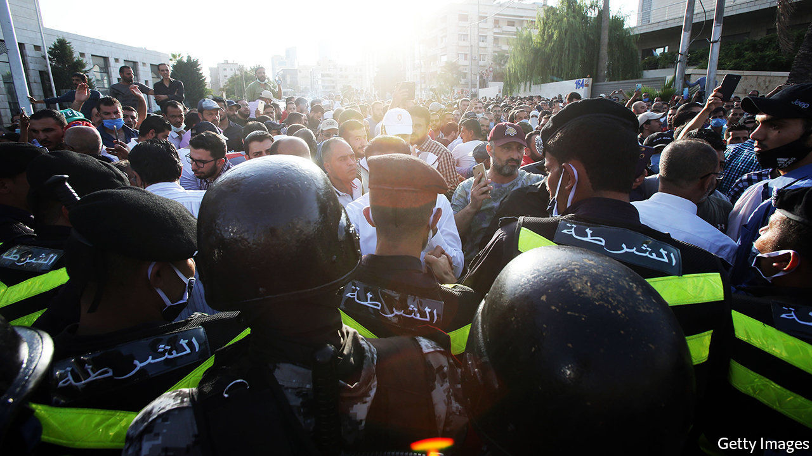

SCHOOLS AROUND the world are grappling with how to teach during a pandemic. Some in Jordan have an added complication: teachers in jail. In July the authorities raided the office of the national teachers’ union, which represents more than 100,000 people. It was ordered to close for two years and its board members were arrested. When teachers came out to protest, an estimated 1,000 of them were detained as well, some under laws meant to restrict gatherings to curb the spread of covid-19. Authorities have used gag orders to limit reporting on the unrest.

The board members were released after a month in detention. Some teachers were freed after signing pledges not to protest again, on pain of heavy fines. Schools opened as planned on September 1st. Still, the academic year may bring more protests. Far from a simple labour dispute, the crackdown on teachers is a symptom of Jordan’s bigger economic and political woes.

Unions in Jordan split roughly into two camps. An umbrella trade federation, which represents 200,000 mostly low-skilled and poorly paid workers (in a country of 10m), receives state funding and is seen as weak and quiescent. More active in recent years have been syndicates that serve middle-class professionals. They joined protests over a new income-tax law in 2018, which led to a general strike that saw doctors walk out of hospitals and pharmacists shut their shops.

The teachers’ union falls somewhere in between. It is Jordan’s largest, with members across the country. Even many experienced teachers earn just 400-500 dinars ($560-710) a month, barely above the official poverty line of 340 dinars for a family of five. Last year the union went on strike for four weeks, the longest public-sector walkout in Jordan’s history, to demand a 50% pay rise. It settled for a promise of increases of 35-75% based on seniority.

The rises were postponed in April, however, when the government froze public-sector salaries because of a financial shortfall caused by the pandemic. Even before covid-19, Jordan’s economy was sluggish: annual growth has been a meagre 2% since 2014. This year it may contract by 4-5%. Lockdowns forced 250,000 labourers out of work. A six-month closure of the airport idled a tourism industry that employs another 50,000 people. Fitch, a ratings agency, thinks the slump will double Jordan’s current-account deficit to 6% of GDP.

The IMF approved $1.3bn in emergency financing in March. But the kingdom, long reliant on foreign aid, may need more help. In 2012, to calm protests inspired by the Arab spring, Gulf states pledged $5bn in aid over five years. In 2018 they offered just $2.5bn. Jordan’s neighbours are frustrated by some of its policies. It refused to join a blockade of Qatar in 2017, for example, despite pressure from Saudi Arabia and the United Arab Emirates.

They have also urged Jordan to end its tolerance for the Muslim Brotherhood, an Islamist group some Gulf monarchs see as a threat. King Abdullah of Jordan is hardly a supporter: he once described the Brotherhood as “wolves in sheep’s clothing”. But the group’s political party, the Islamic Action Front, has been allowed to stand for elections and win seats in parliament. That tolerance seems to have run out. In July the high court dissolved the Brotherhood. Its assets had already been transferred to a state-sanctioned splinter group. Islamists will probably boycott the next parliamentary election, scheduled for November.

That points to a larger problem: Jordanians are frustrated by a government that seems unresponsive. Officials suggest that the teachers’ union was under the Brotherhood’s sway. Though the group does have some influence, the claim is overblown. The crackdown on the union was unpopular at a time when public anger was already rising over the economy and repeated lockdowns. Lately parents have even been concerned about the situation in schools: several have seen covid-19 outbreaks. Jailing teachers is not the sort of social-distancing measure they have in mind. ■

Editor’s note: Some of our covid-19 coverage is free for readers of The Economist Today, our daily [newsletter](https://my.economist.com/user#newsletter). For more stories and our pandemic tracker, see our [hub](https://www.economist.com/news/2020/03/11/the-economists-coverage-of-the-coronavirus)

This article was downloaded by calibre from <https://www.economist.com/middle-east-and-africa/2020/09/12/schools-in-jordan-struggle-with-covid-19-and-jailed-teachers>

|  |  |  |  |
| --- | --- | --- | --- |
| Previous | Articles | Sections | Next |

|  |  |  |  |
| --- | --- | --- | --- |
| Previous | Articles | Sections | Next |

#### Next year in Jerusalem

# Serbia and Kosovo awkwardly embrace Israel

But will the Balkan enemies really set up embassies in Jerusalem?

Sep 12th 2020 | JERUSALEM

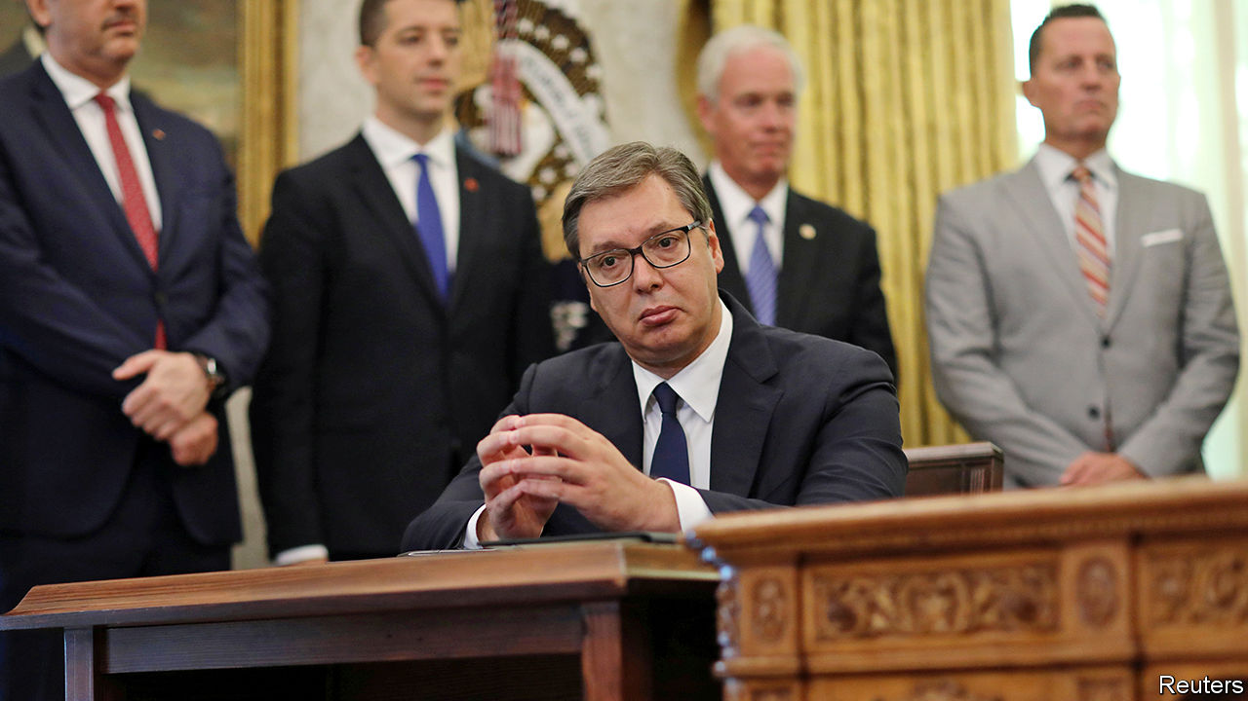

IT IS RARE that events in two of the world’s most enduring troublespots—the Balkans and Israel-Palestine—spill over into each other, least of all in a peaceful way. But on September 4th President Donald Trump telephoned his friend Binyamin Netanyahu, Israel’s prime minister, to say he had persuaded the leaders of Serbia and Kosovo—once part of the same country, now mortal enemies—to give Israel a warm embrace. Kosovo and Israel, he said, would recognise each other. And both Balkan countries, flouting the policy of the European Union, which they hope to join, will recognise Jerusalem as Israel’s capital.

This was a second diplomatic coup for Messrs Trump and Netanyahu after last month’s agreement between Israel and the United Arab Emirates (UAE) to open full diplomatic relations with each other (see [article](https://www.economist.com/node/21791751)). Kosovo would become one of just a handful of majority-Muslim countries to recognise Israel. Ron Dermer, Israel’s ambassador to America and one of Mr Netanyahu’s closest advisers, is said to have been behind the breakthrough.

How Mr Trump cajoled the two Balkan countries into taking such steps is unclear. Their leaders were at the White House to sign an American-brokered economic agreement, to the chagrin of the EU, which is trying separately to persuade the foes to come to terms with each other (Serbia does not recognise Kosovo’s independence). Officials hope the economic deal will boost foreign investment in both countries, perhaps leading to warmer relations.

The deal may not be all it seems at first glance. The opening of embassies in Jerusalem is not due to take place before mid-2021. By then Mr Trump may have had to vacate the White House. And before the ink had dried on the accord, some Serbian sources said their country would not, after all, move its embassy to Jerusalem if Israel recognised Kosovo (which Israel has been reluctant to do, lest it encourage the Palestinians). The president of Serbia, Aleksandar Vucic (pictured), looked somewhat bemused when Mr Trump announced that Serbia would be making the move.

“This is more about American politics than the Balkans or the Middle East,” says Dahlia Scheindlin, an Israeli expert on the Balkans. “Trump is facing a threatening political environment and wanted a foreign- policy spectacle, something his friend Netanyahu is well-versed at orchestrating.” Mr Trump’s election campaigners certainly hope his recent Middle East diplomacy will impress American evangelical Christians and pro-Israel conservatives. ■

This article was downloaded by calibre from <https://www.economist.com/middle-east-and-africa/2020/09/12/serbia-and-kosovo-awkwardly-embrace-israel>

|  |  |  |  |
| --- | --- | --- | --- |
| Previous | Articles | Sections | Next |

|  |  |  |  |
| --- | --- | --- | --- |
| Previous | Articles | Sections | Next |

#### Stealth gap

# How an overpriced warplane complicates diplomacy in the Middle East

America wants to sell F-35s to the United Arab Emirates. Israel objects

Sep 12th 2020 | JERUSALEM

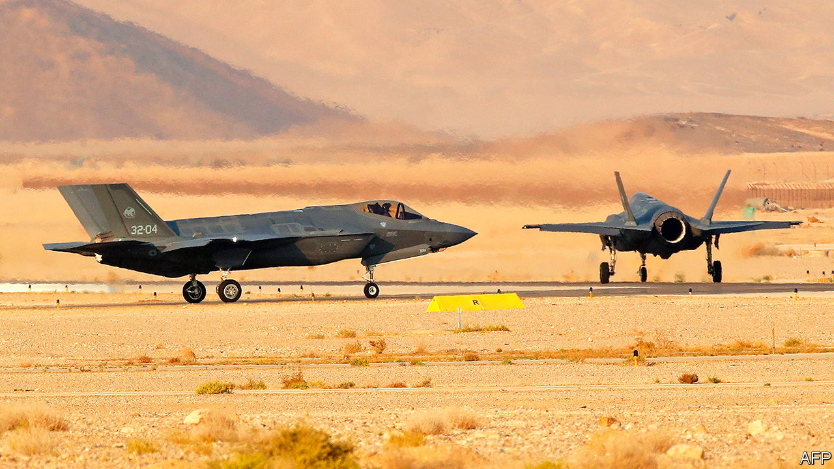

DON’T BE FOOLED by the nondescript buildings of the Nevatim air base, deep in the Negev desert. Lately the facility in southern Israel has served as something like an advanced testing ground for the most state-of-the-art warplanes made in the West. Take the American-made F-35 stealth fighter jet, which Israeli pilots flew over Lebanon, Syria and the Gaza Strip in 2018—the plane’s first combat missions. Israel receives such weapons long before America’s other allies in the region, giving it a unique military advantage. But it may be losing some of that edge.

When Israel and the United Arab Emirates (UAE) agreed to establish diplomatic relations on August 13th, it seemed like a straightforward deal. The countries had been moving closer for some time. Israel quietly works with the Gulf states to counter Iran. The UAE’s decision to become just the third Arab country to recognise Israel, despite its occupation of Palestinian lands, reflected these warmer ties. There was more to it than that, however. It has since emerged that the UAE is in talks with America over an arms deal that will include weapons such as the F-35, which America has hitherto only sold to close allies.

This has not gone down well in Israel. Its prime minister, Binyamin Netanyahu, reportedly went along with the proposed arms deal in private as a way of smoothing the talks over diplomatic relations. He denied this when the deal became public last month, criticising it. But the complaints stopped after a meeting with Mike Pompeo, America’s secretary of state, in Jerusalem. “Netanyahu may have said that he’s against selling F-35s in principle,” says Amos Gilad, a retired major-general in Israel’s army. “But he certainly gave America the impression that Israel wouldn’t try and block it.”

America has long ensured that Israel has a “qualitative military edge” (QME) over its neighbours. The concept, which has been codified into law, means that Israel is consulted on big arms deals in the region. America’s Arab allies, though able to buy its warplanes and missiles, are usually blocked from purchasing its most advanced weapons. “There are teams of Israeli experts who deal with the QME constantly in a dialogue with the Pentagon,” says an Israeli diplomat. “But Netanyahu has gone ahead without consulting them.”

Those experts are now voicing their concerns. The F-35’s unique shape and radar-absorbent materials allow it to evade detection. It is not just a warplane, but a sophisticated intelligence hub capable of swapping intelligence on faraway targets with nearby planes and ships. Other advanced weapons said to be included in the UAE deal—such as Reaper drones and the EA-18G Growler, an electronic-warfare plane—also raise questions about whether they could be used against Israel in a conflict. Some worry that the technology might eventually end up in the hands of Israel’s enemies. “We can’t predict what will happen in ten years, whether radical Islamists take over a country like the Muslim Brotherhood did in 2012. Or a country becomes allied with Iran,” says Mr Gilad.

The UAE has been building up its air force, which has seen action in Iraq, Libya, Syria and Yemen. It has long wanted the F-35, despite its price tag of around $80m per plane. “Under Barack Obama they couldn’t even get a classified briefing on the F-35’s capabilities, let alone the planes,” says Dan Shapiro, a former US ambassador to Israel. But President Donald Trump has made arms sales a central part of his foreign policy. “They have the money and they would like to order quite a few F-35s,” he said of the UAE. “We’ll see what happens.” Last month the Emiratis reportedly cancelled a meeting with Israel and America because they were cross about Mr Netanyahu’s public opposition to the deal.

In normal times the sale would take many months to process. The State Department must certify that it does not undermine Israel’s QME. It might also place restrictions on how the F-35 is used. The Defence Department must ensure that the UAE is capable of securely owning and operating all of the weapons in the deal. (A former American defence official says the sale of F-35s probably would not affect Israel’s QME, in part because the UAE would struggle to exploit the plane’s most advanced capabilities without other technology.) The deal must also be approved by Congress, which has criticised the UAE’s role in the war in Yemen and its support for a warlord who is challenging the UN-backed government in Libya. Still, many politicians will probably say yes if Israel does not make too much of a fuss.

Mr Trump could try to placate Israel by providing it with other advanced weapons. He might also invoke his emergency powers to sidestep Congress and push the deal forward before November, when he is facing re-election. The president did as much last year, declaring an “emergency” over Iranian activity in order to expedite an $8bn arms deal with Saudi Arabia, Jordan and the UAE over objections from Congress. Still, it could take up to a decade to deliver the F-35—plenty of time for a different administration to reconsider the contract. Turkey was kicked out of the F-35 programme over its purchase of a Russian air-defence system.

“It’s not just about the UAE,” says an Israeli diplomat who works on defence issues. “Netanyahu has created a precedent and now other Arab countries will demand F-35s as well.” A precedent was set four decades ago, when Egypt made peace with Israel. Since then America has sold Egypt everything from fighter jets to frigates—but nothing as advanced as the F-35. Some in Israel’s defence establishment think such weapons are a price worth paying for the normalisation of relations with the Arab world. Others question whether such a volatile region really needs more arms. ■

This article was downloaded by calibre from <https://www.economist.com/middle-east-and-africa/2020/09/12/how-an-overpriced-warplane-complicates-diplomacy-in-the-middle-east>

|  |  |  |  |
| --- | --- | --- | --- |
| Previous | Articles | Sections | Next |

|  |  |  |
| --- | --- | --- |
| Middle East & Africa | Sections | Europe |

The Americas

Education in Latin America: Home truths

.

Mexico: Air show

.

Bello: Damned either way

.

|  |  |  |
| --- | --- | --- |
| Middle East & Africa | Sections | Europe |

|  |  |  |  |
| --- | --- | --- | --- |
|  | Articles | Sections | Next |

#### Home truths

# The pandemic further weakens Latin America’s underperforming schools

Before covid-19 more children than in past decades were going to school. Too few were learning

Sep 12th 2020 | MEXICO CITY AND SÃO PAULO

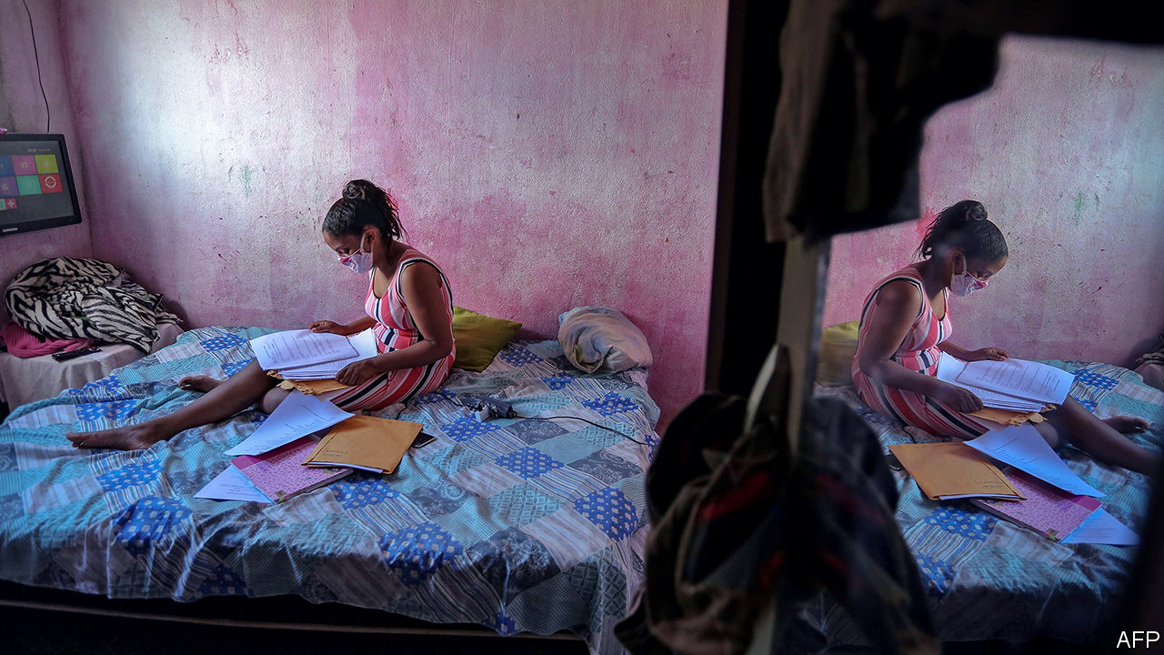

Editor’s note: Some of our covid-19 coverage is free for readers of The Economist Today, our daily [newsletter](https://my.economist.com/user#newsletter). For more stories and our pandemic tracker, see our [hub](https://www.economist.com/news/2020/03/11/the-economists-coverage-of-the-coronavirus)

UNIVERSITY WAS always the plan for Camila Dantas, a 19-year-old high-school graduate from Cidade de Deus, a favela in Rio de Janeiro. Her father, who works in construction, was the first person in his family to go to university. Her mother irons clothes. Ms Dantas works in a nail salon and studies for the entrance exam at night. Favelados, or residents of informal settlements, are still a tiny minority of university students. Ms Dantas and her friends see higher education as a “necessary step” towards improving their lives.

The pandemic, and the recession it has caused, threaten their plans. All but ten of the 50-odd students in Ms Dantas’s online test-prep course have dropped out. Her boyfriend chose work in a tattoo parlour over a fine-arts degree to help his mother pay the bills. A survey published in June by American University in Washington, DC, found that 84% of Latin American universities expect enrolment to fall this year, with half anticipating declines of 10-25%.

Latin America, with less than a tenth of the world’s population, has a third of recorded deaths from covid-19. Although the rate of new infections is slowing, most schools are closed in all but two countries, Uruguay and Nicaragua. More than 95% of the region’s 150m pupils remain at home.

Most countries have set no date for reopening. In many parts of Mexico schools may not reopen until a vaccine becomes available, leaving pupils to learn from a few hours of daily television programming. Bolivia will offer neither in-person nor remote learning until 2021. When schools in São Paulo and Rio de Janeiro, Brazil’s biggest cities, reopen next month, less than half of pupils will attend in person.

If schools stay closed for seven months from March this year, which looks certain in most places, and governments fail to compensate, children could lose the equivalent of an eighth of their years of schooling, estimates the World Bank. Lifetime earnings per pupil could fall by more than $15,000 (adjusted for purchasing-power parity). The share who fail to meet proficiency standards in reading and maths could rise from 53% to 68%. The education interruption will worsen income inequality in the world’s most unequal region. “It’s a silent crisis,” says Emanuela di Gropello, an education expert at the bank.

Rich families can make up for the enforced holiday. In Brazil they are hiring laid-off private-school teachers to tutor their children in small groups, or “learning pods”. Poor ones lack computers and internet connections at home. Their children are also missing out on school meals, a lifeline in many countries. They would be completely isolated but for WhatsApp, which teachers across Latin America use to send assignments. Juliana Rohsner, the head of a school on the poor outskirts of Vitória, the capital of the Brazilian state of Espírito Santo, oversees 37 chat groups, on which staff respond to messages from pupils and parents at all hours. She worries teachers will burn out.

Although 74% of Brazilian pupils have taken part in some kind of distance learning during the pandemic, the share drops to 61% in the north and to 52% in the north-east. The rest are getting no instruction. Pupils from rural areas and those living in favelas are the most likely to miss out. Peru announced plans in April to buy 800,000 tablets for pupils in rural areas, but the first shipment will not arrive until October.

Fiscal challenges exacerbate digital ones. In Brazil municipal revenues, which provide 40% of school funding, could fall by 20-30% because of the recession. Public schools across Latin America expect a jump in enrolment as middle-class parents become unable to pay private-school fees. That will further strain budgets.

The pandemic interrupts three decades of progress in education. As a commodities boom boosted economies, governments spent more on schooling. Primary-school enrolment is now nearly universal in most countries. In Mexico, the share of children who finish that stage doubled to two-thirds between 1990 and 2015. Higher primary-school attendance has led to higher enrolment in secondary schools, though graduation rates vary from around a quarter in poor countries, like Guatemala, to more than 80% in richer ones, like Chile.

Encouraged by economic growth and the rising expectations of lower-middle-class parents, the share of 18-to-24-year-olds in university doubled between 2000 and 2013 to 43%. That is a faster expansion than anywhere else in the world. While students from the poorer half of the population accounted for 16% of the total in 2000, they made up 25% in 2013. In Brazil, quotas for black and low-income students increased their representation.

Quality did not improve as enrolment expanded. PISA tests, which measure learning among 15-year-olds around the world, show Latin America near the bottom, though poorer regions are largely not measured (see chart). In 2018 Latin American youngsters were the three years behind their peers in OECD countries (ie, rich ones). The gap in proficiency between those at the top of the social pyramid and those at the bottom is wide. In Brazil, Argentina, Peru and Uruguay, the poorest fifth of students are, on average, four years of schooling behind the richest fifth. Parents who can afford to almost always send their children to private schools. Latin America has the world’s highest rate of enrolment in private primary schools.

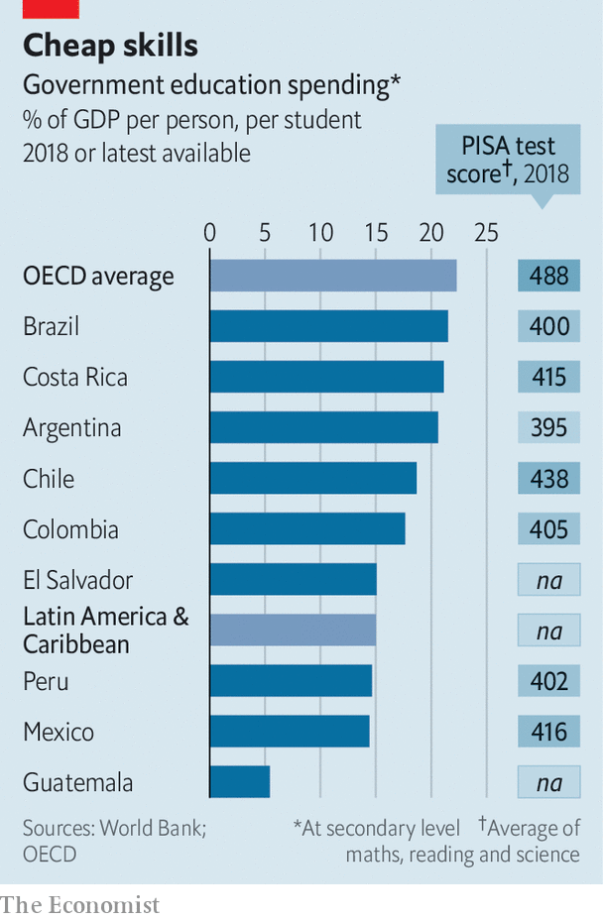

Since the well-off do not send their children to public schools (which teach four-fifths of pupils), they are not especially bothered about improving them. Government spending per student, relative to average incomes, is lower in Latin America than in the OECD.

Teacher training is neglected across the region. In Mexico, teachers are hired and promoted based on union connections rather than merit. Last year Mexico’s populist president, Andrés Manuel López Obrador, reversed a reform enacted in 2013 to improve their quality. A few places have sustained reforms. Chile has doubled its education budget since 2005. Its PISA scores are the highest in the region, though still below the OECD average. Ceará, a poor state in Brazil’s north-east that outperforms richer states, has a record of reforms going back 15 years, including extending daily classroom hours in primary schools from four (the Latin American norm) to seven. It is an exception.

Latin American schools do not equip pupils for work, says Miguel Székely, a former education official in Mexico. Unprepared for university, half of students drop out, which makes the region’s expansion of enrolment less impressive. Students who complete university earn large salaries. Those with just a secondary education tend not to. A Brazilian aged 25 to 34 with a bachelor’s degree makes 2.3 times as much as a high-school graduate of the same age (in the United States the ratio is 1.7).

If students are not to lose a whole year of learning, governments will have to adapt curriculums and train teachers to help their charges catch up. So far, they have done little. Brazil’s federal government spent the first six months of the pandemic lobbying states to reopen schools. It has failed to present a single policy to counter covid-induced learning loss. Two education ministers resigned in June, the second after five days in the job.

The country’s more distant future may be a bit brighter. Last month its Congress approved a revamp of Fundeb, a mechanism that provides a large share of state schools’ financing and to which the federal government contributes. Under the new law, the federal government will raise its contribution (from 10% to 23% by 2026). The law sets a minimum level for spending per pupil, which is more than 50% higher than the current average. Fundeb will funnel more money to poor districts. This may help reduce educational inequality.

But it will not immediately help pupils locked out of their classrooms. Many will join Ms Dantas’s boyfriend in choosing work over study. Some may turn to crime, worries Cláudia Costin, who was education secretary in the city of Rio de Janeiro from 2009 to 2014. She remembers “competing with militias” (organised-crime outfits) for high-schoolers’ attention.

Ms Dantas hopes that the pandemic will delay her dream, not destroy it. She still plans to start studying journalism in 2021. Her three-year-old brother is waiting to return to nursery school. One day, perhaps, he’ll make it to university, too.■

This article was downloaded by calibre from <https://www.economist.com/the-americas/2020/09/12/the-pandemic-further-weakens-latin-americas-underperforming-schools>

|  |  |  |  |
| --- | --- | --- | --- |
|  | Articles | Sections | Next |

|  |  |  |  |
| --- | --- | --- | --- |
| Previous | Articles | Sections | Next |

#### Air show

# The Mexican president’s plane isn’t selling

So he has organised a raffle

Sep 10th 2020 | MEXICO CITY

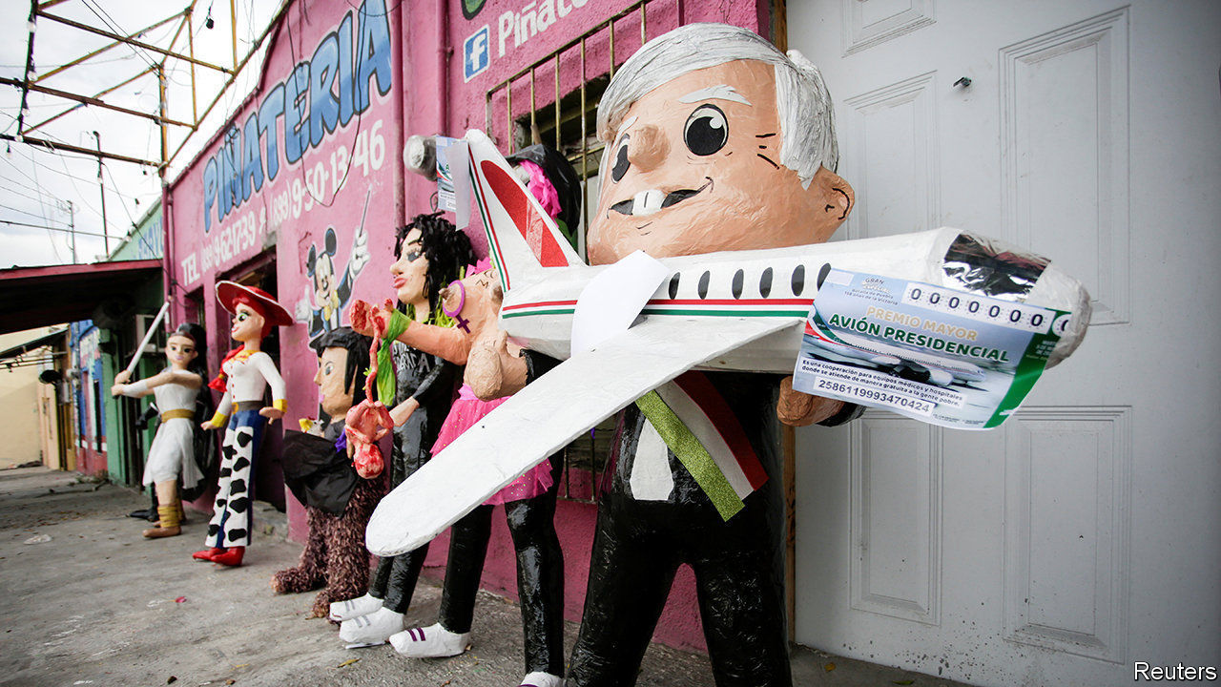

IT SHOULD HAVE been easy. The delivery in 2016 of a luxurious jet for Mexico’s then-president, Enrique Peña Nieto, symbolised an out-of-touch government in a country with lots of poor people. In his campaign to succeed Mr Peña in 2018, Andrés Manuel López Obrador promised to stick a for-sale sign in the window of the Boeing 787-8 Dreamliner, which was bought for $127m (plus $81m for customised fittings). As president, he would travel by commercial airline like ordinary folk. He won the election in a landslide.

Now the “pharaonic” example of “waste and opulence” has become “elegant” and the “pride of a nation”, in the words of the marketing brochure written to tempt a buyer with showier tastes than the Mexican president and $130m to spend. The flannel didn’t work. For 21 months the aeroplane, christened the José María Morelos y Pavón (after a Mexican independence hero), has sat unsold in a hangar in California. A symbol of past excess has become a sign of present ineptitude.

The market for used wide-body private jets is minuscule. Selling them often takes years. Sellers rarely recover fitting costs because new owners have their own ideas about colour schemes and comfy seats. Sloppy maintenance and the recession caused by the pandemic have lowered the plane’s value to $72m, insiders told Expansión, a business-news outlet.

Stymied, in January Mr López Obrador suggested raffling off the plane. The winner would get money to pay for a year or two of maintenance. A month later, perhaps realising its impracticality, he thought better of the idea. Now the prize is 2bn pesos ($93m) in cash, which is to be divided among 100 winners. The total prize money is not vastly less than the plane’s original value. Some 2.5bn pesos in proceeds will go towards equipment for hospitals coping with covid-19. The National Lottery (Lotenal), which is heavily indebted and lost money in seven of the past ten years, is managing the raffle. The prize draw is on September 15th.

The maths do not add up. The 6m tickets, still bearing the image of the plane, are priced at 500 pesos each, more than four times the minimum daily wage. If they sell out, just 500m pesos will be left for hospitals once prize money, administrative costs and the ticket sellers’ cut are paid. To ensure that the scheme would raise enough money to keep the president’s promise to hospitals, the recently renamed Institute for the Return of Stolen Goods to the People (INDEP), which auctions assets seized from criminals, agreed to contribute 2bn pesos to pay for the prizes. Normally, it gives the proceeds to hospitals and the poor.

By September 8th less than two-thirds of the tickets had been sold. The president has said that several rich businessmen will “voluntarily” buy tickets and distribute them to workers. INDEP will stump up an extra 500m pesos to donate 1m tickets to hospitals caring for the poor. The way things are going the government will struggle to break even on the raffle. The air show is exciting to watch but will get Mexico nowhere. Some Mexicans fear that is true of the president, too. ■

This article was downloaded by calibre from <https://www.economist.com/the-americas/2020/09/10/the-mexican-presidents-plane-isnt-selling>

|  |  |  |  |
| --- | --- | --- | --- |
| Previous | Articles | Sections | Next |

|  |  |  |  |
| --- | --- | --- | --- |
| Previous | Articles | Sections | Next |

#### Bello

# No good options for Venezuela’s divided opposition

Foes of Nicolás Maduro are split over whether to boycott a legislative election

Sep 10th 2020 |



EVEN BY RECENT abysmal standards, this has been a bad year for Venezuelans. Covid-19 has struck a country whose health system collapsed long ago. Because of mismanagement and, since last year, swingeing American sanctions, the economy is sinking to subsistence level: GDP is set to decline by about 15% this year, and will be 72% smaller than it was in 2013. A survey by three Venezuelan universities reckons that 79% of the population are extremely poor and that 30% of under-fives suffer chronic malnutrition or stunting. The dictatorial regime of Nicolás Maduro stays in power by harassing opponents, locking up dissidents and, in some cases, slashing prisoners’ feet with razor blades.

This has been a bad year for Venezuela’s opposition, too. In January 2019 Juan Guaidó, the young Speaker of the opposition-controlled National Assembly, proclaimed himself the country’s interim president, on the ground that Mr Maduro’s election to a second term was rigged. Mr Guaidó was swiftly recognised by Donald Trump’s administration, and by most democracies in Europe and Latin America. The assumption among officials in Washington and in opposition circles in Caracas was that American sanctions against the oil industry would soon encourage the armed forces to turn against Mr Maduro, forcing a transition to democracy.

It hasn’t worked. A small military rebellion flopped last year. Aides to Mr Guaidó were linked to an amateurish invasion attempt led by mercenaries from Florida in May. Despite further American sanctions, 20 months after Mr Guaidó’s pronunciamiento Mr Maduro remains in firm control. His approval rating was just 13% in August, but Mr Guaidó’s has fallen from 61% in early 2019 to 26%, according to Luis Vicente León of Datanálisis, a pollster.

The opposition now faces a dilemma. A legislative election is due on December 6th. The assembly’s term, and thus Mr Guaidó’s “interim presidency”, ends on January 5th. He and his allies have called for a boycott of the vote on the grounds that it will not be free or fair. Instead, they plan to prolong the life of the outgoing assembly. There is no constitutional basis for doing so.

Henrique Capriles, the opposition’s presidential candidate in 2012 and 2013 and electorally its most successful figure, has been negotiating with the government over taking part in the legislative vote. Last month the regime released 50 political prisoners (of some 300) and pardoned 60 who are in exile. Having taken over three of the main opposition parties, it has reversed that decision on one. And it wrote to the European Union inviting it to observe the election, something which has not happened in Venezuela since 2006.

Mr Capriles says he is fighting to improve electoral conditions. This week he registered a slate of candidates, though he says he wants a postponement of the election. “A return of politics” requires “no prisoners, no persecuted”, he told El País, a Spanish newspaper. He thinks the invitation to the EU opens space for further negotiation on the political conditions. He insists that his adversary is Mr Maduro, not Mr Guaidó, and that he could still pull his candidates out.

One reading of all this is that Mr Maduro has succeeded in dividing the opposition. In fact, those divisions were already there. They are not just between moderates, like Mr Capriles, and radicals, who mainly back Mr Guaidó, but also between exiles and those in Venezuela. By financing the interim government, the United States has created a perverse incentive for Mr Guaidó’s team to prolong the status quo. The end of the assembly’s term is a reality check.

Electoral abstention has always failed as a political strategy, says Mr León. His poll finds that 52% think the opposition should call on people to vote. “The big question is how to achieve change in Venezuela,” Mr Capriles says. The implicit answer of the opposition radicals is by military action by the United States. That is not going to happen.

Rather, argues Mr Capriles, sanctions should be used to negotiate a return to democracy. That can only happen after the American election in November, since the sanctions relief that is the necessary carrot for the regime is in the gift of the United States. Mr Trump will surely not offer it before then lest he anger Venezuelan-Americans in Florida. Mr Capriles is taking a risk, that he ends up being seen to have legitimised a fraudulent election. But he is right that Mr Guaidó’s strategy is a dead end that suits Mr Maduro fine.

This article was downloaded by calibre from <https://www.economist.com/the-americas/2020/09/10/no-good-options-for-venezuelas-divided-opposition>

|  |  |  |  |
| --- | --- | --- | --- |
| Previous | Articles | Sections | Next |

|  |  |  |
| --- | --- | --- |
| The Americas | Sections | Britain |

Europe

Turkey: Erdogan’s world

.

Italy’s migrants: Blamed for the virus

.

Germany and Russia: The lady may toughen up

.

French intellectuals: Sex, lies and philosophy

.

Charlemagne: Last of the centre-lefties

.

|  |  |  |
| --- | --- | --- |
| The Americas | Sections | Britain |

|  |  |  |  |
| --- | --- | --- | --- |
|  | Articles | Sections | Next |

#### Erdogan thinks big

# Turkey’s strongman, Recep Tayyip Erdogan, takes to the world stage

He is posing as the voice of Muslims everywhere and of the global south

Sep 8th 2020 | ISTANBUL

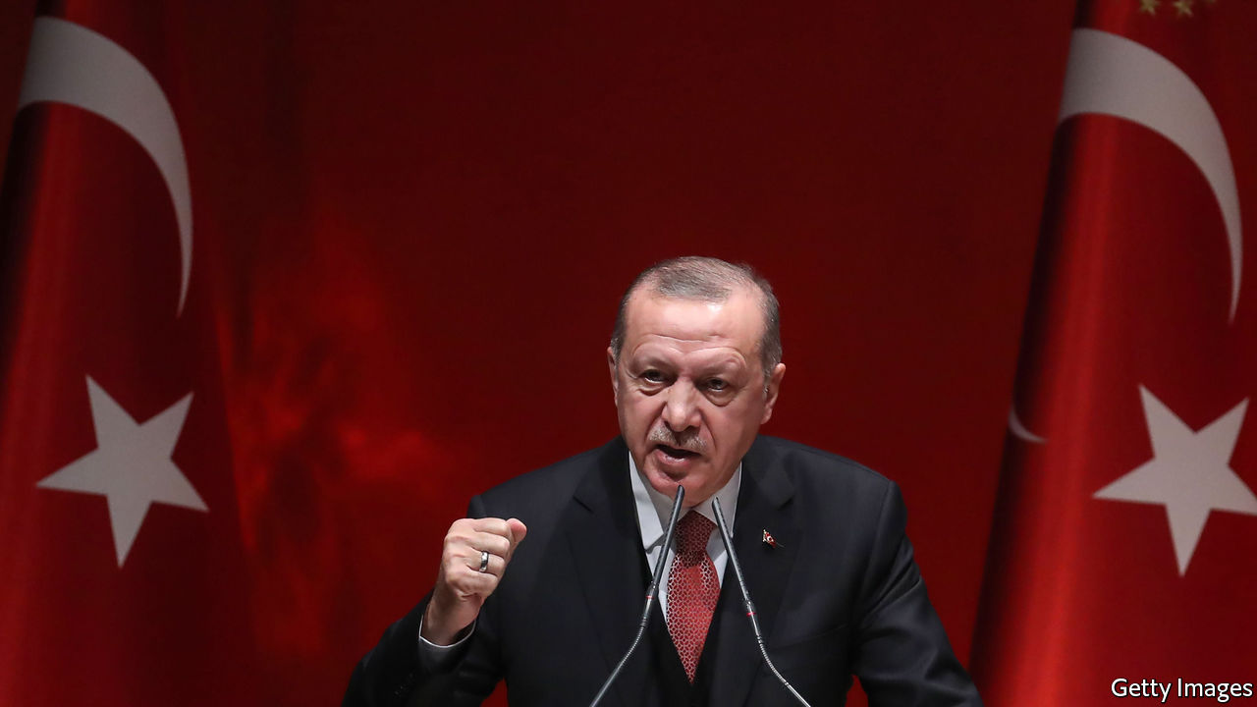

PRESIDENT RECEP TAYYIP ERDOGAN likes to cut to the chase. Others may think the multilateral dispute over territorial waters, continental shelves and hydrocarbons in the eastern Mediterranean, which has brought Turkey close to war with Greece, is complicated. For Turkey’s leader, however, it is simply an “example of modern colonialism” by European countries, as he put it in a speech on September 1st. “The era of those who for centuries have left no region unexploited from Africa to South America, no community unmassacred and no human being unoppressed, is coming to an end,” he added.

Mr Erdogan has long fulminated against the West to stir up patriotic support at home. Now, he is increasingly addressing a global audience, too. Having failed to reshape the Middle East in the wake of the Arab spring, Mr Erdogan is looking elsewhere for greatness. He is trying to reinvent himself as the voice of the umma (ie, Muslims everywhere) and also of the world’s poor.

His efforts so far have focused mostly on Europe. Turkey has traditionally seen itself as a protector of ethnic Turks in countries like France, Belgium and Germany. More recently, Mr Erdogan has started to think bigger. “Turkey is trying to position itself as the main patron of all Muslims,” says Sinem Adar, a researcher at the German Institute for International and Security Affairs. The policy has already worked in the Balkans, where Turkey has competed against Gulf money for the sympathy of Bosniaks, Albanians and Kosovars, but is relatively new elsewhere.

A big part of the new outreach is Turkey’s worldwide campaign against Islamophobia, for which Mr Erdogan’s government has mobilised foreign missions, aid agencies, lobby groups and friendly academics. Turkish consulates have been asked to encourage Muslims to report to them any instances of prejudice or abuse. (Turkey pays rather less attention to abuses in China, where perhaps a million Muslim Uighurs have been locked up in camps and many have been sterilised.)

Prejudice against Muslims is a serious problem in Europe. But critics suspect Mr Erdogan’s campaign is also intended to provoke resentment of Western governments and legitimise his own foreign-policy aims. Others fear the implications for free speech. “Islamophobia”, says Samim Akgonul, an academic at Strasbourg University, “is being used by Turkey as a shield to ban and avoid all critical discourse on Islam in the academic world and the media.”

Turkey is also courting Muslims and black people in America. The campaign has featured the usual—Mr Erdogan has opened an Islamic centre near Washington—and the unexpected. A foundation on the board of which one of his daughters is a director recently bought the Chicago estate of Muhammad Ali, a champion boxer, for $3m and plans to turn the site into a summer school for Muslims. A couple of years ago Mr Erdogan met the daughters of Malcolm X, a Black Muslim and hence another hero; one daughter reportedly said the Turkish strongman embodied her late father’s legacy. Shortly afterwards, Turkey renamed a street near the new American embassy in Ankara “Malcolm X Avenue”.

Not everything has gone according to plan. Mr Erdogan had to cut short his trip to Ali’s funeral in 2016 after learning he would not be allowed to speak or lay a piece of the cloth covering the Kaaba on the boxer’s coffin. And when he condemned the killing of George Floyd, calling his death in a tweet “one of the most painful manifestations of the unjust order”, a black socialist group told him (in words not suitable for print) to mind his own business. Analysts helpfully suggest his message might resonate better if his government stopped arresting thousands of people on flimsy terrorism charges and disenfranchising millions of Kurds by locking up their elected leaders.

None of this has dimmed Mr Erdogan’s global ambitions. Turkey’s president appears genuinely to view himself not only as the voice of all Muslims but of the whole global south. His re-election in 2018, he said, was a victory for “all the aggrieved people in our region, all the oppressed in the world”. He can certainly take credit for increasing humanitarian-aid spending, investing vast sums in impoverished Somalia, opposing India’s siege of Kashmir and hosting nearly 4m refugees from neighbouring Syria. But his anti-imperialist crusade has also taken him to strange places. Mr Erdogan has backed Nicolás Maduro’s repressive regime in Venezuela, a relationship lubricated by hundreds of millions of dollars in gold trade, and former president Omar al-Bashir’s genocidal one in Sudan. Last month he congratulated Alexander Lukashenko, the Belarusian dictator, on his “victory” in rigged presidential elections.

The charm offensive has had some success. Mr Erdogan enjoys popular support in corners of Africa and Asia. Some 75% of Palestinians and roughly the same share of Jordanians approve of his policies, according to a poll published last year. His popularity in Pakistan is such that the country’s prime minister, Imran Khan, joked earlier this year that Mr Erdogan could safely win in his country’s coming elections. Anecdotal evidence, says Mr Akgonul, suggests he may also be the most popular Muslim politician among young Arabs in Europe.

Turkey’s leader and his acolytes seem to be convinced that the old world order is crumbling, and are looking for a role in the new one. His embrace of the global periphery is riven with contradictions and hypocrisy, making it more hype than substance. But it is here to stay. ■

Editor’s note: Ms Adar’s quote has been corrected from “Turkey is trying to position itself as the main patron of all Muslims in Europe” to “Turkey is trying to position itself as the main patron of all Muslims”.

This article was downloaded by calibre from <https://www.economist.com/europe/2020/09/08/turkeys-strongman-recep-tayyip-erdogan-takes-to-the-world-stage>

|  |  |  |  |
| --- | --- | --- | --- |
|  | Articles | Sections | Next |

|  |  |  |  |
| --- | --- | --- | --- |
| Previous | Articles | Sections | Next |

#### Blamed for the virus

# The number of migrants arriving in Italy is up again

But they are coming from different places

Sep 12th 2020 | ROME

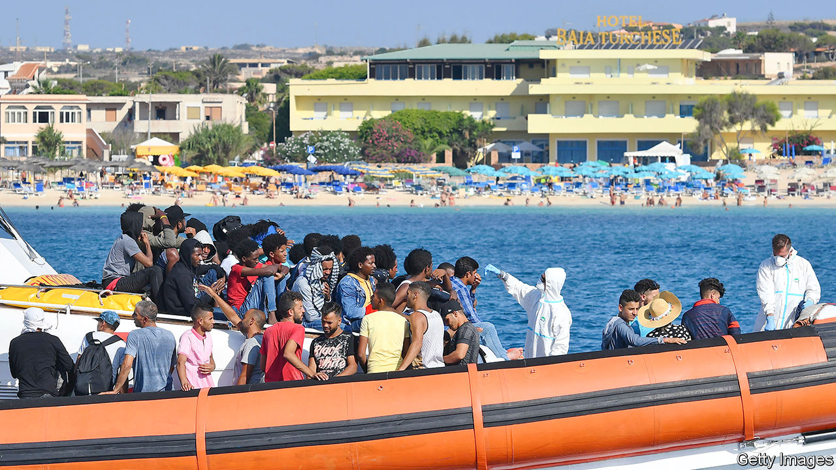

AFTER A PAUSE because of bad weather, the landings began again on September 8th. Three boats carrying 56 people reached Italy’s southernmost island, Lampedusa. A sailing vessel with 62 aboard put into the port of Crotone on the Italian mainland.

That day’s events highlighted the ways that migration across the central Mediterranean has changed. First, and most obviously, it has increased again. According to the International Organisation for Migration, by September 2nd, 21,927 people had reached Italy or Malta this year by sea: 47% more than in all of 2019. By the end of August, the reception centre on Lampedusa, which has a capacity of 192, was trying to cope with around 1,500 people. Still, the number, which is about as big as it was in 2018, is far below its peak of 2016, when more than 180,000 arrived on the shores of the two countries.

This year’s shift has been towards smaller groups on smaller vessels, organised by the refugees themselves rather than by people-smugglers. The arrival points have been more varied, too. Most notably, only a minority of recent immigrants are from sub-Saharan Africa.

That is partly because of lockdowns against covid-19. But it is also happening because the coastguard in Libya, until recently the main departure point, has been more effective since receiving training and equipment from Italy to boost its ability to intercept migrant vessels.

Instead, Tunisians have accounted for more than 40% of this year’s arrivals in Italy, according to the UN’s High Commission for Refugees. The pandemic is responsible for this change, too. It has turned an ailing Tunisian economy into a stricken one. Heavily dependent on tourism, its GDP shrank by 22% in the second quarter, while unemployment rose to 18%. It is not just Tunisia’s poor who have fled across the sea. One woman got off a boat in July wearing sunglasses, a wide-brimmed straw hat and with a poodle on a lead.

In August Italy’s interior and foreign ministers went to Tunisia to see President Kais Saied and members of his government. During the visit it emerged that Italy would provide €11m to help Tunisia in its efforts to stem the migrants’ flow.

Covid-19 has also prompted the hard-line right-wing opposition in Italy to argue that the rise in new cases of the virus since early August is due to the rise in the number of incoming migrants. Matteo Salvini, leader of the hard-right Northern League, claimed that migrants on Lampedusa infected with the virus were mingling with Italian holidaymakers who were then carrying it back to their regions of origin. Giorgia Meloni, who leads the Brothers of Italy party, which has roots in neo-fascism, wrote on Facebook that “the link between clandestine immigration and increases in infection cannot be ignored.”

Yet a report by Italy’s national public-health institute found that, although arrivals from abroad had accounted for a growing proportion of infections since mid-June, the virus was mostly spread either by Italians returning from holidays abroad or by foreigners resident in Italy who had travelled to and from their countries of origin. There was no increase in the number of outsiders arriving with the virus, whether as tourists or as migrants.

But facts are one thing and politics another. The centre-left government, facing regional elections later this month, cannot afford to look soft on immigration. On September 8th Sea Watch, a German NGO that conducts search-and-rescue operations in the Mediterranean, said its spotter plane had been grounded by the authorities after identifying around 2,600 people in danger. “The Italian government has closed our eyes on the central Mediterranean,” said Sea Watch’s spokeswoman. ■

This article was downloaded by calibre from <https://www.economist.com/europe/2020/09/12/the-number-of-migrants-arriving-in-italy-is-up-again>

|  |  |  |  |
| --- | --- | --- | --- |
| Previous | Articles | Sections | Next |

|  |  |  |  |
| --- | --- | --- | --- |
| Previous | Articles | Sections | Next |

#### “Understanding” Russia has limits

# Angela Merkel is losing patience with Vladimir Putin

Yet despite the poisoning of Russia’s top dissident, a gas pipeline to Germany may go ahead

Sep 12th 2020 | BERLIN

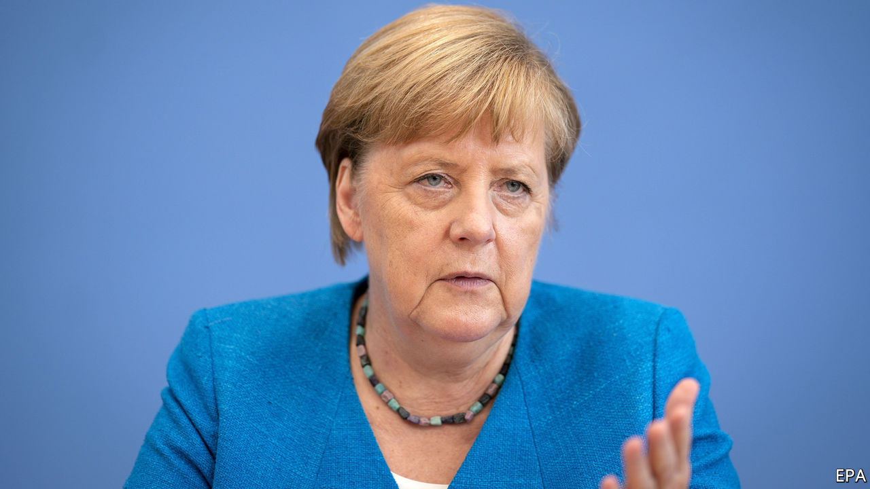

VLADIMIR PUTIN and his officials refuse to utter the name of Alexei Navalny, the Kremlin’s leading opponent, in public. But in Berlin, where Mr Navalny has been recuperating in hospital since his poisoning in Siberia on August 20th, he is the talk of the town. Mercifully, on September 7th he emerged from a medically induced coma. German doctors caution that it is too early to assess the long-term damage to his health. The harm to Germany’s relations with Russia, though, is already clear.

Few global leaders have known each other as long as Mr Putin, inaugurated in 2000, and Angela Merkel, who took office as Germany’s chancellor five years later. At moments of crisis they have spoken daily. But familiarity has bred a certain contempt. In 2014, fed up with Mr Putin’s lies over Ukraine, the chancellor press-ganged the rest of the EU into imposing economic sanctions on Russia. Defying expectations, and a good chunk of Germany’s business lobby, they have held ever since. Since then a steady drip of Russian offences, including the extensive Kremlin-directed hacking of the Bundestag’s computer systems in 2015 and last year’s contract killing of a Chechen dissident in a Berlin park, has further soured the mood.

Mrs Merkel’s response to the attack on Mr Navalny, including demands (as yet unmet) for a thorough Russian investigation, has been uncharacteristically assertive. The poisoning has thinned the ranks of Germany’s habitual Putin-Versteher (“understanders”), opening space for her to take further measures. At the EU level, the default mode for German foreign policy, “horizontal” sanctions—ie, not aimed at specific countries—based on the poisoners’ violation of chemical-weapons bans are possible. Yet the debate in Germany has focused on Nord Stream 2, an almost completed €9.5bn ($11bn) undersea pipeline that could double gas deliveries from Russia’s Yamal peninsula to the German coast, and from there to the rest of Europe.

Eastern Europeans and Americans detest Nord Stream 2 for, as they see it, handing leverage and cash to the Kremlin and undercutting the transit fees earned by Ukraine from an existing land pipeline. (A Polish minister once compared the project to the Nazi-Soviet pact of 1939.) Mrs Merkel, who inherited Nord Stream 2 from Gerhard Schröder, her Putin-Versteher predecessor, has confided to her European counterparts that she is no fan of the project. Yet for years, in line with a German tradition that seeks to separate energy deals with Russia from geopolitics, she has resisted entreaties to ditch it.

Now there are signs of a shift. On September 6th Heiko Maas, the foreign minister, said that continued Russian stonewalling over Mr Navalny may “force” Germany to rethink the pipeline deal. Mrs Merkel let it be known via her spokesman that she concurred. This “raises the stakes”, argues Janis Kluge, a Russia-watcher at the German Institute for International and Security Affairs. Although no details have been offered, Mrs Merkel would not have shifted ground without a plan.

Yet it may be more an attempt to squeeze Mr Putin than a genuine threat. A U-turn on Nord Stream 2 would infuriate German business people and might require payng billions of euros to many European companies. Mrs Merkel has reportedly told her party that she remains undecided on how to proceed. And many in her camp are wary of spiking the deal. “To frame the answer only via Nord Stream 2 would distract from Russia’s violation of the OPCW [Organisation for the Prohibition of Chemical Weapons],” says Roderich Kiesewetter, an MP for Mrs Merkel’s Christian Democrats, who would prefer a Europe-wide response.

The picture is clearer with Belarus. The EU is set to impose travel bans and asset freezes on Belarusian officials responsible for the rigged election in August and for the brutal treatment meted out in its aftermath, most recently to Maria Kolesnikova, an opposition leader detained on September 7th. Formally, the Belarus and Russia sanctions debates are proceeding on separate tracks. But as Mrs Merkel weighs her options over Russia, the escalation in Minsk will not be far from her mind. ■

This article was downloaded by calibre from <https://www.economist.com/europe/2020/09/12/angela-merkel-is-losing-patience-with-vladimir-putin>

|  |  |  |  |
| --- | --- | --- | --- |
| Previous | Articles | Sections | Next |

|  |  |  |  |
| --- | --- | --- | --- |
| Previous | Articles | Sections | Next |

#### Les liaisons prétentieuses

# Sex, lies and philosophy on the Paris left bank

A new French novel settles scores among the bed-hopping intelligentsia

Sep 12th 2020 | PARIS

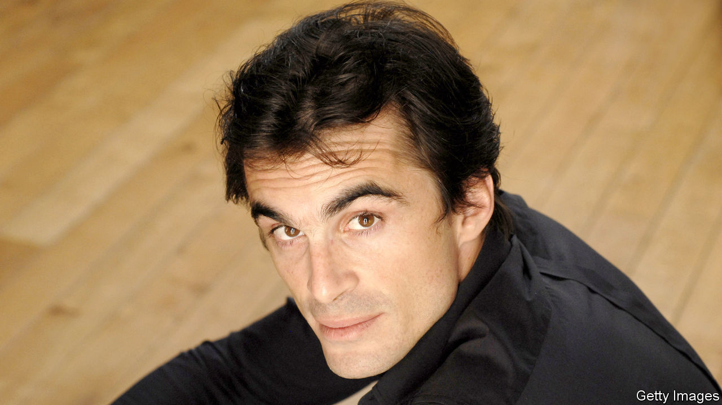

A FRENCH LEFT-BANK philosopher runs off with his father’s younger lover, who is herself now married to an ex-president, during his own failed marriage to a novelist, the daughter of another Parisian philosopher, who was his father’s best friend. Were a scriptwriter to pitch the plot, it would be dismissed for convoluted implausibility. Except that this story, which captures with no apparent irony the intertwined lives of Latin Quarter intellectuals, is true.

In “Le Temps Gagné” (Time Saved, a characteristically Proustian reference), published last month, Raphaël Enthoven settles a score with his ex-wife, Justine Lévy (the fictional “Faustine”). She is the daughter of Bernard-Henri Lévy (“Elie”), a French public intellectual with a line in crisp white shirts and moral outrage. In a novel of her own in 2004, Ms Lévy was unsparing in fictionalising Mr Enthoven (“Adrien”), who walked out on her for Carla Bruni, his father’s then partner. (They had a son together, and Ms Bruni later married Nicolas Sarkozy.)

Mr Enthoven returns the favour. “Faustine” “wasn’t really pretty but had these cheeks.” Their marriage was “not really mine” but also “that of my father with his best friend”, who united two intellectual clans. Tout Paris attended their wedding. The marriage lasted “Four years. Ten million days.” Adding irony to insult, he fell for “Beatrice” while staying at the Moroccan villa belonging to “Elie”, his wife’s father. After the book came out, Mr Enthoven’s father, Jean-Paul, cut off contact with his son.

The novel has all the ingredients to enthral the Paris left bank: philosophy bien sûr, but also sex, psychoanalysis and narcissism. Mr Enthoven describes the day that, as a boy, gazing at his reflection in a train window, he realised that “I was handsome. Objectively handsome.” Did all this really happen? The answer, of course, depends on whose truth it is. Mr Enthoven prefaces his novel thus: “This story is entirely imagined, because I lived it from the beginning to the end.”

This article was downloaded by calibre from <https://www.economist.com/europe/2020/09/12/sex-lies-and-philosophy-on-the-paris-left-bank>

|  |  |  |  |
| --- | --- | --- | --- |
| Previous | Articles | Sections | Next |

|  |  |  |  |
| --- | --- | --- | --- |
| Previous | Articles | Sections | Next |

#### Charlemagne

# Last of the centre-lefties

How social democracy survives in a few corners of Europe

Sep 12th 2020 |

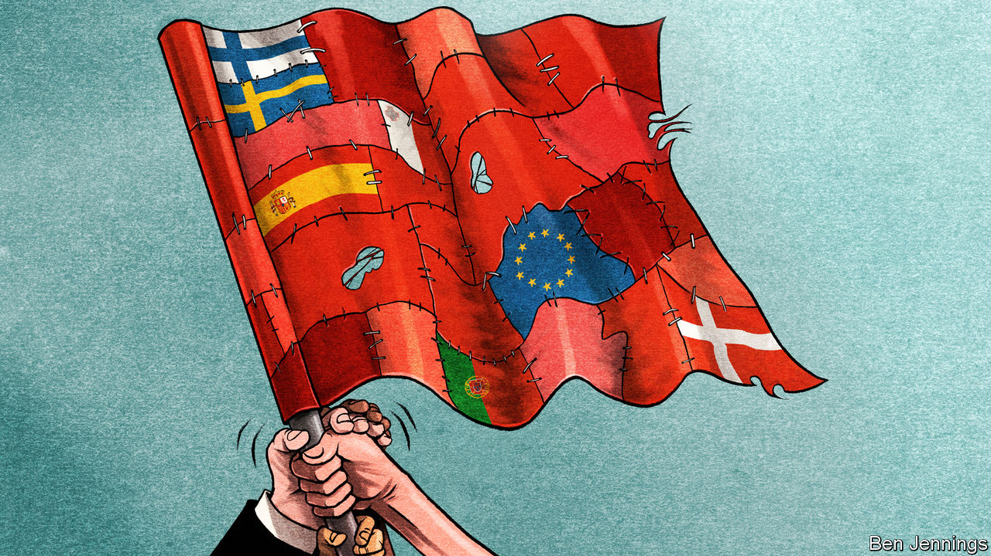

ARGUMENTS ARE always worse when they involve family, politics or money. They are especially bad when they contain all three. So it proved when EU leaders sat down this summer for four days of talks about issuing €750bn-worth ($884bn) of common debt. Rather than left versus right, the main fight was left-on-left. Europe’s small band of social-democratic siblings attacked each other. On one side were Portugal and Spain, who wanted the cash handed out as non-repayable grants. Meanwhile, their supposed political allies from Denmark, Sweden and Finland tried to stop them. It is not just money that divides the EU’s dwindling bunch of centre-lefties. Portugal and Spain have both been advocates of allowing more refugees into Europe. Social democrats across Scandinavia demand the numbers are cut. “We won’t tolerate any xenophobic rhetoric,” declared António Costa, the Portuguese prime minister, in one speech. Denmark, meanwhile, calls for control of non-Western immigration. Siblings can often look very different.

What they share, however, is a worry about the family’s future. Alongside Malta, a social-democratic speck in the middle of the Mediterranean, the five countries have the last remaining centre-left leaders in the EU. Their brothers and sisters have fallen on hard times. In France, the Socialists are barely a rump. At the most recent election in the Netherlands the Dutch Labour Party managed to lose three-quarters of its MPs. In Germany, the Social Democrats are stuck in an unhappy (and seemingly unending) coalition with Angela Merkel’s Christian Democrats. By contrast, the social democratic parties of Iberia and Scandinavia are hanging on. Should their relatives be taking notes?

Portugal is the golden child for lefties fed up with being hammered in elections. Mr Costa, Portugal’s barrel-chested leader, has warned of the perils of grand coalitions across the political spectrum. Instead he has opted for a ragbag partnership with an assortment of communists and leftists. Critics labelled it geringonça (a “contraption”). But the ungainly device has worked. It raised the minimum wage and reduced the hours that public-sector workers toil. It was not all a socialist dream: the government maintained plans to curb the country’s deficit. Voters still liked what they saw. Last year Mr Costa won re-election and is governing as a minority administration. It was a similar story in Spain. Pedro Sánchez, Spain’s socialist prime minister, once said he “wouldn’t sleep at night” if he made an alliance with Podemos, a more radical left-wing party. A few months later, he had reached a deal with them. A leftward shift, followed by partnership with even leftier rivals, marks the Iberian method.

Others may struggle to follow these tactics. Centre-left parties in Portugal and Spain can rely on a pool of working-class votes that has disappeared in other countries, points out Pedro Magalhães of the University of Lisbon. Whereas challenger parties have sprung up in much of the EU, there are fewer such options in Portugal, where Mr Costa’s Socialists and their centre-right (and oddly named) rivals, the Social Democratic Party, have long dominated the political spectrum. New parties have emerged in Spain, but they have not successfully courted the base of Mr Sánchez’s Socialist Workers’ Party (PSOE). Podemos mainly attracted well-educated urban voters, of the tribe that Thomas Piketty calls the “Brahmin left”. PSOE’s bedrock of boomers remained solid, even if Podemos did run the party close in 2016. Nationalist anti-immigrant parties such as Vox have made little headway, as Iberia remains largely unperturbed by a debate on immigration that has roiled much of the rest of Europe. Circumstances, then, rather than strategy lurk at the heart of the survival of Iberian socialism. Compared with the rest of the EU, Iberia resembles a political Galapagos island for the centre-left: there are fewer predators, allowing it to evolve in its own peculiar way.

Scandinavia’s situation is more recognisable. Neuralgic issues such as immigration strain the typical base of social-democratic parties, an alliance of the working class and better-educated middle-class professionals. The Danish Social Democrats have, seemingly, had success with a platform of left-wing economics and tough policy on immigration. Mette Frederiksen, the prime minister, spelled out the shift in a speech. In 1980, 1% of people in Denmark were “non-Western”, she explained. Now it is nearly one in ten. Her solution? A limit on “non-Western immigration” into Denmark. But the policy was a vote-swapper, rather than a vote-winner. Whereas some voters came back from the Danish People’s Party, a far-right opposition party, others quit, fed up with the anti-immigration tone. Again it was the so-called Brahmin left who departed. Importantly, points out Karina Kosiara-Pedersen, a professor at Copenhagen University, these voters drifted to other parties on the left. This enabled the Danish Social Democrats to take power in a left-wing coalition, displacing their liberal rivals.

## Northern limits

Scepticism about the Danish approach abounds. Straight switchers from centre-left to the populist right are rare, points out Tarik Abou-Chadi from the University of Zurich. Nor is it a viable long-term strategy. Trying to rebuild with the votes of a dwindling traditional working class alone—especially at the expense of a growing band of well-educated, relatively liberal voters—is risky. Rather than reforge the old alliance of the working class and liberal middle class, the Danish method is an admission of defeat.

The days of social-democratic parties mopping up nearly half of all voters, as happened in their post-war peak, are over. Neither the Danish nor the Iberian path is easily copied. What they do demonstrate is that an era of complicated and cumbersome coalitions and pacts looms, with different parts of the centre-left going after different segments of left-wing voters. As the base of centre-left parties fragments, so will the parties themselves. Their family reunions will only become more fractious. ■

This article was downloaded by calibre from <https://www.economist.com/europe/2020/09/12/last-of-the-centre-lefties>

|  |  |  |  |
| --- | --- | --- | --- |
| Previous | Articles | Sections | Next |

|  |  |  |
| --- | --- | --- |
| Europe | Sections | International |

Britain

Brexit negotiations: A new barrier

.

Suburban life: The end of commuterland

.

Sandwich strategies: Getting out of a pickle

.

Education: Famine to feast

.

Climate change: Extinguished Rebellion

.

Metal detectorists: Gold diggers

.

Bagehot: Revolutionary conservatism

.

|  |  |  |
| --- | --- | --- |
| Europe | Sections | International |

|  |  |  |  |
| --- | --- | --- | --- |
|  | Articles | Sections | Next |

#### Here we go again

# Brexit negotiations hit a formidable new barrier

By threatening to rewrite the withdrawal treaty, Boris Johnson’s government edges closer still to no deal

Sep 12th 2020 |

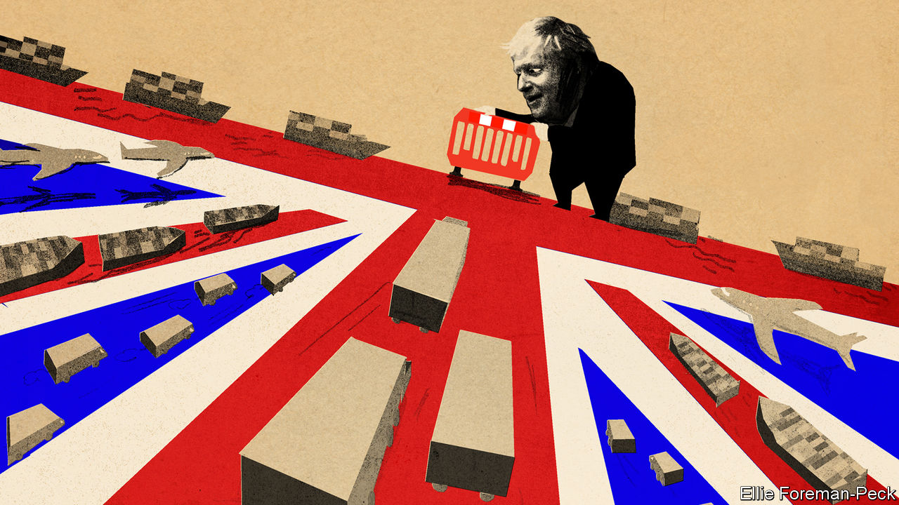

RUMOURS ABOUT a flagrant breach of international law first surfaced in the Financial Times on the evening of September 6th, only to be belittled by the government. A few brave Tory backbenchers cautioned against such a step. Theresa May, the former prime minister, asked: “How can the government reassure future international partners that the UK can be trusted to abide by the legal obligations of the agreements it signs?” It emerged that the government’s top legal adviser, Sir Jonathan Jones, had resigned apparently in protest at what was afoot. On September 9th the government published the bill in question, confirming the rumours had substance.

At issue is the Northern Ireland protocol, which is part of the Brexit withdrawal agreement ratified in January. The protocol provides that, although the province is part of the United Kingdom, it will come under the European Union’s customs code and single-market rules. The intention is to avert a hard border in Ireland, which it is feared would upset the island’s fragile peace. Since Great Britain will leave both the single market and the customs union at the end of the transition period on December 31st, this necessarily implies some checks on goods trade between Northern Ireland and the mainland.

Although he trumpeted the withdrawal agreement last year, Boris Johnson has long jibbed at any such notion. He recently declared once again that there would be a border in the Irish Sea only over his dead body. Now his government has found a way to push against it, using the internal market bill published on September 9th. The bill purports to override the withdrawal agreement, which is an international treaty, in three ways.

First, it gives ministers the power to overrule any requirement for export declarations for goods moving from Northern Ireland to Great Britain. Second, it arrogates to British ministers the power to decide if goods moving from Great Britain to Northern Ireland are at risk of moving on to the Irish Republic (which would necessitate border checks). And third, it gives the government the unilateral right to decide whether to inform the EU about state aid that affects firms operating in the province and might be caught by EU rules.

The government claims these changes are tidying-up measures to reassure Northern Irish businesses if no trade deal is agreed. Yet clarifications to the agreement are meant to be made in a joint EU-UK committee, not unilaterally. Ursula von der Leyen, the European Commission president, called the withdrawal agreement “an obligation under international law and a prerequisite for a future partnership.” Michel Barnier, the EU’s Brexit negotiator, said that “everything that has been signed in the past must be respected.” The EU is considering taking legal action.

It is possible that Mr Johnson sees all this as tactical manoeuvring to push the EU into making concessions that would help get a trade deal through. His proposal that, if a deal is not done at the EU summit on October 15th, the talks should be abandoned and both sides should prepare for no deal and his claim that no deal would be a “good outcome” may reflect similar tactics. So could a promise by his Brexit negotiator, David Frost, that, unlike Mrs May’s team, he would not blink first.

Yet the latest ructions have in fact made a trade deal considerably less likely. The negotiations, which resumed in London this week, remain stuck on access to British fishing waters and state-aid rules the EU wants Britain to observe. The state-aid changes in the new bill for Northern Ireland only confirm fears in Brussels that a post-Brexit Britain may deploy public subsidies to undercut EU firms. These fears were not allayed by the government’s statement this week that it planned to follow only the World Trade Organisation’s relatively light anti-subsidy rules.

With a month to go until the summit, the impasse seems to point to no trade deal. Some of Mr Johnson’s supporters would welcome this. Indeed, many Tory MPs see this week’s changes to the withdrawal agreement as but a start. They say the agreement, including the money being paid to Brussels, was accepted only as a prelude to a trade deal. Should the latter fail to materialise, the former should also be scrapped—never mind that it is an international treaty.

What of Mr Johnson’s claim that no deal would be good for Britain? It is certainly not what he promised voters ahead of the election last December, when all the talk was of his already prepared “oven-ready” deal. Yet it is true that, under a bare-bones trade deal, there would also be enormous disruption to exports and long queues at the port of Dover. The economic impact of no deal is only marginally worse than this, although car and food exporters would face unwelcome tariffs.

The bigger objection to no deal is not its economic impact but what would follow. The decision to override the withdrawal agreement looks almost certain to kybosh hopes of a trade deal with America. Changes to the Northern Ireland protocol raise the spectre of a hard border in Ireland. And leading American politicians, including Joe Biden, the Democratic candidate for president, and Nancy Pelosi, the House speaker, have said they cannot back a trade deal if the peace process in Northern Ireland is under threat.

Nor would going back to the EU to reopen trade talks be easy. After a no-deal Brexit, it is sure to put the same issues back on the table: fisheries, state aid, the level playing-field and the rest. And it will revert to the same arguments about avoiding a hard border in Ireland. The Brexit negotiations begun by Mrs May in 2017 were quickly hijacked by the seemingly insoluble conundrum of what to do about Northern Ireland. Those being pursued by Mr Johnson could now meet the same fate. ■

This article was downloaded by calibre from <https://www.economist.com/britain/2020/09/12/brexit-negotiations-hit-a-formidable-new-barrier>

|  |  |  |  |
| --- | --- | --- | --- |
|  | Articles | Sections | Next |

|  |  |  |  |
| --- | --- | --- | --- |
| Previous | Articles | Sections | Next |

#### Away from the bustle

# Covid-19 and the end of commuterland

The pandemic is changing British suburbs just as profoundly as cities

Sep 12th 2020 | HITCHIN

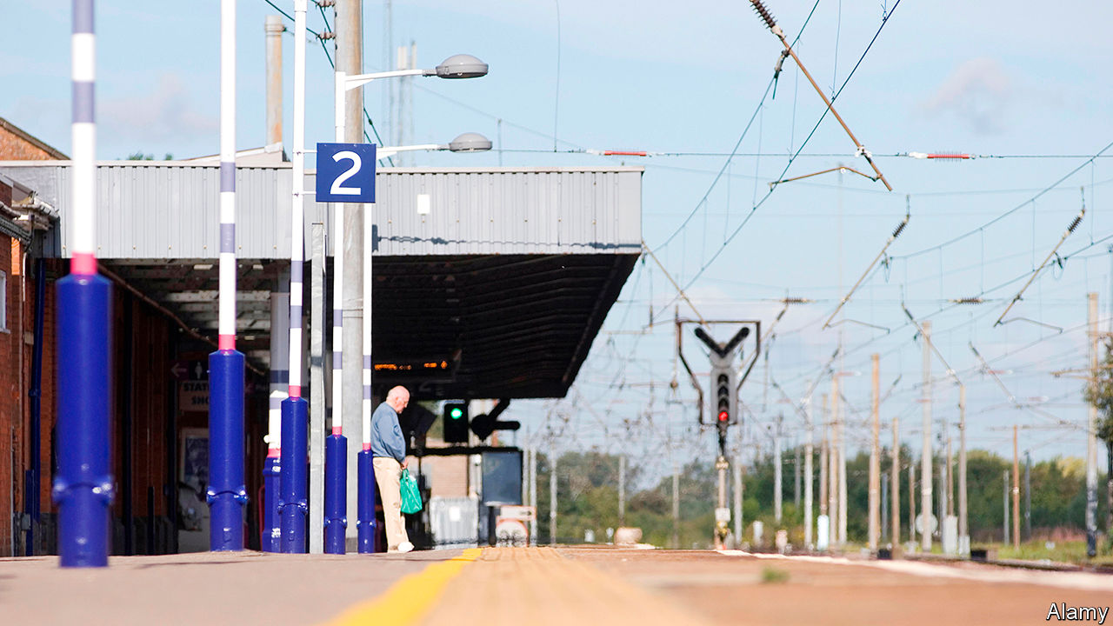

ROBERT EDWARDS and Mario Stephen have responded oddly to the coronavirus pandemic and the crash in high-street spending that it has caused. They have opened a hair salon. Although both men trained and worked for years in London, their new salon is in Hitchin, a town of some 35,000 people that is 50km north of St Paul’s cathedral. After a couple of months, business is good, says Mr Stephen, from behind a face mask and visor: “The lockdown made me realise that I don’t need to be in London any more.”

Covid-19 began as an urban disease. It appeared in Wuhan, China, and spread quickly through big international cities; in Britain, Birmingham and London became hotspots. But the virus did not stay urban for long, and its effects can be seen far beyond the densely populated cores. It has profoundly changed suburbs and commuter towns like Hitchin. In effect, covid-19 has abolished commuterland—a change that is more benign than it sounds.

Commuterland used to be primarily a place for living. It was liveliest at weekends. In his first novel, “Metroland”, Julian Barnes described it as a zone of golf courses, pub lunches, learner drivers practising three-point turns and the sound of lawnmowers “accelerating, braking, turning, accelerating, braking, turning”. On Mondays commuterland fell quiet as people—especially men—took the train back to work in London.

Covid-19 has changed all that. The rise of home-working among the salariat means that Britain’s railways are almost as quiet as the London Underground. According to the Department for Transport, in the last week of August, the number of passengers was 37% of the normal level for the time of year. The car park at Hitchin railway station, normally close to capacity, is about one-quarter full on weekdays.

For high-street businesses in big cities, the loss of commuters is a disaster, compounding the damage from a slump in foreign tourism. The British Retail Consortium, a trade group, says that overall high-street footfall was down by 42% in August compared with a year ago. Central London is especially quiet. Before covid-19 more than 900,000 people (a fifth of the capital’s workers) commuted in. Many of them were wealthy.

But London’s loss is a boon for the commuter towns near it. Charlotte Gatward, who runs Gatwards of Hitchin, a 260-year-old jeweller’s shop, says that commuters who used to pop out for a pendant during their lunch breaks in London are now shopping closer to home. It is difficult to know how healthy Hitchin’s shops really are—like shops everywhere, they have been given government grants and loans. What is certain is that few have shut, and some new shops have even opened. “In the last six weeks I’ve done five ribbon-cuttings,” says Tom Hardy, who manages the town centre for the local business improvement district.

Like almost all commuterland towns, Hitchin also contains some offices and factories—which are fairly quiet. LV, an insurer, normally has 300 workers in an office park near the town centre. Only about 50 are there at the moment, with another 40 expected to return over the next month. Some property analysts believe that suburban offices will hold up better than city-centre ones, because workers can easily drive to them, thereby avoiding germs on trains and buses. Hitchin suggests that might not be true.

Commuterland is becoming a more desirable place to live. It has plenty of gardens and spare bedrooms that can be converted into offices, which are more valuable if you are working from home. It lacks excitement, but so do big cities at the moment. Dataloft, a consultancy, calculates that residential rents rose in most outer-London boroughs between the second quarter of 2019 and the second quarter of 2020, including a swathe of suburban north London from Hillingdon (where Mr Barnes grew up) to Enfield. At the same time, rents fell in most inner-London boroughs, partly because many corporate flats and Airbnb properties were dumped on the market.

Yet the suburbs and commuter towns cannot expand in response to growing demand. London’s huge green belt, which is three times larger than the city, makes home-building hard. Local NIMBYs make it harder. The residents of Hitchin have seen off plans to build lots of houses to the south of the town, and are now unhappy about a scheme to put up 700 homes to the north-east. “Hitchin is a lovely town—why spoil it?” wrote one local, in response to a planning consultation. “Bats etc have been spotted on the site,” noted another. Hertfordshire, the county that includes Hitchin, built 2,620 new homes last year. That is a few more than normal, but not many given its population of 1.2m.

NIMBYism might even intensify, simply because people have more time on their hands. Ellie Clarke, an authority on planning issues at the Hitchin Forum, a local group, says that it has always been hard to persuade commuters to come to meetings. They are tired and often cannot attend before the late evening. Now that they are working from home, she expects that they will become more involved with “the nitty-gritty” of local issues.

Though subtle, that narrowing focus could be one of the most profound effects of covid-19. Bim Afolami, Hitchin’s Conservative MP, says that his party had worried about the steady drift of urbanites into suburbia and commuter towns. Urbanites tend to vote Labour, and they bring their opinions with them. If they are no longer commuting regularly, though, they could turn parochial quicker than they otherwise would. As Mr Afolami puts it, “the prism through which they view the world” will become less urban and more local—meaning, he hopes, more Tory.

These changes may come as a shock to anybody who has watched London and its hinterlands over the last few decades. The city has been on a high. Yolande Barnes, who follows property at University College London, thinks that people have become so used to London’s ever-rising house prices, and its magnetic power over young people, that they have come to think it could never fail. But before the 1980s commuterland seemed more attractive. As she puts it, great cities breathe in and out. At the moment London is breathing out. ■

Editor’s note: Some of our covid-19 coverage is free for readers of The Economist Today, our daily [newsletter](https://my.economist.com/user#newsletter). For more stories and our pandemic tracker, see our [hub](https://www.economist.com/news/2020/03/11/the-economists-coverage-of-the-coronavirus)

This article was downloaded by calibre from <https://www.economist.com/britain/2020/09/12/covid-19-and-the-end-of-commuterland>

|  |  |  |  |
| --- | --- | --- | --- |
| Previous | Articles | Sections | Next |

|  |  |  |  |
| --- | --- | --- | --- |
| Previous | Articles | Sections | Next |

#### Sandwich strategies

# Empty city centres are a crisis for cafés—and also an opportunity

How Britain’s lunch purveyors are rewriting the rules of their business

Sep 10th 2020 |

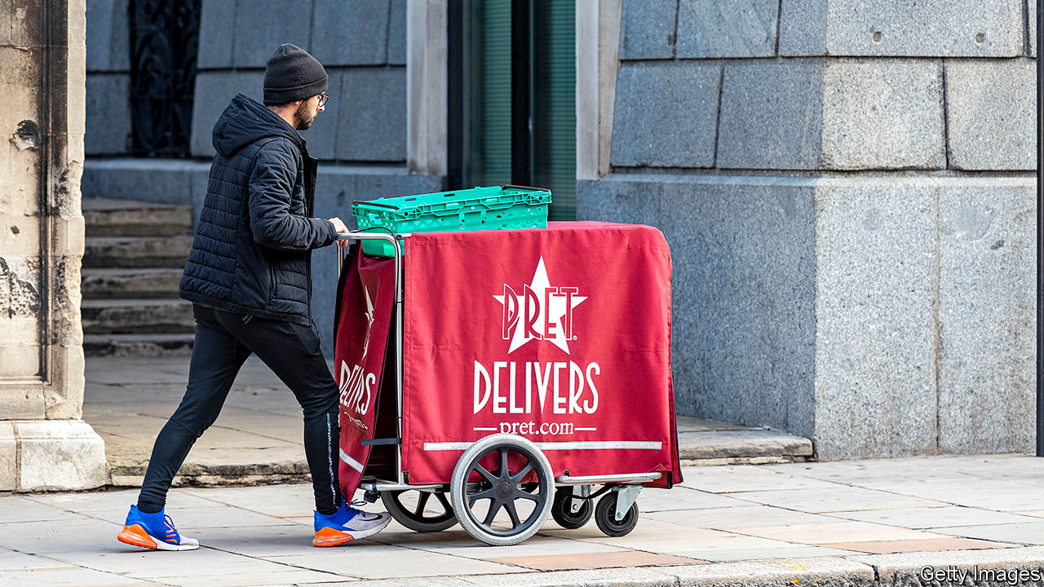

BEFORE THE pandemic, reporters at The Economist’s London office had a wealth of venues from which to get lunch. Within a five-minute walk there were two burger chains (McDonald’s and Five Guys); two fast-casual outfits with the names of Frenchmen (Leon and Paul); three sushi suppliers (Wasabi, Itsu and another Itsu); and four sandwich shops (Pret, Pret, Pret and Pret).

But then hard-toiling journalists had to start working from home. So did most other city-centre workers, spelling disaster for purveyors of grab-and-go lunches. Pret a Manger, the poster-child of the lunchtime economy, cut 2,800 shop jobs, nearly a third of its total. Itsu, Wasabi and Yo!, another sushi chain, are all undergoing restructuring. Each firm is dealing with the same conundrum: how to tear up a successful business model and draw up a new one overnight.

In normal times, established companies face three big obstacles to changing how they work, says Jessica Spungin of the London Business School. One is that if things are running smoothly, managers see no need to change. Another is that even if change is desirable, fears remain that new lines of business will cannibalise old ones. And then there is the difficulty of undoing decisions that have already been made, like long-term leases on high-street shops. Pret exemplifies these problems. “We had such a successful business and such a great culture, we started to really struggle to drive change,” says Pano Christou, the company’s boss. “You had ‘We can’t do it this way, we always did it that way’. It was really difficult for us to kill our sacred cows.”

The pandemic gave managers the ability to push ahead with new ideas. Not all of them worked. When shops reopened in April, Pret introduced a range of groceries, such as milk and bread. It no longer offers those. A “heat at home” range of soups is on its way out as well. This is no bad thing. A wise incumbent tries lots of small things at the same time until something works, says Ms Spungin.

For city-centre lunch outlets that means following customers to where they now spend their time: the suburbs. Pret has opened a “dark kitchen” in Colindale, in deepest north London, which produces food only for delivery. It has started selling coffee beans on Amazon. And it introduced a subscription service that offers up to five coffees a day for £20 ($26) a month, which is designed to entice customers back into shops and to collect data on consumer behaviour. Not to be outdone, Leon quickly followed up with a £15 unlimited coffee offer.

Yet even with pandemic-enforced change, another big strategic question looms, says Jonathan Reynolds of the Said Business School. If a vaccine does arrive soon and life goes back to normal, assumptions made today could be invalid within a year. Sensible business leaders plan for that, too. Many of the moves Pret is trying now were ones it was planning already, albeit at a slower pace. That is the final lesson for business leaders: how to turn crisis into opportunity.

This article was downloaded by calibre from <https://www.economist.com/britain/2020/09/10/empty-city-centres-are-a-crisis-for-cafes-and-also-an-opportunity>

|  |  |  |  |
| --- | --- | --- | --- |
| Previous | Articles | Sections | Next |

|  |  |  |  |
| --- | --- | --- | --- |
| Previous | Articles | Sections | Next |

#### Famine to feast

# A rush of new teachers will help England’s short-handed schools

They arrive just as pupil numbers are shooting up

Sep 10th 2020 |

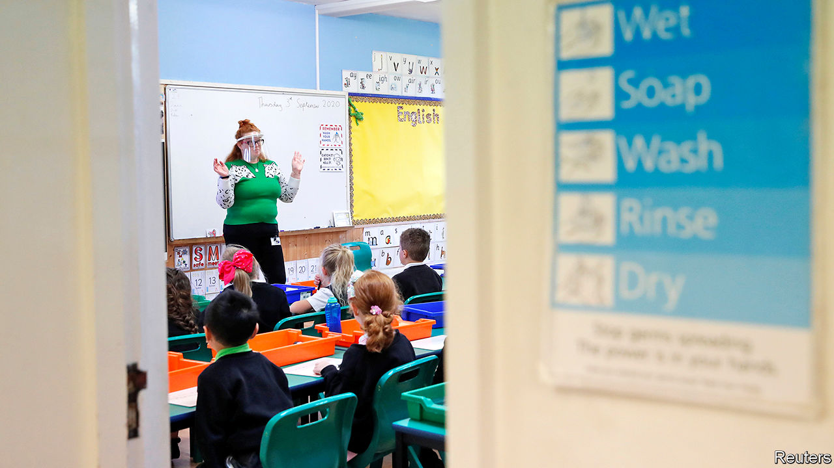

IF THINGS HAD gone to plan, Oli Seadon would be leading a troupe of acrobats on a tour of South America. But the pandemic forced his employer, Cirque du Soleil, to cancel its shows, and prompted the 36-year-old theatre producer to make a fresh start. In April he applied to begin teacher-training with the help of Now Teach, a charity that encourages job-changers to enter the classroom. Mr Seadon comes from a family of educators and says he had been mulling the move for a while. Without the pandemic, he says, “I’m not sure I would have given myself permission to do it.”

Mr Seadon is not alone. Interest in teacher-training courses has soared since lockdowns began. The number of people who had applied to postgraduate ones by mid-August was 16% higher than last year (see chart). Recessions always increase demand for secure jobs in the public sector. This time around, the shock of school closures and the difficulties many parents have experienced while home schooling their children may have had the added effect of raising the status of teaching as a profession, reckons Lynne McKenna, dean of the teacher-training school at the University of Sunderland.

England has long struggled to recruit enough teachers. Its secondary schools have 7% fewer than they did in 2007, according to analysis by the Education Policy Institute, a think-tank. Pupil numbers are expected to rise 7% by 2024, the result of a baby boom ten years ago. Despite this year’s surge in applications, the government will probably still fail to hit its targets for subjects where shortages are most acute, such as physics. But the application round was already half-finished by the time the pandemic struck. Jack Worth of the National Foundation for Educational Research, a charity, thinks the number of people who apply for teacher training next year will be higher than usual, too.

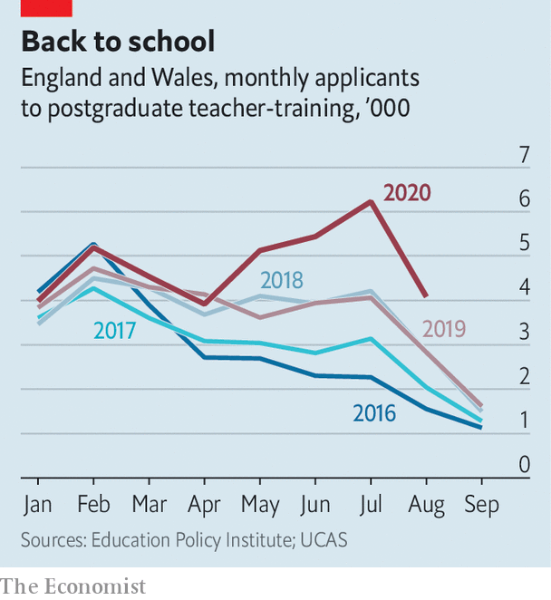

Two worries persist. Universities and the other organisations that train teachers rely on schools to provide their students with work placements. This year stressed-out heads have been less inclined to host trainees. The government has said that school leaders should consider trainees to be essential workers, not outsiders who might bring infection. But concern about the availability of placements means some teacher-training providers snapped up fewer of this year’s applicants than they might have done, says Emma Hollis of NASBTT, a trade group.

A bigger question is how many of the new trainees will stay in teaching. Research in America shows that people who enter the profession during recessions tend to make better teachers than those who do not, perhaps because high-skilled workers have fewer other options during a downturn. But they are also a bit more likely to give up. England already has a problem retaining new teachers. About a fifth leave the job within two years of qualifying. About a third go within five.

Sam Sims at the UCL Institute of Education says “muscular” policies that were put in place before the pandemic provide reason for optimism. Last year the government said that starting salaries would rise to £30,000 ($39,000) by 2022, a 23% increase. It is offering annual bonuses to teachers of subjects with the biggest shortages. And it is promising more mentoring and training for people who are new to the job. The idea is that new teachers will eventually consider themselves better-paid and better-supported than peers in many other professions. That might make Mr Seadon’s cohort a bit more likely to hang around. ■

This article was downloaded by calibre from <https://www.economist.com/britain/2020/09/10/a-rush-of-new-teachers-will-help-englands-short-handed-schools>

|  |  |  |  |
| --- | --- | --- | --- |
| Previous | Articles | Sections | Next |

|  |  |  |  |
| --- | --- | --- | --- |
| Previous | Articles | Sections | Next |

#### Lots of hot air

# Extinction Rebellion shows how not to run a protest group

Internal conflicts have dampened momentum, and harmed the outfit’s cause

Sep 12th 2020 |

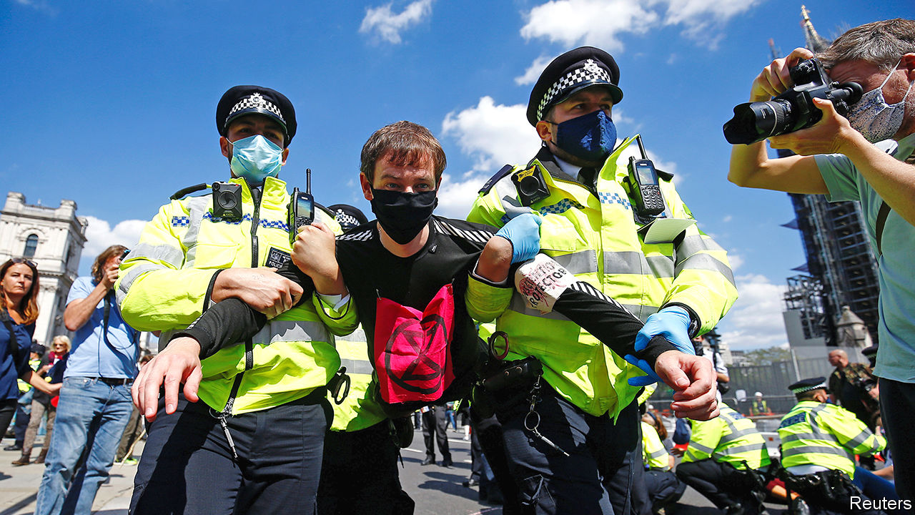

ON SEPTEMBER 5TH Britons woke to discover that their news-stands were rather empty. Overnight, Extinction Rebellion (XR) had blocked access to three printworks owned by Rupert Murdoch’s News UK. The protest was not well received. Newspapers, and many environmentalists, called it an attack on free speech. Boris Johnson, the prime minister, thinks that XR should be classified as an organised-crime group, which would subject activists to surveillance typically reserved for gangsters.

XR’s latest demonstrations, which include marches in central London as well as blockades on printworks, follow noisier protests last year. In April 2019 they occupied major thoroughfares in London and other cities for a week of revelry and political action. Those protests were widely seen as a success. Polls found public support for their aims. Responding to the group’s demands, Parliament declared a “climate emergency”. Since then, however, XR has struggled to retain its influence.

That is partly due to forces beyond its control. A planned protest in March was cancelled because of covid-19. This time round, the group has been prevented from camping out by a curfew put in place by the police to ensure social distancing, and coppers have stopped them taking over Lambeth Bridge and other roads. Yet it also reflects internal conflicts that have harmed the group’s cause.

XR has been through a bitter civil war, emerging scarred and exhausted. In theory, the group was run along “holacratic” lines, based on a theory in which traditional hierarchies are replaced by semi-autonomous “circles”. In XR’s case, this meant that small local groups were able to carry out protests independently. Initially, the approach united disparate factions of the rag-tag climate movement behind a core aim: pressuring the government into declaring a climate emergency.

In practice, though, hierarchies persisted. Many saw the outfit’s co-founders, Gail Bradbrook and Roger Hallam, as the people in charge. They were members of the Anchor Circle and the Rapid Response Team, two small groups that held power during protests last year. The pair were also directors of Compassionate Revolution, a company which handled donations. Yet they did not have a strong enough grip to prevent an unholy alliance of eco-fascists, eco-socialists and eco-anarchists descending into conflict.

The main dispute was about tactics. Farhana Yamin, a prominent lawyer, wanted to work with politicians. Another group represented by Mr Hallam, an organic farmer, wanted to provoke mass arrests to overwhelm the system. “Roger’s theory of change was: if you get enough people to turn up in a central square, like Tiananmen Square or Parliament Square, then that will be revolutionary,” explains Ms Yamin. At first, they struck a productive balance. Protests won Ms Yamin’s team meetings with cabinet ministers, who agreed there was a climate emergency.

But it did not last. Ms Yamin’s faction was denounced as traitors. They were subjected to a “Conflict and Resolution Circle”, which one insider says “was basically a hippie way of saying ‘Fuck off’”. That handed more power to Mr Hallam’s group, who thought riskier actions would provoke a heavy-handed response from the state, and thus public sympathy. The group’s cooler heads say they spent most of the summer of 2019 fighting madcap ideas. One, claims an insider, was to glue thousands of teenagers to London’s Tube carriages at rush hour. A more restrained version led to two activists being pulled from a train roof by angry commuters. A dispute over whether to target Heathrow airport became particularly disruptive.

Both Ms Yamin and Mr Hallam have since left XR. Compassionate Revolution has been replaced by a new company led by three younger directors. Ms Bradbrook, one of XR’s founders, denies they have any authority. “We have some legal bodies that are part of what you need in order to have a bank account and so on, but that’s not where the decision-making takes place,” she explains. A lack of donations means that central organisers can no longer afford to pay themselves; local groups have taken on more responsibility, with demonstrations becoming more dispersed as a result. Recent protests have been led mostly by aligned groups, stitched together by so-called “Rebellion Weavers”.

New divides have emerged. The so-called “Fourth Demand”, which calls for reparations and land rights for indigenous groups, is one. Many think the popularity of Black Lives Matter means XR now needs to take identity politics seriously. The demand has been adopted by local groups, but not by central office. In theory, these disputes should now be easier to settle. Ms Bradbrook says that XR has set up an Actions Council, which will adjudicate on internal battles. It just hasn’t got around to meeting yet. ■

This article was downloaded by calibre from <https://www.economist.com/britain/2020/09/12/extinction-rebellion-shows-how-not-to-run-a-protest-group>

|  |  |  |  |
| --- | --- | --- | --- |
| Previous | Articles | Sections | Next |

|  |  |  |  |
| --- | --- | --- | --- |
| Previous | Articles | Sections | Next |

#### Gold diggers

# Britain’s treasure-hunting hobbyists get professional

But only on their own terms

Sep 10th 2020 |

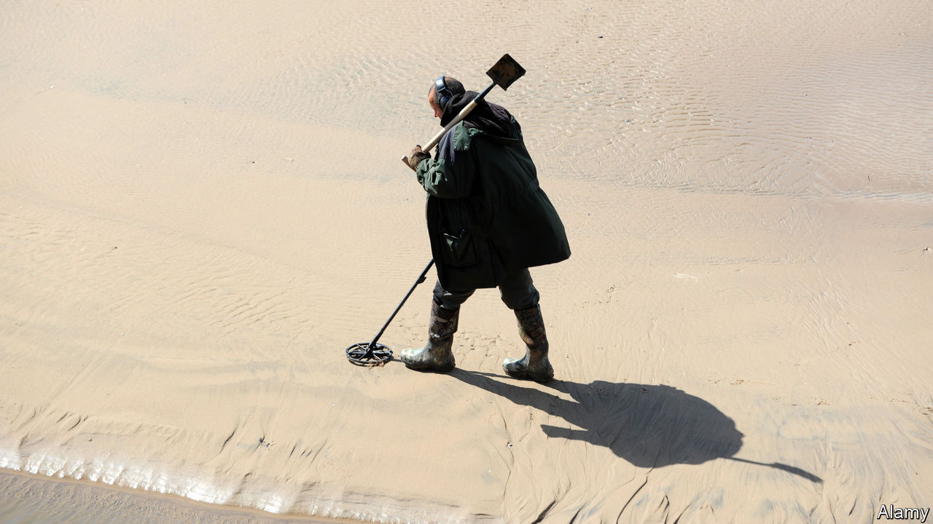

IN A FIELD next to his local pub, Luke Mahoney found a gold coin and a sixpence piece, before heading off for a bite to eat. After lunch, the businessman, who runs a firm selling metal detectors, discovered that a plough had cracked open a pot two feet down. His detector went mad. That afternoon he unearthed 1,080 silver coins, possibly dating back to the civil war, which he thinks could be worth £400,000 ($520,000): “Christ, we literally skipped across the field from the pub, and found 400 grand!”

Lockdown and the furlough scheme have given detectorists even more free time to forage. They have unearthed neolithic arrowheads and ancient coins in their back gardens. In June, a detectorist in Scotland happened upon a complete Bronze Age horse harness and a sword still in its scabbard, with the metal and wood preserved by the soil. Another enthusiast discovered a 467-year-old coin thought to be worth around £15,000.

England provides fertile terrain for detectorists. Under the Treasure Act, diggers must report findings within a fortnight, give museums first refusal on items and split any cash made with landowners, at a rate set by independent experts. But that is still more generous than elsewhere. In Scotland the government takes a share. Parts of the Netherlands made the hobby legal only four years ago. Other countries require licences. Partly as a result of the government’s relaxed regulation, business is booming. According to official figures, last year detectorists found 1,311 objects, up from 1,005 in 2015.

This has prompted the establishment to take notice. Detectorists have tended to have a fraught relationship with scholarly archaeologists. Ian Richardson, the British Museum’s senior treasure registrar, says he worries that amateurs tamper with history by removing artefacts from sites without properly recording them. Last year two detectorists were jailed for stealing 300 Viking coins and other goodies from a Herefordshire field. English Heritage, a charity, has invested £50,000 in a new metal-detecting training body to prod detectorists in the right direction. “There’s a recognition that if people practise metal detecting responsibly, then it can make a useful contribution to the archaeological record,” says Mr Richardson.

Detectorists see attempts to professionalise them as patronising nonsense. Many believe training to be a form of covert licensing. “They’re saying that you have to be trained by these so-called ‘experts’,” says one. “Well these so-called ‘experts’ have been out of university for ten minutes.” Detectorists claim archaeologists often misidentify their finds, causing havoc when they come up for sale.

Instead, they prefer to focus on self-improvement. Some detectorists now live-stream excavations, so newbies can pick up tips. Firms like Joan Allen Metal Detectors, which is run by Mr Mahoney, have started to organise ticketed events, where metal detectorists gather at carefully chosen sites of historical interest.

Mr Mahoney now wants to take this a step further. Buoyed by his recent success, he is putting together a crack team of detectorists. They have been using their skills to help other hobbyists who think they have stumbled across hoards. “My good god, it is staggering how much wealth of history is yet to be uncovered,” Mr Mahoney enthuses. “It’s insane and no one’s talking about it.” ■

This article was downloaded by calibre from <https://www.economist.com/britain/2020/09/10/britains-treasure-hunting-hobbyists-get-professional>

|  |  |  |  |
| --- | --- | --- | --- |
| Previous | Articles | Sections | Next |

|  |  |  |  |
| --- | --- | --- | --- |
| Previous | Articles | Sections | Next |

#### Bagehot

# The modern Tory party’s uncompromising nature has deep historical roots

Edmund Burke and Silicon Valley make for a potent combination

Sep 12th 2020 |

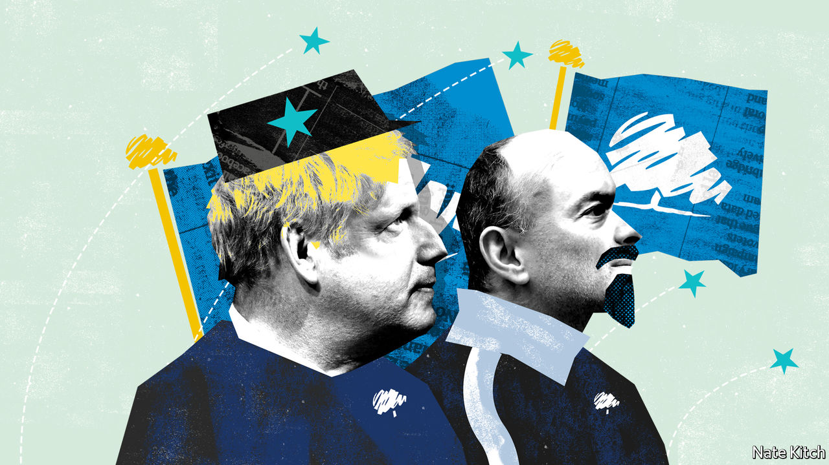

TODAY’S CONSERVATIVES are always smashing things up or threatening to smash things up. Having taken on the BBC, the civil service, Parliament and the Supreme Court, the government has now graduated to international law. Boris Johnson is so determined to reverse elements of the withdrawal agreement with the European Union—an agreement that he negotiated, signed and campaigned on in the general election—that he is willing to break the terms of it. If this means leaving the EU without a deal that would be a “good outcome for the UK”, according to Mr Johnson.

Where does this attitude come from? There is a dash of Donald Trump-style bullying. Threats against the BBC have frightened it into reining in its more outspoken journalists. The savaging of the civil service has produced a more compliant cohort of permanent secretaries. There is also a dash of Silicon Valley. Dominic Cummings, Mr Johnson’s adviser, likes talking about “creative destruction”, with an emphasis on the destruction, and “moving fast and breaking things”, with an emphasis on the breaking. But the willingness to attack also has deep roots in the Conservative tradition.

The conventional view of British conservatism is that it is uniquely flexible. The Tories are the world’s oldest conservative party, the argument goes, because they have avoided the mistake, common on the continent, of looking for ditches to die in. Yet there is also a more bloody-minded Conservative tradition, one well expressed by Lord Salisbury, three times prime minister, when he wrote that “hostility to radicalism, incessant, implacable hostility, is the essential definition of Conservatism. The fear that the Radicals may triumph is the only final cause that the Conservative Party can plead for its own existence.”

Conservatism was forged in reaction to the French revolution, and has repeatedly renewed itself in reaction to slower, milder revolutions, such as the rise of the mixed economy and the evolution of the European Union. There is a limit to the party’s willingness to compromise with such change. Even Robert Peel, the hero of liberal conservatism and champion of free trade, insisted that, at some point, you have to be willing to say to the “restless spirit of revolutionary change, ‘Here are thy bounds, and here shall thy vibrations cease’.” Conservatives eventually ran out of patience with the mixed economy when strikes became a way of life. They are now running out of patience with parts of the liberal revolution. People who made peace with the gay-rights revolution are drawing the line at treating sex as a “social construct”.

This tough-minded conservatism starts with the belief that the best way to prevent (or reverse) revolutions is to learn from them. Conservatives are often the harshest critics of the old regime because they realise the only way to save it is to revitalise it. They can also be secret admirers of revolutionaries. Edmund Burke’s “Reflections on the Revolution in France”, the foundation text of modern conservatism, is full of laments about the decadence of the old regime (“sluggish, inert and timid”) and pleas to learn from the Jacobins. “To destroy that enemy”, he says, “the force opposed to it should be made to bear some analogy and resemblance to the force and spirit which that system exerts.”

Learning from revolutionaries means being willing to engage in ideological struggle. Joseph Schumpeter argued that the problem with business people is that they can’t “say boo to a goose”. They need clear-sighted intellectuals to do the boo-saying for them. It also means being willing to sanction some extraordinary measures, if that is the only way to prevent the locomotive of history from heading over the cliff.

This tradition has been powerfully reinforced by American conservatism, which is tied to its British cousin by a network of think-tanks, fellowships and conferences. Barry Goldwater was regarded as nutty when he pronounced that “extremism in the pursuit of liberty is no vice...Moderation in the defence of justice is no virtue.” In the current Republican Party such sentiments are mainstream. Michael Anton presented revolutionary conservatism in its purest form by dubbing the 2016 election “the flight 93 election”, alluding to United Flight 93, which crashed in a field in Pennsylvania on September 11th 2001: “Charge the cockpit or you die.” He has now published an equally apocalyptic book on the forthcoming election, “The Stakes: America at the Point of No Return”.

Though nobody on the British right has been quite as apocalyptic, the long-term impact of revolutionary conservatism will be bigger on Britain than America. The odds are that Donald Trump will lose the next election, perhaps taking the Republican majority in the Senate with him. Brexit has made revolutionary conservatism the default option of the British right. The government’s willingness to break international law has troubled some Conservatives. But the striking thing is how few have spoken out.

## Pessimism of the spirit, optimism of the will

The party is now dominated by revolutionary Conservatives. Moderates have been purged over Brexit and hard men hold all the highest positions. The likes of Mr Cummings and Michael Gove have studied Lenin and Gramsci, as well as bloody-minded British conservatives such as Maurice Cowling and Norman Stone. They are determined to do for the liberal establishment what they have already done for the European establishment.

These revolutionaries have troops on the ground. If left-wing revolutionaries deal in hope for a better future, however illusory, conservative ones deal in something even more powerful: feelings of loss. The Conservatives have a core of older voters who fear they are losing their country to woke activists. In the last election it added a new army of working-class Britons who fear they have lost their way of life to globalisation and their old party, Labour, to distant elites. These diverse constituencies are united by a common demand that these “vibrations” should cease—and a common willingness to do whatever it takes to make them stop. ■

This article was downloaded by calibre from <https://www.economist.com/britain/2020/09/12/the-modern-tory-partys-uncompromising-nature-has-deep-historical-roots>

|  |  |  |  |
| --- | --- | --- | --- |
| Previous | Articles | Sections | Next |

|  |  |  |
| --- | --- | --- |
| Britain | Sections | Business |

International

The World Health Organisation: What’s wrong with the WHO

.

|  |  |  |
| --- | --- | --- |
| Britain | Sections | Business |

|  |  |  |  |
| --- | --- | --- | --- |
|  | Articles | Sections | Next |

#### Covid-19 and beyond

# The world needs a better World Health Organisation

The WHO has done well against covid-19. But it needs more muscle and more money

Sep 12th 2020 | GENEVA



Editor’s note: Some of our covid-19 coverage is free for readers of The Economist Today, our daily [newsletter](https://my.economist.com/user#newsletter). For more stories and our pandemic tracker, see our [hub](https://www.economist.com/news/2020/03/11/the-economists-coverage-of-the-coronavirus)

THE GLASS and metal headquarters of the World Health Organisation (WHO), the UN’s health agency, contrast starkly with their bucolic surroundings in the hills around Geneva. The only dabs of colour are the flags of its 194 member-states. For now the American flag still flutters beside the rest. But if President Donald Trump has his way, by July 2021 it will be gone. America is the WHO’s biggest donor. A tenth of its staff are American. Its influence runs through the agency, right down to the peanut-butter cups in the staff vending machine.

It is an odd time to cut ties with the world’s foremost public-health body. There is a pandemic going on. Mara Pillinger, a health-policy researcher at Georgetown University in Washington, DC, says the WHO has done a “pretty remarkable job” of coping with covid-19, given the constraints built into the way it works. Nonetheless, the twin threats of Trumpism and coronavirus have illuminated both the agency’s strengths and its weaknesses, and raised questions about its future.

The WHO’s emergency work is governed by a legal framework known as the International Health Regulations, the current version of which has been in force since 2005. They spell out how public-health emergencies should be handled. They set the rules for how nations should behave. And they constrain the WHO. Member-states are bound to report outbreaks of diseases as soon as they can, but if they fail to do so, or delay as China did with covid-19, the organisation has no way of compelling them.

Before 2005 the rules were different. Gro Harlem Brundtland, a former Norwegian prime minister who led the WHO from 1998 to 2003, slammed China for failing to report an outbreak of SARS promptly in 2003. Those days are gone, she says; member-states have now limited what the head of the WHO can do and say. Tedros Adhanom, the current director-general, has not openly criticised China. But nor has he lambasted America, points out Jeremy Hunt, a former British health secretary. Such tact is crucial. UN bodies work by consensus, he says: “That is the price you pay for getting all the countries in the world around the table.”

Ordinarily the job of the WHO is to identify the best public-health measures, share that information and offer technical support to members that need it. It is the main forum where countries co-operate on matters of health. The practical work of public health is not its job. However, when others fail it will step in. It has provided mental-health services in Syria and airlifted ambulances into Iraq. It failed in its response to an outbreak of Ebola in West Africa in 2014 which killed more than 11,000 people. But when the disease struck the eastern Democratic Republic of Congo in 2018 it played a leading role in bringing it under control. When others thought it too dangerous to send staff into the field, the WHO stayed. Two staff were killed by rebels, who often attacked clinics. Dr Tedros visited Congo 14 times, showing unusual pluck for someone in his position.

## who are you

The WHO was central in the eradication of smallpox, a disease killed almost 300m people in the 20th century. It has helped almost wipe out polio, which in the 1980s paralysed 350,000 people in 125 countries each year. The disease is now found in only three countries. The WHO receives information from countries on outbreaks, organises vaccination programmes and often acts as a kind of vaccine-approval agency.

One problem for the WHO, argues Dr Pillinger, is that much of its work is invisible. It co-operates closely with governments and lets them take credit for its efforts. When things go wrong, of course, it makes a convenient scapegoat, as Mr Trump has realised.

Its response to covid-19 has come under intense scrutiny, as it should. Dr Brundtland thinks the WHO declared the outbreak a public-health emergency far too late. That could be because China, once again, withheld information about a novel outbreak. It was, she says, “concealing and waiting and shouldn’t have done, according to International Health Regulations”.

Some say the WHO was too slow to issue guidance on the use of dexamethasone, a drug that can treat some of the sickest patients. Others have blasted it for dragging its feet before promoting the wearing of fabric masks on buses and in shops. Initially it did not have the evidence on which to base such guidance, explains Maria Van Kerkhove, a WHO epidemiologist. It needed to know whether masks would be available and what the science said about the efficacy of the widespread use of the fabric kind. It asked researchers at Stanford University to investigate. On the basis of their research in June it changed its advice to say that such masks should be worn in public where physical distancing is impossible.

But overall the organisation has responded to covid-19 swiftly. At the start of the outbreak officials worked with technology and social-media companies to encourage them to promote accurate information. It coined the phrase “infodemic” to describe the rapid spread of misinformation about the new virus.

It has helped co-ordinate global efforts to find treatments and vaccines. It is working with drug firms to safeguard the supply of medicines. It is now a key player in COVAX, a plan to distribute 2bn doses of a covid-19 vaccine in 2021. The WHO has rushed to digest research produced at high speed and explain what it means. Behind the scenes member-states are regularly told where the WHO thinks their measures are not aggressive or comprehensive enough.

## For who the bell tolls

Its efforts will be further analysed. In May the World Health Assembly, the WHO’s decision-making forum, requested a full independent evaluation of the agency’s response to the pandemic as well as that of individual countries. It will be published next year. Whatever its conclusions, many of the WHO’s weaknesses are already apparent. Last month officials in the German and French health ministries circulated a paper saying the agency is severely underfunded, chronically over-mandated by member-states, and weak by design.

Money is the most immediate problem. The WHO’s budget is a piddling $2.5bn a year (roughly what America spends on health care for a typical small city). “It’s a sad figure,” says Howard Koh, a professor at the Harvard Chan School of Public Health and a former assistant secretary for health in the Obama administration. With this “we expect them to solve the world’s pandemics.” In emergencies the WHO often has to go cap in hand to its funders to scrounge more cash. In the middle of the Ebola outbreak in Congo in 2018-19 it ran out.

Its work is made harder because only 20% of its $2.5bn in funding is guaranteed and comes without strings. Much of that comes from a small number of large donors (see chart). It is like an oil-dependent country, argues Dr Tedros, too reliant on a single source of income, namely America. Other big countries, such as China and France, contribute trifling amounts. The other 80% comes in the form of around 3,000 unpredictable and voluntary contributions earmarked for specific projects. Almost half are for less than $500,000. They are messy, difficult to manage and fragment the organisation, says the WHO’s boss.

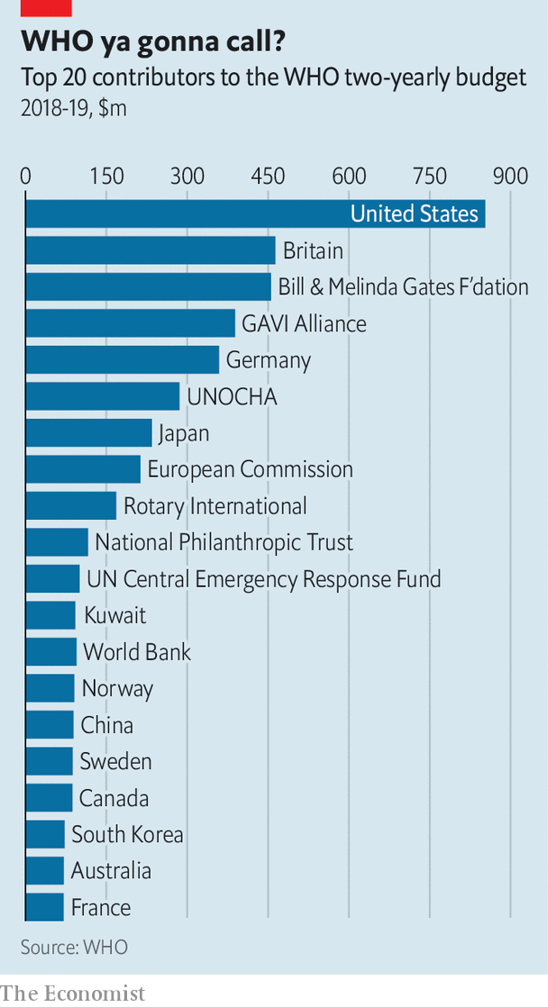

Since he took over in 2017, Dr Tedros has tried to secure the agency’s finances. He set up the WHO Foundation to create a more reliable source of money. He is trying to persuade member-states to give more unconditional funding. Even before the pandemic he had pushed health up the political agenda. Staff at a big health charity say that under him the WHO has gone from discussing its work with health ministers to talking to heads of state.

Dr Tedros credits his staff for feeding him good ideas, such as setting up a WHO Academy to support the training of health workers around the world. He established the role of chief scientist. He has reached out to the private sector, something the WHO has hesitated to do before, for fear of conflicts of interest. He says he is willing to work with the food industry to eliminate trans fat, a particularly unhealthy type of fat, from food by 2023. The agency is looking into working with big tech firms on digital health technologies.

Dr Tedros is the first director-general to be elected by a secret ballot of all member-states—giving him greater independence, he says. A smaller group of countries, the WHO’s executive board, used to control these elections. The reforms he has implemented so far have been ambitious, but member-states must push them further.

Beyond pandemics, the work of promoting science-based policy, strengthening health systems and expanding access to care is not glamorous. But it is vital. The agency’s record on covid-19 is far from perfect but it had long warned of the possibility of a pandemic on such a scale. In 2018 it talked about “Disease X”, an illness caused by a pathogen never seen before in humans that would cause the next pandemic and wreak havoc. Dr Tedros set up a new division to prepare for it. Many countries did not listen.

The world has no better idea than it did a year ago whether an outbreak as bad as covid-19 is a once-in-a-century event or will happen again tomorrow. Meanwhile, new demands on the WHO are emerging. A fresh outbreak of Ebola in Congo requires attention. Poorer countries will need support dealing with covid-19 along with existing diseases such as diabetes and measles. The WHO will have to spread its already limited resources even more thinly.

Dr Tedros has tried to convince the Trump administration that America should stay part of the WHO but says it set “completely unacceptable” conditions for doing so (he did not specify what they were). Joe Biden has promised that America would rejoin the WHO immediately, should he win the presidency. Either way, the possibility of the organisation’s main donor bunking out has made other countries realise that they should do more to bolster it. An internal panel is looking at reforms to the International Health Regulations. The WHO may need the power to investigate outbreaks more independently and to establish a system so that it can issue warnings about public-health emergencies earlier. A year ago the risks of a weak global health system were hard to calculate. Today the costs of failure are measured in trillions of dollars and the loss so far of around 900,000 lives to covid-19. ■

This article was downloaded by calibre from <https://www.economist.com/international/2020/09/12/the-world-needs-a-better-world-health-organisation>

|  |  |  |  |
| --- | --- | --- | --- |
|  | Articles | Sections | Next |

|  |  |  |
| --- | --- | --- |
| International | Sections | Finance & economics |

Business

Netflix: The Hastings doctrine

.

Vaccines: Strong medicine

.

Beverages (1): Caffeine clash

.

Beverages (2): Bottle shock

.

America v Huawei: Creative destruction

.

Bartleby: The delight is in the detail

.

Schumpeter: The one that got away

.

|  |  |  |
| --- | --- | --- |
| International | Sections | Finance & economics |

|  |  |  |  |
| --- | --- | --- | --- |
|  | Articles | Sections | Next |

#### The Hastings doctrine

# Can Reed Hastings preserve Netflix’s culture of innovation as it grows?

The streaming giant’s curious management style faces challenges on several fronts

Sep 12th 2020 |



THE BEST way to stay innovative, many bosses will tell you, is to hire the best people and let them get on with it. Few take this as literally as Reed Hastings of Netflix. The video-streamer’s employees can take as much holiday as they fancy and put anything on the company’s tab so long as, to cite the entirety of its corporate expense policy, they “act in Netflix’s best interest”. Anyone may access sensitive information like a running tally of subscribers, which Wall Street would kill for. Executives seal multimillion-dollar deals without sign-off from top brass. High-achievers are rewarded with the plushest salaries in the business—whether their business is writing computer code or film scripts. Underperformers are unceremoniously cut loose.

It sounds like a recipe for expensive anarchy. But managing “on the edge of chaos”, as Mr Hastings mischievously puts it, has served Netflix well. Most of its 7,900 full-time workers seem happy being treated like professional athletes, paid handsomely as long as no one can do their job better. Each generates $2.6m in annual revenue on average, nine times more than Disney employees, and $26.5m in shareholder value, three times more than a Googler does.

Investors lap it up as hungrily as Netflix binge-watchers, who now number 193m worldwide. Since going public in 2002 the firm’s share price has risen 500-fold (see chart 1), in the top ten 18-year runs in America Inc’s history, as Mr Hastings points out with a hint of pride in his voice. This year it briefly overtook Disney to become the world’s most valuable entertainment company.

## 125 reasons why

This track-record has earned Mr Hastings kudos. A PowerPoint “culture deck” outlining his management philosophy has been viewed 20m times since he posted it online 11 years ago. Sheryl Sandberg, Mark Zuckerberg’s right-hand woman at Facebook, has called it the most important document ever to emerge from Silicon Valley. A new book in which Mr Hastings fleshes out those 125 slides is destined for the bestseller list. But it raises a question: are the “No Rules Rules” of the title the right set as Netflix metamorphoses from California startup into global show-business colossus?

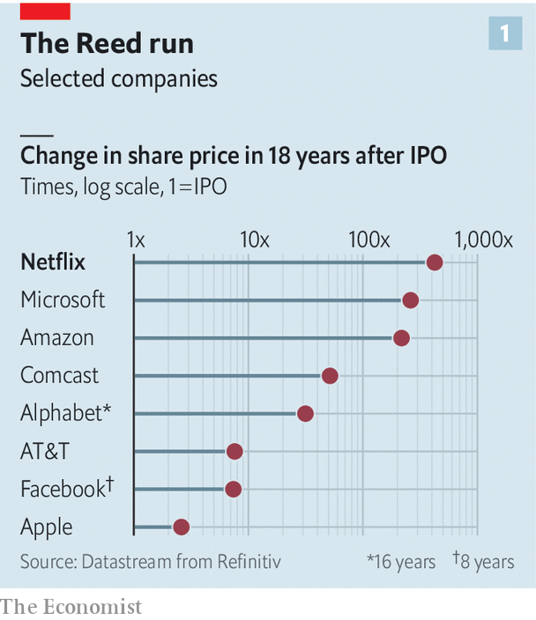

It is easy to put too much stock in corporate culture, which can be a story triumphant companies tell themselves after the fact. GE’s rise in the 1990s had more to do with financial engineering than with the much-aped habit introduced by Jack Welch, the conglomerate’s CEO at the time, of ranking employees and “yanking” the bottom 10%. Netflix would not be where it is without its boss’s uncanny foresight to bet on streaming in the late 2000s, or the uncannily flat-footed response from Hollywood incumbents, which took a decade to grasp the threat. Investors have displayed deep reserves of cheap capital, and deeper ones of patience. Over the past year the firm’s prodigious revenue-generators each burned through $123,000 of cash (see chart 2); this year quarterly cashflow turned positive for only the first time since 2014. Luck played a role, as when cut-price DVD players debuted just in time for Christmas in 2001, months after the dotcom crash forced Mr Hastings to lay off a third of his 120-odd workers, from what was then a DVD-by-mail rental service.

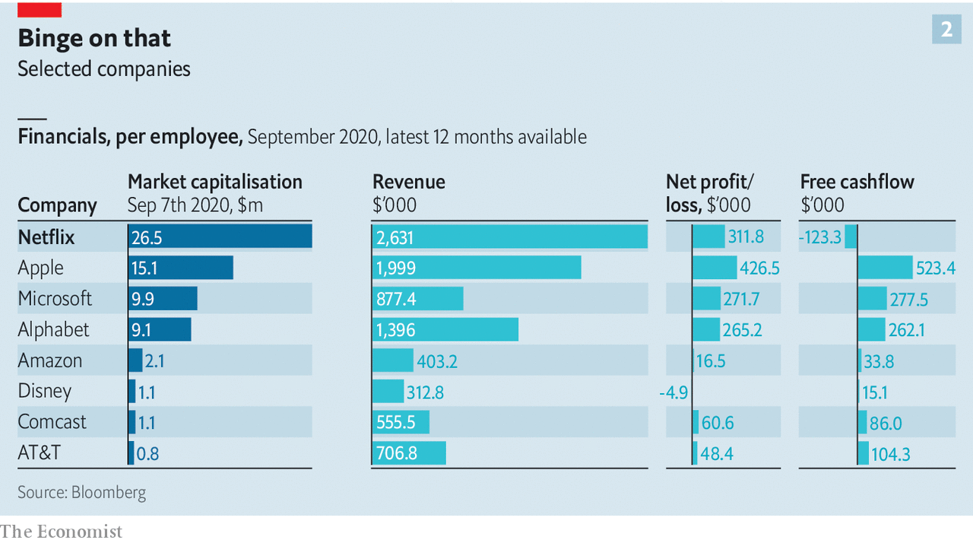

Still, as Michael Nathanson of MoffattNathanson, a consultancy, observes, “Every time that Netflix faced a roadblock it found a clever way to work around it and emerge stronger.” Most notably, when TV networks and studios at last woke up to the reality of streaming and began to hog content licences, Netflix started producing its own shows, and later feature films. The swivel might have taken longer with employees bogged down in chains of approvals. “Radical candour”, whereby everyone’s ideas, from Mr Hastings down, can be challenged by all-comers, helps weed out bad ones. “Sunshining”, the stomach-churning spectacle of publicly explaining choices, helps not to repeat mistakes. Senior Netflixers’ “ability to swallow their pride is truly exceptional”, says Willy Shih of Harvard Business School, who has written two case studies on the firm.

Now this innovation-friendly culture is under fire on three fronts. The first two—the firm’s growing size and scope—are internal to Netflix. The third source of pressure comes from the outside.

Start with size. The flat hierarchy and frankness that works in Silicon Valley, with its narrow range of temperaments and socioeconomic backgrounds, is harder to sustain in a global workforce that has swelled nearly fourfold in five years (more if you include temporary contractors, who now number over 2,200, up from fewer than 400 in 2015). Asians, Europeans and Latin Americans can find visitors from headquarters “exotic”, in Mr Hastings’s words. Negotiating “context”, as Netflix managers and their subordinates do constantly in the absence of explicit rules, offers useful flexibility. But it takes time that could be spent perfecting a product—ever more of it as tacit cultural understanding is diluted by international expansion. Revenue per worker is down by 7% from 2015.

Many countries grant workers more protections than America does. This is a problem for the “keeper test”, which requires managers constantly to question if they would fight to stop their underlings from leaving—and, if the answer is “no”, immediately send the individual on their way with generous severance. These golden handshakes, which range from four months’ salary in America to more than six months in the Netherlands, are “too generous” to reject, says Mr Hastings. Netflix has not been sued even in Brazil, where employee lawsuits are a national sport to rival football. The bonhomie may not last.

A larger workforce poses a separate risk to internal transparency. Even while the attrition rate hovers at around 10%, the number of ex-Netflixers with knowledge of the firm’s finances and strategic bets is now growing by hundreds each year. Unwanted disclosures have been rare and, says Mr Hastings, immaterial. But, he concedes, serious leaks may be “a matter of time”.

The second challenge has to do with Netflix’s sectoral girth. In its first decade it was primarily a firm of technologists like Mr Hastings, whom his co-founder, Marc Randolph (who left the firm in 2003), likened to the hyper-rational, emotionless Mr Spock in “Star Trek”. That was never entirely fair—Netflix products are data-driven but Mr Hastings attaches as much weight to judgment in managing people as Captain Kirk ever did. Still, by the standards of Tinseltown, where he now spends a couple of days most weeks amid studio intrigues and moody showrunners, he and his firm can come across as robotic.

One producer who has worked with Netflix detects hints of its horizontal hierarchy permeating Hollywood “by osmosis”. This can speed things along. But, she grouses, “sometimes you need a production assistant to assist, not commission scripts.” At the same time, Netflix missed a chance to revolutionise other old studio ways. The $150m five-year deal it signed in 2018 with Shonda Rhimes, a star TV producer, may be more generous than most networks could afford. But it is Hollywoodian in its structure, says a former executive—and antithetical to the keeper test.

Moreover, Netflix may have no choice but to expand into new industries. This would be a departure from its laser focus on its core product: quality streamed entertainment. But show business is increasingly the preserve of conglomerates. Disney has theme parks, merchandising and TV networks. Comcast (the cable giant that owns NBCUniversal) and AT&T (the telecoms group which controls HBO and WarnerMedia) possess the pipes along which content flows. Apple’s and Amazon’s Hollywood ambitions are tethered to their powerful technology platforms.

Disrupting sluggish behemoths is one thing. Competing with them head-on may require a different trade-off between flexibility and efficiency. It may also mean takeovers. Mr Hastings has no shopping plans. But a strong culture, he admits, “is a material weakness if you are going to make big acquisitions”. Cultural sparks could fly when you integrate more than a few dozen people, as they flew when his first firm, Pure Software, bought rivals in the 1990s.

The third set of challenges is external. Covid-19 has muted the exchange of ideas. It is also harder to evaluate—and dismiss—people by Zoom; Netflix’s 12-month rolling attrition rate has declined by a third, to 7%. This week Mr Hastings said he does not see “any positives” to home-working.

## Dear White People

Then there is public pressure for corporate America to care more about diversity. Mr Hastings added inclusion to Netflix values in 2016 but it barely features in his investor letters or annual reports. He acknowledges a tension between the desire for diversity and Netflix’s arch-meritocratic ideals (the firm eschews quotas, as it does all management metrics, in favour of that Kirkian judgment). Its corporate temperament screams “hypermasculine”, as Erin Meyer, Mr Hastings’s co-author and professor at INSEAD business school in France, has herself noted. And one person’s radical candour is another’s microaggression.

Netflix shareholders and their representatives on the board have confidence that Mr Hastings can reconcile these strains. He has given them plenty of reasons to trust his own judgment. But he is fully aware that his position is safe only as long as he can keep the magic going. The keeper test applies to him, as well.■

This article was downloaded by calibre from <https://www.economist.com/business/2020/09/12/can-reed-hastings-preserve-netflixs-culture-of-innovation-as-it-grows>

|  |  |  |  |
| --- | --- | --- | --- |
|  | Articles | Sections | Next |

|  |  |  |  |
| --- | --- | --- | --- |
| Previous | Articles | Sections | Next |

#### Strong medicine

# Why drugmakers are telling Donald Trump to cool his heels

Nine pharmaceutical giants pledge to uphold scientific and ethical standards rather than rush a coronavirus vaccine

Sep 12th 2020 |

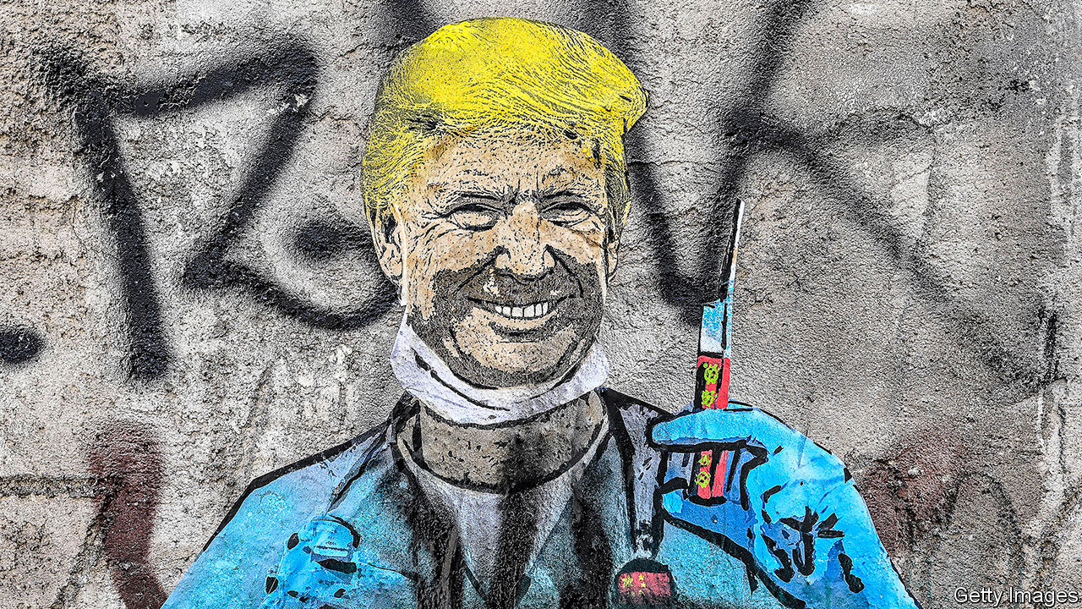

THE WORLD’S 7.5bn people want a vaccine for covid-19 as soon as possible. One person needs it by November 3rd. As President Donald Trump limps towards election day, he wants to report real medical progress against the disease. Earlier this year it seemed possible that one or two pharmaceutical firms might be able to obtain some sort of limited approval by the time Americans cast their ballots. That may still be possible. It is certainly desirable, given the pandemic’s toll on lives and livelihoods. But on September 8th, in an unprecedented move, nine global drugmakers, including AstraZeneca, GSK, Pfizer and Sanofi, announced a pledge to uphold scientific and ethical standards in the search for a coronavirus vaccine.

The message is intended to reassure the public that the companies will not bow to mounting political pressure from the White House to rush through a vaccine without the proper safety and efficacy tests. But it is also a rebuke to the president, who has been politicising the drug-approval process—and eroding public confidence in the Food and Drug Administration (FDA). This could undermine trust in any vaccine that arrives, as sooner or later one almost certainly will.

Mr Trump has already successfully harried the FDA to authorise drugs, such as hydroxychloroquine, with no scientific evidence for their efficacy. He has accused the regulator (unfairly) of being part of a “deep state” effort to try to slow down vaccine development until after the election. It looked like part of a strategy to get the regulator to hurry up.

Big pharma is clearly worried. Drug firms stand to lose a great deal if their products are seen as being waved through prematurely. The industry relies on the FDA to make business possible. In the same way that people fly because they trust the aviation regulator, they take medicines because these are believed to be safe and effective. Take away the trust and the medicines’ makers would suffer.

So would investment in research. Pharmaceutical firms have little incentive to develop better drugs if they can simply claim a new product is superior without having to prove it. When Mr Trump came into office, some in his entourage lobbied him to install as head of the FDA someone with a more relaxed approach to efficacy standards. Doctors and patients immediately raised the alarm. But so did drugmakers, who pushed for a more serious candidate to assume the position.

The industry statement makes it clear that vaccine development will move at the pace of science, not politics. More evidence of this came the same day, when AstraZeneca halted clinical trials around the world after one participant showed an adverse reaction. This may slow down vaccine development. But it is also par for the course. Indeed, AstraZeneca’s decision shows that the system is working. Not so much deep state as deep science.■

Editor’s note: Some of our covid-19 coverage is free for readers of The Economist Today, our daily [newsletter](https://my.economist.com/user#newsletter). For more stories and our pandemic tracker, see our [hub](https://www.economist.com/news/2020/03/11/the-economists-coverage-of-the-coronavirus)

This article was downloaded by calibre from <https://www.economist.com/business/2020/09/12/why-drugmakers-are-telling-donald-trump-to-cool-his-heels>

|  |  |  |  |
| --- | --- | --- | --- |
| Previous | Articles | Sections | Next |

|  |  |  |  |
| --- | --- | --- | --- |
| Previous | Articles | Sections | Next |

#### Caffeine clash

# Who will win the brewing battle between Japan and America?

Japanese-born canned coffee is conquering America. Its Japanese purveyors are not

Sep 12th 2020 | TOKYO

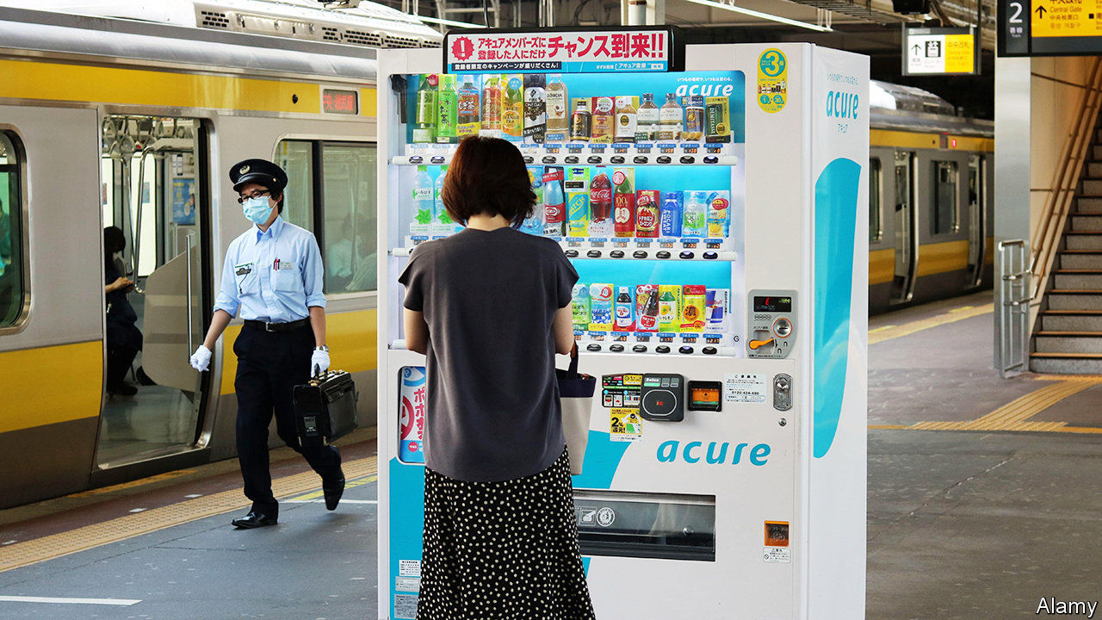

IN THE 1970S Japan gave the world pocket calculators and the Walkman. A less well-known Japanese invention of the era was canned coffee. Fifty years on, the country remains the biggest consumer of ready-to-drink brews, guzzling 3.1bn litres per year, half the global total and enough to fill Tokyo’s new Olympic Stadium almost to the brim. As domestic sales slow—they fell by 12.5% in the five years to 2019, to $11.5bn—Japanese sellers of the stuff are looking abroad, and especially thirstily across the Pacific.

America consumes only around a fifth as much canned and bottled coffee as Japan does. But Americans are developing a taste for it. The market has expanded by 78% since 2014. Margins are more energising than in Japan. This should be a gift to ready-to-drink coffee’s Japanese pioneers. It hasn’t been.

Suntory, a Japanese beverage giant, which dominates its home market for prepackaged coffee, is notable by its absence in America. Matthew Barry of Euromonitor, a research firm, points to differences in consumer preferences between the two countries as one explanation. In America canned coffee is favoured predominantly by young people, and especially young women. They want a large, cold, café-quality beverage in a resealable bottle. In Japan the typical drinker is a middle-aged blue-collar man who buys cans from a vending machine. Another explanation is America’s concentrated market for quality brews. As well as cornering coffee shops, Starbucks accounts for 63% of canned-coffee sales by volume.

The Seattle-based giant is now covetously eyeing Japan, where tastes and consumer habits are growing more similar to Western ones, with a lot more young female tipplers than before, for instance. Starbucks already has nearly 1,600 cafés in the country. Other foreigners, too, are making their presence felt. Japan’s favourite canned coffee, Georgia, is owned by Coca-Cola, which dreamed up the brand in Japan (and named it after its home state). The drinks giant is now launching packaged products by Costa Coffee, a British coffee-shop chain it owns. And last month Blue Bottle, a posh Californian coffee chain owned by Nestlé, a Swiss group, launched its first canned-coffee vending machine—in Tokyo.

This article was downloaded by calibre from <https://www.economist.com/business/2020/09/12/who-will-win-the-brewing-battle-between-japan-and-america>

|  |  |  |  |
| --- | --- | --- | --- |
| Previous | Articles | Sections | Next |

|  |  |  |  |
| --- | --- | --- | --- |
| Previous | Articles | Sections | Next |

#### Beverages

# Nongfu Spring is a hit with tipplers and investors alike

China’s leading water bottler has a blistering stockmarket debut

Sep 12th 2020 | XIAMEN

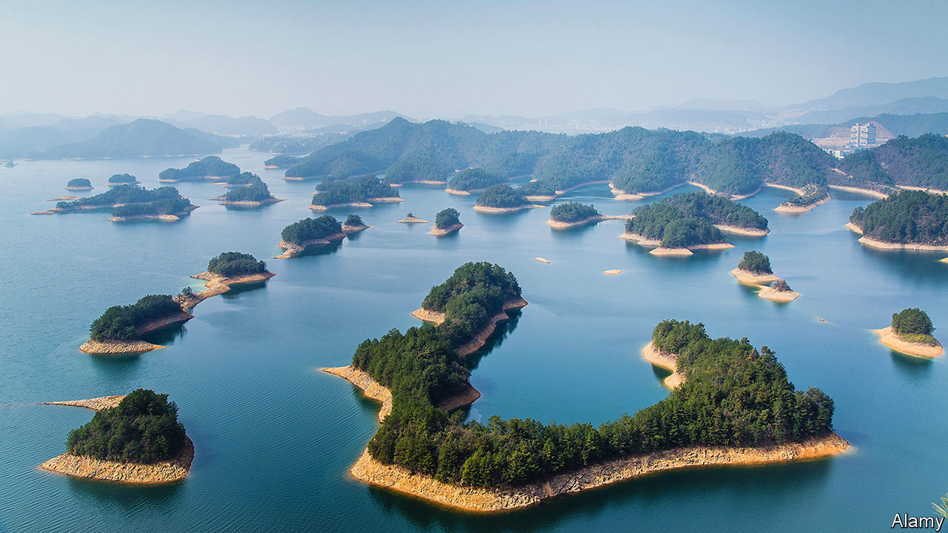

“WE ARE NOT manufacturers of water. We are porters of nature.” So goes a famous quip by Zhong Shanshan, the 66-year-old founder and boss of Nongfu Spring, China’s most popular brand of bottled water. On September 8th the Hangzhou-based bottler listed on Hong Kong’s bourse to spectacular fanfare. Demand for shares from retail investors outstripped supply by 1,148 times (see chart). The share price shot up by 60% over the first three days of trading. Its market capitalisation reached $53bn. Mr Zhong, who still owns 84% of Nongfu Spring, is now China’s third-richest person, narrowly trailing two tech moguls: Jack Ma of Alibaba and (unrelated) Pony Ma of Tencent.

Rising disposable incomes and public anxiety about the safety of tap water, which is unfit to drink in most of China, have fuelled demand among Chinese for the bottled variety. Consumption per person of bottled water rose from 41 litres in 2014 to 59 litres in 2019, according to data from Mintel, a market-research firm. Americans, by comparison, guzzled an average of 141 litres last year. That suggests Chinese bottlers still have plenty of room for growth, not least because tap water in America is (typically) potable.

Nongfu Spring is the runaway industry leader. It accounted for 29% of the volume sold in China in 2019. Foreign brands such as FIJI Water, Evian (owned by Danone) and Aquafina (part of PepsiCo) are easily spotted in many Chinese supermarkets. But none has a market share greater than 6.5%, reckons Mintel.

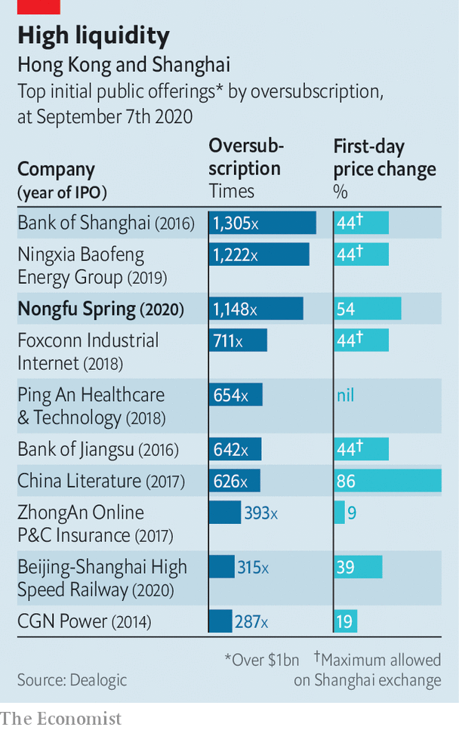

One reason for Nongfu’s success is its effort to cater to all market segments. Stingy folk can buy a mass-market 380ml-plastic bottle for as little as 1.5 yuan ($0.22). The well-heeled may opt for the glass-bottled version, which comes with “award-winning” designs and retails for 30-45 yuan. In between you can get a lithium-rich liquid which is claimed to benefit the nervous system. Total revenues across Nongfu’s waters increased by 42% between 2017 and 2019, to 14.3bn yuan. Gross margins held steady at an impressive 60%.

Nongfu sceptics point out that the bottled-water industry, in China and elsewhere, has few technical barriers to entry. The main raw material is polyethylene terephthalate (PET), a plastic that is cheap and easy to process. No special knowledge is required. Evergrande, a Chinese property developer, boasts its own line of bottled water called Evergrande Spring. The water itself tends to be an afterthought.

Not in Nongfu’s case. As its aggressive marketers never tire of stressing, it possesses water-extraction permits for ten of China’s most famous unspoilt bodies of water—from Thousand Island Lake in the eastern province of Zhejiang to Mount Tianshan in the remote western region of Xinjiang. The permits, granted by local governments for up to 30 years, are a moat against competitors. Loris Li, an independent analyst of China’s beverage industry, observes that “the quality of the original water source” can be a strong point of brand differentiation.

Nongfu Spring has another edge: it is seen as close to Chinese officialdom. At high-level political summits, rows of Nongfu bottles arranged on tables are a common sight. As sources of advantage go, it doesn’t get better than this in China. ■

This article was downloaded by calibre from <https://www.economist.com/business/2020/09/12/nongfu-spring-is-a-hit-with-tipplers-and-investors-alike>

|  |  |  |  |
| --- | --- | --- | --- |
| Previous | Articles | Sections | Next |

|  |  |  |  |
| --- | --- | --- | --- |
| Previous | Articles | Sections | Next |

#### Creative destruction

# How America’s war on Huawei may boost Chinese technology

From September 15th the Chinese telecoms giant will no longer be able to buy vital semiconductors

Sep 12th 2020 |

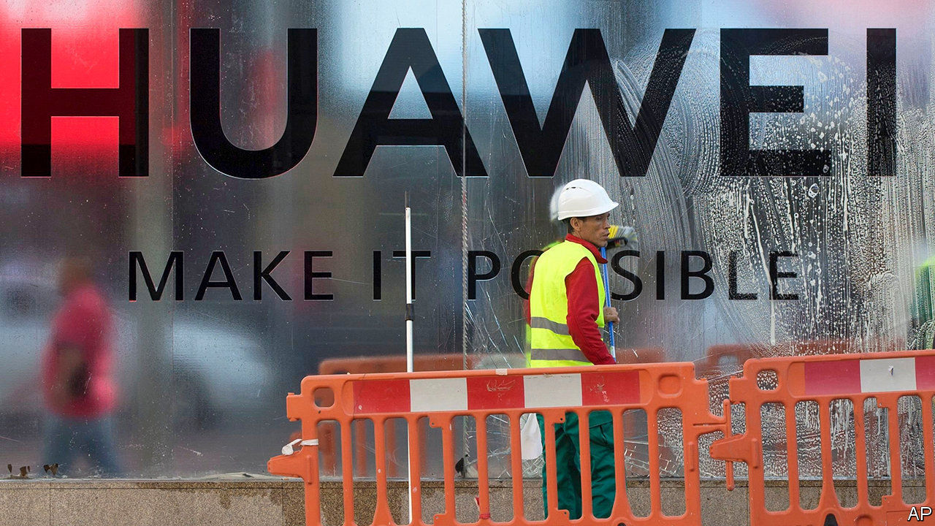

HUAWEI IS ON the ropes. From midnight on September 14th the Chinese technology giant will be cut off from essential supplies of semiconductors. Without chips it cannot make the smartphones or mobile-network gear on which its business depends. America’s latest rules, finalised on August 17th, prohibit companies worldwide from selling chips to Huawei if they have been made with American chipmaking kit. American semiconductor companies, for which Huawei has been a lucrative customer, have implored their government to extend the deadline, as have their industry bodies. A full reprieve looks unlikely.

Huawei now looks likely to follow one of three paths. The first involves Washington granting licences to suppliers so that they can sell chips to the firm in a limited fashion. This would let Huawei stay in business—just about. MediaTek, a Taiwanese chipmaker that is one of its main suppliers, has petitioned America’s Department of Commerce (DoC) for such a permit. To keep Huawei’s edge blunt, suppliers keen to produce chips designed by its in-house semiconductor unit, HiSilicon, are unlikely to be issued such dispensation.

Even a debilitated Huawei may not satisfy America. The DoC’s default setting is to deny permits. That would force the Chinese firm to take more desperate action, such as making its own chips using older technology that could be sourced from supply chains that do not include American firms. Pierre Ferragu of New Street Research, a telecoms-and-technology research firm, expects Huawei to do this within 12 months.

This path has just become rockier. On September 4th Reuters reported that America’s Department of Defence has proposed putting Semiconductor Manufacturing International Corporation (SMIC), China’s leading chipmaker, on the same blacklist as Huawei. The Pentagon alleges that SMIC works with China’s armed forces, and so poses a threat to national security. A blacklisting would destroy SMIC’s business, which relies on American machine tools. Its share price fell by almost a quarter on the news. SMIC denies having military ties and said it is in “complete shock”. The threat of such action may dissuade SMIC from teaming up with HiSilicon, as Huawei might have hoped.

This leaves the third eventuality. Huawei may go bust, or be forced to sell off bits of its business. This would not happen immediately: at the end of 2019 it had cash reserves of 371bn yuan ($53bn), enough to cover operating costs for a year and a half. But if push comes to shove, it may offload HiSilicon. Huawei’s chip-design arm is one of the most advanced such outfits in the world. According to IC Insights, a firm of analysts, HiSilicon broke into the global top-ten design companies by revenue in the first half of 2020, the first Chinese firm to do so. Since it will no longer be able to design chips for its owner after September 14th, HiSilicon could profitably focus on doing so for third parties in China. That would generate a new revenue stream for Huawei. If instead Huawei were forced to shut HiSilicon, its laid-off engineers would be snapped up by chip-design teams at other Chinese technology giants like Alibaba, Tencent and ByteDance. Or they could start new design firms of their own; many are said to be slipping out pre-emptively.

Each scenario worries firms like Qualcomm. The big American chip-designer lists Chinese competition as a risk in its annual filings. Last year Chinese sales made up $11.6bn out of Qualcomm’s $24.3bn in revenue. A HiSilicon liberated from Huawei would threaten those sales.

Huawei is putting on a brave face. It says it will spend over $20bn on research and development this year, $5.8bn more than in 2019 and about as much as Amazon, a firm with double its sales. It hopes to gain new revenue streams less vulnerable to American attacks. These are unlikely to let up even if Joe Biden becomes president next year. But as Uncle Sam tightens the grip, it risks squeezing Chinese technology into a form which it no longer controls. Huawei hopes to hang on until then.■

This article was downloaded by calibre from <https://www.economist.com/business/2020/09/12/how-americas-war-on-huawei-may-boost-chinese-technology>

|  |  |  |  |
| --- | --- | --- | --- |
| Previous | Articles | Sections | Next |

|  |  |  |  |
| --- | --- | --- | --- |
| Previous | Articles | Sections | Next |

#### Bartleby

# Management lessons from Honeywell’s former CEO

David Cote, the industrial conglomerate’s ex-boss, has written an excellent—and useful—memoir

Sep 12th 2020 |

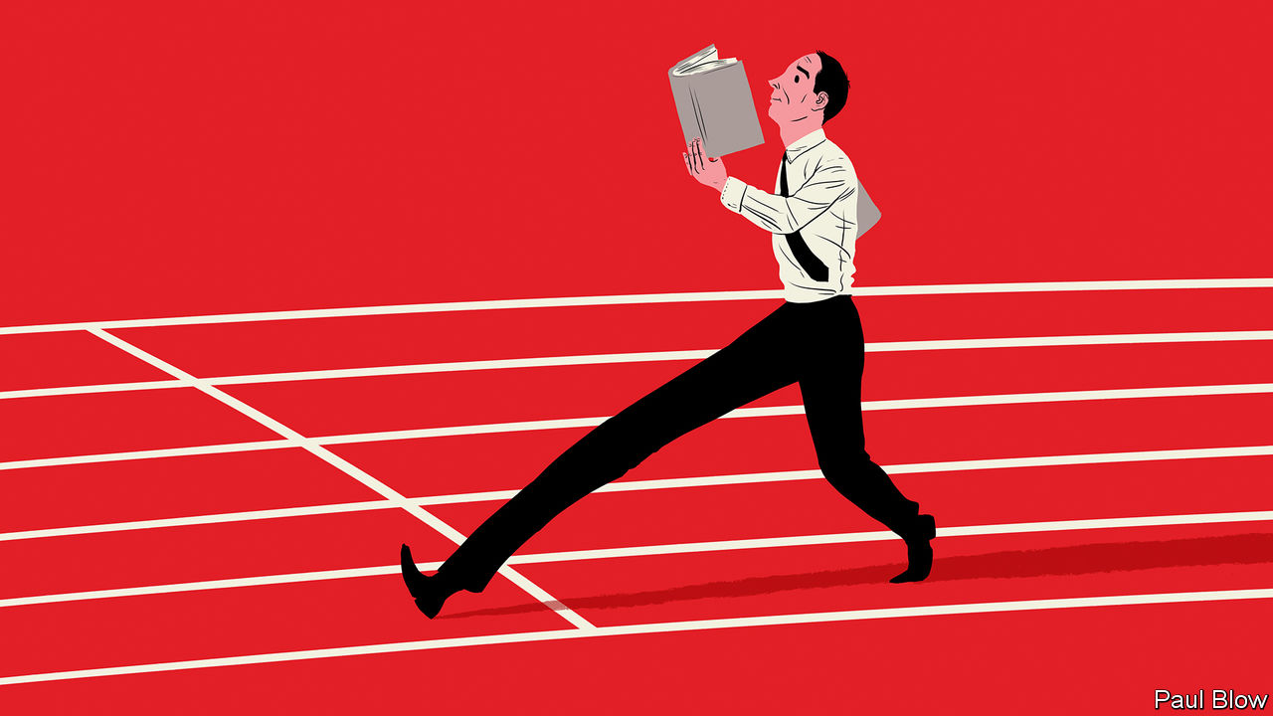

THE MEMOIRS of chief executives can be exercises in pompous self-justification or, just as bad, in grandiose philosophising about social and political trends. Occasionally, however, a corporate titan writes a book that is both readable and a practical guide for managers hoping to follow in their footsteps. David Cote, the former CEO of Honeywell, an industrial conglomerate, has produced an excellent effort with “Winning Now, Winning Later”.

It is true that Mr Cote occasionally comes across as a bit of a martinet. When a team failed to come up with suggestions to cut costs, he ordered them to cancel all other meetings and keep talking until they produced the results. And his juniors were clearly kept on their toes; he was also very much a hands-on manager. “The idea that as a leader you can focus on strategy and delegate its implementation to great people is a fallacy,” he writes. But his approach paid off and the book is a detailed guide to the tricky task of managing a big business.

To give one small example, plenty of executives talk about encouraging greater diversity in the workforce, but little gets done. Mr Cote was fed up with junior managers declaring that they could not find suitable candidates in their area. So he had his team break down the population statistics in places where his factories were located to demonstrate that there should be many opportunities to hire workers from different backgrounds. Diversity duly improved.

The author’s broader aim is illustrated by his subtitle: “How Companies Can Win in the Short Term, While Investing for the Long Term”. He thinks the idea that corporate leaders have no choice but to embrace short-termism in the face of pressure from investors is “one of the most pernicious beliefs circulating in business today”.

When Mr Cote took over at Honeywell in February 2002, he says the company was “a train wreck and on the verge of failure”. Remarkably, the board and outgoing boss refused him any access to the company’s financials until July 2002, when he also became chairman. What he eventually found was that the group had pursued short-term profits through aggressive accounting practices. During the previous decade, for every dollar in earnings Honeywell generated only 69 cents in cash.

He changed the accounting approach, put a greater focus on investment and aimed to expand the business while keeping fixed costs constant. Some of the biggest problems he faced were legacies of the previous regime. For example, former managers had sold a company for $60m but agreed to be liable for meeting asbestos claims in perpetuity. By the early 2000s, the asbestos liability was $1bn. He tried to deal with all such legal claims as quickly as possible. “It’s probably going to be cheaper for your organisation to resolve your legacy issues now than it will be a decade from now, when the harm will have mounted even more,” he writes.

When it came to improving the business, Mr Cote spent a lot of time focusing on Honeywell’s processes. Collectively, these changes were known as the Honeywell Operating System and they included such steps as reducing the use of toxic cleaning chemicals, which cut costs, shortened production time and improved worker safety. Reforming a business is a never-ending task. “Over time all organised systems evolve towards chaos,” he writes. “Unless you pursue change relentlessly, your efforts will eventually wither away.”

Over time, all this made a difference. The company increased investment in research and development from 3.3% of sales in 2003 to 5.5% in 2016, and its operating margins rose from 8% in 2003 to about 16% in 2018. Investors were impressed. Honeywell’s market value rose from $20bn when he took over to $120bn when he left in 2018, with returns easily beating the S&P 500 index.

One suspects Mr Cote’s focus on detail was more important for the company’s success than some of the more standard corporate pronouncements he reveals. Honeywell developed five “initiatives” and 12 “behaviours”, which seems way too many for an employee to keep track.

And despite his best efforts, he does not quite solve the dilemma expressed in his subtitle. At one point, he admits that “Pursuing both short- and long-term performance requires a period of upfront investment during which performance might lag for a little while.” In other words, even an able manager like Mr Cote needs a bit of luck, and patience on the part of directors and shareholders, to turn a company around.

This article was downloaded by calibre from <https://www.economist.com/business/2020/09/12/management-lessons-from-honeywells-former-ceo>

|  |  |  |  |
| --- | --- | --- | --- |
| Previous | Articles | Sections | Next |

|  |  |  |  |
| --- | --- | --- | --- |
| Previous | Articles | Sections | Next |

#### Schumpeter

# How Hermès got away from LVMH—and thrived

The family behind the luxury brand has succeeded by sticking to what it does best: timeless elegance

Sep 12th 2020 |

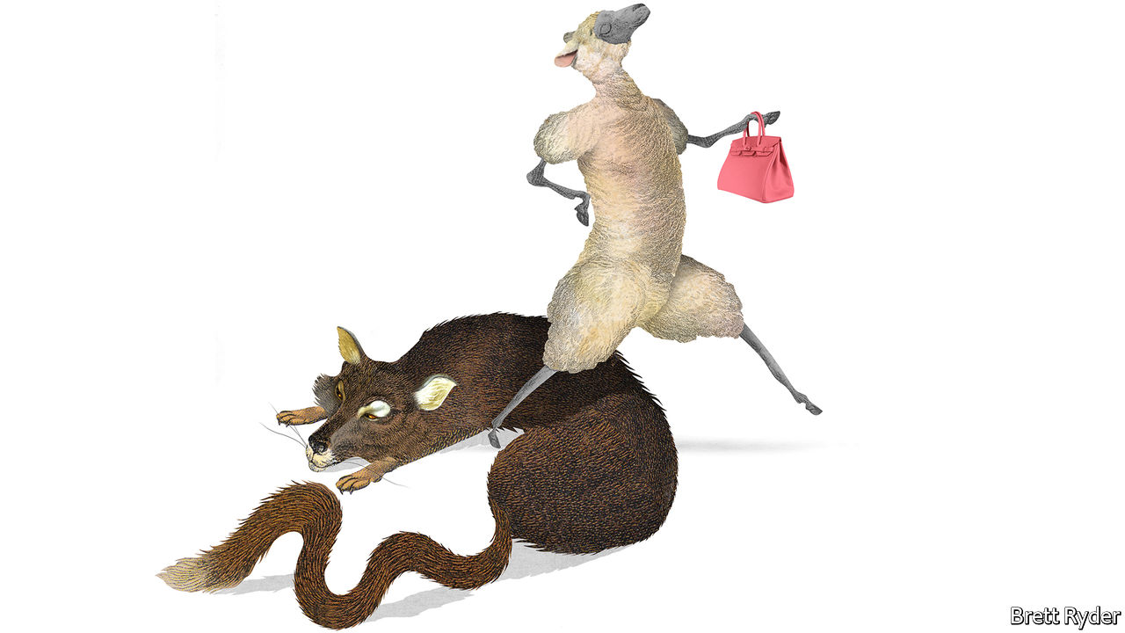

IN THE AUTUMN of 2010 le tout Paris of business braced for the sad, if predictable, end of an era. After 173 years and six generations, Hermès, a purveyor of handbags to bankers and neckties to their husbands, was to become part of LVMH. The champagne-to-evening-gowns mastodon, home to Louis Vuitton and Christian Dior, among many others, had disclosed a stake of 17% and rising. Bernard Arnault, LVMH’s boss, with a knack for closing in on companies he admires, had only to pick off a few Hermès heirs ready to cash out. Bankers assumed the “wolf in cashmere” would take mere weeks to gobble up his elegant prey.

Fast forward to autumn 2020, and the various descendants of Thierry Hermès not only still control their family’s firm, they have beaten LVMH at its own game. One of their own, Axel Dumas, has reclaimed the helm from an outside manager. Mr Arnault has all but scarpered off the Hermès shareholder register and moved on to other targets, though not always successfully: on September 9th LVMH said it would not go ahead with a $17bn bid for Tiffany, an illustrious American jeweller. By just about any measure, Hermès has led the luxury pack, nearly trebling revenues between 2010 and 2019, to €6.9bn ($7.7bn). Operating margins last year hit 34%, best in the industry. Even as it has been roiled by covid-19, its market capitalisation has risen this year to €78bn, while big competitors have shrunk.

Plenty of companies, particularly those with family histories, resist the lure of takeovers by bigger rivals. Often the decision is guided by pride rather than financial sense. Hermès provides a road map of how to stay independent—and how it can pay off.

The first step was to keep the wolf at bay. Though listed since 1993, most of Hermès’s shares belonged to 60 or so descendants, split into various branches. Hermès threw up all manner of defences. Mr Arnault was publicly rebuked as a corporate raider (less polite language was used). Lawyers attacked the underhand way in which his stake was built through complex financial products that skirted disclosure rules (LVMH was later fined €8m by the markets regulator). Ultimately, Hermès family members eager to remain in charge created a structure which pooled just over 50% of shares, committing themselves to owning their stakes come what may until 2031. By 2017 Mr Arnault had given up.

The second step is to use independence wisely. That Mr Arnault coveted Hermès is testament to its good management. But the general rule in the past decade has been that multibrand conglomerates like LVMH, Richemont (home of Cartier and Montblanc) or Kering (Gucci and Saint Laurent) hold an edge over single-brand outfits like Burberry, Prada or Hermès. The cost of building new e-commerce capabilities can be spread more widely; size gives a bargaining advantage with landlords. Creators are lured to the biggest names in a virtuous loop of desirability.

Hermès might have struggled to compete head-on. So instead—and this is the wise part—it played to its strengths. While rivals flocked to the fashionable, ostentatious and cutting-edge, it erred on the side of discretion, timelessness and tradition. Its biggest hits today, the Birkin and Kelly handbags that often sell for $10,000 or more, are refreshed versions of what it has sold for decades. It can do whimsy and eye-catching: its website currently features a functioning porcelain skateboard, a snip at €3,350. And whereas a Dior dress will last one season, an Hermès product is for life. As creative directors shuffle from one brand to the next, at Hermès the same designer has overseen menswear since 1988.

Understatement works as a strategy only because Hermès enjoys an aura of exclusivity. This gives it pricing power to sell knick-knacks for over ten times what they cost to make. Waiting lists for Birkins stretch for years. Because much of what it sells carries through the seasons, Hermès does not need discounts to get it off the shelves. That preserves both margins and the brand, a luxury group’s most valuable asset. The firm claims not to have a marketing department. It is the kind of claim a clever marketing department might dream up, but Hermès does spend only around 5% of revenues on advertising and promotions, half the share of rivals.

The stolid approach has paid off in the pandemic. Sales will probably drop this year because of store and factory closures in the spring. But Hermès looks in better shape than its competitors, says Luca Solca of Bernstein, a broker. It is less reliant than they are on Asian tourists shopping in Paris or New York. It makes most of its wares itself, so does not need to bail out third-party suppliers. Demand wobbles are less of a problem given those long waiting lists. And if well-heeled consumers are to spend in a recession, they favour timeless brands.

For success to endure, Hermès heirs may require one more thing. The company is a digital laggard. A mere 2-3% of its sales last year came from its website, half its rivals’ share. Its Instagram account—a measure of a brand’s buzziness—has just 10m followers, compared with 41m for Chanel or Gucci. It lacks younger consumers who inject brands with vitality; according to Citigroup, a bank, only a quarter of sales are to Gen-Zs or millennials (the oldest of whom are about to turn 40).

## Tough as leather

Mr Dumas is alive to this. Hermès has started to branch out into cosmetics, offering aspiring shoppers a cheaper entry point than Birkins (or skateboards). It has invested in a Chinese venture, Shang Xia, that may be useful if consumers in China—big buyers of luxury goods—start coveting local baubles instead of French ones.

Such moves are not so different from Mr Arnault’s. He might have executed the same savvy strategy at Hermès; LVMH executives still speak of the “brand that got away” with reverence. But the Hermès clan can draw satisfaction from the fact that their investment in the family firm has yielded returns of over 400% since 2010—even juicier than if they had traded their stakes for LVMH shares. ■

This article was downloaded by calibre from <https://www.economist.com/business/2020/09/12/how-hermes-got-away-from-lvmh-and-thrived>

|  |  |  |  |
| --- | --- | --- | --- |
| Previous | Articles | Sections | Next |

|  |  |  |
| --- | --- | --- |
| Business | Sections | Schools brief |

Finance & economics

Stockmarkets: Techtonic shifts

.

Fractional ownership: Money in the Banksy

.

Global trade: Down but not out

.

Climate change: Stormy waters

.

Buttonwood: Eggheads

.

Cyber-heists: Malware and mules

.

European banks: Badwill hunting

.

Free exchange: Which market model is best?

.

|  |  |  |
| --- | --- | --- |
| Business | Sections | Schools brief |

|  |  |  |  |
| --- | --- | --- | --- |
|  | Articles | Sections | Next |

#### Techtonic shifts

# Beware the power of retail investors

Armed with derivatives, they are raising the volatility of tech stocks

Sep 12th 2020 | NEW YORK

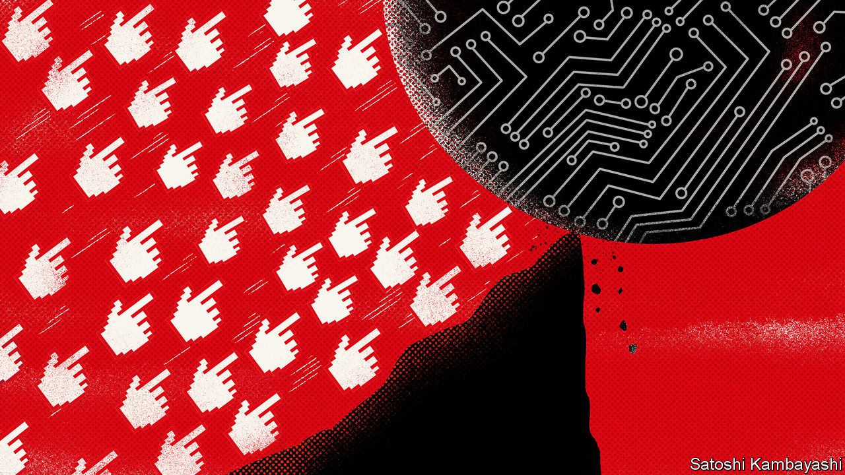

THE END of the summer often brings about a dose of realism. Children bemoan the end of their leisurely holidays and trudge back to the classroom. Summer-lovers return from the beach. This time of the year often brings stockmarket investors back to Earth, too. On average, since the 1950s, September has been the worst month for American shares.

Could it be happening again? The end of summer has brought a burst of volatility to the share prices of America’s tech giants, especially the five “mega-cap” firms—Alphabet, Amazon, Apple, Facebook and Microsoft—that had driven the Nasdaq, an index of tech stocks, and the S&P 500, a broader index, to record highs in late August (see chart). After a blistering three-day sell-off, on September 9th stockmarkets rebounded, suggesting investors are still seeing buying opportunities when markets dip. But the dramatic swings have highlighted a shift in market dynamics that may continue to foster instability. It is driven by a rare combination of retail investors and high-octane derivatives trading.

Derivatives have been called weapons of mass destruction. In this case the masses have weaponised themselves with call options, a type of derivative that gives the buyer the right, but not the obligation, to buy a stock at a given “strike” price on a specific date in the future. Options can have an outsized impact on prices because they leverage investments—a buyer might spend just $1,000 to purchase an option that could give him a position worth $10,000 or $20,000. If a stock price rises above the strike price before the option’s expiry, the holder can buy the share at the lower price and pocket the difference. Otherwise, the option expires worthless. The total nominal value of calls traded on individual American stocks hit a record high in the last two weeks of August, averaging $335bn a day, according to Goldman Sachs—the first time the average daily volume of traded stock options has exceeded trading volume for the shares themselves. The volume of calls was more than triple the rolling average between 2017 and 2019.

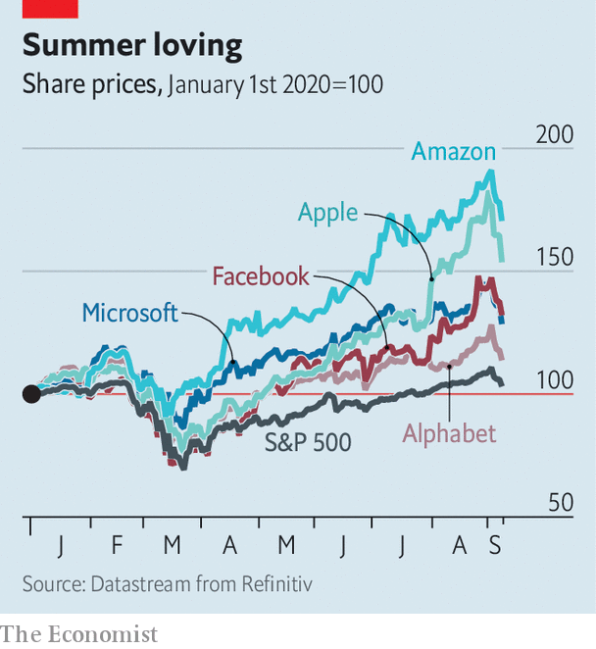

Two types of option activity stand out. The first is institutional trading, in particular the huge option positions purchased by SoftBank, the Japanese conglomerate run by Masayoshi Son. On September 4th the Financial Times reported that SoftBank had purchased $4bn-worth of call options on American tech companies. The notional value was about $30bn.

The second is the rapid growth in purchases of call options by small traders (see chart), dubbed the “Robinhood effect” after the popular platform on which many retail investors punt. Historically, large orders of options—in bundles of more than ten contracts, or around $10,000-worth—were the dominant source of options-buying. But through 2020 small buyers, who acquire fewer than ten contracts at a time, have taken a bigger share of the market. This trend has been especially pronounced over the past four weeks. Small buyers have spent more than $37bn on call options, giving them a notional exposure probably in the region of $500bn or more. Even with the five “mega-cap” tech stocks worth a combined $6trn, that gives them a lot of clout.



Who bears most responsibility for the volatility? First, small-trader flow is much larger in size, although it was likely dispersed among more listed companies. Second, and more importantly, although both types of buyer purchased options, the trades differ greatly. The options bought by SoftBank are reported to be long-term (three- or six-month) bets on the biggest tech firms, like Amazon and Microsoft. They were also “delta-hedged”, as is typical for institutional investors, meaning that at the same time as SoftBank bought the options, its bankers also sold the underlying stocks in proportion to the exposure the option gave them. This is important, because it means that the marketmakers who sold SoftBank the options did not immediately have to hedge their position by buying up shares in, say, Microsoft or Amazon.

This is different to the type of option that retail investors typically buy, which is a call option purchased “naked”, ie without a hedge. Significant volumes of unhedged call options will force the marketmakers to buy up shares in the underlying stocks, creating a positive—and potentially euphoric—feedback loop. Adding to this dynamic is the short-dated nature of the derivatives. The value of an option that is short-lived moves rapidly as the share price moves. As expiry approaches, any increase in the price of the stock makes the option more valuable. Moreover, it means that the marketmakers who sold the option will quickly need to bolster the size of their hedges, increasing the upward momentum. These differences make it more likely that retail flows were a bigger driver of momentum in tech stocks in August than SoftBank was.

This heavy use of derivatives may also explain some unusual market dynamics. Because shares tend to inch higher steadily, but drop more rapidly, rising markets usually occur amid falling volatility. However, the leaps in share prices in recent weeks have caused the correlation between falling volatility and rising prices to break down for the first time since 2018.

What does this imply about the future performance of tech stocks? Because of the influential role of turbocharged retail investment, prices can be expected to remain choppy. Moreover, the market is entering a period where typical covid-19-related volatility may be exacerbated by the twists and turns of America’s presidential election.

That said, much of the tech recovery from the lows in March was rooted in fundamental shifts, like policy interventions, or pandemic-prompted changes to consumer behaviour, such as online shopping, that have helped firms like Amazon. Even if the giddy obsession with tech firms exhibited during the summer fades, there may be little reason for investors to throw in the beach towel yet. ■

This article was downloaded by calibre from <https://www.economist.com/finance-and-economics/2020/09/12/beware-the-power-of-retail-investors>

|  |  |  |  |
| --- | --- | --- | --- |
|  | Articles | Sections | Next |

|  |  |  |  |
| --- | --- | --- | --- |
| Previous | Articles | Sections | Next |

#### Money in the Banksy

# How to bet on art and other baubles

There’s an app for that

Sep 10th 2020 |



IMAGINE OWNING a Claude Monet, a 1977 Lotus Esprit, or a thoroughbred racehorse. Some retail investors have got their kicks during the pandemic taking a punt on call options (see [article](https://www.economist.com/node/21791718)). But others prefer a slice of the high life. With a tap on an app—and often for less than the price of a bottle of champagne—they can fill their boots with expensive baubles.

This is fractional ownership, millennial-style. An investment idea more often associated with private jets and holiday homes has spread to art, vintage cars, sports memorabilia and other esoteric acquisitions, and has soared in popularity since covid-19 put other forms of betting on hold, its protagonists say.

The trend began after America’s Securities and Exchange Commission issued a rule in 2015 increasing the amount that firms could raise in “mini” initial public offerings (IPOs) to $50m. These are open to the public, not just “accredited” investors. Though industry-wide data are scarce, Anthony Citrano, founder of Acquicent, a fractional-ownership startup specialising in classic cars, estimates that the overall market was worth just under $50m at the start of the year. Now he reckons it has grown by a fifth. Rob Petrozzo of Rally Rd, which offers shares in vintage cars, wines and books, says under-30s have flocked to the platform.

Masterworks, founded in 2017, has sold 15 artworks with valuations of at least $1m during the pandemic, says Scott Lynn, its founder. That includes $1.5m-worth of shares sold in a company formed around a single artwork by Brian Donnelly, a former street artist known as Kaws. The price per share was only $20 but the risk factors in the IPO offer document were 15 pages long. The company has no history and expects no revenues, and the painting may be sold at a loss, it warned. Other mini-IPOs have been of works by Andy Warhol and Banksy.

Most commonly the startups acquire something enticing at an auction, say, or from a gallery, then form a firm directly linked to the asset, and sell shares in it. A different model is to acquire a minority stake in something belonging to a private owner or a gallery looking to find some liquidity but unwilling to part with the entire asset. “If I have a Cézanne in my living room, no one will know that I only own 60% of it,” says Kevin Conroy, a former board member of Sotheby’s, an auction house, and an adviser to Acquicent, which plans to use this approach. That model may appeal to museums struggling to make ends meet, he adds.

Some products may generate modest dividends for investors, through sponsored events or leasing arrangements. Investors sometimes have access to galleries run by a platform, or may win a draw to parade a racehorse in the paddock. But the ability to trade shares in secondary markets is rare, the expensive assets acquired are illiquid and fraught with risk, and some punters will inevitably lose their shirts. At least for a while, though, they can feel like they are living “The Great Gatsby” lifestyle. And if their bets go sour, there is always champagne.

This article was downloaded by calibre from <https://www.economist.com/finance-and-economics/2020/09/10/how-to-bet-on-art-and-other-baubles>

|  |  |  |  |
| --- | --- | --- | --- |
| Previous | Articles | Sections | Next |

|  |  |  |  |
| --- | --- | --- | --- |
| Previous | Articles | Sections | Next |

#### Down but not out

# How has trade survived covid-19?

Better than during the global financial crisis

Sep 12th 2020 | WASHINGTON, DC

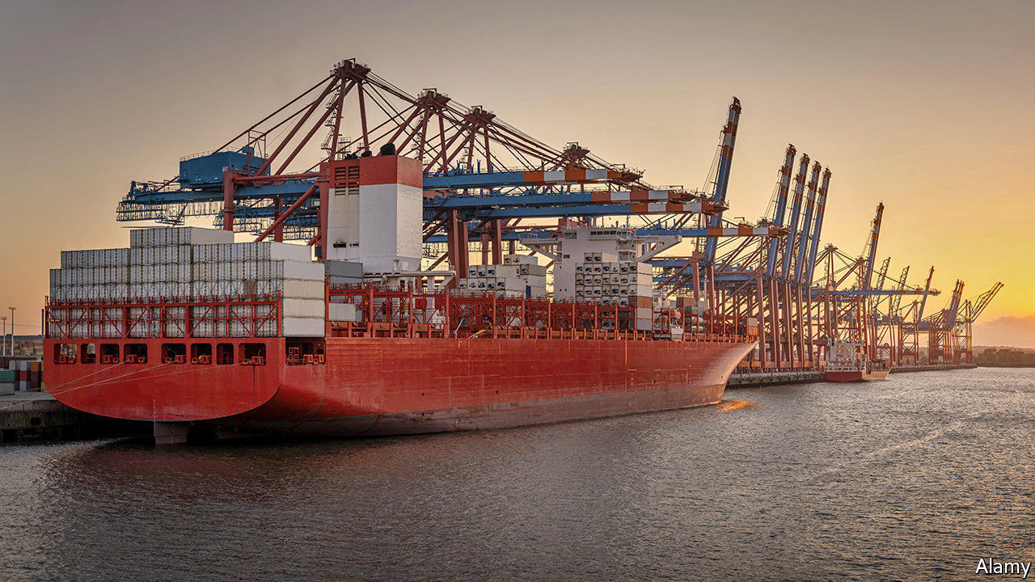

IN QUENTIN TARANTINO’S “Kill Bill: Volume 2”, an action drama, the protagonist, played by Uma Thurman, punches her way out of a coffin. Global trade in goods has performed a similar death-defying stunt during the covid-19 pandemic. In April things looked dismal. Some predicted global trade would slump by more than 30% this year, compared with 2019. But after a gut-wrenching spring, trade volumes recorded their biggest monthly rise on record in June, the last month of available data (see chart). Oxford Economics, a consultancy, predicts that in 2020 as a whole volumes may drop by 10%.

This resilience has defied recent experience, as well as expectations. In 2009, when global GDP fell by 0.1% in the final year of the financial crisis, trade plunged by a whopping 13%. This year the IMF forecasts that global GDP could fall by 4.9%, ie, 50 times more than in 2009. So why will the hit to trade probably be smaller?

After the financial crisis trade volumes fell much further than GDP mostly because people stopped buying heavily traded durable goods, such as cars. But in the current crisis, untraded domestic services have been harder hit than they were back then. Going to the cinema or a restaurant halted during lockdown. Buying an imported fridge did not. That has made the drop in trade relative to GDP smaller.

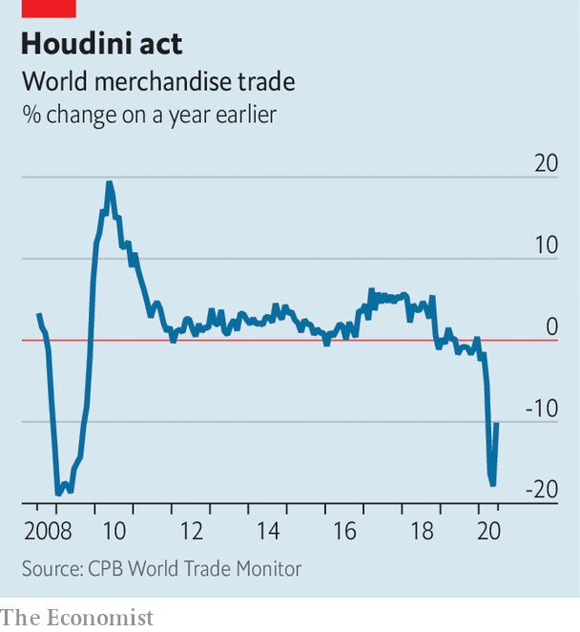

Moreover, the robustness of the world’s production apparatus has underpinned trade flows. Covid-19 froze supply chains, but in Asia at least they swiftly started to thaw. According to Simon Evenett of the University of St Gallen in Switzerland, the number of trade restrictions applied on medical goods and medicine since the start of the crisis peaked in April, and has since fallen by 15%. Even more importantly, lockdowns were lifted more quickly than expected, allowing exporting powerhouses like China and Germany to reopen factories and boost output.

Pandemic-induced demand gave trade in some products extra pep. America’s imports of protective equipment tripled between March and July, calculates Panjiva, a trade-data company. Covid-related products including computing equipment for home-working has accounted for the majority of China’s year-on-year export growth in each month since June. Eytan Buchman of Freightos, an online marketplace, reports that ocean-freight prices are surging for routes between America and South-East Asia, partly because of “near-frantic” e-commerce offerings by small businesses.

Policymakers have played a pivotal role in the trade revival. Monetary and fiscal firepower was bigger and faster than trade experts had expected. Central-bank liquidity measures kept trade finance flowing better than it did during the financial crisis, says Jennifer McKeown of Capital Economics, a research outfit.

Although the trade performance is cause for relief, no one should declare victory yet. A second wave of lockdowns, or overhasty efforts to curtail economic stimulus, could derail the recovery. The value of exports from South Korea dipped in August relative to July, as did those of China after adjusting for an artificially depressed base in 2019. Robert Koopman, chief economist of the World Trade Organisation, which oversees global trade, doubts there will be a sustained V-shaped recovery.

Overlaying this is a concern about the lingering unevenness of trade. Brad Setser of the Council on Foreign Relations, an American think-tank, says that the trade slump has shrunk the gap between most countries’ imports and exports, reducing imbalances. Yet there have been two standout exceptions. The first is China, whose rapid reopening has sent its exports of goods surging to a level last seen before the Sino-American trade war—almost $60bn higher than imports in August. The second is America, whose policies to stoke demand have had the side-effect of causing its trade deficit to increase further—to around $80bn in July.

This imbalance is ominous. Although the so-called Phase One trade deal between America and China was meant to prop up American exports to China, so far it has disappointed. Meanwhile, President Donald Trump is haranguing China ahead of elections in November. Trade may not have performed as badly as many feared. But it still has an alarming ability to pack a Thurmanesque punch. ■

Editor’s note: Some of our covid-19 coverage is free for readers of The Economist Today, our daily [newsletter](https://my.economist.com/user#newsletter). For more stories and our pandemic tracker, see our [hub](https://www.economist.com/news/2020/03/11/the-economists-coverage-of-the-coronavirus)

This article was downloaded by calibre from <https://www.economist.com/finance-and-economics/2020/09/12/how-has-trade-survived-covid-19>

|  |  |  |  |
| --- | --- | --- | --- |
| Previous | Articles | Sections | Next |

|  |  |  |  |
| --- | --- | --- | --- |
| Previous | Articles | Sections | Next |

#### Stormy waters

# Ports are highly exposed to climate change and often ill-prepared

Over half of global trade passes through ports with high climate risks

Sep 12th 2020 |

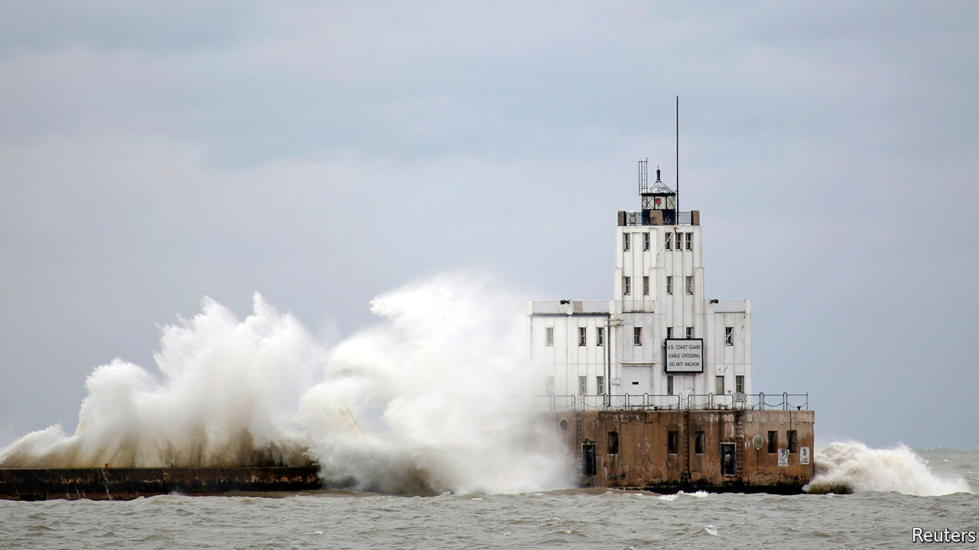

IN MID-JANUARY a storm gathered over Lake Michigan. Gale-force winds dragged water up and dumped it on Milwaukee. The city was “pummelled”, says Adam Tindall-Schlicht, the director of its port, which was badly damaged. Dock walls were ripped off and washed inland. The trade routes the port serves, including those for steel from Europe, were disrupted. Climate change has exacerbated the risk of such storms. Mr Tindall-Schlicht notes that water levels on the Great Lakes have never been so high.

Seaports are by their nature exposed to the elements. But they are also choke-points of global trade, handling 80% of the world’s goods. So disruption at a port can have far-reaching consequences. When Hurricane Katrina shut down three ports that process 45% of America’s agricultural goods, national food prices rose by 3%. Hurricane Harvey had a similar effect on the price of fuel. One study modelled floods hitting the port of Rotterdam in the Netherlands. It estimated the impact on trade would add an extra 64% to 86% to the overall cost, on top of the direct damages.

To find out how big the risk to global trade is, The Economist asked Four Twenty Seven, a climate-risk consultancy, to assess the world’s 340 or so biggest ports, according to the Institute of Shipping Economics and Logistics. The analysis looked at the ports’ annual throughput, measured in 20-foot equivalent units, and their exposure to six types of climate-related events, including storms and wildfires. Fully 55% of global trade passes through ports which have a high risk of at least one type of event. (“High” in this case means roughly the exposure that South Carolina has to hurricanes.) About 8% of trade was vulnerable to three or more climate hazards.

Some ports, particularly big ones in rich countries, have built defences. But often ports are ill-prepared. Ageing infrastructure is one problem. Mr Tindall-Schlicht says much of his port was built in the 1960s.

Other ports do not have the proper procedures in place. Jan Brooke of the World Association for Waterborne Transport Infrastructure highlighted a recent survey that asked 67 ports if they had performed climate-risk assessments, installed early-warning systems or made contingency plans. Only 15% had done all three. Over a fifth had done none at all.

One reason is that it is not always clear who is responsible for a port’s resilience. Many ports are government-owned but operated by a firm. In America building a storm barrier is primarily the purview of the Army Corps of Engineers. Protecting the roads that serve ports is done by state or federal departments of transportation. Rarely do all the actors co-ordinate.

Another hurdle, particularly in poor countries, is climate financing. Ports often go to development banks to raise funds. The banks are used to supporting big infrastructure projects. It is hard to get small amounts of money for a single port.

Efforts to ease the problem are under way. UNCTAD, the UN trade and development body, is teaching port managers about climate resilience. Networks of ports and groups of civil engineers are drawing up guidelines on adaptation. But there is often little incentive to prepare. Ms Brooke notes that the ports hit by extreme events are the ones most willing to adapt. Sadly, their number is only likely to grow.■

For more coverage of climate change, register for The Climate Issue, our fortnightly [newsletter](https://www.economist.com/theclimateissue/), or visit our [climate-change hub](https://www.economist.com/news/2020/04/24/the-economists-coverage-of-climate-change)

This article was downloaded by calibre from <https://www.economist.com/finance-and-economics/2020/09/12/ports-are-highly-exposed-to-climate-change-and-often-ill-prepared>

|  |  |  |  |
| --- | --- | --- | --- |
| Previous | Articles | Sections | Next |

|  |  |  |  |
| --- | --- | --- | --- |
| Previous | Articles | Sections | Next |

#### Buttonwood

# What can be learnt from Chinese futures trading?

If you love eggs, this is the market for you

Sep 12th 2020 |

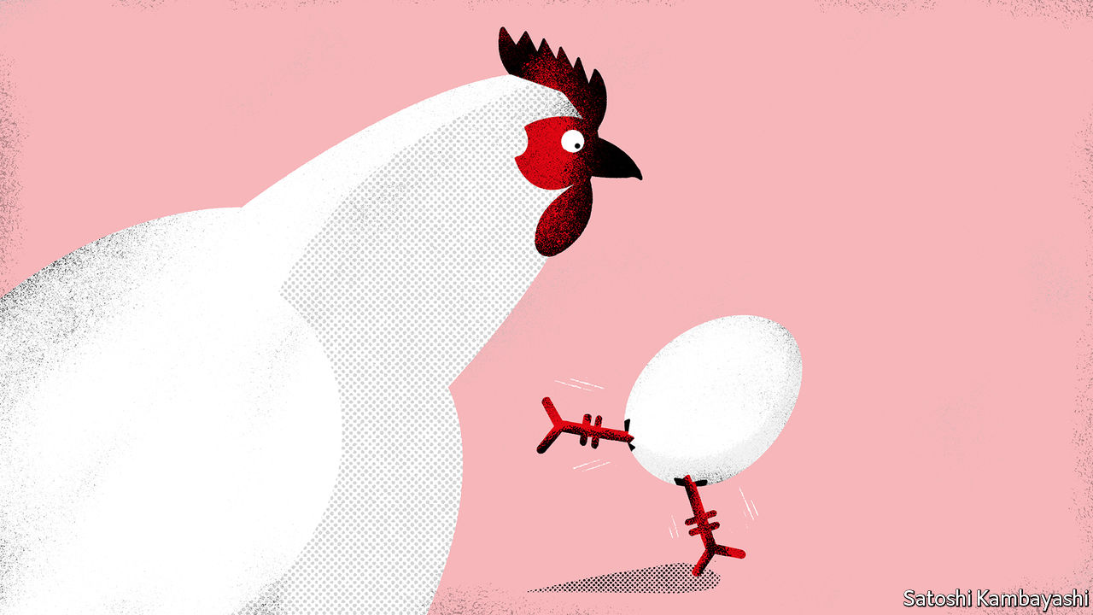

“SO LONG AS you think about what others are thinking about, and stick to your trading strategy, you can always be successful.” This encouraging, if dubious, sliver of market wisdom was proffered on September 3rd by Zhou Chengji, a Chinese investment adviser, during a two-hour online tutorial. China is hardly alone in having a raucous community of would-be market gurus and day traders. But Mr Zhou’s focus was on an asset that makes China look rather unusual: egg futures, the only ones of their kind in the world nowadays.

For punters with strong views about whether hens will be productive this autumn and whether people will crave egg-fried noodles and the like, China is the place to be. All they need do is contact local brokerages and put down a 4,000 yuan ($585) deposit. Going long eggs (ie, betting prices will rise) was, briefly, one of the trades of the summer, with futures soaring 65% from late May to late July. Since then the market has cracked, prices tumbling more than 20%. Turnover is extraordinarily high. Investors buy and sell roughly 3m tonnes in egg futures every day, about a tenth of the total that China actually consumes in a full year. The rights to a single egg may, in effect, pass through a few dozen hands before it lands in boiling water.

All this makes it tempting to dismiss Chinese futures as a hotbed of speculative excess. Retail traders do play a much bigger role on the country’s commodity exchanges—in Shanghai, Dalian and Zhengzhou—than in Chicago or London, which have long been the world leaders in, respectively, agriculture and metals. Officials estimated that in 2016 about 85% of open positions on Chinese exchanges were held by individuals, compared with less than 15% in America, where institutions dominate trading. Nevertheless, the very immaturity of the Chinese market also reveals some enduring truths about futures that are obscured by the smoother functioning of century-old exchanges.

Start with the most basic, the need to hedge. Futures are a tool for producers to guard against prices plunging and for consumers to guard against them soaring. In the West this can look quite straightforward because market power is so concentrated. The top four steel companies accounted for about 80% of production in America in 2017 versus just 20% or so in China. Fragmented spot markets make it harder for futures to serve as a benchmark. Yet it is dangerous to operate without a pricing backstop. So China has been rushing to expand its universe of futures. In the past two years alone it has launched more than ten new contracts, from crude oil and stainless steel to apples and red dates. It will take time to establish their credibility.

If China still has much to learn about futures, there is something to be said for its trading intensity. Of the 20 most active contracts in the world last year, 14 were on Chinese exchanges, according to the Futures Industry Association, a global trade body. Some of that is because of double counting. It can also reflect the swirling pool of money trapped in China by capital controls. Nevertheless, there are limits to the potential irrationality in futures trading because ultimately the underlying commodities are due for physical delivery. Futures contracts thus converge with spot prices as they near expiry. Two other factors help explain China’s trading volume. Lot sizes are generally small (for example, five tonnes for copper futures in Shanghai, compared with 25 tonnes in London). And ordinary investors have easy access through their brokerage accounts. Institutional traders in China love the liquidity that results from this. It eliminates the risk of being unable to enter or exit a position because of a lack of trading.

There is another reason why institutional traders like China. They can profit with relative ease. Commodity futures illustrate how cloistering a financial system from the rest of the world leads to distortions. Darin Friedrichs of StoneX, a commodities brokerage, says that easily disprovable rumours can cause price swings; unfounded reports of a Brazilian port closure recently drove up soyabean futures. Traders relish their “import-arb” windows, when prices of Chinese futures exceed those of their global counterparts, making it worthwhile to arbitrage by buying abroad and selling onshore.

Slowly, regulators are dismantling the walls, allowing more international firms to trade in China. Futures with international counterparts such as oil and corn are starting to align more with global prices. For the adventurous, though, there are always eggs.

This article was downloaded by calibre from <https://www.economist.com/finance-and-economics/2020/09/12/what-can-be-learnt-from-chinese-futures-trading>

|  |  |  |  |
| --- | --- | --- | --- |
| Previous | Articles | Sections | Next |

|  |  |  |  |
| --- | --- | --- | --- |
| Previous | Articles | Sections | Next |

#### Cyber heists

# How to launder ill-gotten gains

A popular form of bank theft blends the digital and physical

Sep 10th 2020 |

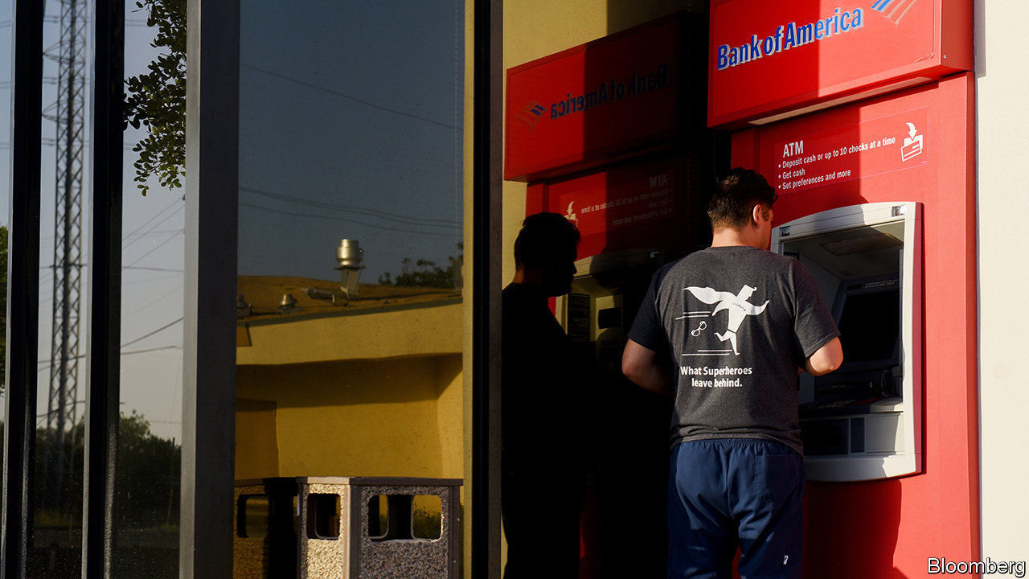

WHEN WILLIE SUTTON was asked why he robbed banks, he reputedly replied: “Because that’s where the money is.” These days there is no need to don a mask and wave a gun: bandits can steal millions from their armchairs, wielding nothing more lethal than malicious code.

Cyber-thieves grow ever more persistent, with banks and cryptocurrency exchanges among the main targets. One estimate, from 2018, put total cyber-crime revenue at $1.5trn or more a year (including not only bank jobs but also theft of intellectual property, counterfeiting, data-ransoms and so on). It could be higher now, thanks to covid-19. Many financial firms have struggled to keep security tight with so many staff working from home.

Most big heists are carried out either by organised-crime groups or state actors. Focus on the latter has sharpened since hackers thought to be linked to the North Korean government stole $101m (and almost got away with another $850m) from Bangladesh’s central bank in 2016, after manipulating transfer instructions from SWIFT, a global payments tool with 11,000 members.

After a lull in activity, the North Koreans are back. American government agencies recently issued an alert warning that they have been cooking up new bank-robbing schemes to help fund the regime of Kim Jong Un, cash-strapped by sanctions.

One such scheme, known as an “ATM cash-out”, is described in a new report by SWIFT and the financial-consulting arm of BAE Systems, a defence contractor, on how cyber-heists are carried out and the gains laundered. Far from being all-digital, it involves hacking cash machines to spit out notes, which are grabbed by accomplices known as “money mules”. Among those who specialise in cash-outs are the BeagleBoyz, a group linked to the Reconnaissance General Bureau, a North Korean spy agency, who have attempted to steal nearly $2bn since 2015, say the American agencies.

The downside of attacking ATMs is that they hold limited amounts of cash. So the hackers do it in volume. Machines in upwards of 30 countries (including America) have been targeted in a single strike. But that also makes it labour-intensive: an attack on one bank, by a group called Lazarus, involved 12,000 ATM withdrawals across 28 countries, all made within two hours, according to the report.

The mules are also used to get the stolen cash back into the financial system. One common way to do this is to take it to a casino, convert it into chips, and then exchange it back into cash in the form of a cheque from the casino showing a legitimate transaction. This can then be deposited in a bank without ringing alarm bells.

Efforts to foil such schemes tend to focus on identifying mules from CCTV footage, then trying to connect dots up the chain of command. Some banks are taking more extreme measures. After being warned about the latest threat from North Korea, some Bangladeshi lenders have opted to shut their ATMs down between midnight and 6am to reduce the threat from cash-outs.■

This article was downloaded by calibre from <https://www.economist.com/finance-and-economics/2020/09/10/how-to-launder-ill-gotten-gains>

|  |  |  |  |
| --- | --- | --- | --- |
| Previous | Articles | Sections | Next |

|  |  |  |  |
| --- | --- | --- | --- |
| Previous | Articles | Sections | Next |

#### Badwill hunting

# Why are European banks merging?

An ECB accounting change is encouraging new alliances

Sep 10th 2020 | BERLIN

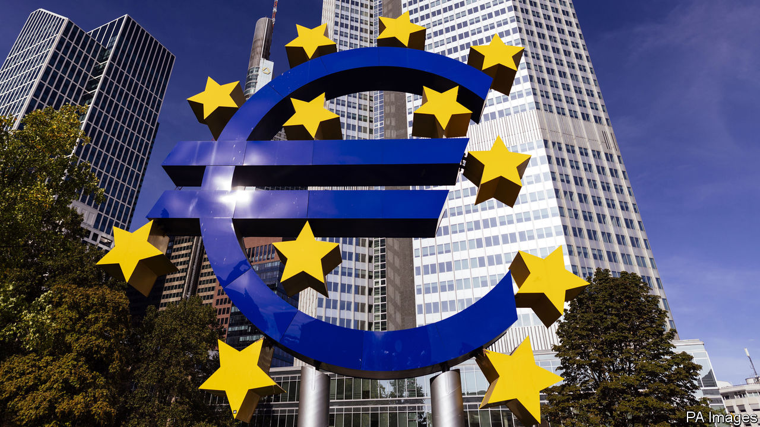

WHEN CAIXABANK and Bankia, its state-owned peer, announced on September 3rd that they were exploring a merger to create Spain’s biggest domestic lender, politicians, regulators and analysts offered unusually unanimous applause. If the deal goes through, it will boost consolidation within the Spanish market, hitherto highly fragmented beneath the two international giants, Banco Santander and BBVA. It may also inspire similar deals elsewhere in the European Union.

If European banks want to catch up with American and Chinese ones, they must push for consolidation. European banks have a 6.7% return on capital on average, the lowest of any region, according to the Banker, a trade publication. Among American banks, it is 14.4%. Greater scale would also help them make the big investments in technology platforms and data analysis required to keep up with digitisation. As it is, parts of the region are massively overbanked, especially when compared with post offices, which are also stalwarts of the analogue era (see chart).

Yet mergers and acquisitions between European banks have plummeted over the past decade. At the start of last year merger talks between Deutsche Bank and Commerzbank, Germany’s largest listed lenders, ended after a mere six weeks. According to S&P Global Market Intelligence, the number of mergers in 2019 fell to the lowest level since the global financial crisis. Only 40 bank takeovers involved buyers or targets based in the European Economic Area or Switzerland. That compared with 62 in 2018 and 122 in 2011.

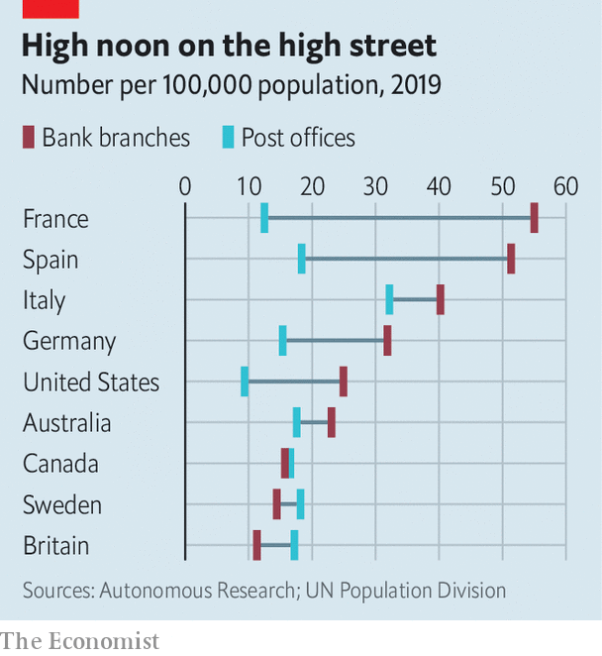

Two factors could boost the urge to merge. The first is the fallout of covid-19, which has left banks saddled with bad loans and struggling with rock-bottom interest rates. That challenges many banks’ ability to soldier on alone. Secondly, the European Central Bank encouraged banks in July to recognise an accounting gain known as negative goodwill, or “badwill”, that they generate when they buy a rival below tangible book value, or at a lower price than the sum of its assets minus liabilities.

This accounting technique enables banks to use badwill to offset restructuring charges—eg, from branch closures or lay-offs—though it cannot be used to pay dividends to shareholders, explains Stuart Graham of Autonomous, a financial-research firm. It is not unprecedented: American regulators allowed banks to use badwill to shore themselves up during the financial crisis. Some dismiss badwill as dodgy accounting but it could be pivotal. A €2bn ($2.4bn) badwill bonus has encouraged Intesa Sanpaolo, Italy’s largest bank, to take over UBI Banca, another Italian bank, this year. It would have a bearing on the proposed Spanish bank merger. For the same reason, Mr Graham predicts that Italy’s Monte dei Paschi di Siena, the country’s oldest bank, could be a takeover target.

Cross-border mergers are not yet on the menu, though. Ronit Ghose of Citigroup, a bank, says bank bosses need to feel confident about their domestic businesses to launch international forays. They are not. Moreover, it is harder to achieve cost-cutting synergies across borders because Europe’s financial market is far from unified. The absence of a common European deposit-insurance scheme is another obstacle; one is not planned until 2025.

Jörg Eigendorf, a spokesman for Deutsche Bank, concedes that in the near future the competitiveness gap between European and American banks is only likely to grow. Sadly, even if Deutsche and Commerzbank rejoined the merger fray, the combination of two such serial underperformers would not change that. ■

This article was downloaded by calibre from <https://www.economist.com/finance-and-economics/2020/09/10/why-are-european-banks-merging>

|  |  |  |  |
| --- | --- | --- | --- |
| Previous | Articles | Sections | Next |

|  |  |  |  |
| --- | --- | --- | --- |
| Previous | Articles | Sections | Next |

#### Free exchange

# Which is the West’s best market model?

Covid tests the merits of two Western modes of capitalism

Sep 12th 2020 |



Editor’s note: Some of our covid-19 coverage is free for readers of The Economist Today, our daily [newsletter](https://my.economist.com/user#newsletter). For more stories and our pandemic tracker, see our [hub](https://www.economist.com/news/2020/03/11/the-economists-coverage-of-the-coronavirus)

POLITICAL ECONOMY is a discipline in which rigorous empirical testing is difficult. Scholars are rarely presented with the kind of naturally occurring experiments which crop up in other fields of economic inquiry, such as when one state increases its minimum wage while its neighbours do not. Covid-19 is different. Though it is quite the cloud, for political economists the silver lining is that it provides an opportunity to look, in real time, at how different models of governance react to a simultaneous shock.

Various taxonomies are used to categorise models of capitalism. A prominent one was set out in 2001 in “Varieties of Capitalism”, a book edited by Peter Hall, a political scientist, and David Soskice, an economist. It distinguished between liberal market economies (LMEs) such as America, Britain and Canada, and co-ordinated market economies (CMEs) such as Germany, the Nordic countries, Austria and the Netherlands. LMEs’ capitalism is red-blooded, relying on market mechanisms to allocate resources and determine wages, and on financial markets to allocate capital. CMEs, though still capitalist, are fonder of social organisations such as trade unions, and of bank finance. Western economies tend to sit on a continuum between these two models. In recent years scholars have also tried to account for the authoritarian, state-driven capitalism found in China and some other countries. Branko Milanovic of the City University of New York calls this model “political capitalism”.

These frameworks are surprisingly good at parsing countries’ responses to the pandemic. Consider innovation. Scholars distinguish between incremental innovation, the continuous process of making marginal improvements to products and processes, and radical innovation, which may involve the launch of entirely new goods and services. Whereas CMEs, with their emphasis on specific skills and long-term thinking, should be better at incremental innovation, they are at a disadvantage when it comes to radical innovation. They are constrained by the structures they have erected to steer the economy, which are slow to adapt to wholesale change.

During the pandemic, CMEs such as Germany have generally had a more coherent strategy for containing the spread of the virus. Lockdowns may not seem like incremental change, but reducing working hours to limit social contact, apportioning the costs across society and gaining public consent for restrictive measures are all easier when there are already institutions in place which allow collective action. Success may be generated more by unity and consistency than by the strength of the intervention that is chosen. For instance, Sweden was able to muster high levels of public support for its unorthodox—but incrementally innovative—strategy of avoiding lockdowns entirely and relying on voluntary social distancing. Co-ordinated economies are well equipped to handle co-ordination problems, such as promoting public health.

By contrast, America’s and Britain’s virus-containment strategies can seem disjointed and occasionally chaotic. As swashbuckling LMEs, however, they are more likely to be the source of the most transformative innovations in the pandemic: treatments and vaccines.

Of 34 vaccine candidates tracked by the World Health Organisation, only four are in CMEs; LMEs have 13 (AstraZeneca, an Anglo-Swedish drugmaker working with Oxford University, straddles both categories). It was British researchers who discovered the effectiveness of dexamethasone, a cheap drug, in treating covid-19 patients who are admitted to hospital. The other leading candidate for effective drug treatment, remdesivir, is American. In a provocative Bloomberg column earlier this year Tyler Cowen, an economist at George Mason University, argued that Britain, despite its high death count, had done more than any other country to stop the spread of the virus.

What about China? Mr Milanovic argues that a key feature of political capitalism is the “zone of lawlessness” that allows the state to suppress and ignore private-sector interest groups. This is reflected in the extreme lockdowns China implemented to suppress the virus. China is also innovative. It has ten different vaccines at varying stages of development. However, political capitalism suffers from endemic corruption, self-dealing and lack of trustworthiness. There might have been no pandemic at all had local officials in China not at first tried to cover up the original outbreak in Wuhan. It also seems doubtful that outsiders would take China’s word that a vaccine it had produced was safe and effective, especially given how much of a propaganda coup it would be for the Communist Party to claim that it had saved the world.

## Vaxx factor

The differences between models of capitalism are also apparent in economic trends. To the extent that the pandemic brings about permanent structural change, LMEs seem better placed to adapt. Anglo-Saxon firms have embraced a move towards more home working; France and Germany seem more resistant (see article). The shift to online retail has been faster in liberal economies, too. And while both LMEs and CMEs have taken action to prop up household incomes, China has shown that under political capitalism the state’s lack of accountability to the public can lead to a disregard for individual welfare in the short term. Its stimulus has been focused on promoting investment and construction; poor households have been mostly left to fend for themselves, especially the migrant workers who often slip through local safety-nets.

After the pandemic, it is likely that every system will have some basis on which to claim victory. CMEs are on course to have lower death counts. China is enjoying a rapid economic rebound. But it is likely to be an LME behind the ultimate defeat of the virus. Life under the liberal model of capitalism can be risky and scary; its failures no doubt cause suffering. But the rewards when things go well can be immense. ■

This article was downloaded by calibre from <https://www.economist.com/finance-and-economics/2020/09/12/which-is-the-wests-best-market-model>

|  |  |  |  |
| --- | --- | --- | --- |
| Previous | Articles | Sections | Next |

|  |  |  |
| --- | --- | --- |
| Finance & economics | Sections | Science & ... |

Schools brief

Government debt: Putting on weight

.

|  |  |  |
| --- | --- | --- |
| Finance & economics | Sections | Science & ... |

|  |  |  |  |
| --- | --- | --- | --- |
|  | Articles | Sections | Next |

#### Putting on weight

# Governments can borrow more than was once believed

Hence only muted concern about borrowing to respond to covid-19

Sep 12th 2020 |

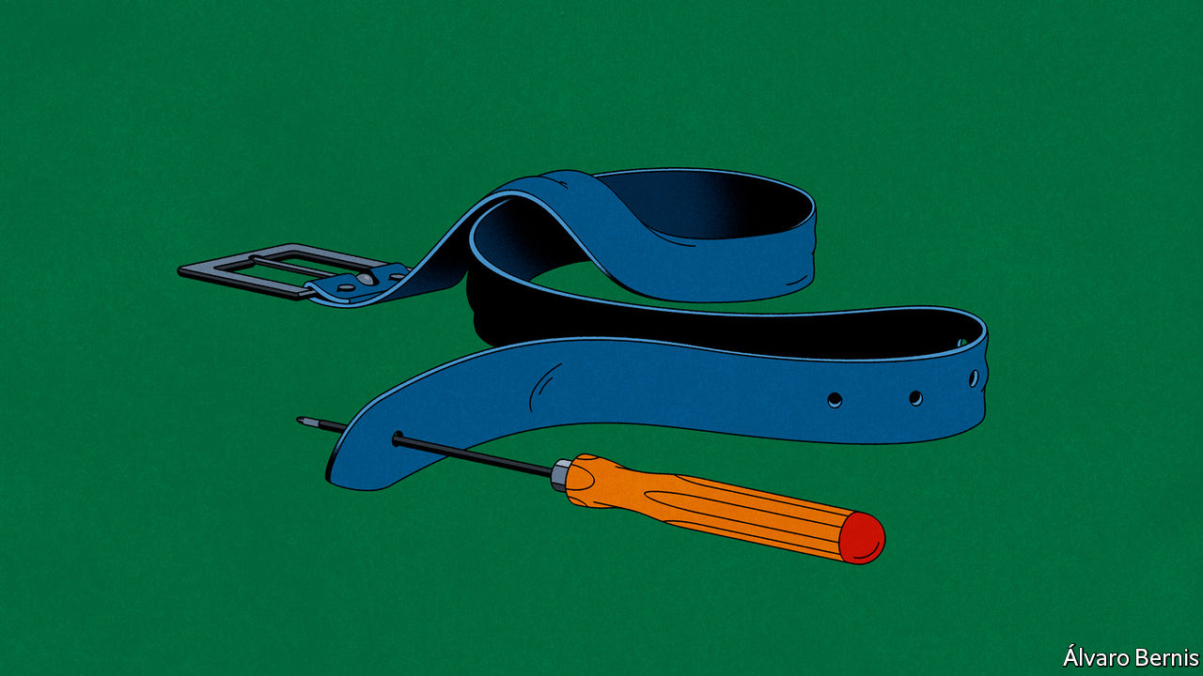

IF PEOPLE KNOW one thing about the thinking of John Maynard Keynes, who more or less founded macroeconomics, it is that he was in favour of governments borrowing lots of money, at least under some circumstances. The “New Keynesian” orthodoxy that evolved from his work in the second half of the 20th century was much less liberal in this regard. It put less faith in borrowing’s purported benefits, and had greater concerns about its dangers.

The 2010s saw the pendulum swinging back. In large part because they feel bereft of other options, many governments have borrowed heavily—and as yet they have paid no dreadful price. Can this go on?

Keynes’s ideas about borrowing reflected his view of recessions—and in particular, the Depression of the 1930s, during which he wrote “The General Theory of Employment, Interest and Money”—as vicious circles. Recessions come about when the economy is hit by a sudden rise in the desire to save money; such desires lead to lower spending, which leads to more unemployment, which leads to yet less spending, and so on. If the government borrows enough to offset lower private spending with increased spending of its own the circle can be broken—or stopped from getting going.

Most early Keynesians assumed that the deficits caused by borrowing to stimulate the economy would be temporary; after borrowing more than they raised in taxes in order to provide a fiscal stimulus, governments would be able to raise more in taxes, and thus pay off their debts, in the good times that followed. Some, though, suspected that the structure of the advanced economies of the 1930s might mean they were low on demand even in the good times, and that a permanent deficit might be necessary to keep the economy going at a rate that minimised unemployment.

Debates about the proper role of fiscal stimulus became less urgent in the decades after the second world war, as robust economic growth eased worries that demobilisation might bring a return of Depression-like conditions. Faith in Keynesian orthodoxy was further shaken by the economic developments of the 1970s and 1980s. Some economists began to argue that the public would eventually adjust to stimulus measures in ways that weakened their impact. Robert Barro, a leading proponent of this “rational expectations” approach, argued that a fiscal stimulus paid for by borrowing would see households spend less and save more, because they would know that tax rises were coming. This decreased private spending would then offset the increased public spending.

Linked to, but broader than, such academic questions was the fact that, by the 1970s, the ways in which Keynesian governments had been running their economies seemed to have failed. A trifecta of slowing growth, soaring inflation and high unemployment brought the idea of governments being able to avoid recessions through stimulus into disrepute.

The new orthodoxy was that governments should instead rely on monetary policy. When the economy slowed, monetary policy would loosen, making it cheaper to borrow, thus encouraging people to spend. Government borrowing, for its part, should be kept on a short leash. If governments pushed up their debt-to-GDP ratio, markets would become unwilling to lend to them, forcing up interest rates willy-nilly. The usefulness of monetary policy demanded a sober approach to fiscal policy.

The 2000s, however, saw a problem with this approach beginning to become plain. From the 1980s, interest rates had been in a long, steady decline. By the 2000s they had reached historical lows. Low rates made it harder for central banks to stimulate economies by cutting them further: there was not room to do so. The global financial crisis pushed rates around the world to near zero.

Governments experimented with more radical monetary policy, such as the form of money printing known as “quantitative easing”. Their economies continued to underperform. There seemed to be room for new thinking, and a revamped Keynesianism sought to provide it. In 2012 Larry Summers, a former American treasury secretary, and Brad DeLong, an economist, suggested a large Keynesian stimulus based on borrowing. Thanks to low interest rates, the gains it would provide by boosting the growth rate of GDP might outstrip the cost of financing the debt taken on.

In the following year Mr Summers followed some 1930s Keynesians, notably Alvin Hansen, in suggesting that borrowing in order to stimulate might be needed not just as an occasional pick-me-up, but as a permanent part of the economy. Hansen had argued that an ageing population and a low rate of technological innovation produced a long-term lack of demand which he called “secular stagnation”. Mr Summers took an updated but similar view. Part of his backing for this idea was that the long-term decline of interest rates showed a persistent lack of demand.

## Way down we go

Sceptics insisted that such borrowing would drive interest rates up. But as the years went by and interest rates remained stubbornly low, the notion of borrowing for fiscal stimulus started to seem more tenable, even attractive. Very low interest rates mean that economies can grow faster than debt repayments do. Negative interest rates, which have been seen in some countries over recent years, mean that the amount to repay will actually be less than the amount borrowed.

Adherents of “Modern Monetary Theory” (MMT) went further than this, arguing that governments should borrow as much as was needed to achieve full employment while central banks focused simply on keeping interest rates low—a course of action which orthodox economics would expect to promptly drive up inflation. Currently MMT remains on the fringes of academic economics. But it has been embraced by some left-wing politicians; Senator Bernie Sanders, the candidate beaten by Joe Biden for the Democratic nomination, counted an MMT enthusiast, Stephanie Kelton of Stony Brook University, among his chief advisers.

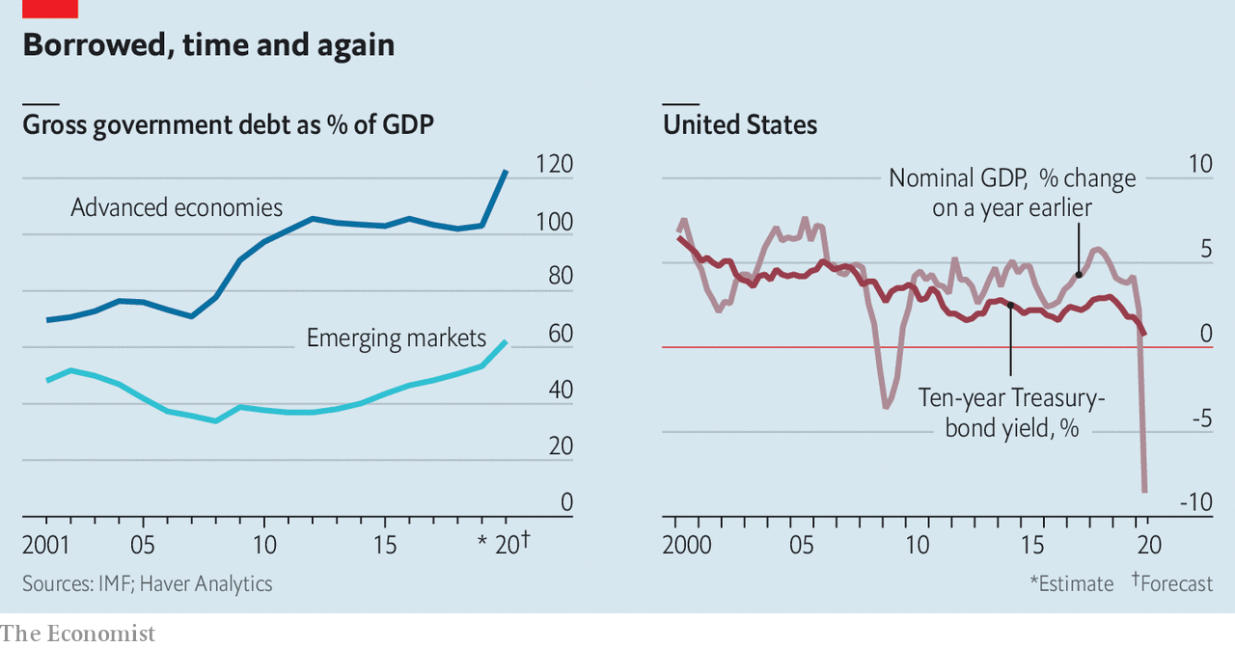

The shift in mainstream thinking on debt helps explain why the huge amounts of government borrowing with which the world has responded to the pandemic has not worried economists. But now that governments have, if only for want of an alternative, become more willing to take on debt, what should be their limit? For an empirical answer, it is tempting to consider Japan, where the ratio of net public debt to GDP stood at 154% prior to the pandemic.

If Japan can continue to borrow with that level of debt, it might seem that countries with lower levels should also be fine. But this ignores the fact that if interest rates stagger back from the floor, burdens a lot smaller than Japan’s might become perilously unstable. There is no immediate account for why this might be likely. But that does not mean it will not happen. And governments need to remember that debt taken on at one interest rate may, if market sentiment changes, need to be rolled over at a much higher one in times to come.

Given this background risk, governments ideally ought to make sure that new borrowing is doing things that will provide a lasting good, greater than the final cost of the borrowing. If money is very cheap and likely to remain so, this will look like a fairly low bar. But there are opportunity costs to consider. If private borrowing has a high return and public borrowing crowds it out, then the public borrowing either needs to show a similarly high return or it needs to be cut back.

At the moment private returns remain well above the cost of new borrowing in most places: in America, for instance, the earnings of corporations are generally high relative to the replacement cost of their capital. This makes it conceivable that resources used by the government would generate a greater level of welfare if they were instead mobilised by private firms.

But it does not currently look as though they would be. Despite the seemingly high returns to new capital, private investment in America is quite low. This suggests either that there are other obstacles to new investment, or that the high returns on investment reflect an insufficient level of competition rather than highly productive companies.

Both possibilities call for government remedy: either action aimed at identifying and dismantling the obstacles to investment, or at increasing competition. And until such actions produce greater investment or lower returns, the case for government borrowing remains quite strong. This is even more the case for public investments which might in themselves encourage the private sector to match them—“crowding in”, as opposed to crowding out. Investment in a much better electricity grid, for example, could increase investment in zero-carbon generation.

In the long run, the way to avoid having to borrow to the hilt is to implement structural changes which will revive what does seem to be chronically weak demand. Unfortunately, there is no consensus over why demand is weak. Is technological progress, outside the realm of computers and communications, not what it was? Is inequality putting money into the hands of the rich, who are less likely to spend their next dollar, rather than the poor, who are more likely? Are volatile financial markets encouraging precautionary saving both by firms and governments? Is the ageing of the population at the root of it all?

Making people younger is not a viable policy option. But the volatility of markets might be addressed by regulation, and a lack of competition by antitrust actions. If inequality is at the root, redistribution (or its jargony cousin, predistribution) could perk up demand. Dealing with the structural problems constraining demand would probably push up interest rates, creating difficulties for those governments which have already accumulated large debt piles. But stronger underlying growth would subsequently reduce the need for further government borrowing, raise GDP and boost tax revenues. In principle that would make it easier for governments in such situations to pay down their increased debt.

The new consensus that government borrowing and spending is indeed an important part of stabilising an economy, and that interest rates are generally low enough to allow governments to manage this task at minimal cost, represents progress. Government borrowing is badly needed to deal with many of the world’s current woes. But this consensus should ideally include two additional planks: that the quality of deficit-spending still matters, and that governments should prepare for the possibility of an eventual change in the global interest-rate environment—much as 2020 has shown that you should prepare for any low-probability disaster. ■

This article was downloaded by calibre from <https://www.economist.com/schools-brief/2020/09/12/governments-can-borrow-more-than-was-once-believed>

|  |  |  |  |
| --- | --- | --- | --- |
|  | Articles | Sections | Next |

|  |  |  |
| --- | --- | --- |
| Schools brief | Sections | Books & arts |

Science & technology

Natural disasters: Learning to live with it

.

Atmospheric dynamics: Fire, then ice

.

Palaeontology: Bones of contention

.

Immunology: Green shoots

.

Armoured warfare: Army surplus?

.

|  |  |  |
| --- | --- | --- |
| Schools brief | Sections | Books & arts |

|  |  |  |  |
| --- | --- | --- | --- |
|  | Articles | Sections | Next |

#### Natural disasters

# Wildfires will be more common in a warming world

Clever design of buildings and infrastructure can limit the damage

Sep 12th 2020 |

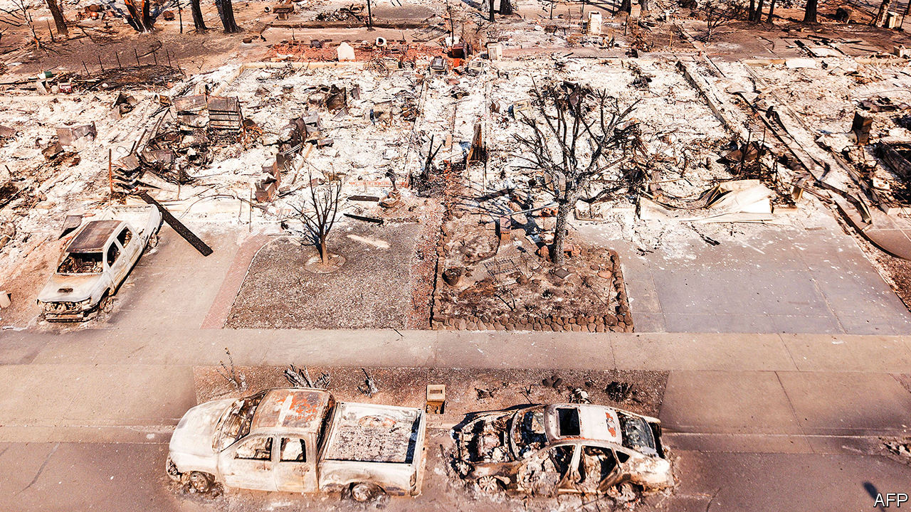

CALIFORNIA BURNS every year. But amid a record-breaking heatwave, 2020 is the fieriest year yet (see map). As The Economist went to press, more than 7,600 fires had burned over 2.5m acres (1m hectares) of land. The season still has months to run.

That fits a long-term trend, for California’s wildfires are getting steadily worse. Blazes in the 2010s burned 6.8m acres on average, up from 3.3m acres in the 1990s. The fire season lasts nearly three months longer now than it did in the 1970s. Over the past decade, the state has spent an average of $3.7bn a year fighting fires. Add the cost of rebuilding, treating casualties and restoration, says Headwaters Economics, a think-tank, and that is perhaps a tenth of the total cost. Although smaller than this year’s, the 2018 fire season was particularly destructive. It killed 100 people and burned tens of thousands of buildings.

The reason is a double whammy of climate change and development. More homes are being built next to forests, in what experts call the “wildland-urban interface” (WUI). A 2018 study estimated that roughly a third of American homes were in the WUI. The problem is acute in California. Pricey housing has pushed people onto cheaper land close to the wilderness.

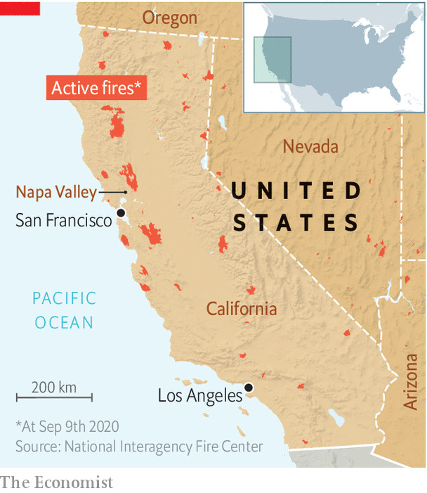

At the same time, climate change is extending the dry season, which stores up fuel for fires. In California, a chronic “megadrought”—in which dry years become more common and wet ones scarcer—is making matters even worse. One paper, citing tree-ring data, concluded that the drought, which started around 2000, is the second-worst in the past 1,200 years. It, too, has been linked to climate change.

Since neither trend shows much sign of reversing, people on America’s west coast will have to learn to co-exist with more, and more frequent, fires. “It’s not that different to building on an earthquake-prone landscape,” says Max Moritz, a wildfire expert at the University of California at Santa Barbara. Buildings and communities can be built in such a way that fires sweep through them—or better still, around them—leaving them more-or-less intact. Infrastructure can be made more resilient. And forests themselves can be managed to reduce the risk of catastrophic blazes.

Start with the buildings. Most buildings burn not when the flaming front of a fire reaches them, but when embers (also called “firebrands”) thrown off by distant fires land on them. A 2010 paper tracked how a 1991 fire in Oakland Hills burned steadily in a cluster of houses before embers were lifted by strong winds, landing on other houses hundreds of metres away and igniting more than a dozen new “spot fires”. Estimates of the share of buildings lost to firebrands vary, but all are large—between 60% and 90%.

Clever design can help make buildings resistant to fires that spread in this way. Materials such as concrete, adobe or stucco are a better bet than cladding walls in flammable wood. Some composite panels promise to hold back the flames for two hours or more. Gaps under roofs can be blocked up, to stop embers drifting in. Vents can be covered with mesh, or eliminated entirely. Heat-resistant windows, which are less likely to break, help keep firebrands out. Experts recommend a five-foot “non-combustible zone” around the base of homes.

Neighbourhoods can be toughened up, too. In a report published in April, Dr Moritz and his colleague Van Bustic at the University of California in Berkeley describe how entire communities can be planned to resist fires. Building near water is one tactic. But moats are not the only defence. Open agricultural lands—including the vineyards common in the Napa Valley—can offer a useful buffer, too. Even golf courses can serve as firebreaks. Rather than lining the greens with homes, Dr Moritz suggests doing the opposite, and putting houses in the middle.

Burying electricity lines can help avoid blackouts, as well as subsequent costly rebuilding. It can also prevent power lines themselves sparking fires. That is a persistent problem in California, and one which has cost Pacific Gas & Electric, a utility, billions in settlements. Australia, which also suffers from wildfires, has experimented with bunkers specially designed to withstand flames for an hour or more—long enough for a flaming front to move through. These offer a last-resort option for trapped residents.

## Sparking a change

But while options exist, adoption is slow. Firewise USA, a volunteer fire-resistance project, was launched in 2002. Nearly two decades later, only around 1,500 communities in America have signed up. One obstacle is the constant maintenance that must be carried out. Vegetation must be regularly thinned. Someone must take responsibility for empty sites. It can be hard to cajole second-home owners, who may visit only rarely, into doing their bit.

Homeowners and contractors often assume that fire-resistant buildings are more expensive, although Headwaters Economics reckons that, for newly built houses, the costs can be comparable. And fire-safe homes often come with secondary advantages, such as greater energy efficiency, which make them cheaper over time. But existing buildings need retrofitting, which comes with a heftier price tag. There are few carrots, and few sticks. The insurance industry offers little relief to those who fire-proof their homes. California’s legal requirements for building in the WUI do not apply to existing buildings. Fire-hazard maps are inadequate.

Perhaps the biggest problem is cultural. “We see the impacts of fires, then turn around and rebuild largely in the same way and the same place, but expect things to go differently next time,” says David Shew, a former staff chief at the Department of Forestry and Fire Protection. “That’s the definition of insanity.” Mr Shew has seen resistance to change at all levels, from homeowners who have strong opinions about materials and aesthetics, to a hidebound construction industry, and even among firefighters themselves.

Still, the measures work. New homes that have adhered to fire codes are far more likely to survive. And some communities are taking it upon themselves to be fire-smart. Circle Oaks is a small community of 180 houses dotted across a steep slope surrounded by tall oaks and madrones. In 2001, recognising their vulnerability, residents began investing around $50,000 to $90,000 each year into a fire-mitigation strategy. Vegetation is regularly cut back, manually or by goats. Extra water is stored on site, ready for firefighting, and hydrants have been upgraded. The residents conduct frequent fire-safety assessments.

At half past midnight on October 9th 2017, they were told to evacuate. A fire on nearby Atlas Peak was heading in their direction. A handful of firefighters, led by Larry Carr, a Circle Oaks resident, did their best to beat back the flames. Circle Oaks’ fire-safety measures greatly aided the efforts—and its houses were saved from one of the worst wildfires to have swept through the region in living memory. ■

For more coverage of climate change, register for The Climate Issue, our fortnightly [newsletter](https://www.economist.com/theclimateissue/), or visit our [climate-change hub](https://www.economist.com/news/2020/04/24/the-economists-coverage-of-climate-change)

This article was downloaded by calibre from <https://www.economist.com/science-and-technology/2020/09/12/wildfires-will-be-more-common-in-a-warming-world>

|  |  |  |  |
| --- | --- | --- | --- |
|  | Articles | Sections | Next |

|  |  |  |  |
| --- | --- | --- | --- |
| Previous | Articles | Sections | Next |

#### Weather and climate change

# How weird weather can span the world

Climate change is making the jet stream wilder

Sep 12th 2020 |

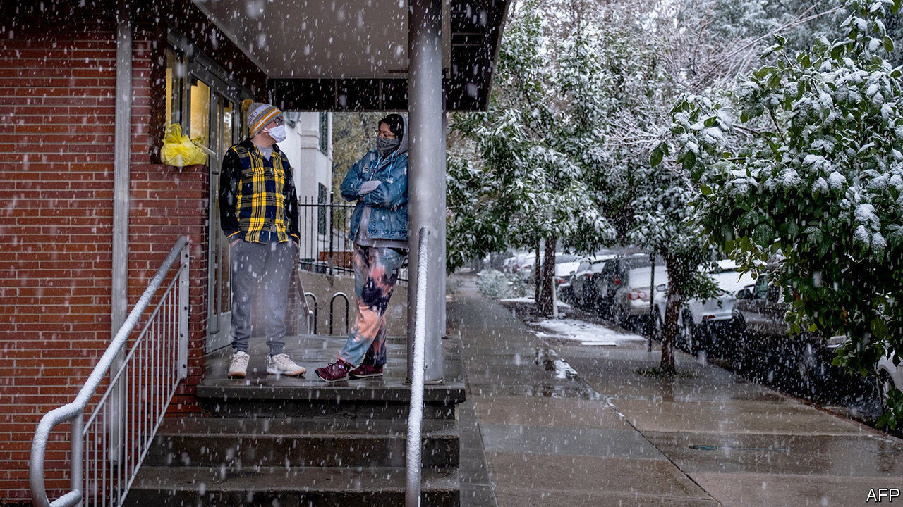

ON SEPTEMBER 7TH in Denver, Colorado, the temperature reached 34°C (93°F), 6°C above what is normal for the time of year. The city was sitting under the dome of hot air encouraging record fires across the American West (see [article](https://www.economist.com/node/21791685)). The next day snow started to fall. By midnight the temperature was below freezing. What happened?

The immediate cause was the polar jet stream, a world-girdling high-altitude wind driven by temperature differences between Arctic air to the north and warmer air to the south. Its meandering path is set by patterns of high and low pressure known as Rossby waves. And because fluid dynamics are never simple, the jet stream exerts its own influence in turn upon these guiding waves.

As the jet stream passed to the north of the high pressure over America’s west coast, the big temperature difference between that hot air and what lay farther to the north added to its energy. This extra impetus meant that as the jet came down the east side of the high-pressure zone it curved back on itself towards the west. In meteorological terms, the Rossby wave broke. In this case the breaking wave’s white water took the form of large quantities of cold air from the Canadian north that were suddenly pulled south, and which crashed down on Colorado.

This is not in itself evidence of climate change. But that may lurk in the background. Go back to the first days of September and Typhoon Maysak was passing north over the Koreas, the second of an unprecedented troika of typhoons to do so this summer, thanks to hot seas and cyclone-friendly conditions to the south (see [article](https://www.economist.com/node/21791756)). The heat Maysak gave up over eastern China drove the jet stream there to particularly impressive speeds. That intensification travelled on over the Pacific, possibly predisposing the system towards what happened five days later in Denver, says Philippe Papin of America’s National Weather Service.

Not all typhoons that pass over Korea will have such effects. (Maysak’s successor, Haishen, did not.) They need to hit the jet stream in the right way. But greenhouse warming is making the tropics larger. Models suggest this will mean that more tropical storms reach high latitudes, where they can invigorate the meanders of the jet stream in rather the same way that a child sends a wave down a skipping rope with a flick of the wrist.

Some scientists are concerned that, as climate change worsens, the ability of Rossby waves to drive sudden changes in the weather will increase. Even today, they can bring about whiplash weather when the circumstances are right.

For more coverage of climate change, register for The Climate Issue, our fortnightly [newsletter](https://www.economist.com/theclimateissue/), or visit our [climate-change hub](https://www.economist.com/news/2020/04/24/the-economists-coverage-of-climate-change)

This article was downloaded by calibre from <https://www.economist.com/science-and-technology/2020/09/12/how-weird-weather-can-span-the-world>

|  |  |  |  |
| --- | --- | --- | --- |
| Previous | Articles | Sections | Next |

|  |  |  |  |
| --- | --- | --- | --- |
| Previous | Articles | Sections | Next |

#### Palaeontology

# How the shark forgot his skeleton

Bony skeletons may be even older than palaeontologists thought

Sep 12th 2020 |



VERTEBRATES—THOSE animals with a backbone—are a diverse bunch, encompassing everything from tuna and budgerigars to snakes, chinchillas and human beings. One way biologists divide them up concerns the composition of their skeletons. Most vertebrates sport hard, calcified bones, and are dubbed the osteichthyans. A second, much smaller category is the chondrichthyans, whose members include sharks, rays and skate. Unlike their hard-boned cousins, chondrichthyans make do with structural parts made of soft, tough cartilage.

Palaeontologists had long assumed that cartilage was the more primitive arrangement. Osteichthyan fetuses, after all, begin life with a cartilaginous skeleton that is gradually replaced by harder, more durable bone as they grow. But a paper just published in Nature Ecology & Evolution suggests that view may be mistaken. In it a team led by Martin Brazeau of Imperial College London describe the discovery of a 410m-year-old fossil in Turgen, a district of Mongolia close to the Russian border. The fossil is the partial skull of a new species of placoderm, a type of armoured fish, which Dr Brazeau and his colleagues have dubbed Minjinia turgenensis.

Placoderms are of interest to palaeontologists because they are an immediate common ancestor of both the chondrichthyans and the osteichthyans, which are thought to have split from each other around 400m years ago. Yet when Dr Brazeau’s team scanned their fossil with X-rays, they discovered tissues defined by microscopic curved struts and rods called trabecles––very similar to the bones found in modern-day bony vertebrates. If an ancestor of both the chondrichthyans and the osteichthyans had the ability to grow a hard skeleton, that implies that, rather than bony fish inventing the trick, it was the ancestors of today’s sharks and their cousins that forgot it.

Exactly why is a matter of conjecture. One possibility is that it was an evolutionary adaptation. “Sharks don’t have swim bladders, which evolved later in bony fish, but a lighter skeleton would have helped them be more mobile in the water and swim at different depths,” speculates Dr Brazeau. “This may be what helped sharks to be one of the first global fish species, spreading out into oceans around the world 400m years ago.”

Whatever the reason, the fact that sharks are still around 400m years later suggests that a soft skeleton is a highly successful strategy, evolutionarily speaking. Yet it may also be a limited one. The swim bladders developed by bony fish to modulate their buoyancy would soon be co-opted for another purpose: transformed into a primitive set of lungs, they allowed their bearers to breathe air, and therefore to colonise the land. Given that inch, early terrestrial vertebrates took a few feet, as it were. The rest is history.■

This article was downloaded by calibre from <https://www.economist.com/science-and-technology/2020/09/12/how-the-shark-forgot-his-skeleton>

|  |  |  |  |
| --- | --- | --- | --- |
| Previous | Articles | Sections | Next |

|  |  |  |  |
| --- | --- | --- | --- |
| Previous | Articles | Sections | Next |

#### Immunology

# Some good news on covid-19

The virus seems to generate a robust and fairly long-lasting immune response

Sep 9th 2020 |

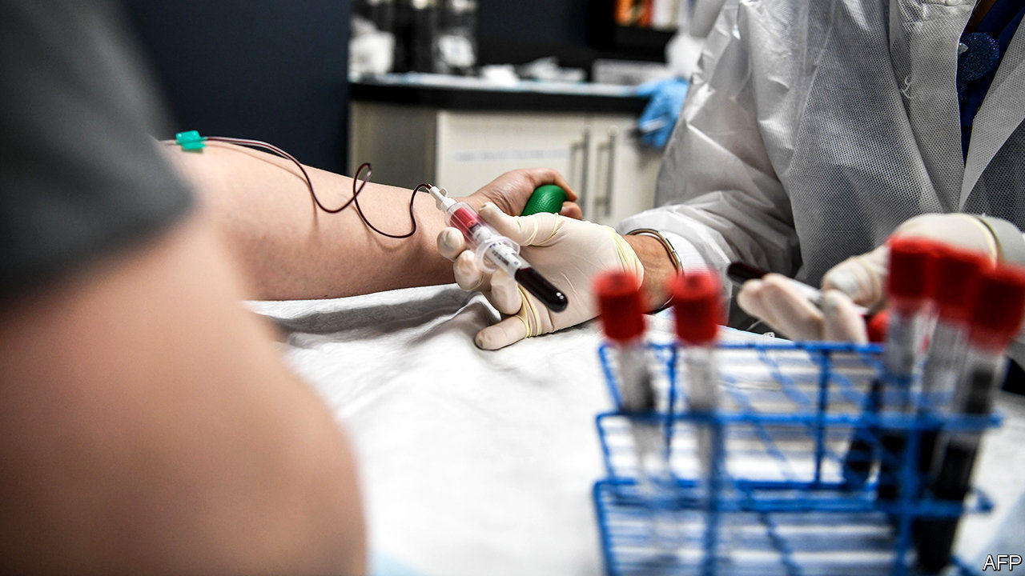

THE BEST hope for ending the covid-19 pandemic is a vaccine. There is no shortage of candidates. The World Health Organisation is tracking 34 in various stages of development. How well they will work, though, is another matter. On September 9th AstraZeneca, a drug firm, announced it was pausing its trials after a participant fell ill. Such pauses are common in vaccine development, a discipline in which effort does not always bring reward. Despite much research, only an imperfect vaccine is available for dengue fever (it has limited efficacy and can cause nasty side-effects). In 1987 the first trial of an HIV vaccine began in Maryland. Three decades later, the cupboard remains bare.

The news about covid-19 in two new papers is more encouraging. The first, written by a team of scientists at deCODE genetics, an Icelandic company, and published in the New England Journal of Medicine, reports antibody levels in 1,200 Icelanders who had been infected with the SARS-CoV-2 virus and recovered. More than 90% tested positive for antibodies twice—once immediately post-infection and again four months later. People who had suffered more serious disease, such as those who had been hospitalised, developed higher levels of antibodies. So did men and older people, both of whom are at greater risk of more severe illness.

The four-month lifespan is cheering for two reasons. Antibodies that hang around are more likely to offer immunity. That means a vaccine that provokes their production should provide reasonably long-lasting protection. They are also easier to find. That suggests that results from population-wide antibody screening programmes, which aim to chart the spread of the virus, should be fairly accurate.

In the second study, scientists led by Tao Dong, an immunologist at the Medical Research Council (MRC), in Britain, went hunting for T-cells. These get less press than antibodies, but play an equally vital role in battling infections and securing long-term protection. (Their importance is vividly demonstrated by HIV, which targets and kills them.)

As described in Nature Immunology, the researchers compared blood samples from 28 mild and 14 severely ill covid-19 patients, as well as 16 healthy donors. The paper describes a “robust” T-cell response in infected people and, as with the Icelandic work, different responses in those who developed mild and severe cases of the illness. Specifically, mild cases were characterised by more CD8+ cells, which kill infected cells directly, rather than CD4+ ones, which regulate the immune response more generally. The MRC study found T-cells that could recognise eight separate parts of the virus, including the spike protein that allows it to penetrate human cells. That target list could offer useful hints for refining vaccines in future.

Al Edwards, an immunologist turned biochemical engineer at the University of Reading (who was not involved with either paper), is cautiously optimistic. The immune response to the disease seems to be working roughly as expected, he says. If that continues, then vaccines developed to trigger long-lasting immunity should work—at least in theory.

In practice, it is still too early to celebrate. Dr Edwards warns that immunology has never been a predictive science. There is no test that can show definitively that a vaccine will work short of actually trying it in the real world. ■

Editor’s note: Some of our covid-19 coverage is free for readers of The Economist Today, our daily [newsletter](https://my.economist.com/user#newsletter). For more stories and our pandemic tracker, see our [hub](https://www.economist.com/news/2020/03/11/the-economists-coverage-of-the-coronavirus)

This article was downloaded by calibre from <https://www.economist.com/science-and-technology/2020/09/09/some-good-news-on-covid-19>

|  |  |  |  |
| --- | --- | --- | --- |
| Previous | Articles | Sections | Next |

|  |  |  |  |
| --- | --- | --- | --- |
| Previous | Articles | Sections | Next |

#### Armoured warfare

# Tanks have rarely been more vulnerable

Some armies are scrapping theirs. Others are innovating

Sep 12th 2020 |

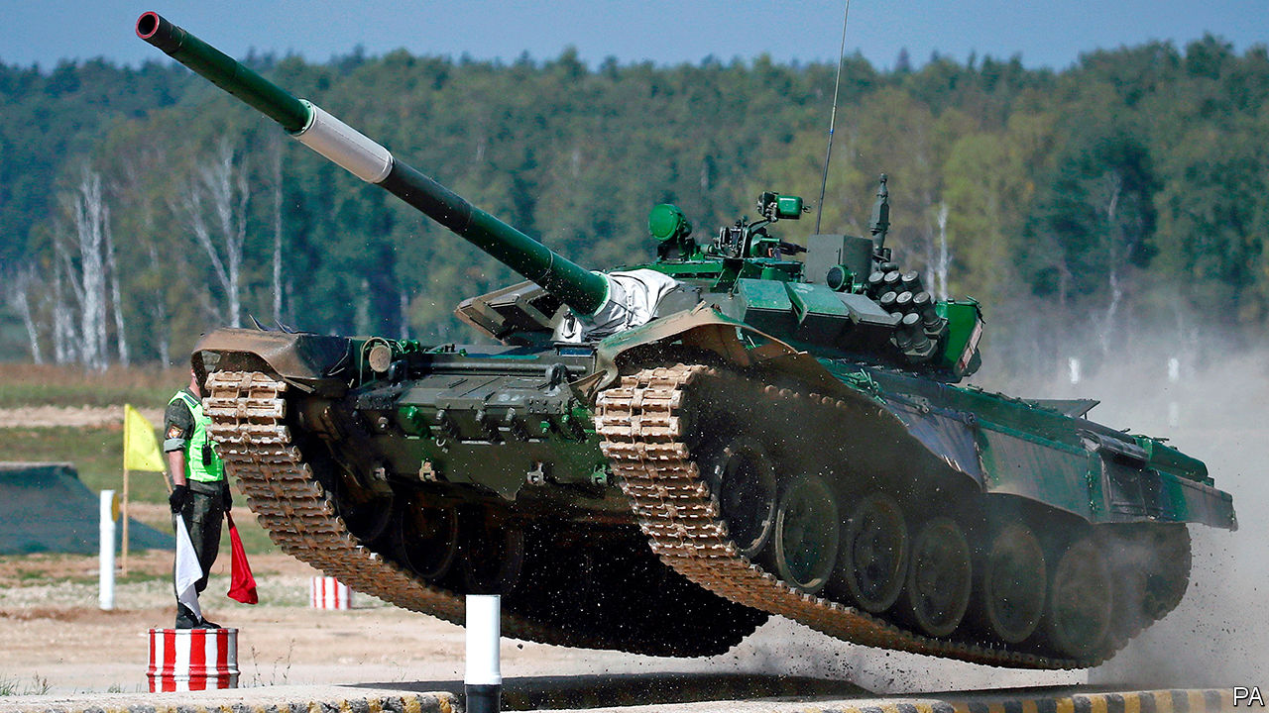

TANK BATTLES are rare these days. Crews that wish to prove themselves can turn instead to the Tank Biathlon, part of the International Army Games—a sort of Olympics with guns—organised each year by Russia. On September 5th Russian tanks raced and blasted their way to victory over teams from China, Belarus and Azerbaijan.

A century after its debut at the Battle of the Somme, the tank—an armoured vehicle typically equipped with a cannon on a turret—remains the backbone of most armies. The International Institute for Strategic Studies (IISS), a think-tank, counts over 5,000 in Europe, and 54,000 globally.

Nothing else can move soldiers around, shield them and wield big guns all at once. Russia was able to slice through Ukraine’s defences with its superior T-72s in 2014. Their absence can be keenly felt. The mostly tank-free offensive against Islamic State in 2016-17 was grinding and bloody, even with help from American bombing. “High-intensity combat operations between technologically comparable countries is unimaginable without the large-scale use of tanks,” says Viktor Murakhovsky, a retired colonel of Russia’s Tank Troops.

Yet in some recent conflicts, tanks have struggled. In February Turkish drones destroyed dozens of Syrian tanks in a two-day killing spree. In the past, camouflage could hide tanks from most planes. Today, sensors can pick out things like engine heat and tracks on the ground. “It must be doubted whether existing concepts of armoured manoeuvre will remain viable,” concluded Nick Reynolds and Jack Watling, both experts at the Royal United Services Institute, another think-tank.

## Tanks or no tanks

Some armies are therefore cutting back. America’s Marine Corps, which has more tanks than most European nations, said in March that it planned to scrap them, to focus on countering China in the Pacific. The tank, it said, had a “long and honourable history in the wars of the past” but was “operationally unsuitable for our highest-priority challenges in the future”. (America’s army still has plenty.) Britain, the first country to make use of the tank, is debating how far to prune its own ageing fleet, to free money for next-generation weapons. The Netherlands scrapped its heavy armour almost a decade ago, though it now leases 18 tanks from Germany.

For most countries, the answer is not to junk the tank but to modernise it. One big change is the view from inside. Tankers of the 1980s saw the battlefield through a pair of periscopes—“a bit like looking through a straw”, says Mr Watling. The newest ones are studded with cameras and other sensors that project a 360-degree view on panoramic displays inside. Such “see-through armour” allows the gunner to aim at one target while the commander looks for the next. Doing away with periscopes also avoids breaks in the armour. Mr Murakhovsky thinks future tanks will use drones to peer around corners and over hills.

Tanks are also beefing up their defences. “Active protection systems” are designed to neuter threats before they hit a tank’s armour. “Soft-kill” methods detect and misdirect the radio, infrared or laser beams that guide anti-tank weapons to their targets. “Hard-kill” systems, such as Russia’s Afghanit and the Israeli Trophy and Iron Fist, intercept and blow up missiles as they home in (the catch being that nearby infantry could be caught in the blast). Ben Barry, a former brigadier in the British Army and now at the IISS, reckons that many of NATO’s anti-tank weapons would struggle to penetrate the newest Russian protection systems.

But these adornments come at a price. Tanks are expensive as it is (a new Russian T-14 Armata costs $4m, for instance). Operating the machines can cost several hundred dollars per kilometre. Piling on defences to protect soldiers—politically essential in wars of choice—adds to the bill, and the machine’s weight. For that reason, only a few NATO countries are investing in hard-kill protection.

And even snazzy new defences are struggling to keep up with innovations in attack. Mr Barry notes that the Israeli Trophy system carries just two rounds, so firing several missiles at the same time could defeat it. “The death of the tank comes round every five years or so,” says Jon Hawkes, head of land warfare for Janes, a research company. “But the tank is more vulnerable now than it has ever been. We’re reaching the apex of the armour versus gun race—and armour has lost that race.”

Tactics, rather than technology, can help redress the balance. Massed tank formations can dominate if they get within 2km of their target, in range of their guns, says Mr Watling. Before they get there, however, they can be pummelled with long-range artillery and missiles.

That means that, in the tank battles of the future, armoured forces would probably fight more slyly, using concealment, cover, darkness and dispersal—much as Serbia did against NATO in 1999. If they can be kept safe, tanks remain uniquely potent weapons. In war games set in the Baltic states, Russian tanks with air cover—to bat away threats like the drones that picked off Syrian tanks in February—“easily punch through” lighter NATO forces, says Chris Dougherty of the Centre for a New American Security, a think-tank in Washington. In war games set in Taiwan, he says, China struggles to seize the island without heavy armour. Heavy metal still counts. ■

This article was downloaded by calibre from <https://www.economist.com/science-and-technology/2020/09/12/tanks-have-rarely-been-more-vulnerable>

|  |  |  |  |
| --- | --- | --- | --- |
| Previous | Articles | Sections | Next |

|  |  |  |
| --- | --- | --- |
| Science & ... | Sections | Economic & ... |

Books & arts

Globalisation: Lowering the drawbridge

.

American history: Out of the closet

.

Prairie gothic: Thicker than water

.

Philosophy: New speak

.

Irish fiction: Memory lane

.

|  |  |  |
| --- | --- | --- |
| Science & ... | Sections | Economic & ... |

|  |  |  |  |
| --- | --- | --- | --- |
|  | Articles | Sections | Next |

#### Lowering the drawbridge

# Two books expound the virtues of open societies

Johan Norberg sees openness as an engine of progress. Matthew Yglesias wants to open up America

Sep 12th 2020 |

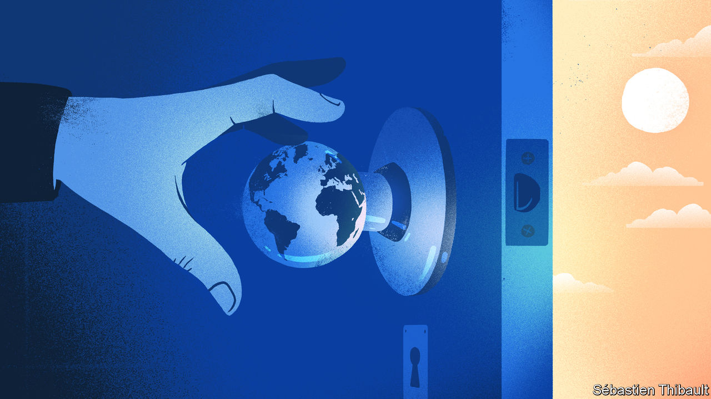

Open: The Story of Human Progress. By Johan Norberg.Atlantic Books; 448 pages; $24.95 and £20.

One Billion Americans: The Case for Thinking Bigger. By Matthew Yglesias.Portfolio; 288 pages; $28 and £23.99.

IT WAS NOT just roads that led to Rome. The shipping lanes did, too. By the first century BC, Rome had conquered the entire Mediterranean coastline. Some 90% of its people lived within 15km of the sea, buying corn from Egypt, olive oil from Spain and toga dye from Carthage. The Roman Empire prospered because it was open to trade, people and ideas, says Johan Norberg, a Swedish thinker. Galleys brought “all the crafts that exist or have existed”, as one Greek observer put it. Foreigners could become citizens; a slave’s son could (occasionally) rise to become emperor.

Mr Norberg’s “Open” is one of two new books that offer big ideas about globalisation, past and future. He argues that progress depends on openness, but that this tends to create resistance that sets back the clock. In “One Billion Americans” Matthew Yglesias, a co-founder of Vox (a wonky leftish news outlet), ponders how the United States might evolve if it were much more open to immigrants.

“Open” is clear, colourful and convincing, marshalling evidence from a range of eras and civilisations. The Roman Empire ceased to prosper when it ceased to be open. Christianity became the established religion, and sought to crush all others. “This new intolerance…led to vicious conflicts…between Christians and pagans, who saw their old gods being banned and their temples torn down.” Persecuted pagans joined Rome’s enemies, even welcoming barbarian invaders as liberators.

Human history, in Mr Norberg’s telling, is a cacophony of drawbridges being lowered and then raised. Mathematics and medicine flourished under the cosmopolitan Abbasid caliphate, but froze when religious conservatives won control. By driving out Jews, Muslims and heretics, he argues, the Inquisition helped impoverish Spain (between 1500 and 1750 the Spanish economy actually shrank).

China’s Song dynasty, which welcomed Muslim traders, Indian monks and Persians, developed paper money, water-powered textile machines and the makings of an industrial revolution 400 years before the West. But later dynasties turned inward and stagnated. Ming officials smashed clever machines, banned overseas trade on pain of death and curbed movement within China itself. The Manchus were even worse: to prevent contact with the outside world, in 1661 they forced the whole population of the southern coast to move 30km inland. A century later the Qianlong emperor banned or burned any books that seemed sympathetic to previous dynasties, including a great encyclopedia of economic and technical matters.

The author is often amusing as well as illuminating. Genghis Khan was a vicious warlord, but his domestic policies “would today open him up to accusations of being a politically correct, latte-drinking virtue signaller”. The Mongols practised ethnic and religious tolerance, which is one reason why they were so effective. They promoted skilled fighters, engineers and administrators of all backgrounds. Of the 150,000-strong horde that invaded Europe in 1241, only around a third were ethnic Mongols. Habsburg soldiers were surprised to find that one captured officer was a middle-aged literate Englishman, who had fled persecution for heresy at home and sought refuge among the more open-minded Mongols.

All regions have had rulers who tried to preserve stability by shutting out foreign influence. The key to thwarting them has often been for the ruled to vote with their feet. Early modern Europe was no more advanced than China, but power was more dispersed, so thinkers who offended one prince could simply move. Hobbes wrote “Leviathan” while in exile in Paris; Locke and Descartes went to Amsterdam. Their books could always be printed somewhere, and so were impossible to suppress.

Backlashes against openness are inevitable because they are rooted in human nature, Mr Norberg contends. Human brains evolved over millennia in which disruptive change often meant death; mutually beneficial exchanges with strangers were rare. If the past 300,000 years of history were compressed into a single day, it would not be until the final minute that steady material progress, fuelled by disruptive innovation, took off. Small wonder people’s instincts are so conservative. When threatened, they seek shelter within their tribe, which is why demagogues try to scare them. Fear wins elections.

## The more the merrier

The book ends on an optimistic note. Populist demagogues eventually lose power because they are hopeless at governing. Four in ten wind up being indicted for corruption, by one count. Citizens get used to change: today American Muslims are as tolerant of homosexuals as the country was overall in 2006. The open society “may yet be saved”, Mr Norberg concludes.

Mr Yglesias makes a bold case for openness in his own country. If America made both child-rearing and immigration easier, its population could in time swell to 1bn. It would thus remain the pre-eminent power, outstripping China and India. A bigger America would make for a more innovative and democratic world, he argues.

But wouldn’t an America of 1bn people be horribly crowded? No, it would be as sparsely populated as France is now. Even popular cities could accommodate many more residents if building codes were less restrictive. Enlightened visa rules could revive declining towns. Congestion could be eased with policies that have worked elsewhere, from road pricing to better railways.

Mr Yglesias is swimming against the tide, and knows it. He notes that a recent immigration bill backed by Donald Trump is so restrictive that it would not let Kazuo Ishiguro, a British Nobel prizewinner, apply for a work visa unless his job paid $240,000 or more. Yet as Mr Norberg shows, political tides can change. ■

This article was downloaded by calibre from <https://www.economist.com/books-and-arts/2020/09/12/two-books-expound-the-virtues-of-open-societies>

|  |  |  |  |
| --- | --- | --- | --- |
|  | Articles | Sections | Next |

|  |  |  |  |
| --- | --- | --- | --- |
| Previous | Articles | Sections | Next |

#### White supremacy in America

# “Life of a Klansman” brings the past out of the closet

This family history is not exceptional, Edward Ball writes. It is ordinary

Sep 12th 2020 |

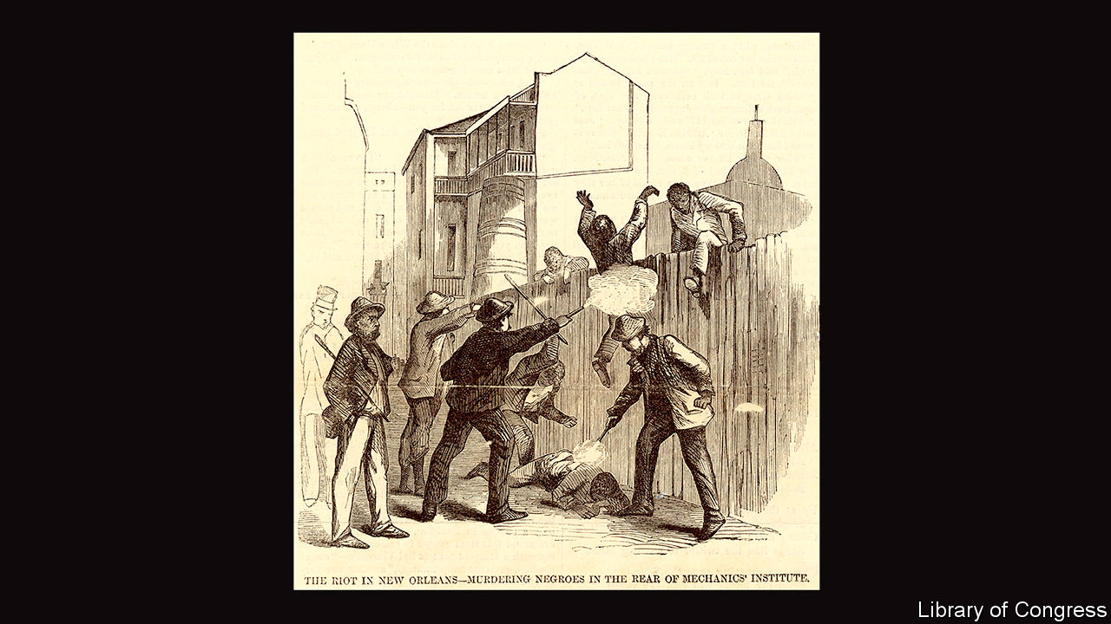

Life of a Klansman: A Family History in White Supremacy. By Edward Ball.Farrar, Straus and Giroux; 416 pages; $28 and £17.99.

THIS IS A story of horrors, albeit of a tragically widespread kind. It is also a conjuring trick. It recounts the “insignificant and yet calamitous, strange but common life” of Polycarp Constant Lecorgne, a carpenter, terrorist and Edward Ball’s great-great-grandfather. Few records of Lecorgne survive, obliging Mr Ball to patch his narrative together from documents of the era and the biographies of similar men—of whom there were many.

In “Slaves in the Family”, published in 1998, Mr Ball told the stories of his slaveholding paternal ancestors in South Carolina and the black people they owned, and sometimes fathered. He harrowingly showed how pain and racial injustice cascaded through generations. By contrast, his new book is a tale of wilful forgetting. “Life of a Klansman” turns to his mother’s forebears in Louisiana, a state which was (and is) at once an extreme example of wider problems and a special case—because of its large populations of free people of colour and Francophones, overlapping categories that were a legacy of French control.

Lecorgne’s father was a sailor in Napoleon Bonaparte’s navy. Mr Ball speculates that he was involved in ferrying refugees from the revolution in Haiti around the Caribbean, before jumping ship in New Orleans, where the author himself partly grew up. The father married into the slaveholding Creole gentry—an upward mobility that his son quickly reversed. Born on a family plantation in 1832, Lecorgne seems to have been a habitual flop. During the civil war, his first unit disgraced itself in a drunken riot before it saw combat. Lecorgne and his wife, who had arrived from Guadeloupe via Cuba, sank their savings into Confederate bonds. Five of their children died young.

Probably, Mr Ball says, his ancestor was an inadequate and unhappy man, humiliated by his failings and enraged by the post-war influx of freedmen into New Orleans, some of them in uniform. Like many such men, he found a bitter solace in violent prejudice, joining a series of Ku Klux Klan-like militias (though plenty of successful whites also signed up). In tandem with repressive local laws, these groups harassed, raped and killed black people and sometimes white Republicans. They aimed to fix elections, annul their results, and ultimately thwart and overturn Reconstruction—the federal effort to impose a fairer settlement on the recalcitrant South in the years after the war.

The brazenness of these crimes, which included mass murder and treason, and their perpetrators’ more or less complete impunity, cannot fail to shock even readers familiar with the period. Because he was arrested—though not punished—Lecorgne is known to have taken part in an attempted white-supremacist putsch in New Orleans in 1873. He was probably implicated in a massacre of black supporters of a constitutional convention seven years earlier.

To begin with, all the “probablys” in Mr Ball’s chronicle seem a weakness. Soon, though, the conjectures become pointed. All of this happened, whether or not it happened to Lecorgne. He is a looming spectre in a book that is really a portrait of his time. (The men, women and children whom his family bought and sold are indistinct ghosts, too; Mr Ball strains to imagine their lives, separate from their owners’ yet intimately entwined, though the evidence is even scantier than it is for Lecorgne.)

This is also, the author insists, a book about modern times. He decries the ready moral condescension of the present towards the past—the blithe confidence that “if we were alive then, we would do it all differently”. Working with data from the time of the Klan’s revival in the 1920s, he calculates that half of white Americans have an ancestor who was involved. “The rarity is not in having a Klansman around,” he says in his clipped, epigrammatic style. “The unusual thing is to bring him out of the closet to interrogate under light.” He goes further. Regardless of their own views on race, he argues, today’s white Americans are beneficiaries of the havoc once wreaked by the likes of Lecorgne. And, in their unconscious biases, Mr Ball thinks, they have a trace of the Klan in their psyches as well as in their family trees.

Some white Americans have already embraced that chastening conclusion; some will bridle at it. No one can deny that the Klansmen won. Another white-supremacist insurrection in 1874 succeeded in taking over New Orleans, at least for a few days until the army showed up. Louisiana, scene of so much bloodletting, eventually played a pivotal role in the contested presidential election of 1876, which led to the end of Reconstruction. Twenty years later the Supreme Court’s ruling in Plessy v Ferguson, a case that originated in New Orleans, affirmed the constitutionality of segregation. “None of this”, Mr Ball sighs, “is long ago, when you think of it.” ■

This article was downloaded by calibre from <https://www.economist.com/books-and-arts/2020/09/12/life-of-a-klansman-brings-the-past-out-of-the-closet>

|  |  |  |  |
| --- | --- | --- | --- |
| Previous | Articles | Sections | Next |

|  |  |  |  |
| --- | --- | --- | --- |
| Previous | Articles | Sections | Next |

#### Thicker than water

# A chilling memoir of troubled parents

Even when the ice recedes, writes Vicki Laveau-Harvie, it still shapes the landscape

Sep 12th 2020 |

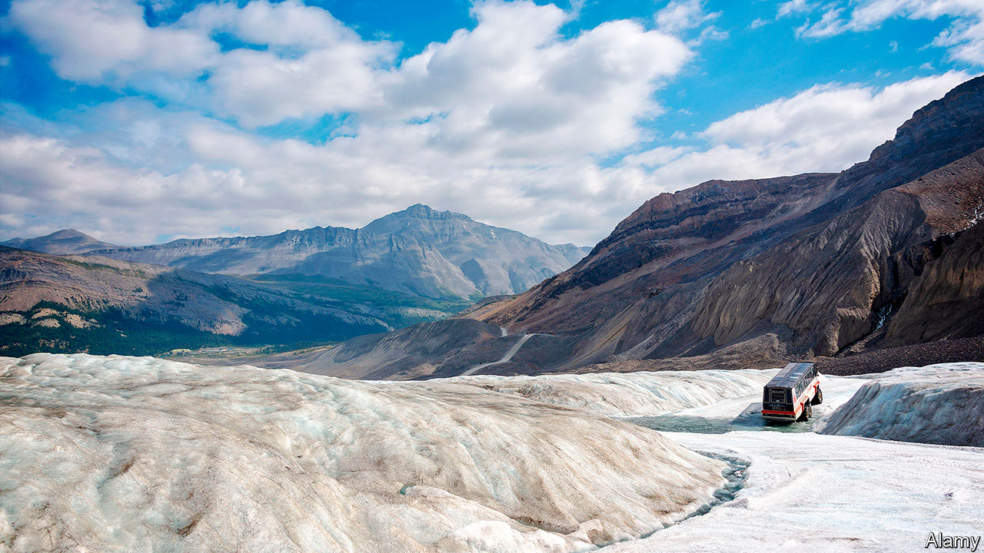

The Erratics. By Vicki Laveau-Harvie.Knopf; 224 pages; $25.95.

“I’M GETTING DAD 2.0, director’s cut,” writes Vicki Laveau-Harvie of her visit to her father at his ranch in Southern Alberta, Canada—where the phone rings unanswered near a windowless library, a grand piano and a bomb shelter. When she and her sister decide to clean the big house, “sealed against the outside world for a decade”, they discover a cupboard of shoe boxes filled with cancelled cheques. It would take “carbon dating” to identify the items in the refrigerator.

This is a part of North America where people commute in darkness and cars start at minus 40 degrees. It is a world of harsh winters, black ice and septic-tank disputes; a place where ranchers and farmers still make crab-apple jelly and tomato chutney in the summer. In this tough environment, Ms Laveau-Harvie’s parents’ marriage was a saga of disappointment and bitterness. They neglected her and her sister, then disowned and disinherited them.

Their mother keeps their father in rural isolation and starves him. Only late in life is she diagnosed with a personality disorder. Things begin to unravel when she breaks a hip; she tells a social worker that Interpol is looking for Ms Laveau-Harvie in South America. “The Erratics” is an account of the author’s travels back and forth from her home in Sydney, Australia to care for the old man and make sure her mother stays in hospital.

Wit and generosity seep through the poised prose. “The leaves of the trembling aspens can shake all day like gold coins in air as clear as cider,” Ms Laveau-Harvie writes, “but this is not a welcoming place.” Insight compensates for a lack of dramatic tension. She fathoms the heart’s reserves of both ruthlessness and vulnerability; she considers the natural urge to embellish “the stories of who we are or who we think we are”.

In recent years a niche genre of memoir has focused on the ministrations of the middle-aged to elderly parents. For instance, George Hodgman, an editor at Vanity Fair, left New York to care for his nonagenarian mother in Missouri, an experience which became the basis of his book “Bettyville”. Ms Laveau-Harvie, a retired academic and translator, has won acclaim for this contribution to the trend in Australia. She deserves it. Lives can be scarred, she muses, by the gap between what you take and what you give.

Despite the emotional abuse her parents inflicted, or because of it, Ms Laveau-Harvie has never escaped them; sometimes she can even hear them, “like people who pick up the local radio station broadcasts through the fillings in their teeth”. You can’t blank out the past, her book insists. As with the glacier which, tens of thousands of years ago, swept from Alaska to Alberta—pushing the kind of giant rock known as an erratic—even when the old ice fractures, it will always dominate the landscape.

This article was downloaded by calibre from <https://www.economist.com/books-and-arts/2020/09/12/a-chilling-memoir-of-troubled-parents>

|  |  |  |  |
| --- | --- | --- | --- |
| Previous | Articles | Sections | Next |

|  |  |  |  |
| --- | --- | --- | --- |
| Previous | Articles | Sections | Next |

#### New speak

# The philosophers who imagined a new world

In the 1920s they walked the walk, as well as doing a lot of dizzying talk

Sep 12th 2020 |

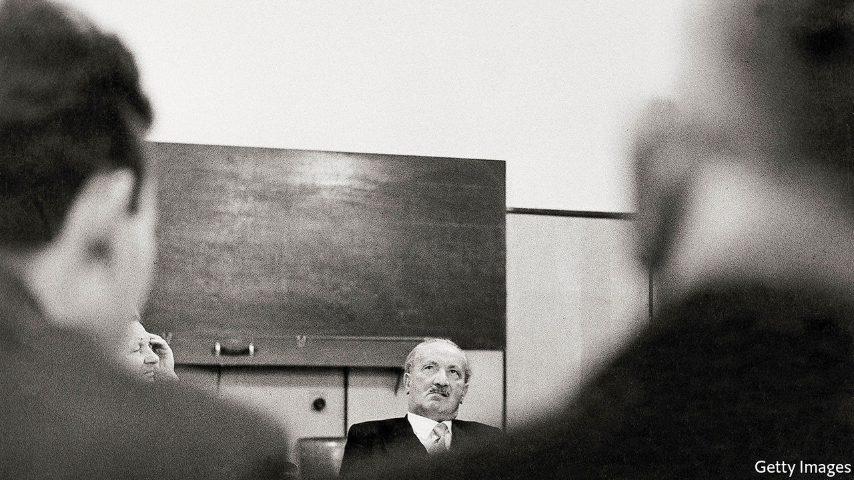

Time of the Magicians: The Invention of Modern Thought, 1919-1929. By Wolfram Eilenberger. Translated by Shaun Whiteside.Penguin; 432 pages; $30. Allen Lane; £25.

TIMES OF CRISIS breed upheavals in intellectual as well as social life. So Wolfram Eilenberger’s survey of high thoughts and low politics among German-language philosophers of the 1920s is a salutary tale for today, not just a gripping panorama of century-old dreams and feuds. The founding editor of Germany’s Philosophie Magazin, Mr Eilenberger follows four men who aspired to “process the intensity of the experience of war” into revolutionary forms of peacetime thought and action.

In their various ways, Martin Heidegger, Ernst Cassirer, Ludwig Wittgenstein and Walter Benjamin built a new philosophical framework for what Heidegger called the “high-tension intensities of meaningful life”. Fresh thinking would dispense with worn-out concepts while permitting a transformative “leap into faith” and usher in a truly ethical existence. However, three of the quartet believed that “only the gaze into the abyss produces authenticity”. For them, the path towards a redemptive way of being ran through anxiety, rupture, even breakdown. They played for high stakes, and courted huge risks.

Heidegger, the only one not to come from a Jewish background, was a country sexton’s son from Baden. Enamoured of sturdy, rooted peasant toil, he was drawn to the “existential guide” of German culture. Wittgenstein, lonely child of a Viennese industrial magnate, was brought up as a Catholic, gave away a fortune and then demolished old-school metaphysics with his “brilliant amalgam of radical modernity and rock-hard conservatism”. Benjamin, a feckless drifter and esoteric outsider, oscillated between mystical Judaism, even more mystical Marxism and surrealistic forays into mass culture as he fashioned his critique of alienated urban life.

Those three thinkers sought to remedy a “crisis of the public use of language”. In the aftermath of the first world war, the old words seemed to have failed. High culture felt bankrupt, social relations corrupt, and philosophy itself a windy wasteland of defunct notions. For all the opacity of some of their ideas (Heidegger’s above all), these three advocates of a “new kind of speaking” believed that “practice trumps theory”.

Right thinking and meaningful living went together. Heidegger brooded in not-quite-solitary splendour in a hut in the Black Forest built by his wife Elfride (his lover Hannah Arendt also features here). Wittgenstein worked miserably as an Austrian village schoolteacher; Benjamin hoped for communal salvation either in Moscow—where, briefly and unhappily, he lived—or Palestine. Each “loved the idea of the ‘simple people’, but not the reality”.

Mr Eilenberger’s odd man out is Cassirer, the only democrat in this group, who doggedly kept to his bourgeois habits of mediation and moderation as a professor in Hamburg. He never renounced old-fashioned Kantian idealism, and championed the fragile liberal order of the Weimar Republic. His multi-volume “Philosophy of Symbolic Forms” posited an optimistic bridge between Renaissance creativity and the breakthroughs of his own age of global communication. Cassirer may have floundered when Heidegger denounced him at a conference in Davos in 1929: a shrewd Swiss journalist described a stand-off between “a very nice person and a very violent person”. Yet readers may find that this glamour-free worthy, “the thinker of the possible”, emerges as the quiet hero of “Time of the Magicians”.

In keeping with the fragmentary style favoured by his subjects, Mr Eilenberger avoids a didactic approach. Snapshots, anecdotes, quotations and summaries combine into a montage; after all, both Wittgenstein and Benjamin crafted their books as “albums” or “sketches” rather than formal treatises. This technique leads to some breathless expositions of works as gnomic as Heidegger’s “Being and Time” and Wittgenstein’s “Tractatus Logico-Philosophicus”. But Mr Eilenberger shows flair in knitting complex ideas into the fabric of his sages’ lives and times, just as they themselves yearned to operate not as abstract “engineers of the soul” but as “creative seekers in an open space without a final foundation or a protective cover”. Shaun Whiteside, the book’s translator, serves the author adroitly as he shifts from chatty biographical vignettes to dense synoptic argument.

Without foundation or shelter, the pure life of the mind can disturb, even destroy. The hard-up freelancer Benjamin lurched from emergency to emergency; he would commit suicide as a desperate refugee in 1940. Wittgenstein returned to Cambridge to teach, and reluctantly ascended to guru status. Cassirer promptly went into exile when Hitler seized power. As for Heidegger, he plunged into the abyss he had so long contemplated. In an article to mark his appointment as rector of Freiburg University in May 1933, the prophet of authentic being again rejected “theoretical principles and ‘ideas’”. Why? Because “The Führer himself and he alone is the German reality and its law today.” ■

This article was downloaded by calibre from <https://www.economist.com/books-and-arts/2020/09/12/the-philosophers-who-imagined-a-new-world>

|  |  |  |  |
| --- | --- | --- | --- |
| Previous | Articles | Sections | Next |

|  |  |  |  |
| --- | --- | --- | --- |
| Previous | Articles | Sections | Next |

#### Memory lane

# Roddy Doyle’s new novel is funny and moving

In “Love”, his characters are once again in Dublin—and in the pub

Sep 12th 2020 |

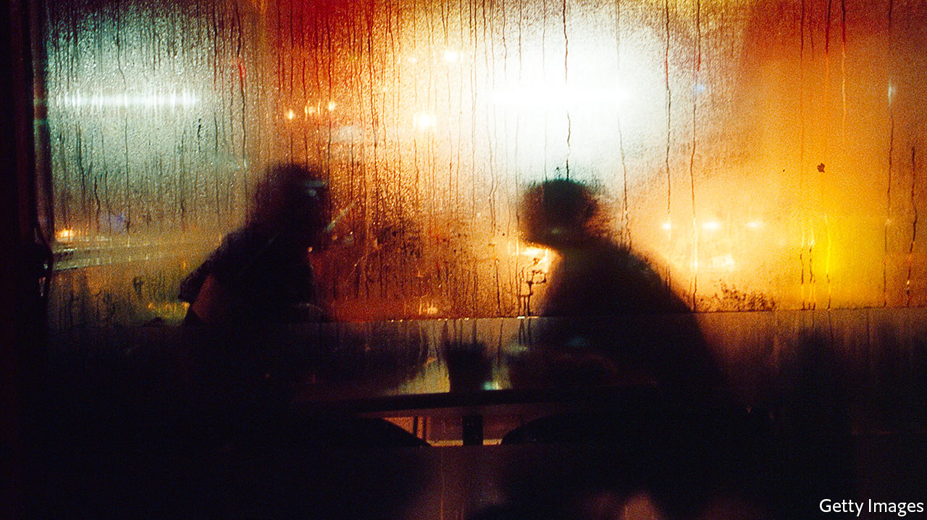

Love. By Roddy Doyle.Viking; 336 pages; $27. To be published in Britain by Jonathan Cape in October; £18.99.

THE SPRIGHTLINESS of Roddy Doyle’s writing makes it hard to believe that “Love” is his 18th work of fiction. As well as novels and short stories, his output has included theatrical adaptations and books for children. His first novel, “The Commitments” (published in 1987), was made into an award-winning film; having been shortlisted for the Booker prize for “The Van” in 1991, he went on to win it two years later with “Paddy Clarke Ha Ha Ha”. Amid the intimate stories he tells, Mr Doyle has chronicled the evolution of modern Ireland and Irish identity over the past few decades. As always, beneath the zing of his prose beats a warm heart.

In “Love” the author is on familiar ground: the city of Dublin, his home town. Not for the first time his principal settings are pubs and other hostelries. Joe and Davy, old friends, are catching up over a few pints. And then a few more. The pair are well into middle age, with all the perspective and regret that entails. The occasion is a rare and unexpected appearance back home by Davy, who now lives in England with his wife Faye and their children. The reason for this visit is fully explained only in the novel’s final, urgent pages.

Mr Doyle is justly renowned for his whip-smart dialogue, which combines salty humour and the loving use of local vernacular (and helps his writing transfer easily and entertainingly from page to screen and stage). The back and forth between Joe and Davy covers decades and relationships, the twists and turns of paths pursued and of roads not taken. For all the camaraderie, beneath the exchange flows an undercurrent of wariness and rivalry dating back to their early adulthood.

At first it is Joe’s story which takes precedence. He has left his long marriage to Trish for a fellow parent at his children’s school. The woman, Jessica, is an enigmatic figure from the friends’ past, part of a group of music students whom they used to encounter in an unremarkable city-centre pub which became their weekend haunt in the early 1980s. Jessica, whose name was then unknown to them, had been an unobtainable, much-discussed object of desire, an attractive cello player to whom neither man later recalls speaking. But as the novel unfolds memories and recollections become slippery.

Mr Doyle juggles his time-frames with characteristic aplomb: from a grey Dublin that still observes “the holy hour”, during which pubs shut every afternoon, to a 21st-century city sweltering in the unaccustomed heat of a tropical summer. The book is infused with male concerns and disappointment but ranges beyond them, too. Flashbacks to two-handed scenes between Davy and Faye, and between Joe and Trish, give a satisfyingly rounded perspective on these lives. Sometimes the effect is comic; more often it is moving.

And there is beauty and compassion in Mr Doyle’s sculpted, spare writing. Among all the banter and gags he manages to articulate feelings that are rarely expressed so fittingly. Whether it is describing the agonising death of an elderly parent, or evoking the euphoria of an unlikely late-life passion, “Love” is a reminder that its author is one to treasure. ■

This article was downloaded by calibre from <https://www.economist.com/books-and-arts/2020/09/12/roddy-doyles-new-novel-is-funny-and-moving>

|  |  |  |  |
| --- | --- | --- | --- |
| Previous | Articles | Sections | Next |

|  |  |  |
| --- | --- | --- |
| Books & arts | Sections | Graphic detail |

Economic & financial indicators

Economic data, commodities and markets

.

|  |  |  |
| --- | --- | --- |
| Books & arts | Sections | Graphic detail |

|  |  |  |  |
| --- | --- | --- | --- |
|  | Articles | Sections | Next |

# Economic data, commodities and markets

Sep 12th 2020 |

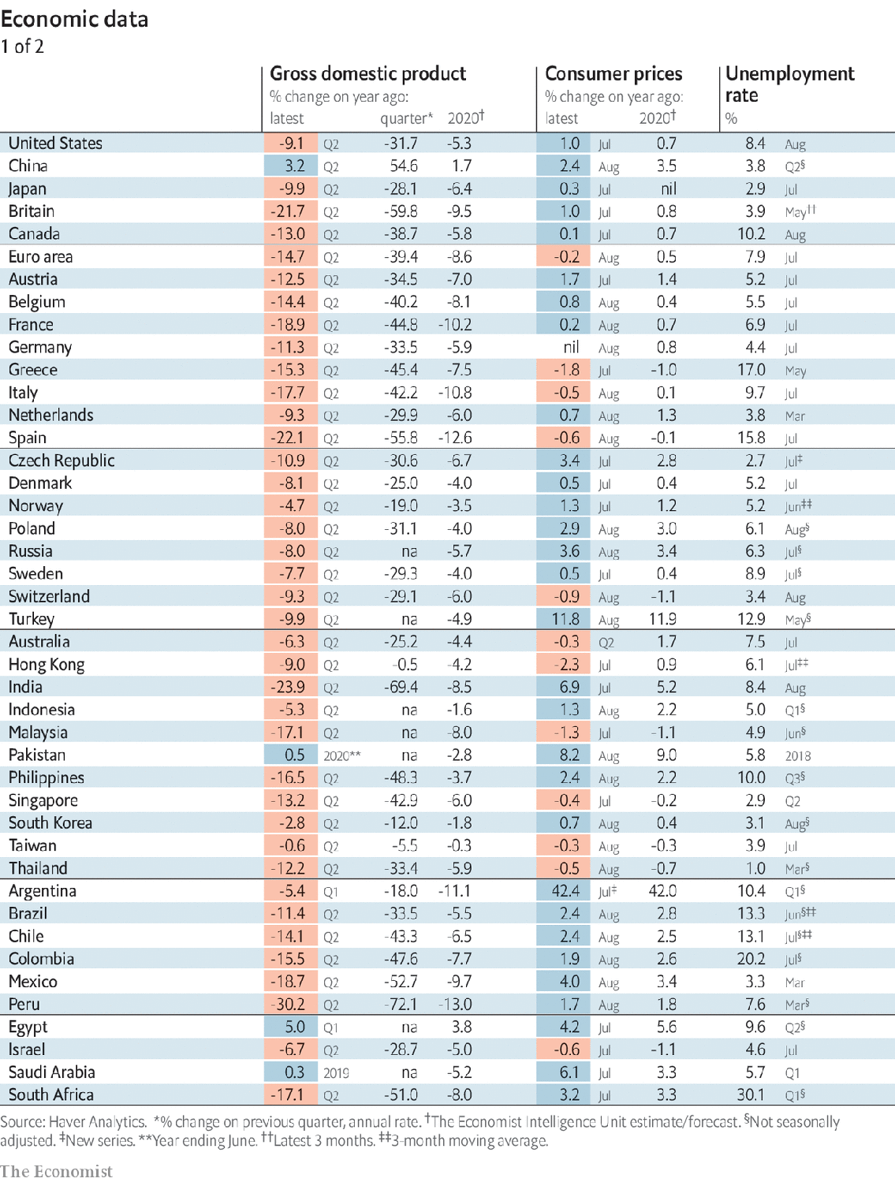

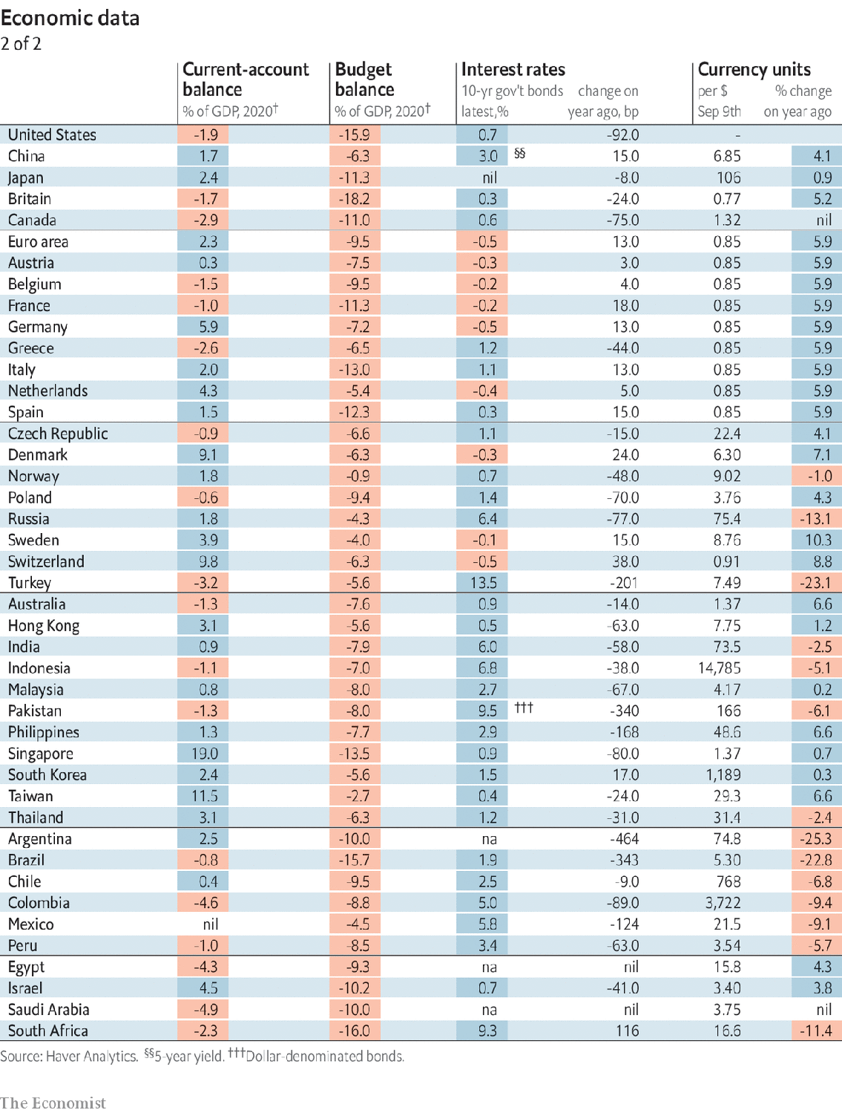

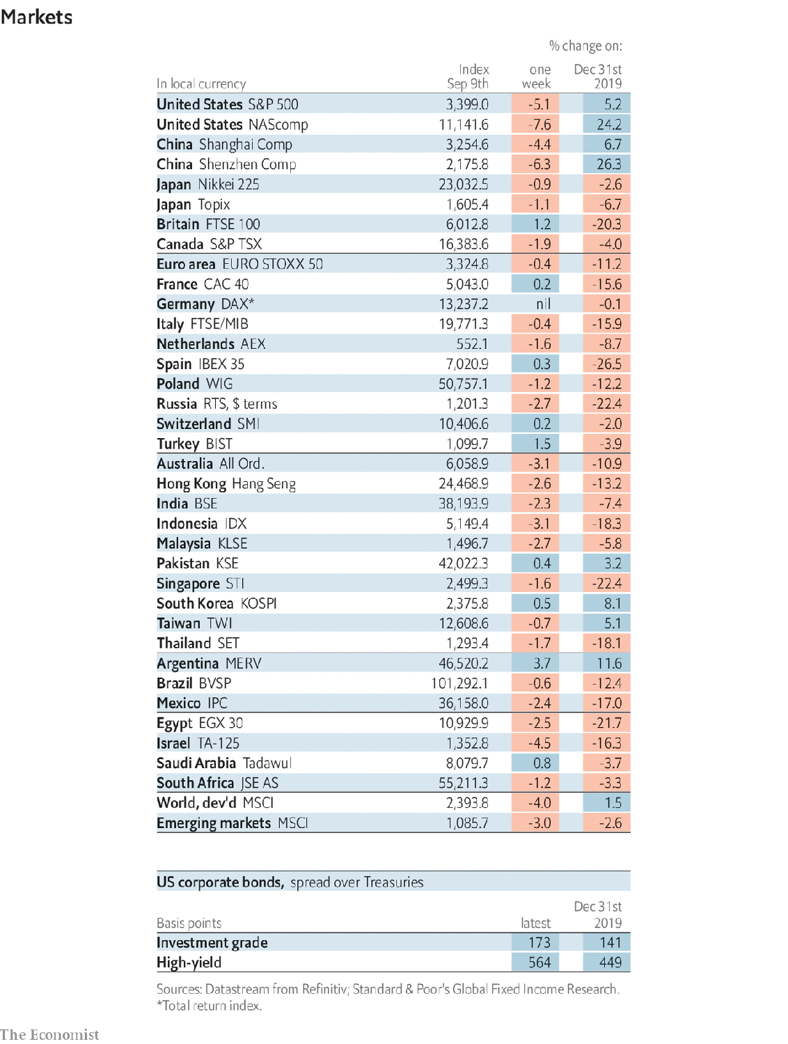

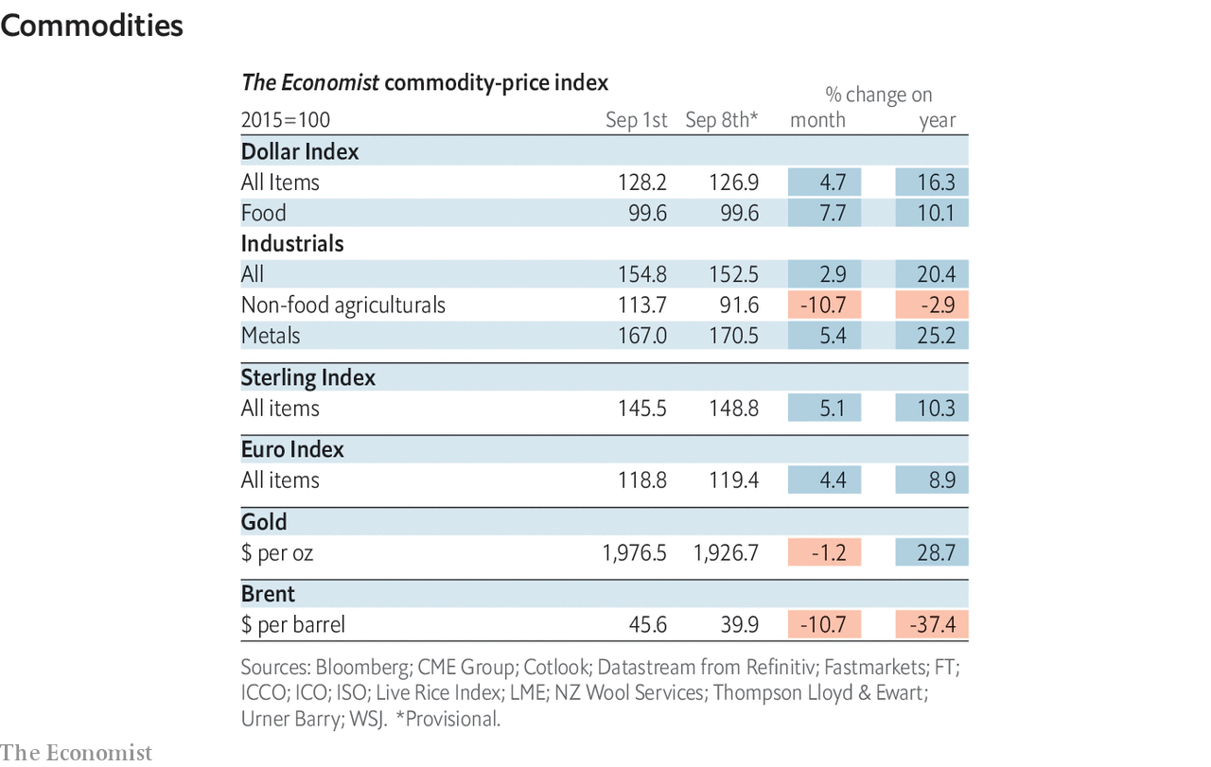

This article was downloaded by calibre from <https://www.economist.com/economic-and-financial-indicators/2020/09/12/economic-data-commodities-and-markets>

|  |  |  |  |
| --- | --- | --- | --- |
|  | Articles | Sections | Next |

|  |  |  |
| --- | --- | --- |
| Economic & ... | Sections | Obituary |

Graphic detail

Influenza: Cold case

.

|  |  |  |
| --- | --- | --- |
| Economic & ... | Sections | Obituary |

|  |  |  |  |
| --- | --- | --- | --- |
|  | Articles | Sections | Next |

#### Cold case

# The southern hemisphere skipped flu season in 2020

Efforts to stop covid-19 have had at least one welcome side-effect

Sep 12th 2020 |

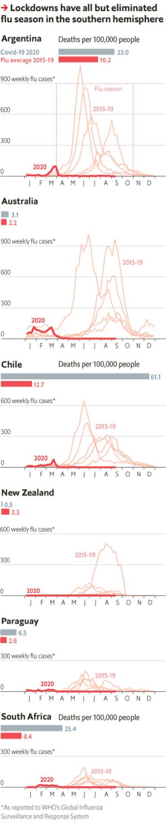

EVERY WINTER, from May to October, tens of thousands of Australians and New Zealanders are asked how they feel. More precisely, they are asked by their governments in weekly surveys if they have a cough or a fever. Although 2020 has been a difficult year in many ways for Aussies and Kiwis, it has not necessarily been bad for their physical health. This winter only around 0.4% of people in the two countries said they were suffering from flu-like symptoms, down by four-fifths compared with last year. Other countries in the southern hemisphere have reported similar slowdowns in the spread of influenza.

The cause for this steep decline in infections is clear. Governments all around the world have enacted costly lockdowns to fight the novel coronavirus. In doing so, not only have countries in the southern hemisphere slowed the spread of covid-19, but they also appear inadvertently to have stopped the proliferation of another deadly disease: the flu.

Since 1952 the World Health Organisation (WHO) has tracked influenza in member countries, relying on local partner laboratories to report both the number and types of viruses they detect. In the first two weeks of August, the WHO processed nearly 200,000 influenza tests, and found just 46 were positive. In a typical year, the number would be closer to 3,500.

One might worry that because health-care systems are strained, the declines in reported flu cases reflect reduced testing capacity, rather than a genuine reduction in infections. Fortunately, this is not so. WHO data are readily available in six countries in the southern hemisphere: Australia, Argentina, South Africa, Paraguay, New Zealand and Chile. There the total number of influenza tests has fallen by just 20%, while the share of tests that have come up positive has plummeted to record lows.

Data from Australia tell a remarkable tale. From May to mid-August of 2015-19, an average of 86,000 Australians tested positive for the flu each year, and around 130 died of it. This winter the government has registered only 627 influenza infections and just a single death.

The reduction in flu cases helps explain at least one puzzle in covid-19 data: some countries have seen a smaller increase in overall mortality than their covid-19 deaths would suggest. For instance, Chile has recorded around 9,800 covid-19 deaths from June to August 25th, but an increase of only about 8,800 deaths overall compared with the same period in 2015-19. It is possible that Chile is undercounting how many of its residents have died. But the near elimination of the flu has helped too.

Influenza cases may yet rise in the south both this year and next, since fewer people have developed immunities. Meanwhile, countries in the northern hemisphere should expect fewer flu cases since fewer will be imported from abroad, and most people are social distancing. Seasonal influenza kills an estimated 300,000-650,000 people annually. In a year filled with terrible news, a victory against the flu is a welcome respite. ■

Sources: “Estimates of global seasonal influenza-associated respiratory mortality” by Danielle Iuliano et al. (2018);WHO; Johns Hopkins University

This article was downloaded by calibre from <https://www.economist.com/graphic-detail/2020/09/12/the-southern-hemisphere-skipped-flu-season-in-2020>

|  |  |  |  |
| --- | --- | --- | --- |
|  | Articles | Sections | Next |

|  |  |  |
| --- | --- | --- |
| Graphic detail | Sections |  |

Obituary

Comrade Duch: The mathematics of death

.

|  |  |  |
| --- | --- | --- |
| Graphic detail | Sections |  |

|  |  |  |  |
| --- | --- | --- | --- |
|  | Articles | Sections | Next |

#### The mathematics of death

# Comrade Duch died on September 2nd

The supervisor of killings for Cambodia’s murderous Khmers Rouges was 77

Sep 12th 2020 |

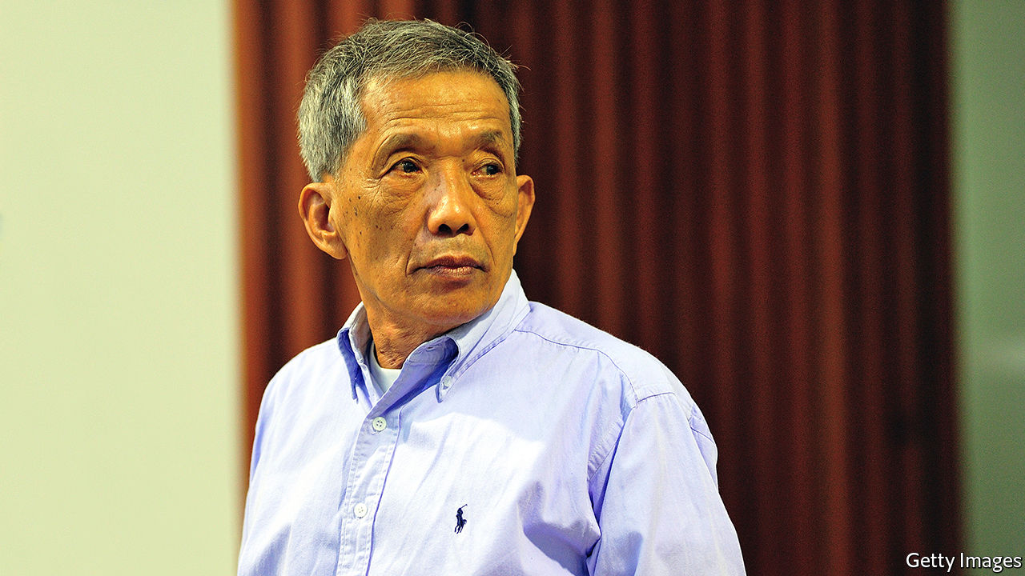

AS THE VIETNAMESE army closed in on Phnom Penh in January 1979, Comrade Duch was ordered to kill the prisoners remaining in his charge. He just about had time to supervise that. (Killing was not usually done in his prison, only in the fields he had designated at Choeung Ek, seven kilometres away. Unless someone slipped up.) He also started to destroy his archive, but did not get far. The orders from Brother Number Two, Nuon Chea, had not specifically requested that. Besides, he did not greatly want to.

The archive was well over 100,000 pages, containing meticulous details of the detainees who had passed to death through his prison, Tuol Sleng, or S-21, over the previous four years. (The most exact figure given later was 15,101, but the archive was by then incomplete.) Prisoners’ weight on entering. Their photographs, with the blank look of people at the end of the line. And their confessions, in as many versions as were needed to condemn them. He kept all the versions, with defective parts crossed out in red. In the margins, neatly, he put comments. “Do not write these words.” “Do not play tricks.” The final acceptable confession was typed and sent to “Angkar”, the high leadership of the Communist Party of Cambodia, to Brother Number Two and Brother Number One, Pol Pot himself. That was the rule. He kept at least two copies. Each carried his decision about the prisoner: “Can be destroyed.” “Take away.” “Keep for medical experiment.” His preferred word was “smash”. That too was the party rule. At once, or later.

The system he had devised at S-21 was simple, logical and perpetual. It could feed unceasingly Comrade Pol Pot’s hunger (which had become his own hunger) to root out the bourgeois oppressor class and purge the country of traitorous elements. Each prisoner was made to incriminate in writing between eight and 11 others. Those others were arrested. They, in turn, incriminated at least eight people. So it went on at the most important and most feared prison in the country: a sequence relentlessly reproducing.

He felt proud of this system. It appealed to him as a mathematician. He had been a star in the subject at school, brilliant enough to get to the Lycée Sisowath in Phnom Penh, even though his family was poor and he was mocked as half-Chinese. His graduation marks in the Baccalaureate were the second-highest in the country. He became a maths teacher, quiet but firm, until communist revolution distracted him. And when that failed he returned. He taught maths and English in refugee camps, maths and Khmer in China, and when he emerged from hiding in 1999 presented himself as a maths teacher. As though he had never diverted.

Teaching, too, was his natural bent. At S-21 he rarely did interrogations himself, but trained the interrogators. Many came with him from the first prison he had ever run, M-13 in the maquis. They were mostly young peasants with a low level of culture, but he trusted them. At S-21 he would telephone them every 20 minutes to check on progress. Most prisoners could be bullied verbally into “confessing” with threats, or “evidence” against them, or even with the steady humiliation of being called “Monsieur”, as if they were colonialists. He kept his usual neat record of what was done to resisters. “About 20 whippings with fine rattan.” “20-30 whippings with electrical wire.” “Stuffing with water.”

He claimed later that he had hated running the prison. He had tried to get sent to the Industry Ministry instead. It was not the torture that troubled him, though he tried to play that down. Nor was it the deaths. He did not see those; the slit throats, the hoe severing the neck, happened elsewhere. His sleep was untroubled by his victims’ faces. What bothered him was that S-21 was meant to be a tool to find out truth. Or so he had convinced himself. Yet perhaps 60% of each “confession” was false, and perhaps 80% of those he sent to death did not oppose the regime. He knew this at the time. Everyone knew it, Angkar included. No one dared say it, for sheer fear. He got through the days, he said later, by quoting Alfred de Vigny: “Energetically perform your long and heavy task/On the path to which Fate has called you/Then…suffer and die without a word.”

To poetry he could add another salve: complete identification with the revolutionary struggle. He had fallen for communism Chinese-style at the Institut de Pédagogie, teacher-training college. That promise of progress and change was irresistible. By the early 1970s he was in the maquis with the Khmers Rouges, learning to fight for a Democratic Kampuchea that would be agrarian, classless and untainted by the West. His nom de guerre, Duch, meant the schoolboy who stood up when his master asked him to. He may have hated the prison work, but he faithfully repeated the slogans. “Our party makes absolutely no mistakes.” “Angkar knows who is good and who is bad.” They did not quite smother the rising fear that his perpetual system might swallow him, too.

Was he sorry? In 1999, when a journalist found him, he wanted to talk. By then he had become a Christian, another ideology in which he could immerse himself. He knew about sins and forgiveness now. Occasionally he shed tears. He was the first high Khmer Rouge official to go on trial, in 2009. There, often dressed in pure white, his soft voice demanding exact dates and transcripts, he explained himself. But what he said one day he might retract the next. He played with truth, as he had done before. Uniquely among Khmer Rouge leaders, he accepted responsibility for his actions at S-21. But his superiors had given the orders, so he was bound to obey. And he hoped, having been useful, that he might be released.

He was not. In 2012 his original sentence of 35 years for torture, murder and crimes against humanity was extended to life. He was not surprised, or did not let it show. He had learned young the most pertinent of Khmer Rouge mottoes for him, “Extinguish your heart.” And he had not thrown off the motivations of those days. Given the chance, he would discuss Marxism for hours. He clung tightly, too, to his nom de guerre. “Kaing Guek Eav” was the quiet teacher’s name he could have reverted to. But “Duch” was still who he was, the diligent boy who pleased his master. And wrote daily, for years, above that name, “Smash.” “Keep.” “Grind to dust.” ■

This article was downloaded by calibre from <https://www.economist.com/obituary/2020/09/12/comrade-duch-died-on-september-2nd>

|  |  |  |  |
| --- | --- | --- | --- |
|  | Articles | Sections | Next |